4th Grade Mathematics

Unit 4 Curriculum Map: April 7 - June 22

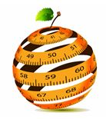
ORANGE PUBLIC SCHOOLS
OFFICE OF CURRICULUM AND INSTRUCTION
OFFICE OF MATHEMATICS

Table of Contents
I. | Unit Overview /NJSLS/21 Century Practices | p. 4
II. | MIF Lesson | p. 11
III. | MIF Pacing & Resources For ELL’s & Special Needs | p. 14
IV. | Pacing Calendar | p. 19
V. | Unit 4 Math Background | p. 22
VI. | PARCC Assessment Evidence/Clarification Statements | p. 24
VII. | Connections to the Mathematical Practices | p. 26
VIII. | Visual Vocabulary | p. 28
IX. | Potential Student Misconceptions | p. 32
X. | Teaching Multiple Representations | p. 33
XI. | Assessment Framework | p. 37
XII. | Performance Tasks | p. 38
XIII. | Supplement Resources | p. 53
XIV. | Extensions and Sources | p. 58
XV. | Revised Standards | p. 60

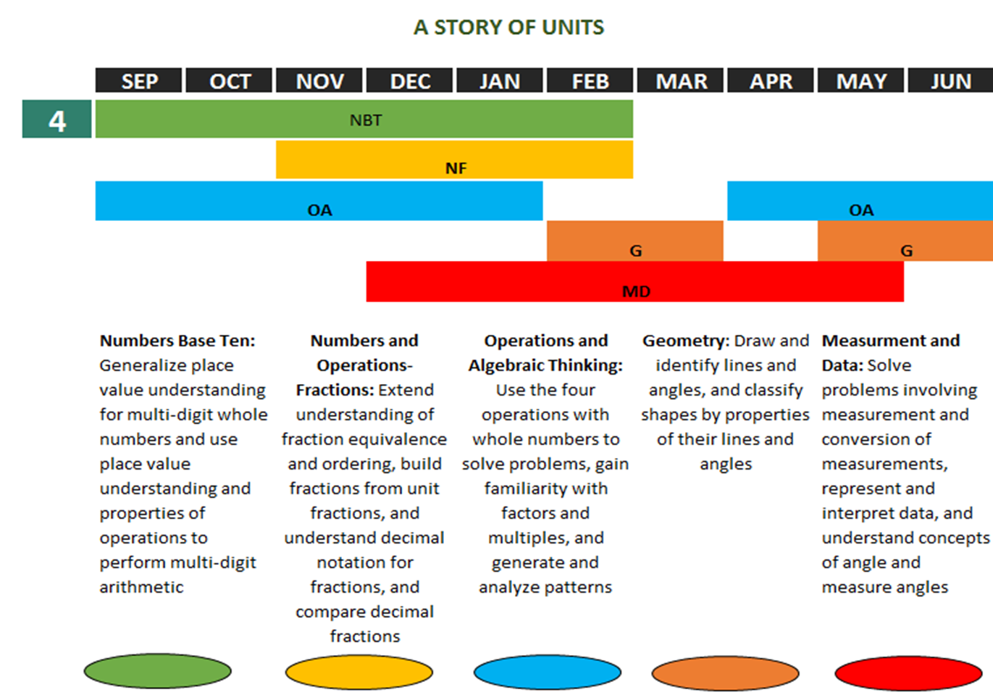
Unit Overview
Unit 4: Chapters 13,14, 4, 5
In this Unit Students will be:
Chapter 13
In this chapter, students learn to find the area and perimeter of figures using formulas. Area is the amount of surface covered by a figure. It is measured in square units. It is measured by counting the number of same sized units of area that cover the shape without gaps or overlaps. Perimeter is the distance around a figure. Using the formula area=length x width, students connected this model to the area model for multiplication. They will also apply what they have learned to find the perimeter of a composite figure. In addition, they will find one side of a rectangle or square given its perimeter or area.
Chapter 14
In this chapter, students learn to identify lines of symmetry of figures and to make symmetric shapes and patterns. Students apply knowledge in this chapter to solve problems involving congruence and symmetry. Students experiment to make symmetric figures with by cutting out patterns or folding paper.

Chapter 4 & 5
In these combined chapters, students will explore tables and graphing using line plots. Data that is tabulated or plotted on graphs can be retrieved easily, and visually elicit patterns and trends. Comparing, analyzing, and classifying are just some of the thinking skills students will apply as they look for patterns and trends.

Essential Questions
- How is perimeter used?
- What is the difference between perimeter and area of a two dimensional figure?
- How is the perimeter of a rectangle determined?
- How is the area of a rectangle determined?
- How can information be gathered, recorded, and organized
- How does the type of data influence the choice of display?
- What aspects of a graph help people understand and interpret the data easily?
- What kinds of questions can and cannot be answered from a graph?
Enduring Understandings
- Finding the area and perimeter of a figure by counting squares
- Students find the area of a rectangle using the formula A=length x width
- Students solve real-world problems involving area and perimeter of figures
- Students identify lines of symmetry in figures
- Students learn to collect and organize data, as well as present data in a form(line plot) that is easy to read.
- Students use the four operations of whole numbers when they analyze data presented in graphs and tables to solve problems

Common Core State Standards
4.OA.3 | Solve multistep word problems posed with whole numbers and having whole-number answers using the four operations, including problems in which remainders must be interpreted. Represent these problems using equations with a letter standing for the unknown quantity. Assess the reasonableness of answers using mental computation and estimation strategies including rounding.
The focus in this standard is to have students use and discuss various strategies. It refers to estimation strategies, including using compatible numbers (numbers that sum to 10 or 100) or rounding. Problems should be structured so that all acceptable estimation strategies will arrive at a reasonable answer. Students need many opportunities solving multistep story problems using all four operations.
Example: On a vacation, your family travels 267 miles on the first day, 194 miles on the second day and 34 miles on the third day. How many miles did they travel total? Some typical estimation strategies for this problem:
- Student 1- I first thought about 267 and 34. I noticed that their sum is about 300. Then I knew that 194 is close to 200. When I put 300 and 200 together, I get 500.
- Student 2 -I first thought about 194. It is really close to 200. I also have 2 hundreds in 267. That gives me a total of 4 hundreds. Then I have 67 in 267 and the 34. When I put 67 and 34 together that is really close to 100. When I add that hundred to the 4 hundreds that I already had, I end up with 500.
- Student 3- I rounded 267 to 300. I rounded 194 to 200. I rounded 34 to 30. When I added 300, 200 and 30, I know my answer will be about 530.
The assessment of estimation strategies should only have one reasonable answer (500 or 530), or a range (between 500 and 550). Problems will be structured so that all acceptable estimation strategies will arrive at a reasonable answer.
Estimation skills include identifying when estimation is appropriate, determining the level of accuracy needed, selecting the appropriate method of estimation, and verifying solutions or determining the reasonableness of situations using various estimation strategies. Estimation strategies include, but are not limited to:
• clustering around an average (when the values are close together an average value is selected and multiplied by the number of values to determine an estimate),
• rounding and adjusting (students round down or round up and then adjust their estimate depending on how much the rounding affected the original values),
• using friendly or compatible numbers such as factors (students seek to fit numbers together - e.g., rounding to factors and grouping numbers together that have round sums like 100 or 1000),
• using benchmark numbers that are easy to compute (students select close whole numbers for fractions or decimals to determine an estimate).
4.MD.2 | Use the four operations to solve word problems involving distances, intervals of time, liquid volumes, masses of objects, and money, including problems involving simple fractions or decimals, and problems that require expressing measurements given in a larger unit in terms of a smaller unit. Represent measurement quantities using diagrams such as number line diagrams that feature a measurement scale.
This standard includes multi-step word problems related to expressing measurements from a larger unit in terms of a smaller unit (e.g., feet to inches, meters to centimeter, and dollars to cents). Students should have ample opportunities to use number line diagrams to solve word problems.
Example: Charlie and 10 friends are planning for a pizza party. They purchased 3 quarts of milk. If each glass holds 8oz will everyone get at least one glass of milk? possible solution:
Charlie plus 10 friends = 11 total people 11 people x 8 ounces (glass of milk) = 88 total ounces 1 quart = 2 pints = 4 cups = 32 ounces Therefore 1 quart = 2 pints = 4 cups = 32 ounces 2 quarts = 4 pints = 8 cups = 64 ounces 3 quarts = 6 pints = 12 cups = 96 ounces
If Charlie purchased 3 quarts (6 pints) of milk there would be enough for everyone at his party to have at least one glass of milk. If each person drank 1 glass then he would have 1- 8 oz glass or 1 cup of milk left over. Additional Examples with various operations:
Division/fractions: Susan has 2 feet of ribbon. She wants to give her ribbon to her 3 best friends so each friend gets the same amount. How much ribbon will each friend get? Students may record their solutions using fractions or inches. (The answer would be 2/3 of a foot or 8 inches. Students are able to express the answer in inches because they understand that 1/3 of a foot is 4 inches and 2/3 of a foot is 2 groups of 1/3.)
Addition: Mason ran for an hour and 15 minutes on Monday, 25 minutes on Tuesday, and 40 minutes on Wednesday. What was the total number of minutes Mason ran?
Subtraction: A pound of apples costs $1.20. Rachel bought a pound and a half of apples. If she gave the clerk a $5.00 bill, how much change will she get back?
Multiplication: Mario and his 2 brothers are selling lemonade. Mario brought one and a half liters, Javier brought 2 liters, and Ernesto brought 450 milliliters. How many total milliliters of lemonade did the boys have? Number line diagrams that feature a measurement scale can represent measurement quantities.
Examples include: ruler, diagram marking off distance along a road with cities at various points, a timetable showing hours throughout the day, or a volume measure on the side of a container.
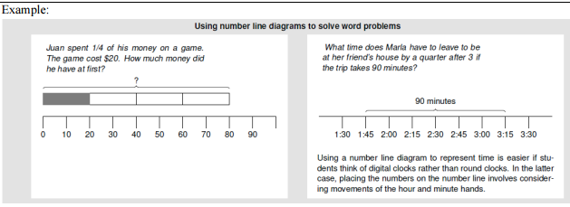

Students also combine competencies from different domains as they solve measurement problems using all four arithmetic operations, addition, subtraction, multiplication, and division. Example: “How many liters of juice does the class need to have at least 35 cups if each cup takes 225 ml?” Students may use tape or number line diagrams for solving such problems.
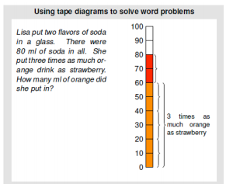

4.MD.3 | Apply the area and perimeter formulas for rectangles in real world and mathematical problems. For example, find the width of a rectangular room given the area of the flooring and the length, by viewing the area formula as a multiplication equation with an unknown factor.
Based on work in third grade students learn to consider perimeter and area of rectangles. Fourth graders multiplication, spatially structuring arrays, and area, they abstract the formula for the area of a rectangle A = l x w.
The formula is a generalization of the understanding, that, given a unit of length, a rectangle whose sides have length w units and l units, can be partitioned into w rows of unit squares with l squares in each row. The product l x w gives the number of unit squares in the partition, thus the area measurement is l x w square units. These square units are derived from the length unit. Students generate and discuss advantages and disadvantages of various formulas for the perimeter length of a rectangle that is l units by w units.
For example, P = 2l + 2w has two multiplications and one addition, but P = 2(l + w), which has one addition and one multiplication, involves fewer calculations. The latter formula is also useful when generating all possible rectangles with a given perimeter. The length and width vary across all possible pairs whose sum is half of the perimeter (e.g., for a perimeter of 20, the length and width are all of the pairs of numbers with sum 10).
Giving verbal summaries of these formulas is also helpful. For example, a verbal summary of the basic formula, A = l + w + l + w, is “add the lengths of all four sides.” Specific numerical instances of other formulas or mental calculations for the perimeter of a rectangle can be seen as examples of the properties of operations, e.g., 2l + 2w = 2(l + w) illustrates the distributive property.
Perimeter problems often give only one length and one width, thus remembering the basic formula can help to prevent the usual error of only adding one length and one width. The formula P = 2 (l x w) emphasizes the step of multiplying the total of the given lengths by 2. Students can make a transition from showing all length units along the sides of a rectangle or all area units within by drawing a rectangle showing just parts of these as a reminder of which kind of unit is being used. Writing all of the lengths around a rectangle can also be useful. Discussions of formulas such as P = 2l + 2w, can note that unlike area formulas, perimeter formulas combine length measurements to yield a length measurement.
Such abstraction and use of formulas underscores the importance of distinguishing between area and perimeter in Grade 3 and maintaining the distinction in Grade 4 and later grades, where rectangle perimeter and area problems may get more complex and problem solving can benefit from knowing or being able to rapidly remind oneself of how to find an area or perimeter. By repeatedly reasoning about how to calculate areas and perimeters of rectangles, students can come to see area and perimeter formulas as summaries of all such calculations.
Mr. Rutherford is covering the miniature golf course with an artificial grass. How many 1-foot squares of carpet will he need to cover the entire course?
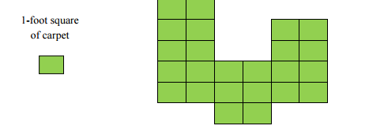
Students learn to apply these understandings and formulas to the solution of real-world and mathematical problems. Example: A rectangular garden has as an area of 80 square feet. It is 5 feet wide. How long is the garden? Here, specifying the area and the width creates an unknown factor problem. Similarly, students could solve perimeter problems that give the perimeter and the length of one side and ask the length of the adjacent side.
Students should be challenged to solve multistep problems. Example: A plan for a house includes rectangular room with an area of 60 square meters and a perimeter of 32 meters. What are the length and the width of the room? In fourth grade and beyond, the mental visual images for perimeter and area from third grade can support students in problem solving with these concepts. When engaging in the mathematical practice of reasoning abstractly and quantitatively in work with area and perimeter, students think of the situation and perhaps make a drawing. Then they recreate the “formula” with specific numbers and one unknown number as a situation equation for this particular numerical situation. “Apply the formula” does not mean write down a memorized formula and put in known values because in fourth grade students do not evaluate expressions (they begin this type of work in Grade 6). In fourth grade, working with perimeter and area of rectangles is still grounded in specific visualizations and numbers. These numbers can now be any of the numbers used in fourth grade (for addition and subtraction for perimeter and for multiplication and division for area). By repeatedly reasoning about constructing situation equations for perimeter and area involving specific numbers and an unknown number, students will build a foundation for applying area, perimeter, and other formulas by substituting specific values for the variables in later grades.

4.G.3 | Recognize a line of symmetry for a two-dimensional figure as a line across the figure such that the figure can be folded along the line into matching parts. Identify line-symmetric figures and draw lines of symmetry.
Students need experiences with figures which are symmetrical and non-symmetrical. Figures include both regular and non-regular polygons. Folding cut-out figures will help students determine whether a figure has one or more lines of symmetry.
This standard only includes line symmetry not rotational symmetry.
Example: For each figure, draw all of the lines of symmetry. What pattern do you notice? How many lines of symmetry do you think there would be for regular polygons with 9 and 11 sides. Sketch each figure and check your predictions. Polygons with an odd number of sides have lines of symmetry that go from a midpoint of a side through a vertex.
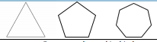

M : Major Content S: Supporting Content A : Additional Content

21st Century Career Ready Practices
CRP1. Act as a responsible and contributing citizen and employee.
CRP2. Apply appropriate academic and technical skills.
CRP3. Attend to personal health and financial well-being.
CRP4. Communicate clearly and effectively and with reason.
CRP5. Consider the environmental, social and economic impacts of decisions.
CRP6. Demonstrate creativity and innovation.
CRP7. Employ valid and reliable research strategies.
CRP8. Utilize critical thinking to make sense of problems and persevere in solving them.
CRP9. Model integrity, ethical leadership and effective management.
CRP10. Plan education and career paths aligned to personal goals.
CRP11. Use technology to enhance productivity.
CRP12. Work productively in teams while using cultural global competence.
MIF Lesson Structure
LESSON STRUCTURE  PRE TEST | RESOURCES | COMMENTS
Chapter Opener  Assessing Prior Knowledge  The Pre Test serves as a diagnostic test of readiness of the upcoming chapter | Teacher Materials  Quick Check  PreTest (Assessm’t Bk)  Recall Prior Knowledge  Student Materials  Student Book (Quick Check); Copy of the Pre Test; Recall prior Knowledge | Recall Prior Knowledge (RPK) can take place just before the pre-tests are given and can take 1-2 days to front load prerequisite understanding  Quick Check can be done in concert with the RPK and used to repair student misunderstandings and vocabulary prior to the pre-test ; Students write Quick Check answers on a separate sheet of paper  Quick Check and the Pre Test can be done in the same block (See Anecdotal Checklist; Transition Guide)  Recall Prior Knowledge – Quick Check – Pre Test
Direct Involvement/Engagement  Teach/Learn  Students are directly involved in making sense, themselves, of the concepts – by interacting the tools, manipulatives, each other, and the questions  DIRECT ENGAGEMENT | Teacher Edition  5-minute warm up  Teach; Anchor Task  Technology  Digi  Other  Fluency Practice | - The Warm Up activates prior knowledge for each new lesson  - Student Books are CLOSED; Big Book is used in Gr. K  - Teacher led; Whole group  - Students use concrete manipulatives to explore concepts  - A few select parts of the task are explicitly shown, but the majority is addressed through the hands-on, constructivist approach and questioning  - Teacher facilitates; Students find the solution
Guided Learning and Practice  Guided Learning  GUIDED LEARNING | Teacher Edition  Learn  Technology  Digi  Student Book  Guided Learning Pages  Hands-on Activity | Students-already in pairs /small, homogenous ability groups; Teacher circulates between groups; Teacher, anecdotally, captures student thinking  Small Group w/Teacher circulating among groups  Revisit Concrete and Model Drawing; Reteach  Teacher spends majority of time with struggling learners; some time with on level, and less time with advanced groups  Games and Activities can be done at this time

Independent Practice  INDEPENDENT PRACTICE  A formal formative assessment | Teacher Edition  Let’s Practice  Student Book  Let’s Practice  Differentiation Options  All: Workbook  Extra Support: Reteach  On Level: Extra Practice  Advanced: Enrichment | Let’s Practice determines readiness for Workbook and small group work and is used as formative assessment; Students not ready for the Workbook will use Reteach. The Workbook is continued as Independent Practice.  Manipulatives CAN be used as a communications tool as needed.  Completely Independent  On level/advance learners should finish all workbook pages.
Extending the Lesson  ADDITIONAL PRACTICE | Math Journal  Problem of the Lesson  Interactivities  Games
Lesson Wrap Up | Problem of the Lesson  Homework (Workbook , Reteach, or Extra Practice) | Workbook or Extra Practice Homework is only assigned when students fully understand the concepts (as additional practice)  Reteach Homework (issued to struggling learners) should be checked the next day
End of Chapter Wrap Up and Post Test  POST TEST | Teacher Edition  Chapter Review/Test  Put on Your Thinking Cap  Student Workbook  Put on Your Thinking Cap  Assessment Book  Test Prep | Use Chapter Review/Test as “review” for the End of Chapter Test Prep. Put on your Thinking Cap prepares students for novel questions on the Test Prep; Test Prep is graded/scored.  The Chapter Review/Test can be completed  - Individually (e.g. for homework) then reviewed in class  - As a ‘mock test’ done in class and doesn’t count  - As a formal, in class review where teacher walks students through the questions  Test Prep is completely independent; scored/graded  Put on Your Thinking Cap (green border) serve as a capstone problem and are done just before the Test Prep and should be treated as Direct Engagement. By February, students should be doing the Put on Your Thinking Cap problems on their own.

TRANSITION LESSON STRUCTURE (No more than 2 days)
- Driven by Pre-test results, Transition Guide
- Looks different from the typical daily lesson

Transition Lesson – Day 1

Objective:
CPA Strategy/Materials | Ability Groupings/Pairs (by Name)
Task(s)/Text Resources | Activity/Description

MIF Pacing Guide

Activity | NJSLS | Estimated Time  (# of block) | Lesson Notes
**12.3 Time | 4.MD.2 | 2 Blocks
**Authentic Assessment #9 | 4.MD.6, 4.MD.7, 4.G.1 | ½ Block
**12.4 Real Life Word Problems Day 1 | 4. MD. 1 | 1 Block
**12.4 Real Life Word Problems Day 2 | 4. MD. 1 | 1 Block
**Chapter 12  Wrap Up/Review |  | ½ Block | Reinforce and consolidate chapter skills and concepts
**Chapter Test/Review 12 | 4.MD. 1 | ½ Block
**Mini Assessment #11 | 4.MD.1-3 | ½ Block
Pre Test 13 | 4.MD.2, 4.MD.3 | 1/2 Block
Area and Perimeter Chapter 13 – Intro | 4.MD.2, 4.MD.3 | 1 Block | Intro the Big Idea
Area of a Rectangle  13.1 Day 1 | 4.MD.2, 4.MD.3 | 2 Blocks | You may want to teach this lesson in two mini lessons.  - One lesson – counting grid squares to find area.  - Second Lesson – use formula to find area.
Area of a Rectangle  13.1 Day 2 | 4.MD.2, 4.MD.3 | 1 Block | Provide students with key for shaded regions.
Area of a Rectangle  13.1 Day 3 | 4.MD.2, 4.MD.3 | 1 Block | Remind students of the array model when calculating the squares.
Rectangles and Squares  13.2 Day 1 | 4.MD.2, 4.MD.3 | 1 Block | Have students determine the order of operation to solve the problem
Rectangles and Squares 13.2 Day 2 | 4.MD.2, 4.MD.3 | 1 Block
Portfolio Assessment- Perimeter/Area | 4.MD.3 | 1/2 Block
Composite Figures  13.3 Day 1 | 4.MD.3, 4.OA.3 | 1 Block | Show students how to make squares and rectangles with composite figures.
Composite Figures  13.3 Day 2 | 4.MD.3, 4.OA.3 | 1 Block | Have students shade dimensions not identified.
Using Formulas for Area and Perimeter  13.4 Day 1 | 4.MD.3, 4.OA.3 | 1 Block | Try to have students use the formula to find area.
Area and Perimeter  Chapter 13  Wrap Up/Review |  | 1 Block | Reinforce and consolidate chapter skills and concepts
Test Prep 13 | 4.MD.3, 4.OA.3 | ½ Block
Geometry Town Project (rubric) | 4.MD.3 | Home Project | Students will receive project information before Spring Recess to allow students time to work with parent/guardian on Geometry town Idea
Pre Test 14 |  | ½ Block
Identifying Lines of Symmetry  14.1 Day 1 | 4.G.3 | 2 Block | Have students cut out the object/figure and fold it to see symmetry. Day one on letters, day two on figures.
Making Symmetric Shapes and Patterns  14.3 Day 1 | 4.G.3, 4.OA.5 | 1 Block
TestPrep 14 | 4.G.3 | ½ Block
Mini Assessment #12 | 4.G.3 | 1/2 Block
The Mathematics department suggests that at this moment the teacher,
make data informed decisions to review content pertinent to the grade.
Making and Interpreting a Table  4.1 Day 1 | 4.MD.4 | 1 Block | Students should know how to interpret data from 3grade, however, use this lesson as a refresher to introduce line plotting with median, mode, and range.
Making and Interpreting a Table  4.1 Day 2 | 4.MD.4 | 1 Block | Have students create their own table using bar graph to ensure data understanding. Make sure students understand tick marks on the graph divide the scale into intervals of 10.
Using a Table  4.2 Day 1 | 4.MD.4 | 1 Block | Use index cards to align data in table.
Median, Mode, and Range  5.2 Day 1 | n/a | 2 Blocks | Day 1 – Explain Range and Mode  Day 2 – Explain Median
Median, Mode, and Range  5.2 Day 2 | n/a | 2 Blocks | Demonstrate the use of the X’s orally with students with common topic like birthdays.
Chapter Review 4,5 | 4.G.3, 4.OA.5 | 1 Block | Select questions from Let’s Practice to create a mini review for Test Prep
Test Prep 4, 5 | 4.G.3, 4.OA.5 | ½ Block | Only certain questions from each test, complied into one test. Chapter 4 and 5 are not CCC related, however, line plots are a 4th grade standard.
Mini Assessment #13 | 4.MD.4 | ½ Block
***From Unit 3, depending on PARCC schedule.

Resources for Special Needs and ELL’s
Chapter 13
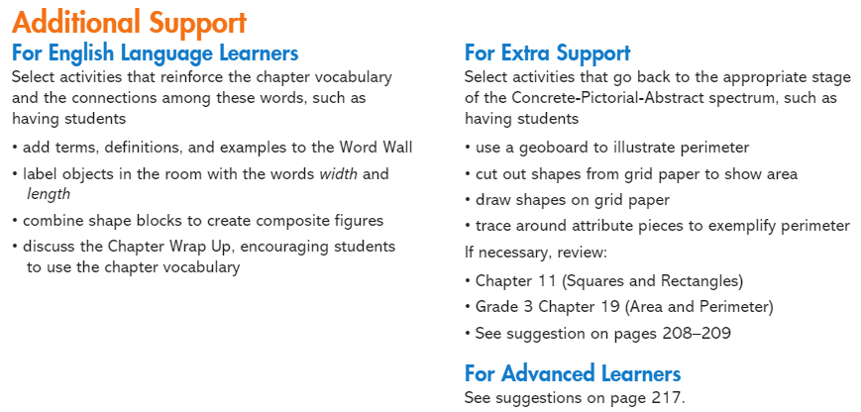
Chapter 14
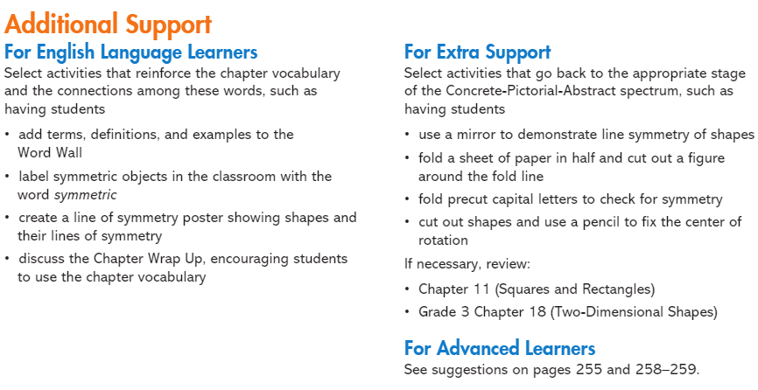

Chapter 4
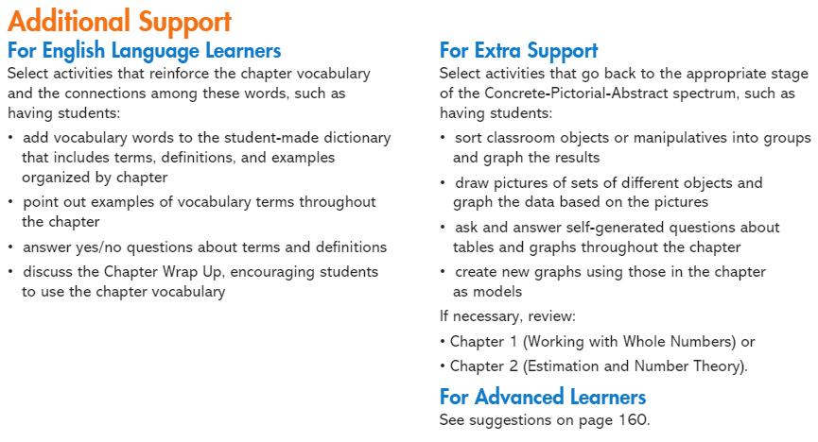
Chapter 5
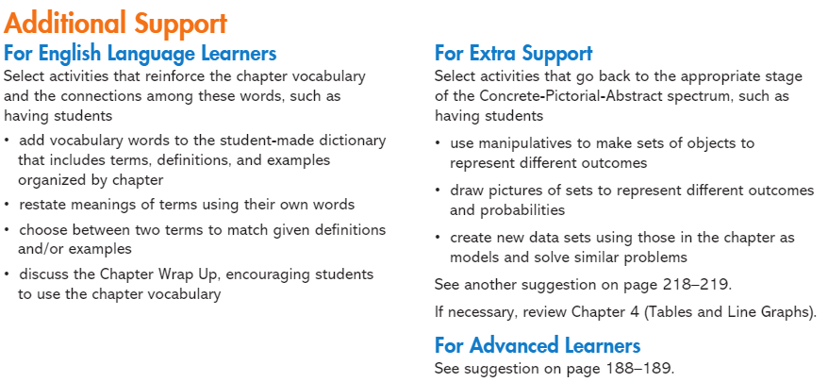
Pacing Calendar

April
Sunday | Monday | Tuesday | Wednesday | Thursday | Friday | Saturday
 |  |  |  |  |  | 1
2 | 3 | 4 | 5 | 6 | 7  Chapter 12 Continued from Unit 3 | 8
9 | 10 | 11  Authentic Assessment #9 | 12 | 13 | 14  No School | 15
16 | 17  No School | 18  No School | 19  No School | 20  No School | 21  No School | 22
23 | 24 | 25  Chapter 12 Test | 26  Mini Assessment #11 | 27  Pre-Test 13 | 28 | 29
30

May
Sunday | Monday | Tuesday | Wednesday | Thursday | Friday | Saturday
 | 1 | 2 | 3 | 4 | 5 | 6
7 | 8 | 9  Authentic Assessment #10 | 10 | 11 | 12 | 13
12 | 15 | 16  Test Prep 13 | 17  Chapter 14 Pre-Test | 18 | 19 | 20
21 | 22 | 23  Mini Assessment #12 | 24 | 25  Test Prep 14 | 26  Chapter 4 | 27
28 | 29  No School | 30 | 31

June
Sunday | Monday | Tuesday | Wednesday | Thursday | Friday | Saturday
 |  |  |  | 1 | 2 | 3
4 | 5  Chapter 5 Pre-Test | 6 | 7 | 8 | 9 | 10
11 | 12 | 13  Review Chapters 4 and 5 | 14  Chapter 4 and 5 Combined Test | 15  Mini Assessment # 13 | 16 | 17
18 | 19 | 20  12:30 Dismissal | 21  12:30 Dismissal | 22  12:30 Dismissal | 23 | 24
25 | 26 | 27 | 28 | 29 | 30
Unit 4 Math Background
Students learned to measure length, weight, and capacity using customary units of measurement. Students learned to tell time to the minute and elapse time. Students used the four operations to solve measurement real life problems.
Students in early grades counted square units to find the area and perimeter. Students learned to add the lengths of all the sides to find perimeter. Students also used length x width and connecting it to the area model to solve for area.

Transition Guide References:
Chapter : 13
Transition Topic: Area and Perimeter
Grade 4  Chapter  Pre Test Items | Grade 4  Chapter  Pre-Test Item Objective | Additional Support for the Objective:  Grade 4 Reteach | Additional Support for the Objective:  Grade 4  Extra Practice | Grade 4  Teacher Edition Support
Items 2,3,5,7,8,9 | Find the area of a figure | pp. 145-152 | pp. 93-98 | pp. 200-210
Item 4 | Identify square inch | pp. 169-172 | pp. 109-112 | pp. 224-236
Item 1,10,11 | Find the perimeter of a figure | pp. 163-168 | pp. 105-108 | pp. 218-223

Chapter : 14
Transition Topic: Symmetry
Grade 4  Chapter  Pre Test Items | Grade 4  Chapter  Pre Test Item  Objective | Additional Support for the Objective: Grade 4  Reteach | Additional Support for the Objective: Grade 4  Extra Practice | Grade 4  Teacher Edition Support
Item 3, 6 | Identify line of symmetry | pp. 173-176 | pp. 115-118 | Pp. 249-250

PARCC Assessment Evidence/Clarification Statements
NJSLS | Evidence Statement | Clarification | Math Practices
4.MD.2 | Use the four operations to solve word problems involving distances, intervals of time, liquid volumes, masses of objects, and money, in problems that require expressing measurements given in a larger unit in terms of a smaller unit. Represent measurement quantities using diagrams such as number line diagrams that feature a measurement scale. | i) Situations involve whole number measurements and require expressing measurements given in a larger unit in terms of a smaller unit.  ii) Tasks may present number line diagrams featuring a measurement scale. iii) Tasks may include measuring distances to the nearest cm or mm. iv) Units of mass are limited to grams and kilograms. | MP.4,MP.5
4.MD.3 | Apply the area and perimeter formulas for rectangles in real world and mathematical problems. For example, find the width of a rectangular room given the area of the flooring and the length, by viewing the area formula as a multiplication equation with an unknown factor. | None | MP.2, MP.5
4.OA.3 | Solve multistep word problems posed with whole numbers and having whole-number answers using the four operations, including problems in which  Remainders must be interpreted. Represent these problems using equations with a letter standing for the unknown quantity. Assess the reasonableness of answers using mental computation and estimation strategies including rounding | i) Assessing reasonableness of answer is not assessed here.  ii) Tasks involve interpreting remainders. | MP .1, MP2, MP.4, MP.7
4.OA.5 | Generate a number or shape pattern that follows a given rule. Identify apparent features of the pattern that were not explicit in the rule itself. For example, given the rule “Add 3” and the starting number 1, generate terms in the resulting sequence and observe that the terms appear to alternate between odd and even numbers. Explain informally why the numbers will continue to alternate in this way | i) Tasks do not require students to determine a rule; the rule is given.  ii) 75% of patterns should be number patterns. | MP.8
4.G.2 | Classify two-dimensional figures based on the presence or absence of parallel or perpendicular lines, or the presence or absence of angles of a specified size. Recognize right triangles as a category, and identify right triangles. | i) A trapezoid is defined as “A quadrilateral with at least one pair of parallel sides.” ii) Tasks may include terminology: equilateral, isosceles, scalene, acute, right, and obtuse. | MP.7
4.G.3 | Recognize a line of symmetry for a two-dimensional figure as a line across the figure such that the figure can be folded along the line into matching parts. Identify line-symmetric figures and draw lines of symmetry. | None
4.NF.1 | Use the principle a/b = (nxa)/(nxb) to recognize and generate equivalent fractions. | i) The explanation aspect of 4.NF.1 is not assessed here. ii) Tasks are limited to denominators 2, 3, 4, 5, 6, 8, 10, 12, and 100 iii) Tasks may include fractions that equal whole numbers. Fractions equivalent to whole numbers are limited to 0 through 5. | MP.7

Connections to the Mathematical Practices
1 | Make sense of problems and persevere in solving them
1 | Mathematically proficient students in grade 4 know that doing mathematics involves solving problems and discussing how they solved them. Students explain to themselves the meaning of a problem and look for ways to solve it. Fourth graders may use concrete objects or pictures to help them conceptualize and solve problems. They may check their thinking by asking themselves, “Does this make sense?” They listen to the strategies of others and will try different approaches. They often will use another method to check their answers.
2 | Reason abstractly and quantitatively
2 | Mathematically proficient fourth graders should recognize that a number represents a specific quantity. They connect the quantity to written symbols and create a logical representation of the problem at hand, considering both the appropriate units involved and the meaning of quantities. They extend this understanding from whole numbers to their work with fractions and decimals. Students write simple expressions, record calculations with numbers, and represent or round numbers using place value concepts.
3 | Construct viable arguments and critique the reasoning of others
3 | In fourth grade mathematically proficient students may construct arguments using concrete referents, such as objects, pictures, and drawings. They explain their thinking and make connections between models and equations. They refine their mathematical communication skills as they participate in mathematical discussions involving questions like “How did you get that?” and “Why is that true?” They explain their thinking to others and respond to others’ thinking.
4 | Model with mathematics
4 | Mathematically proficient fourth grade students experiment with representing problem situations in multiple ways including numbers, words (mathematical language), drawing pictures, using objects, making a chart, list, or graph, creating equations, etc. Students need opportunities to connect the different representations and explain the connections. They should be able to use all of these representations as needed. Fourth graders should evaluate their results in the context of the situation and reflect on whether the results make sense.
5 | Use appropriate tools strategically
5 | Mathematically proficient fourth graders consider the available tools(including estimation) when solving a mathematical problem and decide when certain tools might be helpful. For instance, they may use graph paper or a number line to represent and compare decimals and protractors to measure angles. They use other measurement tools to understand the relative size of units within a system and express measurements given in larger units in terms of smaller units.
6 | Attend to precision
6 | As fourth graders develop their mathematical communication skills, they try to use clear and precise language in their discussions with others and in their own reasoning. They are careful about specifying units of measure and state the meaning of the symbols they choose. For instance, they use appropriate labels when creating a line plot.
7 | Look for and make use of structure
7 | In fourth grade mathematically proficient students look closely to discover a pattern or structure. For instance, students use properties of operations to explain calculations (partial products model). They relate representations of counting problems such as tree diagrams and arrays to the multiplication principal of counting. They generate number or shape patterns that follow a given rule.
8 | Look for and express regularity in repeated reasoning
8 | Students in fourth grade should notice repetitive actions in computation to make generalizations Students use models to explain calculations and understand how algorithms work. They also use models to examine patterns and generate their own algorithms. For example, students use visual fraction models to write equivalent fractions.

Visual Vocabulary
Visual Definition
The terms below are for teacher reference only and are not to be memorized by students. Teachers should first present these concepts to students with models and real life examples. Students should understand the concepts involved and be able to recognize and/or use them with words, models, pictures, or numbers.
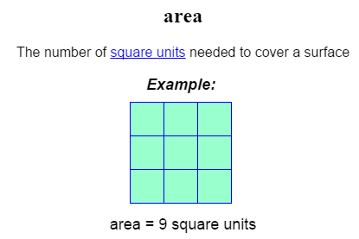
Composite Figure
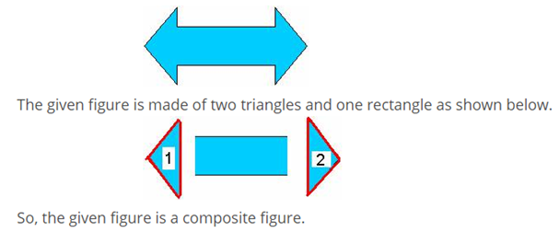
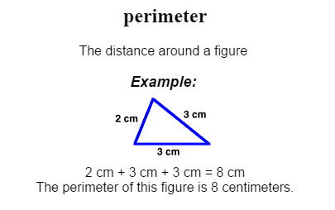
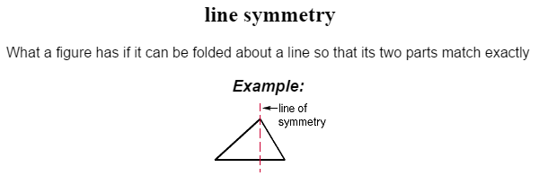
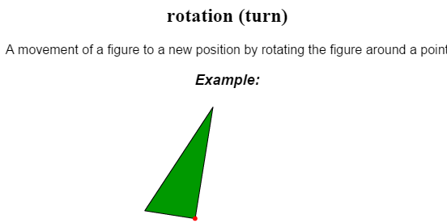
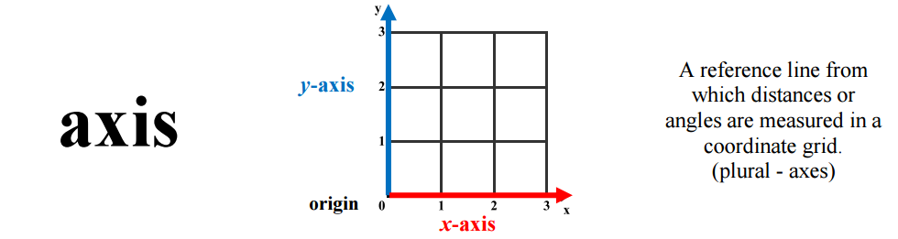
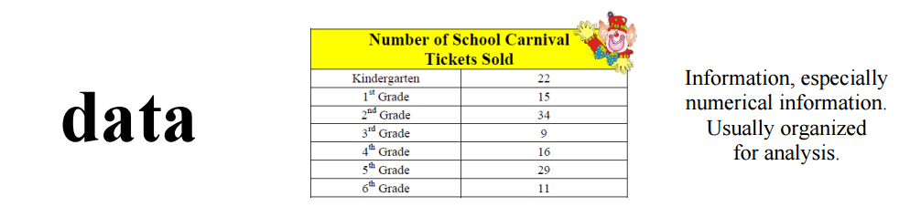
Horizontal Axis

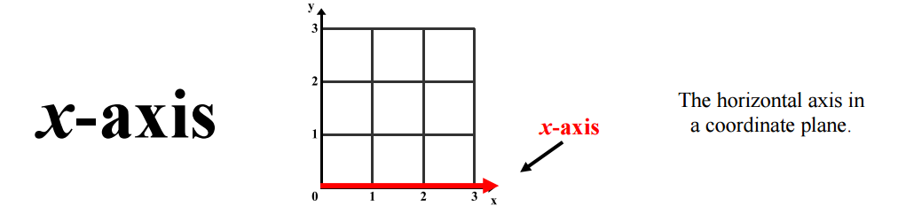

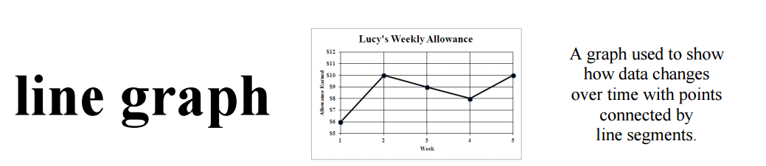
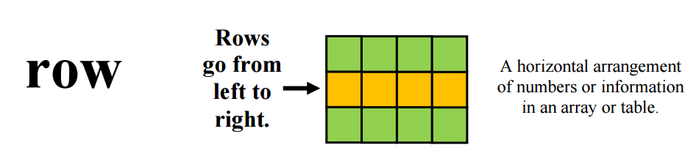
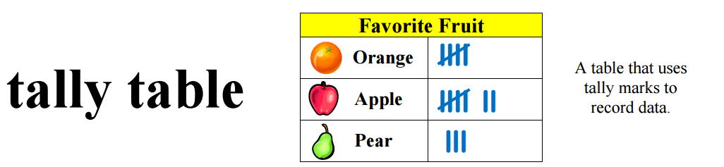
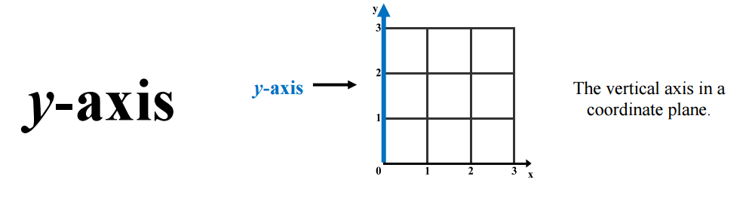
Vertical Axis
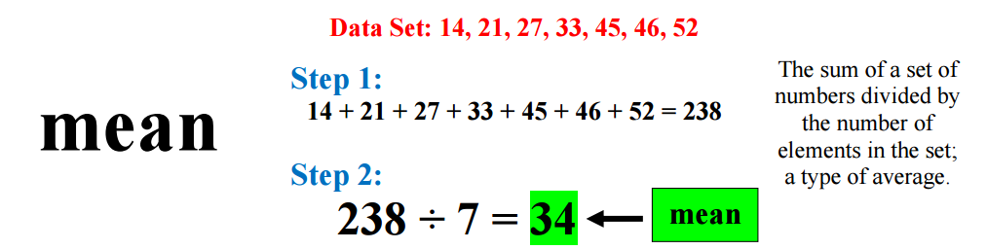
Mean and Average are synomyns

Potential Student Misconceptions

Chapter 12
- Students believe that larger units will give the larger measure.
- Students should be given multiple opportunities to measure the same object with different measuring units.
- Student have trouble converting from meters to centimeter.

Chapter 13
- When finding the area some students may add the lengths of the sides instead of multiplying them. Remind students of the array model of multiplication. This may help them remember to multiply when finding the area.
- Some students may forget to determine the dimensions not identified. Suggest that students copy the figure on paper and then write all of the dimensions in the appropriate place.
- Students may have trouble estimating irregular figures. They may not know how to count ½ square units. Refer students to the chart on page 206, and encourage them to make a similar chart of their own.
Chapter 14
- Some students may have trouble recognizing symmetric figures. Have students trace the figures and dotted lines. Have them cut out each figure and fold it along the dotted line. If both parts match, that line is a line of symmetry.
- Some students may have difficulty recognizing rotational symmetry. Have students trace the figures on a piece of paper, cut them out, and use the tip of a pencil to fix the center of rotation.
- Some students may not copy the figure correctly on the grid paper. After students have copied the figure, have them place the grid paper over the page to confirm that they have copied the figure correctly.
Chapter 4
- Students may not know that the tick marks on the graph divide the scale into intervals of 10. Have them use an index card to keep track of each tick mark as they count together from 0 through 100 by tens. Repeat for 100 through 200, 200 through 300, and so on through 600.
- Some students may not understand how to fill in missing numbers in a table. Have students write an equation for each row. Then solve the equation to complete that row.
- Some students may misinterpret a problem because they do not understand the term interval. Explain that interval means the time that passes from one hour to the next. Have students restate the question in their own words to be sure they understand what they need to find.
Chapter 5
- Students may count the total as part of the set of data. Then divide by the wrong number to find the average. Have students count and record the number of data before they add and divide to find the average or mean.
- Some students may forget to arrange the data in numerical order before finding the median. Have students order the data and circle the two numbers they will use to find the median before they calculate the median in each data set.
- Students may not distinguish between an outcome being equally likely and more likely. Point out that for outcomes to be equally likely there must always be an equal, or the same, number of possible outcomes.
- Some students may not understand how to find the total given the average. Remind students that they need to multiply the average or mean by the number of items to find the total.

Teaching Multiple Representations
Multiple Representations Framework

Area  By Counting | 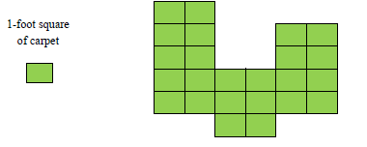
Area | 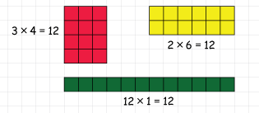  If each side of a tile is 1 unit in length…  How many different rectangles can you build with an area of 12 square units?
Area of a Rectangle  Formula | 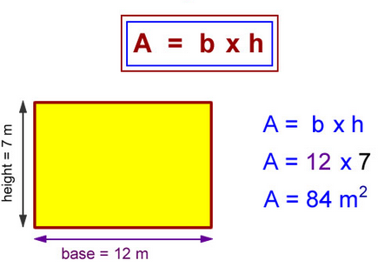  The area of a rectangle equals the base times the height.
Area of a Rectangle Formula | 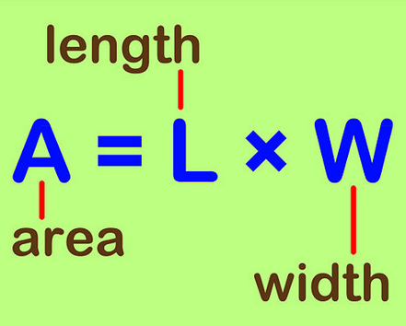
Perimeter of a square | 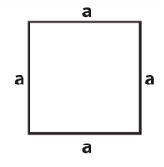  Since it is a square all sides are equal in length.  P=a + a + a + a  Or  P=a2
Perimeter of a rectangle | 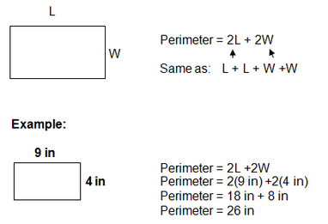
Equivalent Fractions | 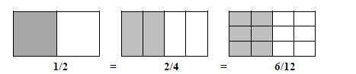  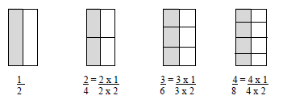
Lines of Symmetry | 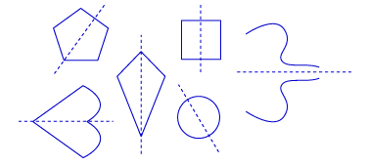
Line Plots | 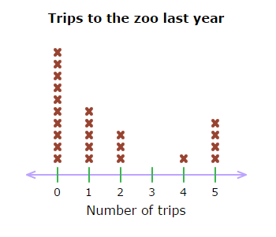
Stem and Leaf | 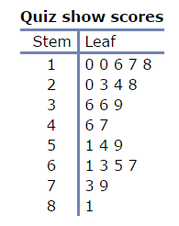  In a stem-and-leaf plot, the stem tells the first part of the number and the leaf tells the last digit of the number.
Patterns:  - Shapes  - Charts | 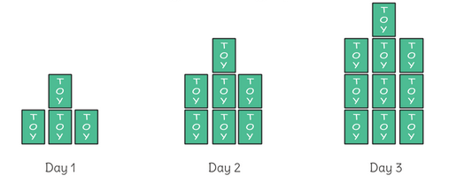    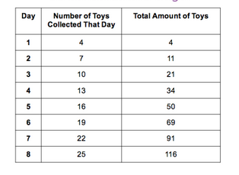  Recognize patterns and continue them by following a rule.
Assessment Framework

Unit 4 Assessment / Authentic Assessment Framework
Assessment |  |  | NJSLS |  | Estimated Time | Format | Graded
Pre Test 13 |  |  | 4.MD.3 |  | 30 minutes | Individual | Y
Portfolio Authentic Assessment-Perimeter and Area (3 Options) |  |  | 4.MD.3 |  | 30 minutes | Individual | Y
Test Prep. 13 |  |  | 4.MD.3 |  | 1 Block | Individual | Y
Geometry Town Project |  |  | 4.G.1-3 |  | Home Project  Optional | Individual | Optional
Pre Test 14 |  |  | 4.G.3, |  | 30 minutes | Individual | Y
Portfolio Authentic Assessment |  |  | 4.G.3 |  | 30 minutes | Individual | Y
Test Prep. 14 |  |  | 4.G.3 |  | 1Block | Individual | Y
Mini Assessment #12 |  |  | 4.G.3 |  | 30 minutes | Individual | Y
Geometry Robot |  |  | 4.G.1-3 |  |  | Optional | Y
Chapters 4 and 5 |  |  | 4.MD.2 |  | 1Block | Individual | Y
Test Prep 4 |  |  | 4.MD.4 |  | 30 minutes | Individual | Y
Test Prep 5 |  |  | 4.MD.4 |  | 1 Block | Individual | Y
Mini Assessment #13 |  |  | 4.MD.4 |  | 30 minutes | Individual | Y
 | PLD | Genesis Conversion
Rubric Scoring | PLD 5 | 100
Rubric Scoring | PLD 4 | 89
Rubric Scoring | PLD 3 | 79
Rubric Scoring | PLD 2 | 69
Rubric Scoring | PLD 1 | 59

Performance Tasks – Authentic Assessments
4th Grade Authentic Assessment # 4.MD.3

Name: ________________________________________________ Date: _____________

Use the rectangle to solve the problem.

28 cm.

The area of the rectangle is 420 square centimeters.

What is the perimeter, in centimeters of the rectangle?

Teacher notes:
The authentic Smarter Balanced task is an online task. The task has buttons with numerals for the students to click on to type the answer.
4. MD.3 Apply the area and perimeter formulas for rectangles in real world and mathematical problems. For example, find the width of a rectangular room given the area of the flooring and the length, by viewing the area formula as a multiplication equation with an unknown factor.

•To complete this task, students need to find the missing dimension. Students need to recognize that 28 x n = 420. Once they have determined that the missing dimension is 15, students need to find the perimeter.
• Students earn 3, 4 or 5 points for full accomplishment, by finding the perimeter of 86 cm. Students do not need to label the missing dimensions to demonstrate full accomplishment.
• Students earn 1or 2 points, partial accomplishment, if they write the missing dimension of 15 instead of the perimeter.
• If the student’s answer is incorrect due to a computation error (mistake made while dividing to find the missing dimension), but the overall work shows that he or she understands how to use area to find perimeter, he or she can still be rated as having “got” the target concept.
• If a particular student is struggling from the very start and seems like he or she will not be able to show any understanding of area and perimeter, you may suggest that they think about how to find the missing dimensions (420 ÷ 28). You can then indicate on the completed task that the student received teacher assistance.
Not yet: Student shows evidence of misunderstanding, incorrect concept or procedure |  | Got It: Student essentially understands the target concept. |  | More than Got it.  Student completely understands the target concept, and has no errors.
1 Unsatisfactory:  Little Accomplishment  The task is attempted and some mathematical effort is made. There may be fragments of accomplishment but little or no success. Further teaching is required. | 2 Marginal:  Partial Accomplishment  Part of the task is accomplished, but there is lack of evidence of understanding or evidence of not understanding. Further teaching is required. | 3 Proficient:  Substantial Accomplishment  Student could work to full accomplishment with minimal feedback from teacher. Errors are minor. Teacher is confident that understanding is adequate to accomplish the objective with minimal assistance. | 4 Very Good:  Full Accomplishment  Strategy and execution meet the content, process, and qualitative demands of the task or concept. Student can communicate ideas. May have minor errors that do not impact the mathematics. | 5 Excellent  Full Accomplishment  Strategy and execution meet the content, process, and qualitative demands of the task or concept. Student can communicate ideas. Student have no mathematical errors.

Performance Tasks-Authentic Assessments
4th Grade Portfolio Assessment – Perimeter/Area 4.MD.3

Name: ________________________ Date: ____________________
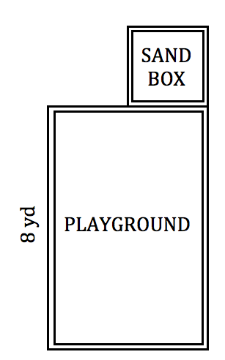

The park in Alyssa’s neighborhood had new
equipment and play areas added. The picture
to the right shows part of the new park.

The new playground space has a length of 8 yards
and an area of 48 square yards. Attached to the
playground is a square sandbox. The width of the
sandbox is half the width of the playrgound.

Alyssa was wondering about the area of the
sandbox. Use the space below to show the steps
that Alyssa could follow to find the area of the
sandbox. Fill in the blank at the bottom of the
page with the correct area.

The area of the sandbox is _____________ square yards.
Teacher notes:

• Students are directed show their thinking in space provided on the paper. Some students may require more space than the paper provides or may need lined paper to better structure their work. You may choose to give those students, or all students, extra paper on which they can do their work.
• For this particular task, it is very important that students show their thinking as fully as possible. If they end up with the wrong answer, the only way to adequately distinguish between varied levels of proficiency, the students need to show their work so the scorer can have some sense of how close they came to the right answer.
• The area of the sand box is 9 square yards. Since this task requires several steps to arrive at the correct answer and the directions specify that students need to show the steps that Alyssa could follow to find the area, students need to show some degree of work in order to be rated as showing “full accomplishment”. Since the numbers in this task are small and lend themselves to mental calculations, some students may be able to figure out the correct answer entirely in their head, without doing any pencil and paper work. If a student simply writes an answer and does not show any work, you may choose to direct them to go back and show their thinking as indicated in the task.
• As indicated in the rubric, students may make minor errors that do not relate to the target concept (i.e., failing to label numbers with units), but if their work shows a complete understanding of the relationship between side length and area, they can still be rated as showing “full accomplishment”.
Not yet: Student shows evidence of misunderstanding, incorrect concept or procedure. |  | Got It: Student essentially understands the target concept.
1 Unsatisfactory:  Little Accomplishment  The task is attempted and some mathematical effort is made. There may be fragments of accomplishment but little or no success. Further teaching is required. | 2 Marginal:  Partial Accomplishment  Part of the task is accomplished, but there is lack of evidence of understanding or evidence of not understanding. Further teaching is required. | 3 Proficient:  Student could work to full accomplishment with minimal feedback from teacher. Errors are minor. Teacher is confident that understanding is adequate to accomplish the objective with minimal assistance. | 4 Very Good:  Full Accomplishment  Strategy and execution meet the content, process, and qualitative demands of the task or concept. Student can communicate ideas. May have minor errors that do not impact the mathematics. | 5 Excellent  Strategy and execution meet the content, process, and qualitative demands of the task or concept. Student can communicate ideas. No errors

Performance Task Authentic Assessment
4th Grade Portfolio Assessment – Perimeter/Area 4.MD.3

Name___________________________ Date__________________________
Jackson is helping his father set up and build a new pen for the hens, cows, and goats on their farm. The pen will be rectangular and divided into three sections. He has given Jackson a list describing the three sections of the pen and a drawing to show how the pen will be divided.
Jackson’s dad asked him to go to the store and buy enough fencing for the perimeter of the cow section. Help Jackson figure out how much fencing to buy. Use the space below to show Jackson the steps he should follow to find the amount of fencing for the perimeter of the cow section.
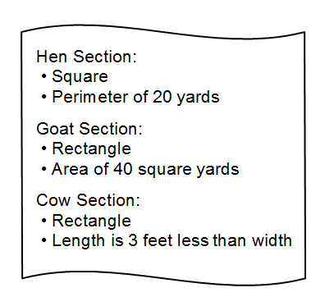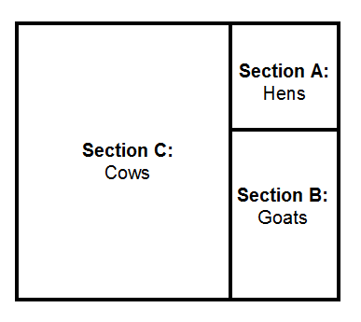

Jackson needs to buy _______________ yards of fencing.
Teacher notes:

• Students are directed to show their thinking in space provided. Some students may require more space than the paper provides or may need lined paper to better structure their work. You may choose to give those students, or all students, extra paper on which they can do their work.
• For this particular task, it is very important that students show their thinking as fully as possible. If they end up with the wrong answer, the only way to adequately distinguish between varied levels of proficiency, the students need to show their work so the scorer can have some sense of how close they came to the right answer.
• The cow section has a perimeter of 46 yards. Since this task requires several steps to arrive at the correct answer and the directions specify that students need to show the steps that Jackson could follow to find the perimeter, students need to show some degree of work in order to be rated as showing “full accomplishment”. Since the numbers in this task are small and lend themselves to mental calculations, some students may be able to figure out the correct answer entirely in their head, without doing any pencil and paper work. If a student simply writes an answer and does not show any work, you may choose to direct them to go back and show their thinking as indicated in the task.
• As indicated in the rubric, students may make minor errors that do not relate to the target concept (i.e., failing to label #s), but if the work shows full understanding of the relationship between side length, area, & perimeter, they can still be considered to show “full accomplishment”.
• If a particular student is struggling from the very start and seems like he or she will not be able to show any understanding of area and perimeter, you may suggest that they think about the clues for the hen section and label the diagram with possible side lengths. You can then indicate on the completed task that the student received teacher assistance.
Not yet: Student shows evidence of misunderstanding, incorrect concept or procedure. |  | Got It: Student essentially understands the target concept.
1 Unsatisfactory:  Little Accomplishment  The task is attempted and some mathematical effort is made. There may be fragments of accomplishment but little or no success. Further teaching is required. | 2 Marginal:  Partial Accomplishment  Part of the task is accomplished, but there is lack of evidence of understanding or evidence of not understanding. Further teaching is required. | 3 Proficient:  Substantial Accomplishment  Student could work to full accomplishment with minimal feedback from teacher. Errors are minor. Teacher is confident that understanding is adequate to accomplish the objective with minimal assistance. | 4 Very Good:  Full Accomplishment  Strategy and execution meet the content, process, and qualitative demands of the task or concept. Student can communicate ideas. May have minor errors that do not impact the mathematics. | 5 Excellent  Strategy and execution meet the content, process, and qualitative demands of the task or concept. Student can communicate ideas. Has no errors.

Performance Task Authentic Assessment
4th Grade Portfolio Assessment – Symmetry 4.G.3

Name__________________________________ Date__________________

Finding Lines of Symmetry
- Each shape below has a line of symmetry. Draw a line of symmetry for each shape.

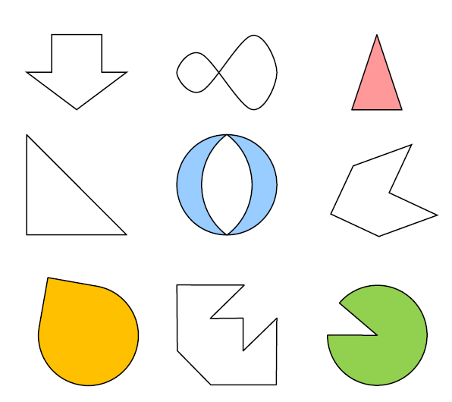

- Not every shape has a line of symmetry. Which of the four shapes below have a line of symmetry? Draw a line of symmetry on them.

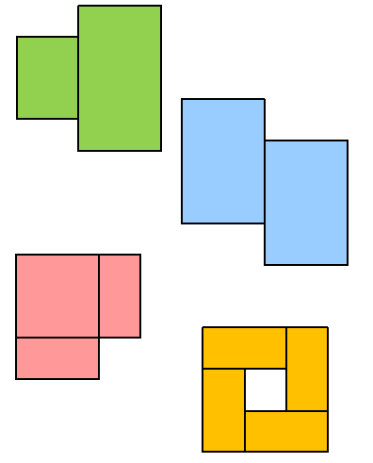

- Some shapes have many lines of symmetry. Draw all the lines of symmetry you can on the shape below. How many are there?

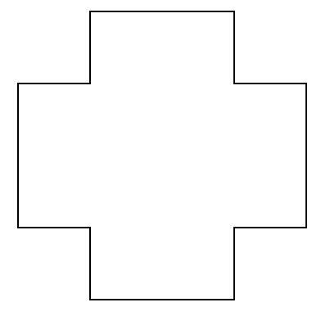

Authentic Assessment 4.G.3

Solution

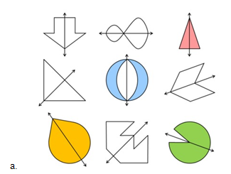

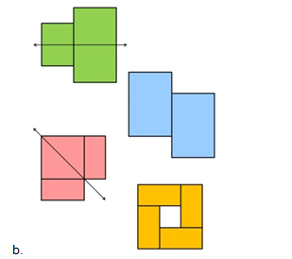
c.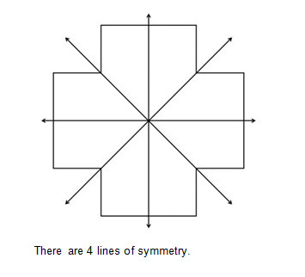

Not yet: Student shows evidence of misunderstanding, incorrect concept or procedure. |  | Got It: Student essentially understands the target concept.
1 Unsatisfactory:  Little Accomplishment  The task is attempted and some mathematical effort is made. There may be fragments of accomplishment but little or no success. Further teaching is required. | 2 Marginal:  Partial Accomplishment  Part of the task is accomplished, but there is lack of evidence of understanding or evidence of not understanding. Further teaching is required. | 3 Proficient:  Substantial Accomplishment  Student could work to full accomplishment with minimal feedback from teacher. Errors are minor. Teacher is confident that understanding is adequate to accomplish the objective with minimal assistance. | 4 Very Good:  Full Accomplishment  Strategy and execution meet the content, process, and qualitative demands of the task or concept. Student can communicate ideas. May have minor errors that do not impact the mathematics. | 5 Excellent

Supplement Resources
Reading Survey
4.MD.4 - Task 1
Domain | Measurement and Data
Cluster | Represent and interpret data.
Standard(s) | 3.MD.4 Generate measurement data by measuring lengths using rulers marked with halves and fourths of an inch. Show the data by making a line plot, where the horizontal scale is marked off in appropriate units— whole numbers, halves, or quarters.
Materials | Paper, pencils, white boards and dry-erase markers (optional)
Task | Directions for students:  - As a class, have students survey 10 classmates and ask them “How long do you think fourth graders should read each night at home?” They can choose ¼, ½, ¾ or 1 hour. Students should record results on a piece of paper.  - Create a line plot to represent the data.  - Have students write a sentence about an observation that they notice from the line plot.  - If you were using this line plot to make a decision about how long students should read each night, which time would you choose? Why?

How High Did it Bounce?
4.MD.4-Task 2
Domain | Measurement and Data
Cluster | Represent and interpret data.
Standard(s) | 4.MD.4 Make a line plot to display a data set of measurements in fractions of a unit (1/2, 1/4, 1/8). Solve problems involving addition and subtraction of fractions by using information presented in line plots. For example, from a line plot find and interpret the difference in length between the longest and shortest specimens in an insect collection.
Materials | Paper, pencil, Activity sheet
How High Did it Bounce?
A class measures how high a bouncy ball will bounce compared to the height of the wall.
Based on the data, make a line plot to display the data.

3/8 | 5/8 | 7/8 | 6/8 | 5/8 | 6/8
6/8 | 5/8 | 4/8 | 4/8 | 2/8 | 6/8
5/8 | 7/8 | 5/8 | 6/8 | 4/8 | 5/8

- How many bouncy balls went halfway up the wall or higher?
- How may bouncy balls went 3/4 of the wall or higher?
- What is the combined height of all of the heights of the bouncy balls?

How High Did it Bounce?

A class measures how high a bouncy ball will bounce compared to the height of the wall. Based on the data, make a line plot to display the data.

3/8 | 5/8 | 7/8 | 6/8 | 5/8 | 6/8
6/8 | 5/8 | 4/8 | 4/8 | 2/8 | 6/8
5/8 | 7/8 | 5/8 | 6/8 | 4/8 | 5/8

0 |  | 1/8 |  | 2/8 |  | 3/8 |  | 4/8 |  | 5/8 |  | 6/8 |  | 7/8 |  | 1

- How many bouncy balls went halfway up the wall or higher?
- How may bouncy balls went 3/4 of the wall or higher?
- If the wall is 8 feet high, what is the combined height of all of the heights of the bouncy balls?
Measuring Strings
4.MD.4-Task 3
Domain | Measurement and Data
Cluster | Represent and interpret data.
Standard(s) | 4.MD.4 Make a line plot to display a data set of measurements in fractions of a unit (1/2, 1/4, 1/8). Solve problems involving addition and subtraction of fractions by using information presented in line plots. For example, from a line plot find and interpret the difference in length between the longest and shortest specimens in an insect collection.
Materials | Paper, pencil, Activity sheet
Measuring Strings
A basket of strings is measured by the class and graphed. Based on the line plot:
- How many strings are ½ of a foot or longer?
- How many strings are shorter than 3/8 of a foot?
- If students put the string together that is 1/8 or 2/8 of a foot long, how long would that string be?
- If students put all of the pieces of string together, how long would that string be?

Measuring Strings

A basket of strings is measured by the class and graphed.

Lengths of string (feet)
 |  | x |  | x |  |  |  | x |  |  |  |  |  | x
 |  | x |  | x |  | x |  | x |  | x |  | x |  | X
 |  | x |  | x |  | x |  | x |  | x |  | x |  | X
0 |  | 1/8 |  | 2/8 |  | 3/8 |  | 4/8 |  | 5/8 |  | 6/8 |  | 7/8 |  | 1

Based on the line plot:

- How many strings are more than ½ of a foot or longer?

- How many strings are shorter than 3/8 of a foot?

- If students put the string together that is 1/8 or 2/8 of a foot long, how long would that string be?

- If students put all of the pieces of string together, how long would that string be?

Additional Assessment Resources

Illustrative Math: http://illustrativemathematics.org/

PARCC: http://www.parcconline.org/samples/item-task-prototypes

NJDOE: http://www.state.nj.us/education/modelcurriculum/math/ (username: model; password: curriculum)

DANA: http://www.ccsstoolbox.com/parcc/PARCCPrototype_main.html

New York: http://www.p12.nysed.gov/assessment/common-core-sample-questions/

Delaware: http://www.doe.k12.de.us/assessment/CCSS-comparison-docs.shtml

Perimeter Games:
http://www.indiana.edu/~atmat/units/area_perimeter/rectex1.htm
Online Geo-boards:
http://nlvm.usu.edu/en/nav/frames_asid_172_g_2_t_3.html?open=activities&from=category_g_2_t_3.html
Exploring Area:
http://www.shodor.org/interactivate/activities/AreaExplorer/

Literature:
Spaghetti and Meatballs for All! Marilyn Burns (Great for perimeter and area activities.)
“Using Representations to Explore Perimeter and Area.” This article is based on, Spaghetti and Meatballs for All!
http://www.math.ccsu.edu/mitchell/math409tcmusingrepresentationperimeterarea.pdf

Extensions and Sources

Think Central
https://www-k6.thinkcentral.com/ePC/start.do

Common Core Tools
http://commoncoretools.me/
http://www.ccsstoolbox.com/
http://www.achievethecore.org/steal-these-tools
Achieve the Core
http://achievethecore.org/dashboard/300/search/6/1/0/1/2/3/4/5/6/7/8/9/10/11/12
Manipulatives
http://nlvm.usu.edu/en/nav/vlibrary.html
http://www.explorelearning.com/index.cfm?method=cResource.dspBrowseCorrelations&v=s&id=USA-000
Problem Solving Resources
Illustrative Math Project
http://illustrativemathematics.org/standards/k8
The site contains sets of tasks that illustrate the expectations of various CCSS in grades K–8 grade and high school. More tasks will be appearing over the coming weeks. Eventually the sets of tasks will include elaborated teaching tasks with detailed information about using them for instructional purposes, rubrics, and student work.
Inside Mathematics
http://www.insidemathematics.org/index.php/tools-for-teachers
Inside Mathematics showcases multiple ways for educators to begin to transform their teaching practices. On this site, educators can find materials and tasks developed by grade level and content area.
Engage NY
http://www.engageny.org/video-library?f[0]=im_field_subject%3A19

IXL
http://www.ixl.com/
Georgia Department of Education
https://www.georgiastandards.org/Common-Core/Pages/Math-K-5.aspx
Georgia State Educator have created common core aligned units of study to support schools as they implement the Common Core State Standards.

Grade level | Standard | Revised Standard
3 | 3.OA.1 Interpret products of whole numbers, e.g., interpret 5 × 7 as the total number of objects in 5 groups of 7 objects each. For example, describe a context in which a total number of objects can be expressed as 5 × 7. | 3.OA.1 Interpret products of whole numbers, e.g., interpret 5 × 7 as the total number of objects in 5 groups of 7 objects each. For example, describe and/or represent a context in which a total number of objects can be expressed as 5 × 7.
3 | 3.OA.2 Interpret whole-number quotients of whole numbers, e.g., interpret 56 ÷ 8 as the number of objects in each share when 56 objects are partitioned equally into 8 shares, or as a number of shares when 56 objects are partitioned into equal shares of 8 objects each. For example, describe a context in which a number of shares or a number of groups can be expressed as 56 ÷ 8. | 3.OA.2 Interpret whole-number quotients of whole numbers, e.g., interpret 56 ÷ 8 as the number of objects in each share when 56 objects are partitioned equally into 8 shares, or as a number of shares when 56 objects are partitioned into equal shares of 8 objects each. For example, describe and/or represent a context in which a number of shares or a number of groups can be expressed as 56 ÷ 8.
3 | 3.NF.1 Understand a fraction 1/b as the quantity formed by 1 part when a whole is partitioned into b equal parts; understand a fraction a/b as the quantity formed by a parts of size 1/b | 3.NF.1 Understand a fraction 1/b as the quantity formed by 1 part when a whole is partitioned into b equal parts; understand a fraction a/b as the quantity formed by a parts of size 1/b.  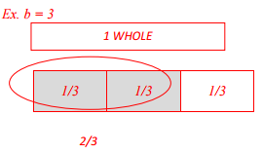
3 | 3.NF.2 Understand a fraction as a number on the number line; represent fractions on a number line diagram. a. Represent a fraction 1/b on a number line diagram by defining the interval from 0 to 1 as the whole and partitioning it into b equal parts. Recognize that each part has size 1/b and that the endpoint of the part based at 0 locates the number 1/b on the number line. b. Represent a fraction a/b on a number line diagram by marking off a lengths 1/b from 0. Recognize that the resulting interval has size a/b and that its endpoint locates the number a/b on the number line. | 3.NF.2 Understand a fraction as a number on the number line; represent fractions on a number line diagram. a. Represent a fraction 1/b on a number line diagram by defining the interval from 0 to 1 as the whole and partitioning it into b equal parts. Recognize that each part has size 1/b and that the endpoint of the part based at 0 locates the number 1/b on the number line. b. Represent a fraction a/b on a number line diagram by marking off a lengths 1/b from 0. Recognize that the resulting interval has size a/b and that its endpoint locates the number a/b on the number line.  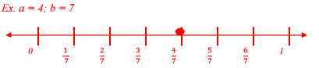
3 | 3.MD.6 Measure areas by counting unit squares (square cm, square m, square in, square ft, and improvised units). | 3.MD.6 Measure areas by counting unit squares (square cm, square m, square in, square ft, and non-standard units).
4 | 4.MD.1 Know relative sizes of measurement units within one system of units including km, m, cm; kg, g; lb, oz.; l, ml; hr, min, sec. Within a single system of measurement, express measurements in a larger unit in terms of a smaller unit. Record measurement equivalents in a two - column table. For example, know that 1 ft is 12 times as long as 1 in. Express the length of a 4 ft snake as 48 in. Generate a conversion table for feet and inches listing the number pairs (1, 12), (2, 24), (3, 36), | 4.MD.1 Know relative sizes of measurement units within one system of units including km, m, cm, mm; kg, g; lb, oz.; l, ml; hr, min, sec. Within a single system of measurement, express measurements in a larger unit in terms of a smaller unit. Record measurement equivalents in a two-column table. For example, know that 1 ft is 12 times as long as 1 in. Express the length of a 4 ft snake as 48 in. Generate a conversion table for feet and inches listing the number pairs (1, 12), (2, 24), (3, 36), ...
5 | 5.MD.5b. Apply the formulas V = l × w × h and V = b × h for rectangular prisms to find volumes of right rectangular prisms with whole- number edge lengths in the context of solving real world and mathematical problems | 5.MD.5b Apply the formulas V = l × w × h and V = B × h for rectangular prisms to find volumes of right rectangular prisms with whole- number edge lengths in the context of solving real world and mathematical problems
5 | 5.MD.4 Measure volumes by counting unit cubes, using cubic cm, cubic in, cubic ft, and improvised units. | 5.MD.4 Measure volumes by counting unit cubes, using cubic cm, cubic in, cubic ft, and non-standard units.

