Name: ________________________ Date: ___________________ Period: ____________
Algebra 2 Section 6.7: Inverse Functions Notes

Step 1: Find the ordered pairs for. Complete the chart below.

Step 2: Interchange the x- and y- coordinates from step 1.

Step 3: Choose two of the ordered pairs from the table in step 2 and find the equation of the line.

Name this line.

__________________________
Step 4: For, interchange the variables and then solve for in terms of .

Call this new function.

__________________________

What do you notice about and? Why do you think this is?

Step 5: Use and from above to find:

a) b)

- If and are inverses of each other, then always equals _____________
and always equals ______________.
- The function and its inverse always reflect over the line _____________________.

Algebraically, find the inverse of the following functions.
1. 2.

3. 4.

Finding Non-Linear Inverses Algebraically:
7. 8.

9. 10.

11. 12.

Horizontal Line Test
If a horizontal line drawn through a graph hits more than one point, then the inverse is not a function.

13. Determine if the inverse of each function is also a function.
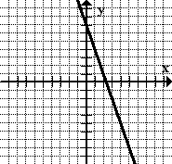
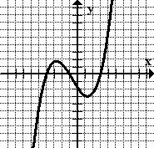
a) b)

c) d)

Composition and Inverses
If f and are inverses of each other, then

14. Prove that f(x) and g(x) are inverses of each other.

