LAKESIDE ELEMENTARY SCHOOL - SUPPLY LISTS FOR 2019/2020

SUPPLY LIST FOR 1ST GRADE

Backpack – large size – NO ROLLING BACKPACKS
1 supply box with attached cover – NO handles
(Approximately 7 ½” x 5”)
4- 3 prong folders – red, yellow, blue, & green
4 boxes of 24-count CRAYOLA crayons
24 new pencils (sharpened)
1 box Washable markers
1 bottle of Elmer’s white school glue
24 glue sticks
1 pack of expo markers - black
1 marble composition books (not spiral)
1 pair scissors – Fiskars brand
2 boxes of tissues
1 container antibacterial wipes
2 containers of playdough
Sandwich size bags-Girls
Gallon size bags – Boys

SUPPLY LIST FOR 2ND GRADE

NO ROLLING BACKPACKS
6 hardback black/white composition books
2 box Crayons (24 count only)
20 Glue sticks (not bottles)
1 headset headphones
Pencils – 4 dozen regular #2 (sharpened)
2 boxes Washable Markers
8 black chisel-tip Expo markers
Dry-erase whiteboard (about 9x12)
Small plastic box for supplies
1 pocket folder
2 Pink Block Erasers
2 pair scissors
2 large boxes of tissues
1 Large Bottle of Hand Sanitizer
girls: 1 box sandwich size baggies
1 box of Baby Wipes
boys: 1 box of gallon size baggies
1 box Antibacterial Wipes

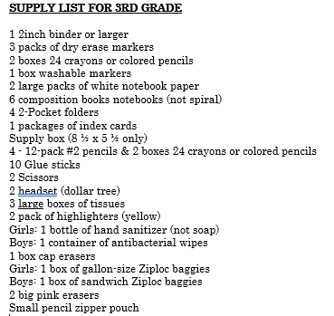

SUPPLY LIST FOR 4TH GRADE

8 composition notebooks
4 folders
3 packs of wide-ruled, loose-leaf paper
6 packs of 24 #2 pencils
1 pack of 3X5 index cards
2 packages of pencil-top erasers
2 packs of pink erasers
4 packages of black dry erase markers (chisel tip only)
4 boxes of tissues
3 large containers Lysol or Clorox disinfecting wipes
1 large bottle of hand sanitizer
4 four packs of glue sticks
1 pack of crayons or markers or colored pencils
1 pack of highlighters
1 supply box
2 headphones
Girls: 1 box of Gallon size Ziplock baggies
Boys: 1 box of sandwich size Ziplock baggies

SUPPLY LIST FOR 5TH GRADE

8 black and white marble notebooks
2 folders with prongs
3 packs of wide-ruled, loose-leaf paper
4 packs of 24 #2 pencils
2 pack of 3X5 index cards
5 packages of pencil-top erasers
2 packages of black dry erase markers
4 boxes of tissues
3 large containers of antibacterial wipes
1 bottle of hand sanitizer
6 packs of glue sticks
1 pair headphones or earbuds
1 box of Ziplock sandwich bags
1 pack of highlighters
1 pair of scissors

***Please join the PTA (Dues: $5.00) so that our class will have 100% participation.

The PTA Wishes for all families to join. Please look for information at the beginning of the school year!

Updated 5/31/19

