5th Grade Mathematics
Number Operations and Volume
Curriculum Map March 10th – April 18th

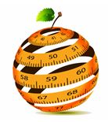

ORANGE PUBLIC SCHOOLS
OFFICE OF CURRICULUM AND INSTRUCTION
OFFICE OF MATHEMATICS

Table of Contents
I. | Unit Overview | p. 2
II. | Important Dates | p. 5
III. | Unit 4 Common Core Standards | p. 6
IV. | Connections to Mathematical Practices | p. 8
V. | Visual Vocabulary | p. 9-15
VI. | Potentials Misconceptions | p. 16
VII. | Structure of the Modules | p. 17
VIII. | Modules | p. 18-28
IX. | Multiple Representations Framework | p. 29
X. | Suggested Lessons and Tasks | p. 31-62
XI. | Extensions and Sources | p. 63-65

Unit Overview
CCSS
Do Now Standards
5.NBT. 1 & 2
5.NBT.5 & 6
Review Standards
5.NF.2
5.NF.4
5.NF.5
New Content-
Extensions of Fractions, Operations and Volume
5.NF.6 & 7
5.OA.1
5.MD.5
In this unit, students will ….
NUMBERS AND OPERATIONS-FRACTIONS
- Solve word problems involving multiplication of fractions and mixed numbers.
- Represent the product of fractions in simplest form
- Write equations to represent word problems involving multiplication of fractions.
- Draw/show multiplication of fractions through visual models.
- Define a unit fraction as fraction with a numerator of 1.
- Divide a unit fraction by a whole number.
- Draw/show division of a unit fraction by a whole number as dividing the unit fraction into smaller parts.
- Create a story in which division of a unit fraction by a whole number is used.
- Explain the effects of dividing a unit fraction by a whole number.
- Justify the reasonableness of answer in the context of a problem.
- Simplify/reduce quotients to lowest terms.
- Define a unit fraction as a fraction with a numerator of 1.
- Divide a whole number by a unit fraction.
- Create a story in which division of a whole number by a unit fraction is
- Explain the effects of dividing a whole number by a unit fraction.
- Define the reciprocal of a unit fraction for the purpose of division.
- Simplify/reduce quotients to lowest terms.
- Justify the reasonableness of answer in the context of a problem.
- Divide a whole number by a unit fraction (vice versa) in the context of word problems.
- Solve a story/word problem in which division of a whole number by a unit fraction (vice versa) is used.
- Explain the effects of dividing a whole number by a unit fraction (vice versa) in the context of a word problem.
- Justify the reasonableness of answer in terms of the context of the problem.
- Simplify/reduce quotients to lowest terms.

OPERATIONS AND ALGEBRAIC THINKING

- Translate verbal expressions to numerical expressions.
- Write simple numerical expressions from verbal expressions without evaluating the
expression.
- Translate numerical expressions to verbal expressions.

MEASUREMENT & DATA
- Explain a unit cube as having side length of one.
- Describe volume in terms of cubic units.
- Describe volume in terms of cubic units.
- Explain/show the volume of a solid figure through repeated addition of unit cubes.
- Explain the difference between 2D and 3D figures.
- Calculate the volume of a solid figure by counting the unit cubes.
- Select the appropriate unit of measure for calculating the volume of a figure.
- Convert between units of measure when calculating volume.
- Define right rectangular prism.
- Calculate the volume of a right rectangular prism by packing it with unit cubes.
- Calculate the volume of a right rectangular prism by using the formulas V = l x w x h and V =B x h (Area of the Base times the height.)
- Explain how finding the volume using the methods above result in the same solution.
- Calculate the volume of a rectangular prism using the formulas: V=l x wx h and V=B x h
- Describe/show how l x w = B (length times width equals area of the base (B).
- Calculate the volume of a right rectangular prism in the context of a word problem.
- Calculate the volumes of non-overlapping right rectangular prisms and add them together.
- Solve word problems requiring the calculations of multiple volumes and adding them together.
Essential Questions
Numbers and Operations – Fractions
- Why is it important to estimate before solving problems?
- How can you mentally estimate the sum or difference of fractions with unlike denominators?
- Explain why multiplying a fraction by does not change the value of the original fraction.
- Compare and contrast how fraction models, benchmark fractions and equivalent fractions can be used to solve addition and subtraction of fractions with unlike denominators
- How are fractions related to division?
- Write a multiplication or division story problem and give the fraction that can be used to represent and solve your story.
- Use a model to explain why multiplying a number by a fraction less than 1 results in a product smaller than the given number.
- How is multiplication similar to or different from scaling (resizing)?
- How is dividing a whole number by a fraction similar to/different from dividing a fraction by a whole number?

Operations and Algebraic Thinking
- How does the placement of grouping symbols affect the answer?\
- What is an expression for the following: (say e.g., “write an expression that is 5 times as large as 3487 + 7432.”)
- What is an equivalent expression for 4 x (75 +32) ÷ 4?
- Do we need a conventional order for working with parentheses, brackets and braces? Why or why not? Support your position with evidence.

Measurement and Data
- How do we represent the inside of a 3 dimensional figure?
- Why does “what” we measure influence “how” we measure?
- How is volume related to multiplication?
- When finding the volume of two non-overlapping right rectangular prisms what measurements do you need? Explain.

Important Dates and Calendar
Week of … | Monday |  | Tuesday | Wednesday |  | Thursday | Friday
3/10
3/17 | REVIEW CONTENT
3/24
3/31
4/7 | NEW CONTENT
4/14
4/21 | NO SCHOOL – SPRING BREAK
IMPORTANT DATES
Week of April 7th |  | SGO POST ASSESSMENT  UNIT 4 Check Up
Week of April 28th |  | 7th /8th Grade NJASK
Week of May 5th |  | 5th /6th Grade NJASK
Week of May 12th |  | 3rd/4th Grade NJASK

Common Core Standards
Unit 4
REVIEW CONTENT
5.NF.2 | Solve word problems involving addition and subtraction of fractions referring to the same whole, including cases of unlike denominators, e.g., by using visual fraction models or equations to represent the problem. Use benchmark fractions and number sense of fractions to estimate mentally and assess the reasonableness of answers. For example, recognize an incorrect result 2/5 + 1/2 = 3/7, by observing that 3/7 < 1/2.
5.NF.4 | Apply and extend previous understandings of multiplication to multiply a fraction or whole number by a fraction.  a. Interpret the product (a/b) × q as a parts of a partition of q into b equal parts; equivalently, as the result of a sequence of operations a × q ÷ b. For example, use a visual fraction model to show (2/3) × 4 = 8/3, and create a story context for this equation. Do the same with (2/3) × (4/5) = 8/15. (In general, (a/b) × (c/d) = ac/bd.)  b. Find the area of a rectangle with fractional side lengths by tiling it with unit squares of the appropriate unit fraction side lengths, and show that the area is the same as would be found by multiplying the side lengths. Multiply fractional side lengths to find areas of rectangles, and represent fraction products as rectangular areas.
5.NF.5 | Interpret multiplication as scaling (resizing), by:  - Comparing the size of a product to the size of one factor on the basis of the size of the other factor, without performing the indicated multiplication.  - Explaining why multiplying a given number by a fraction greater than 1 results in a product greater than the given number (recognizing multiplication by whole numbers greater than 1 as a familiar case); explaining why multiplying a given number by a fraction less than 1 results in a product smaller than the given number; and relating the principle of fraction equivalence a/b = (n×a)/(n×b) to the effect of multiplying a/b by 1.
 | NEW CONTENT
5.NF.6 | Solve real world problems involving multiplication of fractions and mixed numbers, e.g., by using visual fraction models or equations to represent the problem.
5.NF.7 | Apply and extend previous understandings of division to divide unit fractions by whole numbers and whole numbers by unit fractions  - Interpret division of a unit fraction by a non-zero whole number, and compute such quotients. For example, create a story context for (1/3) ÷ 4, and use a visual fraction model to show the quotient. Use the relationship between multiplication and division to explain that (1/3) ÷ 4 = 1/12 because (1/12) × 4 = 1/3.  - Interpret division of a whole number by a unit fraction, and compute such quotients. For example, create a story context for 4 ÷ (1/5), and use a visual fraction model to show the quotient. Use the relationship between multiplication and division to explain that 4 ÷ (1/5) = 20 because 20 × (1/5) = 4.  - Solve real world problems involving division of unit fractions by non-zero whole numbers and division of whole numbers by unit fractions, e.g., by using visual fraction models and equations to represent the problem. For example, how much chocolate will each person get if 3 people share 1/2 lb of chocolate equally? How many 1/3-cup servings are in 2 cups of raisins?
5.OA.1 | Use parentheses, brackets, or braces in numerical expressions, and evaluate expressions with these symbols.
5.MD.3 -5 | Geometric measurement: understand concepts of volume and relate volume to multiplication and to addition.  3. Recognize volume as an attribute of solid figures and understand concepts of volume measurement.  a. A cube with side length 1 unit, called a “unit cube,” is said to have “one cubic unit” of volume, and can be used to measure volume.  b. A solid figure which can be packed without gaps or overlaps using n unit cubes is said to have a volume of n cubic units.  4. Measure volumes by counting unit cubes, using cubic cm, cubic in, cubic ft, and improvised units.  5. Relate volume to the operations of multiplication and addition and solve real world and mathematical problems involving volume.  a. Find the volume of a right rectangular prism with whole-number side lengths by packing it with unit cubes, and show that the volume is the same as would be found by multiplying the edge lengths, equivalently by multiplying the height by the area of the base. Represent threefold whole-number products as volumes, e.g., to represent the associative property of multiplication.  b. Apply the formulas V = l × w × h and V = b × h for rectangular prisms to find volumes of right rectangular prisms with whole number edge lengths in the context of solving real world and mathematical problems.  c. Recognize volume as additive. Find volumes of solid figures composed of two non-overlapping right rectangular prisms by adding the volumes of the non-overlapping parts, applying this technique to solve real world problems.
Connections to the Mathematical Practices
1 | Make sense of problems and persevere in solving them
1 | Students solve problems by applying their understanding of operations with whole numbers, decimals, and fractions including mixed numbers. They solve problems related to volume and measurement conversions. Students seek the meaning of a problem and look for efficient ways to represent and solve it. They may check their thinking by asking themselves, “What is the most efficient way to solve the problem?”, “Does this make sense?”, and “Can I solve the problem in a different way?”
2 | Reason abstractly and quantitatively
2 | Fifth graders should recognize that a number represents a specific quantity. They connect quantities to written symbols and create a logical representation of the problem at hand, considering both the appropriate units involved and the meaning of quantities. They extend this understanding from whole numbers to their work with fractions and decimals. Students write simple expressions that record calculations with numbers and represent or round numbers using place value concepts.
3 | Construct viable arguments and critique the reasoning of others
3 | In fifth grade, students may construct arguments using concrete referents, such as objects, pictures, and drawings. They explain calculations based upon models and properties of operations and rules that generate patterns. They demonstrate and explain the relationship between volume and multiplication. They refine their mathematical communication skills as they participate in mathematical discussions involving questions like “How did you get that?” and “Why is that true?” They explain their thinking to others and respond to others’ thinking.
4 | Model with mathematics
4 | Students experiment with representing problem situations in multiple ways including numbers, words (mathematical language), drawing pictures, using objects, making a chart, list, or graph, creating equations, etc. Students need opportunities to connect the different representations and explain the connections. They should be able to use all of these representations as needed. Fifth graders should evaluate their results in the context of the situation and whether the results make sense. They also evaluate the utility of models to determine which models are most useful and efficient to solve problems.
5 | Use appropriate tools strategically
5 | Fifth graders consider the available tools (including estimation) when solving a mathematical problem and decide when certain tools might be helpful. For instance, they may use unit cubes to fill a rectangular prism and then use a ruler to measure the dimensions. They use graph paper to accurately create graphs and solve problems or make predictions from real world data.
6 | Attend to precision
6 | Students continue to refine their mathematical communication skills by using clear and precise language in their discussions with others and in their own reasoning. Students use appropriate terminology when referring to expressions, fractions, geometric figures, and coordinate grids. They are careful about specifying units of measure and state the meaning of the symbols they choose. For instance, when figuring out the volume of a rectangular prism they record their answers in cubic units.
7 | Look for and make use of structure
7 | In fifth grade, students look closely to discover a pattern or structure. For instance, students use properties of operations as strategies to add, subtract, multiply and divide with whole numbers, fractions, and decimals. They examine numerical patterns and relate them to a rule or a graphical representation.
8 | Look for and express regularity in repeated reasoning
8 | Fifth graders use repeated reasoning to understand algorithms and make generalizations about patterns. Students connect place value and their prior work with operations to understand algorithms to fluently multiply multi-digit numbers and perform all operations with decimals to hundredths. Students explore operations with fractions with visual models and begin to formulate generalizations.
Vocabulary

Visual Definition
The terms below are for teacher reference only and are not to be memorized by students. Teachers should first present these concepts to students with models and real life examples. Students should understand the concepts involved and be able to recognize and/or use them with words, models, pictures, or numbers.
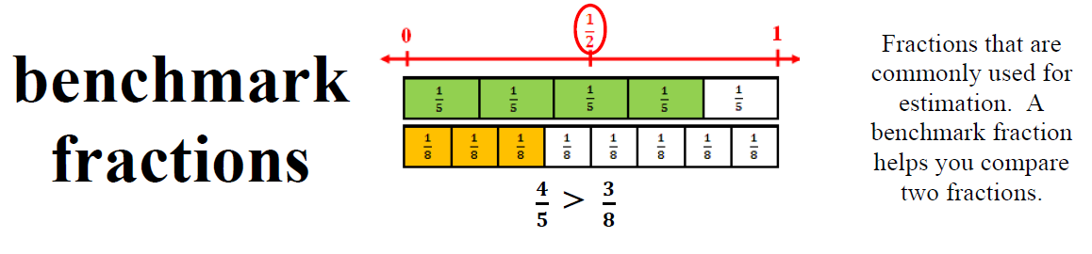
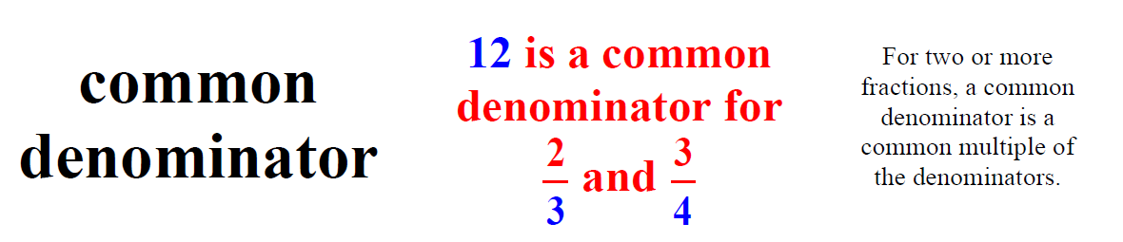
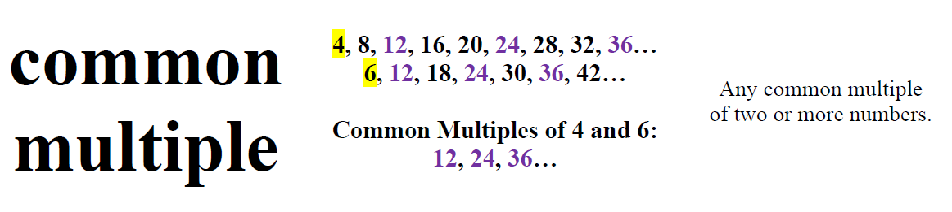
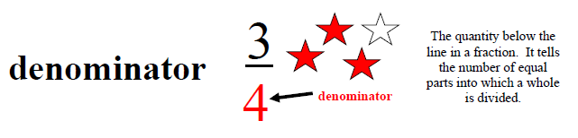
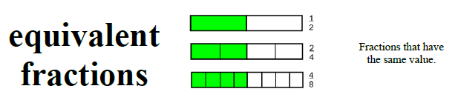
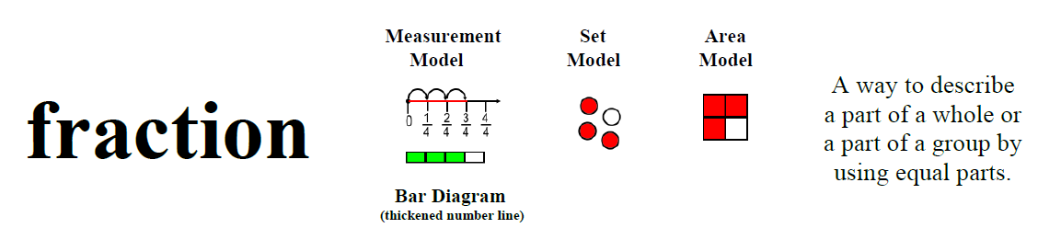
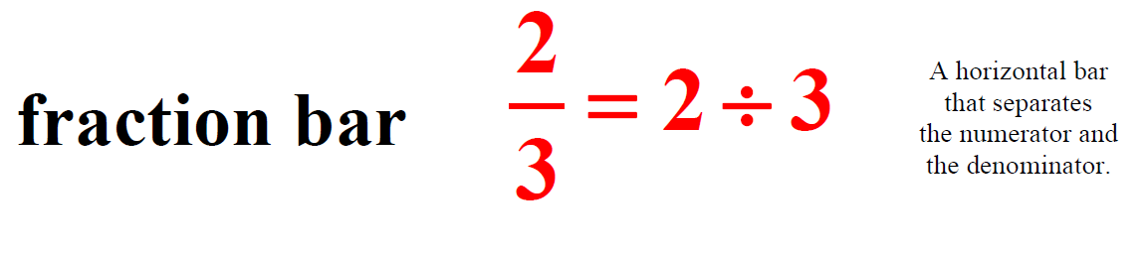
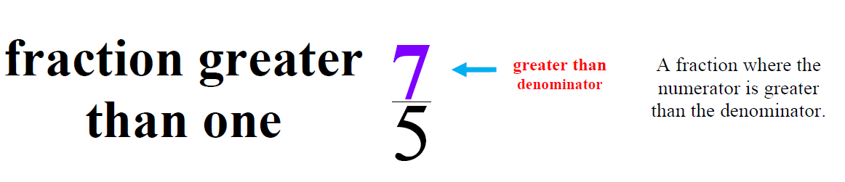
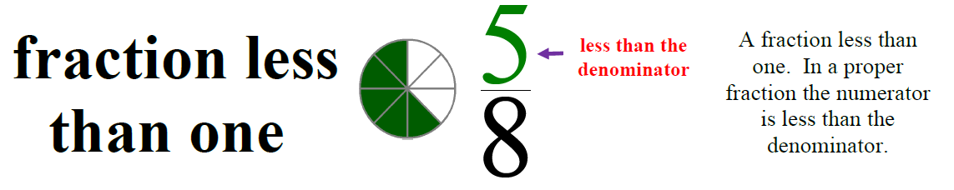
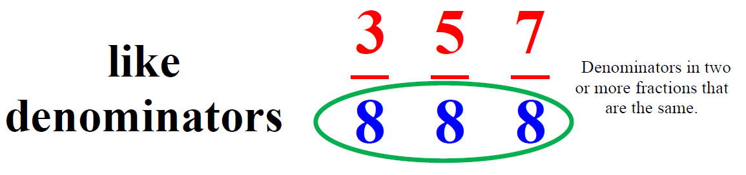
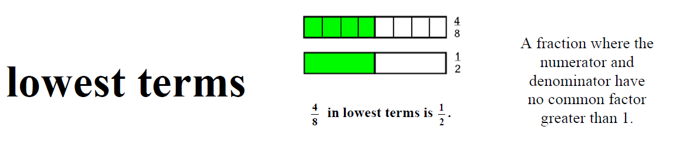
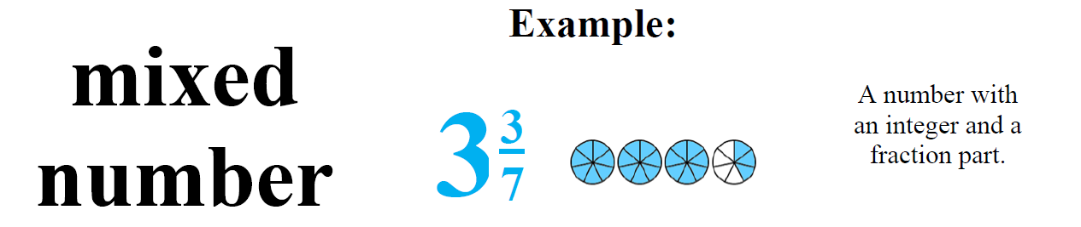
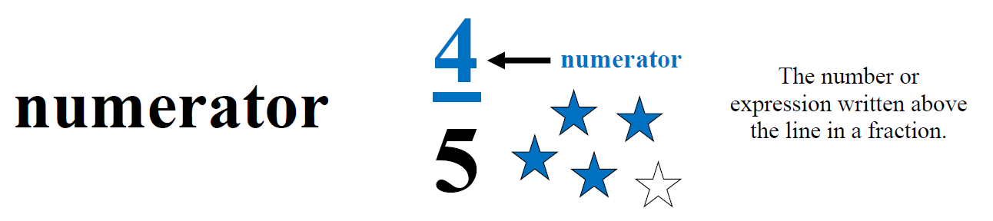
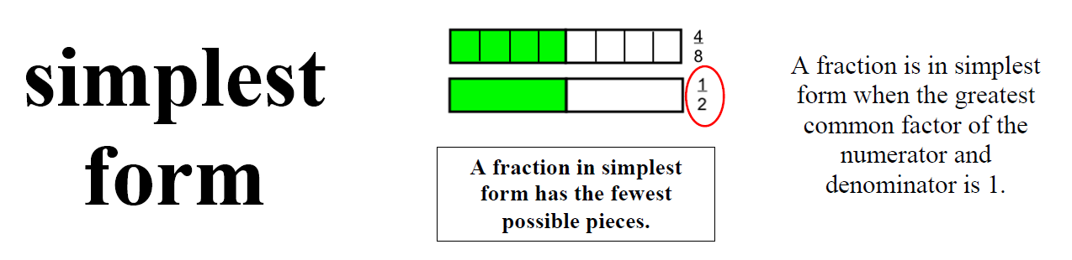
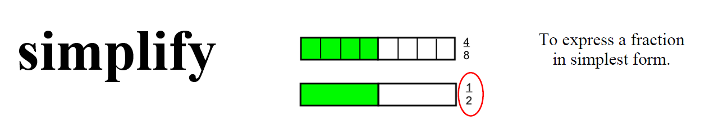
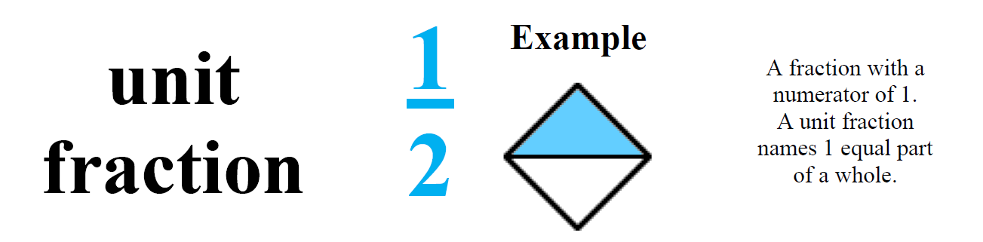
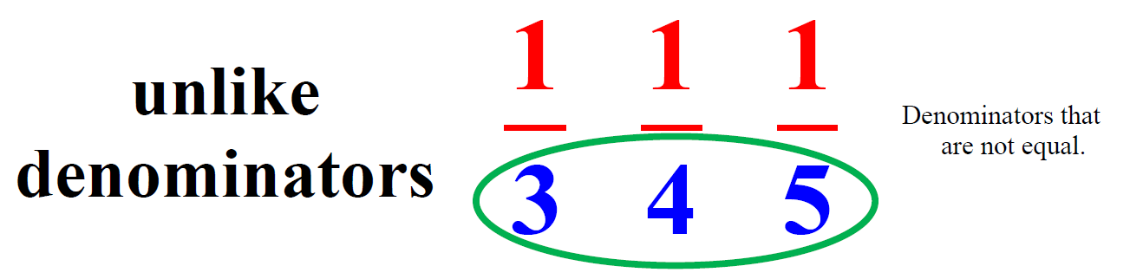
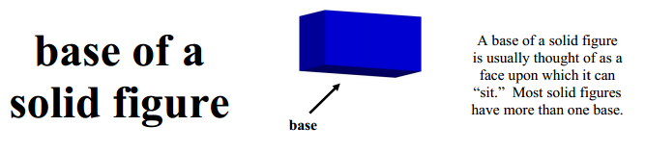
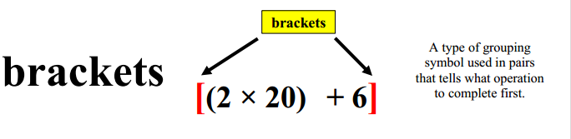
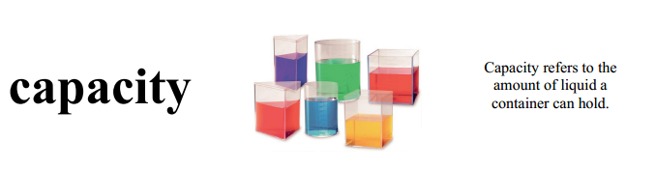
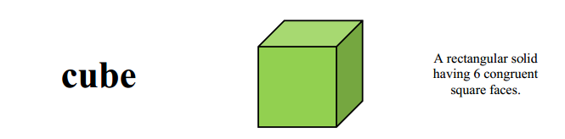
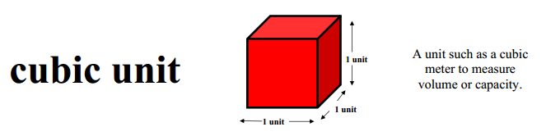
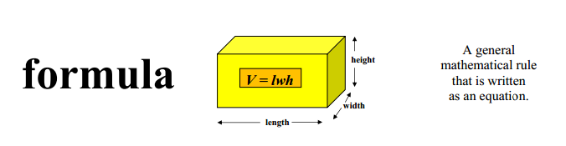
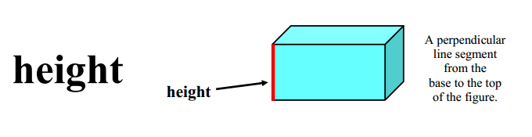
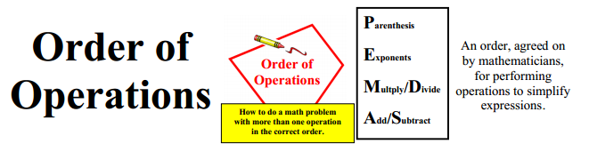
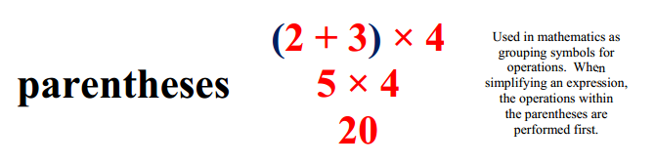
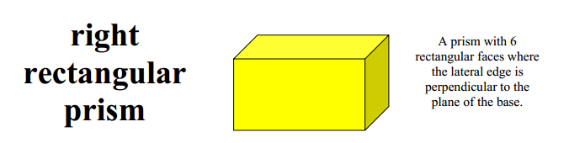
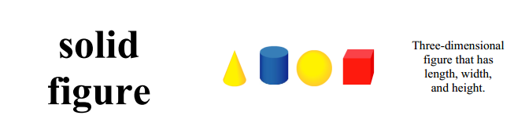
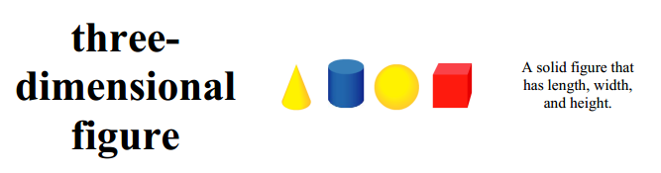
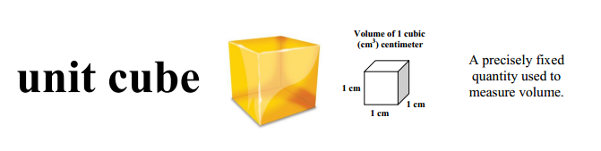
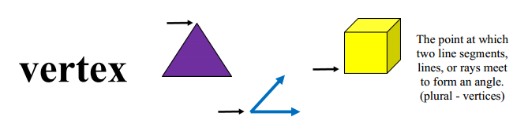
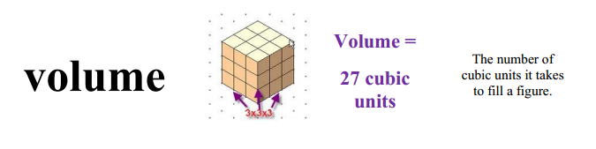

Potential Student Misconceptions

Number and Operations – Fractions
- Students may not understand that fractional parts must be equal amounts.
Students may create fractions of circular regions by dividing them horizontally and vertically, creating unequal parts. Having students draw fractional models. Ask questions that focus students on the equality of parts. Having students cut out the parts and place them on top of each other may highlight this idea.

- Students may not realize that, in order to compare fractions with models, the wholes must be the same size.
From time to time have students draw their own representations of the fractions they are comparing. Always giving students pre-made physical models can mask this misconception. Have students solve this problem: Fernando had ½ of a pizza and Lucy had 1/3 of a pizza. Lucy said that she had more pizza. Is she correct? If so, how could that be? If not, why not?

- Students may mix models when adding, subtracting, or comparing fractions. Students will use a circle for thirds and a rectangle for fourths when comparing fractions with thirds and fourths.
Remind students that the representations need to be from the same whole.

- Students may believe that multiplication always results in a larger number. Students may also believe that division always results in a smaller number.
Connect the meaning of multiplication and division of fractions with whole number multiplication and division. Consider area models of multiplication and both sharing and measuring models for division. Using models when multiplying with fractions will enable students to see that the results will be smaller. Using models when dividing with fractions will enable students to see that the results will be larger.
Structure of the Modules
The Modules embody 3 integrated frameworks that promote the development of conceptual and problems solving skills and computational fluency. The conceptual framework of the Modules builds from the concrete to the pictorial to the abstract (and the constant blending of each) to help students develop a deeper understanding of mathematics. The Modules also reference a multiple representations framework that encourages teachers to present content in multiple modalities to support flexible thinking. These frameworks go beyond concrete representation (i.e. manipulatives) to promote the realistic representation of concepts addressed in multiple settings. Lastly, the Modules embody a ‘gradual release’ framework that encourages teachers to progress from whole group to collaborative and finally to an independent practice format.
OVERVIEW
Each module begins with an overview. The overview provides the standards, goals, prerequisites, mathematical practices, and lesson progression.
INTRODUCTORY TASKS
The Introductory Tasks serve as the starting point for the referenced standard and are typically either diagnostic, prerequisite or anticipatory in nature.
GUIDED PRACTICE
Serves for additional teacher guided instruction for students who need the additional help. The tasks can be modeled with students.
COLLABORATIVE PRACTICE
Serve as small group, or partnered work. The work should promote student discourse, which allows students to make sense of problems and persevere in solving them (MP.1). Through teacher-facilitated, whole group discussion, students will have the opportunity to critique the reasoning of others (MP.3).
JOURNAL QUESTIONS
Provide the opportunity to individual, independent reflection and practice. This independent format encourages students to construct viable arguments (MP.3) and to reason abstractly/quantitatively (MP.2).
HOMEWORK
Can be used as additional in-class practice, Independent Practice, etc. This work should be reviewed and discussed. Procedural fluencies are reinforced within this section.
GOLDEN PROBLEM
The Golden Problem is a performance task that reflects an amalgamation of the skills addressed within the Module. The Golden Problem assesses the student’s ability to apply the skills learned in a new and non-routine context. More than one-step; problems usually require intermediate values before arriving at a solution (contextual applications). In the US, we see one step problems that require either recall or routine application of an algorithm.

5.NF.2 Solve word problems involving addition and subtraction of fractions referring to the same whole, including cases of unlike denominators, e.g., by using visual fraction models or equations to represent the problem. Use benchmark fractions and number sense of fractions to estimate mentally and assess the reasonableness of answers.
Introductory Task
Each year the Williams family makes a mark on the wall to keep track of their son’s height. At age 11 he grew 1/10 of an inch and when he was 12, he grew 4/5 of an inch. In total, how much did their son grow in the 2 years? Check the reasonableness of your answer.

Multiple Representations
Use of benchmark fractions
Visual Fraction Models
Bar Models
Equivalent Fractions

Source: Problem(s) generated by the Office of Mathematics and/or adapted from various web resources.

Guided Practice
Which has the smallest value? Explain your reasoning.
1/3 +/4
¼ + 1/5
1/5 + 1/6
½ + 1/3
Maria received a chocolate chip cookie as big as a birthday cake for a present. She cut it into
’s and shared the cookie with her friend LeAnna. Maria ate
the cookie and Leanna ate
Together, how much did they eat?

Martin was making play dough. He added ¾ cup of flour to the bowl. Then he added another 3/6 cup. Is the total amount of flour he used greater or less than one? How much flour did he use?

Marty divided a candy bar into 12 equal parts. He ate 1/6 of the candy bar before lunch. He ate 1/4 of the candy bar after lunch. Did he eat more or less than 1-half of the candy bar? Did he eat the whole candy bar? Explain your reasoning.

Terri ate
of a small pizza and
of another small pizza. Did she eat more than one whole pizza? Explain your reasoning.

Alex used 1/3 cup of flour in one recipe and ¼ cup of flour in another recipe. Together did he use more than ½ cup of flour? Explain your reasoning.

Lesson 2 – Guided Practice

Introductory Task | Guided Practice | Collaborative Work | Homework | Assessment

Source: Problem(s) generated by the Office of Mathematics and/or adapted from various web resources.

Lesson 2 – Collaborative Work

Introductory Task | Guided Practice | Collaborative Work | Homework | Assessment

Collaborative Work
List 5 fractions greater than
. How do you know that they are greater than
?

Terri ate
of a small pizza and
of another small pizza. About how much of a whole pizza did she eat? With your models, find out the exact amount.

Allie rode her bicycle 7/8 of a mile to school. Then she rode ¼ of a mile to her friend’s house. About how far did she ride altogether? Exactly how far did she ride altogether?

Because of a rainstorm, the water level in a swimming pool rose
of an inch. The following day it rained again. The pool rose another
of an inch. About how high did the water level increase?

Karen had 4
yd. of cotton fabric. She used 3
for a skirt. How much fabric was left?
In Mr. Mark’s class, QUOTE
of the students are making videos for their project and QUOTE
are making dioramas. What fraction of the students are making either a video or a diorama?

In the summer planet Moo-Noo is QUOTE
of a light year away from planet earth. In the winter it is QUOTE
away from earth. How much farther away is planet Moo-Noo in the summer?
Journal Question
If you ran 3/ 4 of a mile before lunch and ran 7/8 of a mile after lunch. How many miles did you run? In a letter, explain how another student can check the reasonableness of your answer.

Source: Problem(s) adapted from
Source:
The NPS Office of Mathematics

Source: Problem(s) generated by the Office of Mathematics and/or adapted from various web resources.

Lesson 2 – Homework

Introductory Task | Guided Practice | Collaborative Work | Homework | Assessment

- Marissa placed an order for 3/4 of a sack of brown lentils and 1/2 of a sack of green lentils. How much more brown lentils did Marissa order?

- Yardley's zoo has two elephants. The male elephant weighs 3/5 of a ton and the female elephant weighs 3/10 of a ton. How much more does the male weigh than the female?

- In Charles's apartment complex, 1/10 of the apartments are one-bedroom apartments and 1/2 are two-bedroom apartments. What fraction of the apartments are either one- or two-bedroom apartments?
- Sandra bought 2¾ yards of red fabric and 1¼ of blue. How much cloth did she buy in all?

- Emma made ½ a quart of hot chocolate. Each mug holds 1/10 of a quart. How many mugs will she be able to fill?

- Yaira owns 7 acres of farm land. She plants 5/6 of the land with rye seed. How many acres did she plant with rye?

- Jessica bought 8/9 of a pound of chocolates and ate 1/3 of a pound. How much was left?

- Tom bought a board that was 7/8 of a yard long. He cut off 1/2 of a yard. How much was left?

5.NF. 2 Lesson 3: (Extension)

Introductory Task | Guided Practice | Collaborative Work | Homework | Assessment

5.NF.2 Solve word problems involving addition and subtraction of fractions referring to the same whole, including cases of unlike denominators, e.g., by using visual fraction models or equations to represent the problem. Use benchmark fractions and number sense of fractions to estimate mentally and assess the reasonableness of answers. (Extended Problem Solving)
Introductory Task
Problem 1: If 2
= 1
, then how can you find n?

Problem 2:The track is 3/5 of a mile long. If Tyrone jogged around it twice, how far did he run?*

*Encourage the use of repeated addition in examples such as these. Module 2 explores the multiplication and division of fractions.

Multiple Representations
Use of benchmark fractions
Visual Fraction Models
Bar Models
Equivalent Fractions

Source: Problem(s) generated by the Office of Mathematics and/or adapted from various web resources.

Guided Practice

Masayo's Cheese Shop sells a variety platter with 11/12 of a pound of Cheddar cheese, 5/12 of a pound of Swiss cheese, and 1/12 of a pound of Muenster cheese. How many pounds of cheese are on the platter?

During a canned food drive, items were sorted into bins. The drive resulted in 3/5 of a bin of soup, 3/5 of a bin of vegetables, and 4/5 of a bin of pasta. Altogether, how many bins would the canned food take up?

Which apple weighs more, one that weighs 2/3 of a pound or one that weighs 5/6 of a pound?

Tim’s fish tank was filled with 4/9 liters of water. He added more water. Now it is 2/3 full. How much water did he add?

Find the value of 6 – 3 QUOTE
.

Lesson 3 – Guided Practice

Introductory Task | Guided Practice | Collaborative Work | Homework | Assessment

Source: Problem(s) generated by the Office of Mathematics and/or adapted from various web resources.

Lesson 3 – Collaborative Work

Introductory Task | Guided Practice | Collaborative Work | Homework | Assessment

Collaborative Work

An equilateral triangle measures 3½ inches on one side. What is the perimeter of the triangle?

Frank brought 20 cupcakes to school. He and his friends ate 3/4 of the cupcakes before lunch. Frank decided to give his teacher 2/5 of the remaining cupcakes. How many cupcakes did Frank give his teacher?

A metal company makes sheets of metal that are 1/5 of an inch thick. If a worker makes a stack of 10 sheets, how many inches thick will the stack be?

Jon spent 4/9 of his savings on pants and 1/3 on 2 shirts how much of his savings does he have left?

ABCD is a square of side 50 mm. The area of BCEF is QUOTE
of the area of ABCD. Find the area of the shaded part.

A
D

E
F
B
C

Lesson 3 – Homework

Introductory Task | Guided Practice | Collaborative Work | Homework | Assessment

- Stanley ordered two pizzas cut into eighths. If he ate 5/8 of a pizza, how much was left?

- If 3/5 of a number is 24, what is the number?

- Find the value of 4 ½ minus 1 2/3?

- Travis completed ¾ of his trip by plane, and the remaining distance by car. How far did he travel by car?

- Jen uses ¾ cup of butter for every 1 batch of cookies that she bakes. How many cups of butter will Jen use when she bakes 6 batches of cookies?

Lesson 4 – Golden Problem

Introductory Task | Guided Practice | Collaborative Work | Homework | Assessment

Dante decided to spend Saturday at home and catching up on watching all of his favorite shows that he had missed throughout the week. Because he recorded all of the programs, sometimes he would ‘skip” the commercials and fast forward to the best parts of each show.

- First, he watched two comedies. He spent of an hour watching the first comedy and ¾ of an
hour watching the second comedy. About how much time did he spend in total watching the comedies?

- Dante recorded a total of 7 hours of television. 1 of that time was commercials. If Dante erases all of the commercials, how much time would be left of his recordings?

- Dante spent about of an hour watching his favorite cartoon. He liked it so much that he watched it a total of 3 times. How much time did he spend watching his favorite cartoon?

- Dan was watching a musical that lasted 2 hours and ended at 7pm. What time did he begin watching the musical?

Golden Problem RUBRIC

SCORE POINT = 3
The student correctly determines that Dante spent approximately 1 hour watching the comedies.
AND
correctly determines that without commercials, his recordings are 6 hours long.

AND
correctly determines that he watched his favorite cartoon for a total o f or 1 hours.
AND
correctly determines that Dante began watching the musical at 4:30pm.

SCORE POINT = 2
The student correctly solves at least two of the four parts. Explanation or steps must be shown on how the student arrives at the answers. The explanation may not be clear.

SCORE POINT = 1
The student correctly solves one of the four parts. However, the student shows incomplete
explanation.

SCORE POINT = 0
The response shows insufficient understanding of the problem’s essential mathematical concepts.
The procedures, if any, contain major errors. There may be no explanation of the solution or the reader
may not be able to understand the explanation.

Golden Problem_Basic Answer Key:
Part I: Approximately 1 hour
Part II: 6 hours
Part III: or 1 hours
Part IV (BONUS): 4:30pm

Concrete and Pictorial Representations
Multiple Representations Framework
Equal Partitioning and Unitizing  Using Visual Fraction Models  - Fraction Strips  - Fraction Circles  - Number line | 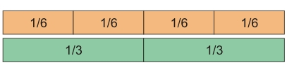  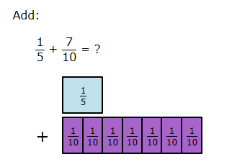  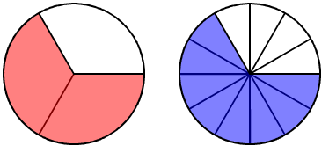  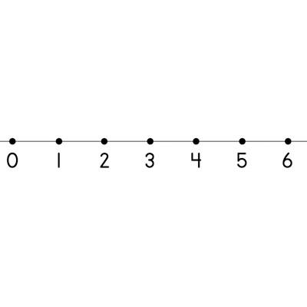
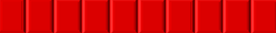  Bar Model | Leticia read 7 ½ books for the read-a-thon. She wants to read 12 books in all. How many more books does she have to read?  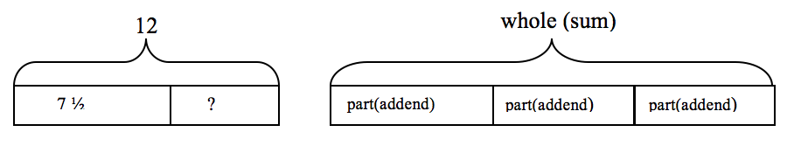  12 - 7 ½ = ? or 7 ½ + ? = 12 so Leticia needs to read 4 ½ more books.
Tangram Puzzle  Choosing each piece of the Tangram set, students are asked identify the size of the pieces based upon  - The original square  - The size of a select piece  - When assigning a value to each piece, for example when the large right triangle is equal to 2. |   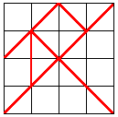
Equivalent Fractions | For example, 2/3 + 5/4 = 8/12 + 15/12 = 23/12. (In general, a/b + c/d = (ad + bc)/bd.)
Benchmark Fractions | 1/2, 1/3, 1/4, 1/5, 1/6. 1/8, 1/10
Abstract Representations
Basic Mathematical Properties | Additive Inverse  Example: 7 + (-7) = 0
Algorithm | In general,  a/b+c/d=(ad+bc)/bd

Suggested Lessons and Tasks
Lesson Suggestion from Current Resources | CCSS | Teacher Notes
8-5  Fractions of Fractions | 5.NF.6 | Mental Math and Reflexes  Part 1 Only
8-6  An Area Model for Fractions Multiplication | 5.NF.6 | Part 1 Only
8-7  Multiplication of Fractions and Whole Numbers | 5.NF.6 | Mental math and Reflexes  Part 1 Only
8-8  Multiplication of Mixed Numbers | 5.NF.6 | Mental math and Reflexes  Part 1 : Starting with Multiplying with Mixed Numbers
8-12  Fractions Division | 5.NF.7
7-4 Parentheses in Number Sentences | 5.OA.1 | Mental Math and Reflexes  Part 1 & Part 3
7-5 Order of Operations | 5.OA.1 | Part 1 Only
9-8  Volume of Rectangular Prisms | 5.MD.3-5 | Part 1 Only
9-9  Volume of Right Prisms | 5.MD.5 | Part 1 Only : Exploring Volume
9-10 Review of Geometric Solids: Part 1 | 5.MD.3-5 | Part 2 Only: Volume of a Rectangular Prism

Math Tasks - Fractions
Multiplying Fractions with Color Tiles
5.NF.6 - Task 1
Standard(s) | 5.NF.6 Solve real world problems involving multiplication of fractions and mixed numbers, e.g., by using visual fraction models or equations to represent the problem.
Materials | Paper and pencil  1 inch grid paper and color tiles
Task | Part 1:  Have students cut a 4x4 inch grid and solve the problem below.  Cover 3/4 of the grid with one color of the tiles.  Cover 1/2 of the covered area with another color of the tiles.  Write an equation to show how much of your model is covered by both colors of tiles.  Part 2:  Have students cut a 6x6 inch grid and solve the problem below.  Cover 2/3 of the grid with one color of the tiles.  Cover 1/4 of the covered area with another color of the tiles.  Write an equation to show how much of your model is covered by both colors of tiles.  Part 3:  What relationship do you notice between the numerators in your two factors and your product? What relationship do you notice between the denominators?

Bird Feeder Fractions
5.NF.6 - Task 2
Standard(s) | 5.NF.6. Solve real world problems involving multiplication of fractions and mixed numbers, e.g., by using visual fraction models or equations to represent the problem.
Materials | Paper and pencil  Optional: Color tiles, fraction bars
Task | Solve the problems below. Use models and equations to show your answers.  - Desiree has 3½ bags of bird seed to fill the bird feeders. Each bag weighs ¾ of a pound. How many pounds of birdseed does Desiree have? If Desiree needs double the amount of bird seed how many bags should she buy?  - Brooks used 2/3 of a can of paint to paint the bird feeder. A full can of paint contains 7/8 of a gallon. How much paint did Brooks use? If Brooks painted more and only had 1/12 of a can of paint left what fraction of the can of paint did he use?  - Write about a strategy that you used to solve the tasks.

Sloan’s Coins
5.NF.7 - Tasks
Standard(s) | 5.NF.7 Apply and extend previous understandings of division to divide unit fraction by whole numbers and whole numbers by unit fractions. (Note: Students able to multiply fractions in general can develop strategies to divide fractions in general, by reasoning about the relationship between multiplication and division. But division of a fraction by a fraction is not a requirement of this grade.)
Materials | Paper and pencil
Task1 | Sloan has begun saving half dollar coins. She has $6.00 worth of coins. How many half dollar coins does Sloan have? Draw a model to support your solution. Write an equation for this problem.
Task 2 | Mrs. Sullivan owns a bakery. One of her customers cancelled their cake order after the cake was already made. Mrs. Sullivan gave half of the cake to her employees to eat. She brought the other half home for her family to eat. If there are 5 members of the Sullivan family, and they share the cake equally, how much of the original cake will each family member get to eat?  Draw a model and write an equation to show your work.
Task 3 | Mackenzie used 2 cups of sugar to make cookies. 2 cups is 1/3 of all the sugar she had. How much sugar did Mackenzie have before she made cookies?  Draw a model and write an expression to support your reasoning.

Measuring Cups (5.NF.A)
Lucy has measuring cups of sizes 1 cup, cup, cup, and cup. She is trying to measure out of a cup of water and says ''if I fill up the the cup and then pour that into the cup until it is full, there will be of a cup of water left.''
- Is Lucy's method to measure of a cup of water correct? Explain.

- Lucy wonders what other amounts she can measure. Is it possible for her to measure out of a cup? Explain.

- What other amounts of water can Lucy measure?

Egyptian Fractions (5.NF.A.1)

Ancient Egyptians used unit fractions, such as and , to represent all fractions. For example, they might write the number as +.
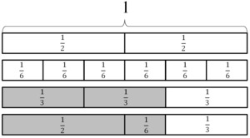

We often think of as , but the ancient Egyptians would not write it this way because they didn't use the same unit fraction twice.
- Write each of the following Egyptian fractions as a single fraction:
  - ,
  - ,
- How might the ancient Egyptians have written the fraction we write as ?

Mixed Numbers with Unlike Denominators (5.NF.A.1)

Find two different ways to add these two numbers:
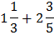

Jog-A-Thon (5.NF.A.1)

Alex is training for his school's Jog-A-Thon and needs to run at least 1 mile per day. If Alex runs to his grandma's house, which is of a mile away, and then to his friend Justin's house, which is of a mile away, will he have trained enough for the day?

Finding Common Denominators to Add (5.NF.A.1)

- To add fractions, we usually first find a common denominator.
  - Find two different common denominators for and .
  - Use each common denominator to find the value of . Draw a picture that shows your solution.
- Find . Draw a picture that shows your solution.
- Find .

Finding Common Denominators to Subtract (5.NF.A.1)
- To subtract fractions, we usually first find a common denominator.
  - Find two different common denominators for and
  - Use each common denominator to find the value of . Draw a picture that shows your solution.
- Find . Draw a picture that shows your solution.
- Find .

Making S’Mores (5.NF.A.1)
Nick and Tasha are buying supplies for a camping trip. They need to buy chocolate bars to make s’mores, their favorite campfire dessert. Each of them has a different recipe for their perfect s’more.

Nick likes to use of a chocolate bar to make a s’more.
Tasha will only eat a s’more that is made with exactly of a chocolate bar.
- What fraction of a chocolate bar will Nick and Tasha use in total if they each eat one s’more?

- Nick wants to cut one chocolate bar into pieces of equal size so that he and Tasha can make their s’mores. How many pieces should he cut the chocolate bar into so that each person will get the right amount of chocolate to make their perfect s’more?
- After Nick cuts the chocolate bar into pieces of equal size, how many pieces of the chocolate bar should he get? How many pieces of the chocolate bar should he give to Tasha?

Do These Add Up? (5.NF.A.2)

For each of the following word problems, determine whether or not 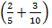represents the problem. Explain your decision.
- A farmer planted 2/5 of his forty acres in corn and another of his land in wheat. Taken together, what fraction of the 40 acres had been planted in corn or wheat?
- Jim drank of his water bottle and John drank of his water bottle. How much water did both boys drink?
- Allison has a batch of eggs in the incubator. On Monday of the eggs hatched, By Wednesday, more of the original batch hatched. How many eggs hatched in all?
- Two fifths of the cross-country team arrived at the weight room at 7 a.m. Ten minutes later, of the team showed up. The rest of the team stayed home. What fraction of the team made it to the weight room that day?
- Andy made 2 free throws out of 5 free throw attempts. Jose made 3 free throws out of 10 free throw attempts. What is the fraction of free throw attempts that the two boys made together?
- Two fifths of the students in the fifth grade want to be in the band. Three tenths of the students in the fifth grade want to play in the orchestra. What fraction of the students in the fifth grade want to be in one of the two musical groups?
- There are 150 students in the fifth grade in Washington Elementary School. Two fifths of the students like soccer best and of them like basketball best. What fraction like soccer or basketball best?
- The fifth grade at Lincoln School has two mixed-sex soccer teams, Team A and Team B. If of Team A are girls and of Team B are girls, what fraction of the players from the two teams are girls?
- Wesley ran of a mile on Monday and of a mile on Tuesday. How far did he run those two days?

To Multiply or Not to Multiply? (5.NF.A)
Some of the problems below can be solved by multiplying , while others need a different operation. Select the ones that can be solved by multiplying these two numbers. For the remaining, tell what operation is appropriate. In all cases, solve the problem (if possible) and include appropriate units in the answer.
- Two-fifths of the students in Anya’s fifth grade class are girls. One-eighth of the girls wear glasses. What fraction of Anya’s class consists of girls who wear glasses?
- A farm is in the shape of a rectangle of a mile long and of a mile wide. What is the area of the farm?
- There is of a pizza left. If Jamie eats another of the original whole pizza, what fraction of the original pizza is left over?
- In Sam’s fifth grade class, of the students are boys. Of those boys, have red hair. What fraction of the class is red-haired boys?
- Only of the guests at the party wore both red and green. If of the guests wore red, what fraction of the guests who wore red also wore green?
- Alex was planting a garden. He planted of the garden with potatoes and of the garden with lettuce. What fraction of the garden is planted with potatoes or lettuce?
- At the start of the trip, the gas tank on the car was full. If the trip used of the remaining gas, what fraction of a tank of gas is left at the end of the trip?
- On Monday, of the students in Mr. Brown’s class were absent from school. The nurse told Mr. Brown that of those students who were absent had the flu. What fraction of the absent students had the flu?
- Of the children at Molly’s daycare, are boys and of the boys are under 1 year old. How many boys at the daycare are under one year old?
- The track at school is of a mile long. If Jason has run of the way around the track, what fraction of a mile has he run?

Salad Dressing (5.NF.A.2)

Aunt Barb’s Salad Dressing Recipe
- cup olive oil
- cup balsamic vinegar
- a pinch of herbs
- a pinch of salt
Makes 6 servings

- How many cups of salad dressing will this recipe make? Write an equation to represent your thinking. Assume that the herbs and salt do not change the amount of dressing.

- If this recipe makes 6 servings, how much dressing would there be in one serving? Write a number sentence to represent your thinking.

Painting a Wall (5.NF.B)
Nicolas is helping to paint a wall at a park near his house as part of a community service project. He had painted half of the wall yellow when the park director walked by and said,
This wall is supposed to be painted red.
Nicolas immediately started painting over the yellow portion of the wall. By the end of the day, he had repainted of the yellow portion red.
What fraction of the entire wall is painted red at the end of the day?

Connor and Makayla Discuss Multiplication (5.NF.B.4)
Makayla said, "I can represent with 3 rectangles each of length." 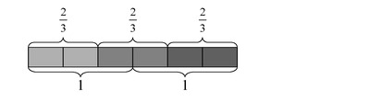
Connor said, “I know that can be thought of as . Is 3 copies of the same as ?”
- Draw a diagram to represent .
- Explain why your picture and Makayla’s picture together show that =.
- What property of multiplication do these pictures illustrate?

Folding Strips of Paper (5.NF.B.4)
  - Label the points on the number line that correspond to .
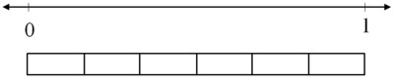
  - Carefully cut out a strip of paper that has a length of .
    - Bring the ends of the strip together to fold the strip of paper in half. How long is half of the strip? Use your strip to mark this point on the number line.
    - What two numbers can you multiply to find the length of half the strip? Write an equation to show this.
  - Unfold your paper strip so that you start with again. Now fold the strip of paper in half and then in half again.
    - How long is half of half of the strip? Use your strip to mark this point on the number line.
    - What numbers can you multiply to find the length of half the strip? Write an equation to show this.
Running a Mile (5.NF.B.5)

Curt and Ian both ran a mile. Curt's time was Ian's time. Who ran faster? Explain and draw a picture.

Fundraising (5.NF.B.5)

Cai, Mark, and Jen were raising money for a school trip.
- Cai collected times as much as Mark.
- Mark collected as much as Jen.
Who collected the most? Who collected the least? Explain.

Calculator Trouble (5.NF.B.5)

Luke had a calculator that will only display numbers less than or equal to 999,999,999. Which of the following products will his calculator display? Explain.
- 792×999,999,999
- ×999,999,999
- ×999,999,999
- 0.67×999,999,999

Comparing a Number and a Product (5.NF.B.5)

Decide which number is greater without multiplying.

Grass Seedlings (5.NF.B.5)

The students in Raul’s class were growing grass seedlings in different conditions for a science project. He noticed that Pablo’s seedlings were times a tall as his own seedlings. He also saw that Celina’s seedlings were as tall as his own. Which of the seedlings shown below must belong to which student? Explain your reasoning.
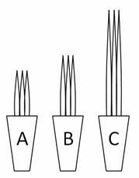

Reasoning about Multiplication (5.NF.B.5)

Your classmate Ellen says,
When you multiply by a number, you will always get a bigger answer. Look, I can show you.
Start with 9.
Multiply by 5. 9×5=45
The answer is 45, and 45>9
45 is bigger than 9.
It even works for fractions.
Start with .
Multiply by 4.
The answer is 2, and 2 >
2 is bigger than .
Ellen's calculations are correct, but her rule does not always work.
For what numbers will Ellen's rule work? For what numbers will Ellen's rule not work? Explain and give examples.
Running to School (5.NF.B.6)

The distance between Rosa’s house and her school is mile. She ran of the way to school. How many miles did she run?

Drinking Juice (5.NF.B.6)

Alisa had a liter of juice in a bottle. She drank of the juice that was in the bottle. How many liters of juice did she drink?

Half a Recipe (5.NF.B.6)

Kendra is making of a recipe. The full recipe calls for cup of flour. How many cups of flour should Kendra use?

Making Cookies (5.NF.B.6)

A recipe for chocolate chip cookies makes 4 dozen cookies and calls for the following ingredients:
- C margarine
- C sugar
- 2 tsp vanilla
- C flour
- 1 tsp baking powder
- tsp salt
- 8 oz chocolate chips
- How much of each ingredient is needed to make 3 recipes?
- How much of each ingredient is needed to make of a recipe?

Dividing by One- Half (5.NF.B.7)

Solve the four problems below. Which of the following problems can be solved by finding 3÷ ?
- Shauna buys a three-foot-long sandwich for a party. She then cuts the sandwich into pieces, with each piece being foot long. How many pieces does she get?
- Phil makes 3 quarts of soup for dinner. His family eats half of the soup for dinner. How many quarts of soup does Phil's family eat for dinner?
- A pirate finds three pounds of gold. In order to protect his riches, he hides the gold in two treasure chests, with an equal amount of gold in each chest. How many pounds of gold are in each chest?
- Leo used half of a bag of flour to make bread. If he used 3 cups of flour, how many cups were in the bag to start?

How Many Servings of Oatmeal (5.NF.B.7)

A package contains 4 cups of oatmeal. There is cup of oatmeal in each serving.
How many servings of oatmeal are there in the package? Explain. Draw a picture to illustrate your solution.

Banana Pudding (5.NF.B.7)

Carolina’s Banana Pudding Recipe
- 2 cups sour cream
- 5 cups whipped cream
- 3 cups vanilla pudding mix
- 4 cups milk
- 8 bananas

Carolina is making her special banana pudding recipe. She is looking for her cup measure, but can only find her quarter cup measure.
- How many quarter cups does she need for the sour cream? Draw a picture to illustrate your solution, and write an equation that represents the situation.
- How many quarter cups does she need for the milk? Draw a picture to illustrate your solution, and write an equation that represents the situation.
- Carolina does not remember in what order she added the ingredients but the last ingredient added required 12 quarter cups. What was the last ingredient Carolina added to the pudding? Draw a picture to illustrate your solution, and write an equation that represents the situation.

5.NF.7
Problem 1
Edward buys 2 pounds of pecans.
  - If Jenny puts 2 pounds in each bag, how many bags can she make?

  - If she puts 1 pound in each bag, how many bags can she make?

  - If she puts ½ pound in each bag, how many bags can she make?

  - If she puts 1/3 pound in each bag, how many bags can she make?

  - If she puts ¼ pound in each bag, how many bags can she make?

Problem 2
Leslie buys 2 pounds of pecans.

- If this is ½ the number she needs to make pecan pies, how many pounds will she need?

- If this is 1/3 the number she needs to make pecan pies, how many pounds will she need?

- If this is ¼ the number she needs to make pecan pies, how many pounds will she need?

Problem 3

Tina wants to cut foot lengths from a board that is 5 feet long. How many boards can he cut?

Math Tasks – Operations and Algebraic Thinking
5.OA.1
Evaluate the following numerical expressions.

- 2 × 5 + 3 × 2 + 4
- 2 × (5 + 3 × 2 + 4)
- 2 × 5 + 3 ×(2 + 4)
- 2 ×(5 + 3)× 2 + 4
- (2 × 5 ) + (3 × 2) +4
- 2 ×(5 + 3) × (2 + 4)

Can the parentheses in any of these expressions be removed without changing the value the expression?

5.OA.1

What numbers can you make with 1, 2, 3, and 4? Using the operations of addition, subtraction, and multiplication, we can make many different numbers. For example, we can write 13 as
13 = ( 3 × 4 ) + 1.
You can use parentheses as many times as you like and each of the numbers 1, 2, 3, and 4 can be used at most once.

- Find two different ways to make 9.
- Find two different ways to make 7.
- Find two different ways to make 11.
- Can you make 26?

5.OA.1
Explain, using what you know about order of operations, how the problem above was solved to get the answer of 2. Hint: you need to add parenthesis to solve this problem correctly.

50 ÷ 2 + 8 – 3 = 2

______________________________________________________________________________________________________________________________________________________________________________________________________________________________________________________________________________________________________________________________________________________________________________________________________________________________________________________________________________________________________________________________
__________________________________________________________________________________________________________________________________________________________________________

What number can you substitute for s to make the equation true?

s x (9 + 11) = 6 x 11 + 6 x 9

Explain how you found your answer.

5.OA.1
Danny wrote an equation using all four operations (+, -. x, ÷), and one set of parentheses, with an answer of 24. What did Danny’s equation look like? Give an example on the line below.

_______________________________

Use what you know about order of operations to explain why your answer is correct.

5.OA.1
Look at the expressions. Decide if the value of each expression is less than, equal to or greater than 15. Write the expressions in the correct category on the chart.
2 x ½ x (5 x 3) (5 x 3) ÷ 5 ¼ x (5 x 3)
(5 x 3) ÷ 6 20 - (5 x 3) (5 x 3) x (8 - 7)

1 x (5 x 3) 2 x (5 x 3)

 | Less than 15 |  | Equal to 15 | Greater than 15
5.OA.1 - Tasks
Standard(s) |  | 5.OA.1 Use parentheses, brackets, or braces in numerical expressions, and evaluate expressions with these symbols.
Task 1  Target Number |  | Choose four one-digit numbers. Choose any numbers you like. (You MAY use 0).  Write an expression that has a value of 10. Follow the rules below:  You must use all four of your numbers. You may use any combination of the following symbols: + - x ÷ ( )  Using the same numbers, write an expression that has a value of 9.  Write an expression that has a value of 8.  Write an expression that has a value of 7.  Write an expression that has a value of 6.  Write an expression that has a value of 5.  Write an expression that has a value of 4.  Write an expression that has a value of 3.  Write an expression that has a value of 2.  Write an expression that has a value of 1.  Write an expression that has a value of 0.  Are there any that are not possible with the 4 numbers you have chosen? If so, choose another 4 numbers and try to reach that target with your new four numbers.
Task 2  Expression Sets |  | Choose one set of expressions.  Set A Set B Set C Set D  1 + 2 + (3 + 4) 1 x 2 x (3 x 4) 1 + 2 x (3 + 4) (1 x 2) + 3 x 4  (1 + 2) + 3 + 4 (1 x 2) x 3 x 4 (1 + 2) x 3 + 4 1 x 2 + (3 x 4)  1 + (2 + 3) + 4 1 x (2 x 3) x 4 1 + (2 x 3) + 4 1 x (2 + 3) x 4  1 + 2 + 3 + 4 1 x 2 x 3 x 4 1 + 2 x 3 + 4 1 x 2 + 3 x 4  - Find the value of each expression. What patterns do you notice? What impact does the position of the parentheses have on the value of the expressions?  - Find a partner who chose a different set than the one you chose. What did they notice about their expressions?  Why do we use parentheses in mathematical expressions? When is it important to use parentheses? When are parentheses not necessary?
Math Tasks – Measurement and Data
5.MD.3-5
A box 2 centimeters high, 3 centimeters wide, and 5 centimeters long can hold 40 grams of clay. A second box has twice the height, three times the width, and the same length as the first box. How many grams of clay can it hold?

5.MD.5
Make sure you have plenty of snap cubes.
- Build a rectangular prism that is 2 cubes high, 3 cubes wide, and 5 cubes long.

- We will say that the volume of one cube is 1 cubic unit. What is the volume of the rectangular prism?

- The volume of the cube is 2 × 3 × 5 cubic units. The expression
2 × (3 × 5)
can be interpreted as 2 groups with 3×5 cubes in each group. 3×5 can be interpreted as 3 groups with 5 cubes in each groups. How can you see the rectangular prism as being made of 2 groups with (3 groups of 5 cubes in each)?

- Explain how you can see each of these products by looking at the rectangular prism in different ways:
2 × (5 × 3)
3 × (2 × 5)
3 × (5 × 2)
5 × (2 × 3)
5 × (3 × 2)

5.MD
Make sure you have plenty of snap cubes.
- Build a rectangular prism that is 2 cubes on one side, 3 cubes on another, and 5 cubes on the third side.
- We will say that the volume of one cube is 1 cubic unit. What is the volume of the rectangular prism?
- Jenna said,
The rectangular prism is 2 cubes by 3 cubes by 5 cubes, so the volume of the prism is
2 × 3 × 5 cubic units.

Ari said,
I don't know what 2×3×5 means. Do you multiply the 2 and 3 first
2×3×5=(2×3)×5=6×5
so you have 6 groups of 5, or do you multiply the 3 and the 5 first
2×3×5=2×(3×5)=2×15
so you have 2 groups of 15?

  - Explain how you can see the rectangular prism as being made of 2 groups with 15 cubes in each.
  - Explain how you can also see the rectangular prism as being made of 6 groups with 5 cubes in each.
- Does it matter which numbers you multiply first when you want to find the volume of a rectangular prism?

5.MD Cari’s Aquarium

Cari is the lead architect for the city’s new aquarium. All of the tanks in the aquarium will be rectangular prisms where the side lengths are whole numbers.
- Cari’s first tank is 4 feet wide, 8 feet long and 5 feet high. How many cubic feet of water can her tank hold?
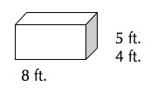
- Cari knows that a certain species of fish needs at least 240 cubic feet of water in their tank. Create 3 separate tanks that hold exactly 240 cubic feet of water. (Ex: She could design a tank that is 10 feet wide, 4 feet long and 6 feet in height.)

- In the back of the aquarium, Cari realizes that the ceiling is only 10 feet high. She needs to create a tank that can hold exactly 100 cubic feet of water. Name one way that she could build a tank that is not taller than 10 feet.

Extensions and Sources
Online Resources

Common Core Tools
http://commoncoretools.me/
http://www.ccsstoolbox.com/
http://www.achievethecore.org/steal-these-tools
Manipulatives
http://nlvm.usu.edu/en/nav/vlibrary.html
http://www.explorelearning.com/index.cfm?method=cResource.dspBrowseCorrelations&v=s&id=USA-000
http://www.thinkingblocks.com/
Problem Solving Resources
*Illustrative Math Project
http://illustrativemathematics.org/standards/k8
http://illustrativemathematics.org/standards/hs
The site contains sets of tasks that illustrate the expectations of various CCSS in grades K–8 grade and high school. More tasks will be appearing over the coming weeks. Eventually the sets of tasks will include elaborated teaching tasks with detailed information about using them for instructional purposes, rubrics, and student work.
*Inside Mathematics
http://www.insidemathematics.org/index.php/tools-for-teachers
Inside Mathematics showcases multiple ways for educators to begin to transform their teaching practices. On this site, educators can find materials and tasks developed by grade level and content area.

IXL
http://www.ixl.com/
Sample Balance Math Tasks
http://www.nottingham.ac.uk/~ttzedweb/MARS/tasks/
New York City Department of Education
http://schools.nyc.gov/Academics/CommonCoreLibrary/SeeStudentWork/default.htm
NYC educators and national experts developed Common Core-aligned tasks embedded in units of study to support schools in implementation of the CCSSM.
*Georgia Department of Education
https://www.georgiastandards.org/Common-Core/Pages/Math-K-5.aspx
Georgia State Educator have created common core aligned units of study to support schools as they implement the Common Core State Standards.
Gates Foundations Tasks
http://www.gatesfoundation.org/college-ready-education/Documents/supporting-instruction-cards-math.pdf
Minnesota STEM Teachers’ Center
http://www.scimathmn.org/stemtc/frameworks/721-proportional-relationships
Singapore Math Tests K-12
http://www.misskoh.com
Math Score:
Math practices and assessments online developed by MIT graduates.
http://www.mathscore.com/
Massachusetts Comprehensive Assessment System
www.doe.mass.edu/mcas/search
Performance Assessment Links in Math (PALM)
PALM is currently being developed as an on-line, standards-based, resource bank of mathematics performance assessment tasks indexed via the National Council of Teachers of Mathematics (NCTM).
http://palm.sri.com/
Mathematics Vision Project
http://www.mathematicsvisionproject.org/
*NCTM
http://illuminations.nctm.org/
Assessment Resources
  - *Illustrative Math: http://illustrativemathematics.org/
  - *PARCC: http://www.parcconline.org/samples/item-task-prototypes
  - NJDOE: http://www.state.nj.us/education/modelcurriculum/math/ (username: model; password: curriculum)
  - DANA: http://www.ccsstoolbox.com/parcc/PARCCPrototype_main.html
  - New York: http://www.p12.nysed.gov/assessment/common-core-sample-questions/
  - *Delaware: http://www.doe.k12.de.us/assessment/CCSS-comparison-docs.shtml

PARCC Prototyping Project
Elementary Tasks (ctrl+click) | Middle Level Tasks (ctrl+click) | High School Tasks (ctrl+click)
- Flower gardens (grade 3)  - Fractions on the number line (grade 3)  - Mariana’s fractions (grade 3)  - School mural (grade 3)  - Buses, vans, and cars (grade 4)  - Deer in the park (grade 4)  - Numbers of stadium seats (grade 4)  - Ordering juice drinks (grade 4) | - Cake weighing (grade 6)  - Gasoline consumption (grade 6)  - Inches and centimeters (grade 6)  - Anne’s family trip (grade 7)  - School supplies (grade 7)  - Spicy veggies (grade 7)  - TV sales (grade 7) | - Cellular growth  - Golf balls in water  - Isabella’s credit card  - Rabbit populations  - Transforming graphs of quadratic functions
Professional Development Resources
Edmodo
http://www.edmodo.com
Course: iibn34
Clark County School District Wiki Teacher
http://www.wiki-teacher.com/wikiDevelopment/unwrappedSearch.php#contentAreaId=6&courseId=474
Learner Express Modules for Teaching and Learning
http://www.learner.org/series/modules/express/videos/video_clips.html?type=1&subject=math
Additional Videos
http://www.achieve.org/achieving-common-core; http://www.youtube.com/user/TheHuntInstitute/videos
Mathematical Practices
Inside Mathematics
http://www.insidemathematics.org/index.php/commmon-core-math-intro
Also see the Tools for Educators
The Teaching Channel
https://www.teachingchannel.org
*Learnzillion
https://www.learnzillion.com
Engage NY
http://www.engageny.org/video-library?f[0]=im_field_subject%3A19

*Adaptations of the these resources has been included in various lessons.

