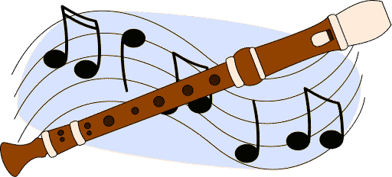
To: 4th Grade Parents

From: Mrs. Tyler
Re: Recorders

This week, your 4th graders will be embarking on the exciting adventure of playing the recorder! Here are some important notes:

- Is the recorder a real instrument? Your child has learned that the recorder is a real instrument that has been around for hundreds of years and they are to treat it carefully and respectfully like any other musical instrument. They have been told to not let anyone else play their recorder. Not only can this spread germs, but if the other person doesn't know how to play, they could damage the recorder, teach themselves bad playing habits and make a lot of noise.
- Everything they learn about the recorder will apply when they have an opportunity to join band in the Middle School.
- This experience is a new one and they are definitely beginners, but a little encouragement goes a long way. Feel free to have them perform for you and your family and friends☺
- What about practicing? The recorder needs to be practiced regularly and it would be best if recorder practice could be included in their regular homework routine. They need a place to be able to concentrate just like homework. I tell them that it is best to practice 10-15 minute, 5-6 days a week. It doesn't help to practice 2 hours on one day. You can't cram to be a good musician. Being a good musician takes a lot of self-discipline. What a great practice to help them in life!
- What do they need to practice? They have a recorder book that will have a song they need to be working on each day. If they lose their music, they can get another copy in a basic under my desk. Also, check the Music Room News website for help and information. Most recorder book pages will be on the website.
- To clean the recorder: The recorders need to be cleaned thoroughly at least once a month or any time your child is sick. The recorder should be cleaned thoroughly by washing it in the sink with regular dish soap. You can just clean it before you wash the rest of the dishes. If you have a dishwasher, you can just lay it down in the top rack. Make sure it is dry before you put it back in the case to prevent mildew problems. I lay it on a dishtowel so the front holes are facing downward over night.
- Whose recorder is it? The recorders are their property. If a child moves, the recorder goes with them. At the end of the year, the recorder will be theirs to take home also. The school has paid for the first recorder, but if this one is lost or broken, it must be replaced. The current cost is $3.00. If you would like to buy an extra recorder so they have one at school and one at home, please feel free to send the $3.00 in anytime. They will take the money to the office and will receive receipt to bring home. We have a few extras, but if we have to order more, we may have to pay more and the cost will need to be adjusted.
- How will I know their recorder grade? The recorder playing grade will be sent home on a half sheet of paper and has a picture of recorders in the top, right corner. Please check their take home folders for their recorder grade sheet. You can always check their complete grade on their web based grade report.
- Whose responsibility and where to put them? The recorders are their responsibility and are to be kept in their book bags to take home to practice. If they have another recorder at home to practice, they can leave one at school. The recorders are made of a strong plastic, but it isn’t THAT strong, so please encourage them to be careful and treat them like glass.
- When do they need to be brought to school? The recorders need to be brought to school every music day. They always have music class the day after they have Art Class. If the recorder is not brought to school that day, they will get a failing grade for the recorder class part of their participation grade that day. Otherwise, their grade will be determined by playing tests. If I see a pattern of forgetting their recorder, they will have to leave their recorder at a school for an extended period of time. It is SO important for them to bring their instrument to every lesson
- When to play their recorder at school? I have told the children that the recorders are not to be played on the bus or at school, except during music class. . If your students are “tooting” in the halls or other places adults will probably take them away. Also, I tell them to be thoughtful of others both at home and in school. We talk about good manners with our recorder☺

Thank you for your patience with our little musicians! If you have any questions, please ask.

