Name: ________________________ Date: ___________________ Period: ____________
Algebra 2: Section 4.8 Complex Numbers Notes

In the past we said that you could not take the square root of a negative. Well we can!!

The imaginary unit i represents the number whose square root is -1
and i² = -1

Rewriting imaginary numbers
- For any positive real number k, .

Practice:
1) Evaluate 2) Evaluate

3) Evaluate 4) Evaluate

Complex Numbers
- Complex numbers are numbers that can be written in the form a + bi, where a and b are real numbers
- The real number a is the ________ part of the complex number.
- The real number bi is the ________ part of the complex number.
- The standard form of a complex number is a + bi.

Practice:
5) Write in standard form: $\frac{\text{18}+2\sqrt{−\text{36}}}{3}$

6) Write in standard form:

Add and Subtract Complex Numbers
- To add and subtract complex numbers, add “like terms”:
Practice:
7)

8)

9)

Multiply Complex Numbers

- To multiply complex numbers, use the distributive property, then combine “like terms”
- One thing to keep in mind: the product property of radicals does not apply when the radicand is a complex number, so evaluate the square root of the negative number first, then multiply the radicals.

Correct:  ☺ | Incorrect:  ☹

Practice:
10)

11)

12)

13)

Divide Complex Numbers

- The complex number a + bi has a _____________________ a – bi.

- When you multiply a complex number by its conjugate you get a _________ number.

Example: $\left(3+4i\right)\left(3−4i\right)=$

- To divide complex numbers, multiply the numerator and denominator by the conjugate of the denominator.

Practice:
14) 15)

16) $\frac{9+\text{12}i}{3i}=$ 17) $\frac{9+\text{12}i}{3i}=$

Using this new knowledge we can provide more specific solutions:

18) $5m^{2}+\text{14}=4$ 19) $2x^{2}+\text{18}=−\text{72}$

To compute powers of i, use an exponent that is the remainder of dividing the original exponent by 4. This works because the powers of i repeat themselves every four factors of i, as can be seen from making a list of powers of i.

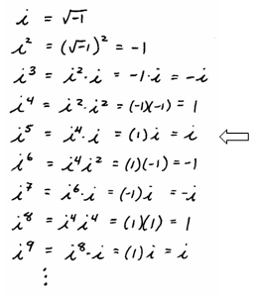

20) 21)

22) $i^{\text{150}}=$ 23) $i^{\text{111}}=$

