DEPARTMENT OF FIRE/RESCUE

The Rio Rancho Department of Fire/Rescue provides fire, emergency medical and other life safety services to those who reside, work and travel through the City of Rio Rancho. The Department of Fire/Rescue continually works to meet the ever-increasing challenges in improving the quality and types of service that we provide to our fast-growing community.

The Department operates out of five stations with 99 authorized fire/rescue personnel who provide fire prevention/suppression and emergency medical care to all of our residents and guests. We have improved the Public Protection Classification to 3 from ISO (Insurance Service Organization) that translates into hazard insurance savings for both residential and commercial properties.

The Department of Fire/Rescue provides a vast array of services, not only to the citizens of Rio Rancho, but also to the commercial and industrial occupancies doing business here. The employees of these enterprises together with their customers and the other guests of our City are also recipients of fire services that include fire prevention, fire control and suppression, rescue, Emergency Medical Services, public education, and emergency management. Specifically, the Department is responsible for the following activities:
- To extinguish accidental or destructive fires and to prevent the occurrence and spread of such fires;
- To enforce all fire prevention regulations and all other ordinances and laws within the competence of the Department;
- To provide for emergency medical and rescue services;
- To review all building plans to ensure adherence to all fire prevention methods and procedures;
- To educate and train Department personnel to efficiently perform in their areas of responsibility and prepare them to function in the next highest position;
- To provide safety equipment for Department personnel that will assure adequate protection in all atmospheres and under all working conditions encountered.

The Department of Fire/Rescue also includes the Emergency Management Division which has as its mission to conduct planning, training, hazard identification, risk and vulnerability analyses, and resource identification for the City of Rio Rancho to further individual, business and community preparedness for all hazards thereby promoting a safe working environment and a sustainable community in pursuit of the mission of the City of Rio Rancho. The City’s Office of Emergency Management is established by ordinance to carry out the responsibility of community preparedness under the State Civil Emergency Preparedness Act, State Emergency Management Act, and other acts embodied in the State statutes to ensure our community is prepared for any emergency or disaster. This critical office exists to mitigate the effects of potential hazards, prepare/plan for measures to be taken which will preserve life and minimize damage to property, respond during emergencies and provide necessary assistance, and ensure a
rapid recovery from disasters by restoring the community to its pre-disaster condition.

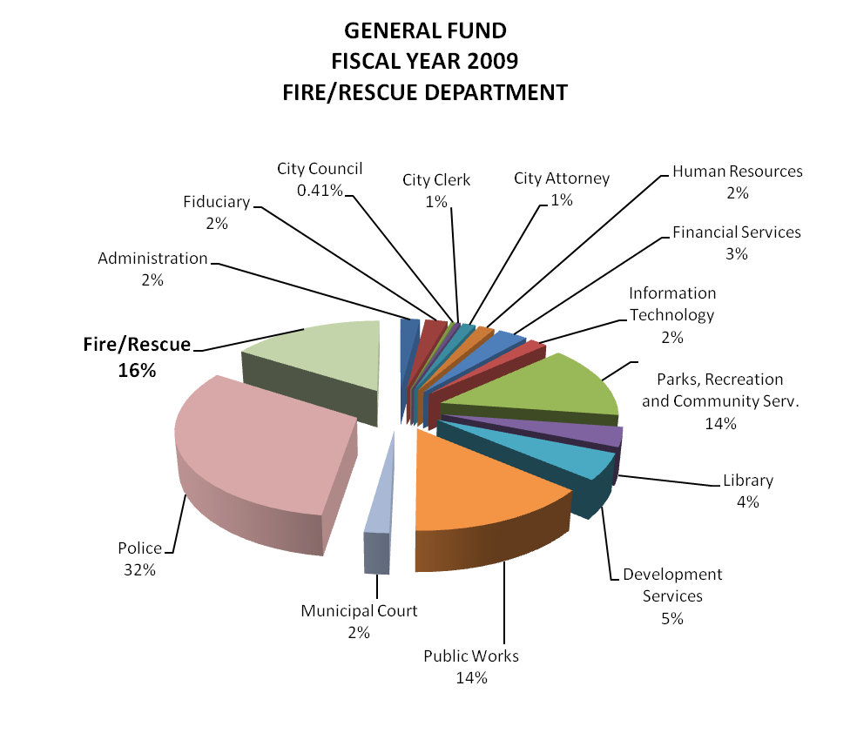
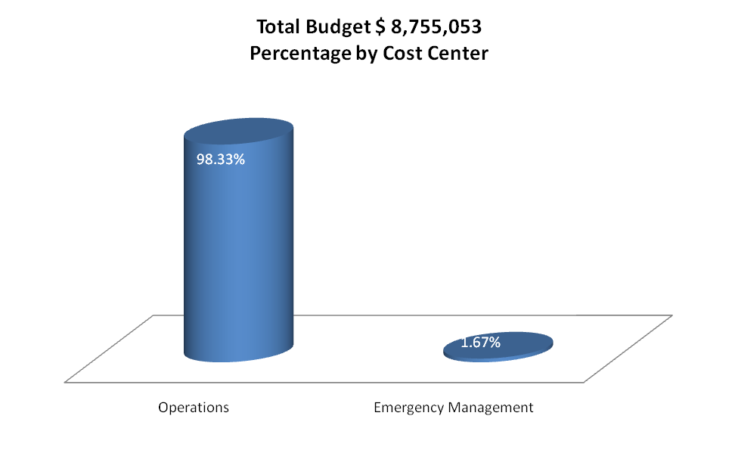
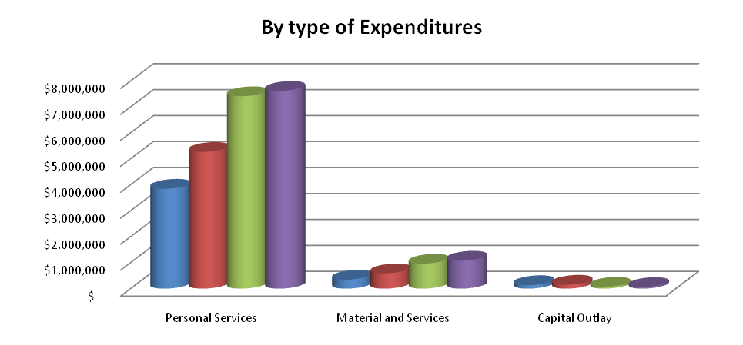
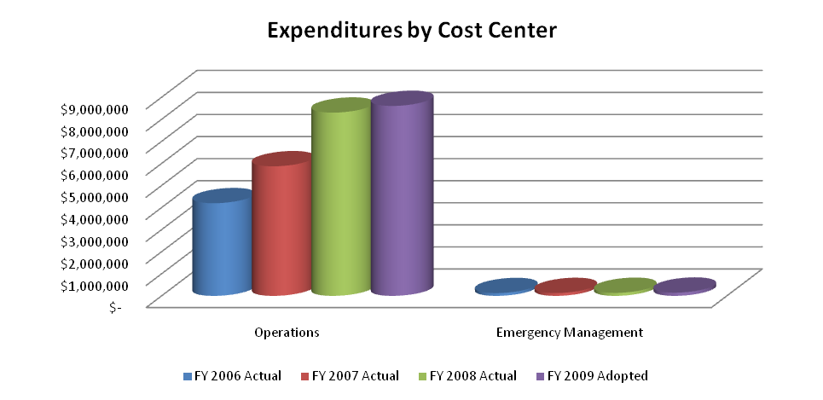
Fire / Rescue / Operations (6530)

Program Description:

The Department of Fire and Rescue provides fire suppression and emergency medical services to the citizens of the community. Fire prevention efforts are in accordance with regulations set forth in the adopted Fire Code and the Occupational Safety and Health Administration (OSHA).

Goals and Objectives:

PUBLIC SAFETY GOAL: Assure a safe, secure, and healthful community through the efficient delivery of Life Safety services designed to be preventive, protective, and responsive.

- OBJECTIVE: Invest in fire prevention and life safety education.
- In cooperation with schools, use the Fire Safety Trailer to train children K-3rd grade on residential evacuation.
- Plan and implement additional fire prevention by having engine company inspections of businesses.
- Deliver life safety education programs to neighborhood organizations, corporate supporters and community service organizations.

OPERATIONS GOAL: Continue to define, improve, and enhance the delivery and efficiency of operations and services within city government and to the citizens of the community.

- OBJECTIVE: Meet minimum national response standards of NFPA 1710 50% of the time.
- Increase each engine company’s staffing to three firefighters (from two).
- Increase the number of stations to reduce response times for areas outside a five minute capability.
- Add nine firefighters to staff three personal on Engines 2, 3, and 6.

Performance Indicators:

Fire and Rescue became an independent department beginning July 1, 2007. Operating expenditures per population increased in FY07 and FY08 due to an additional 24 firefighters that were hired mid-way through FY07. The City also approved a customer service representative position due to the increased work required for a new department.

Prior Year Accomplishments:

- Increased minimum staffing from 17 to 25 Firefighters per shift.
- Successfully increased the ISO rating from a Class 4 to Class 3.
- Implemented paramedic training for 12 firefighters.
- Purchased four (4) new fire apparatus.
- Arranged to obtain properties for new fire stations.
- Submitted and received a federal grant to subsidize 24 new firefighters.
- Conducted fire safety training for more than 2,500 children and adults.
- Hired a plans review specialist in the Fire Inspections Division to meet City needs.

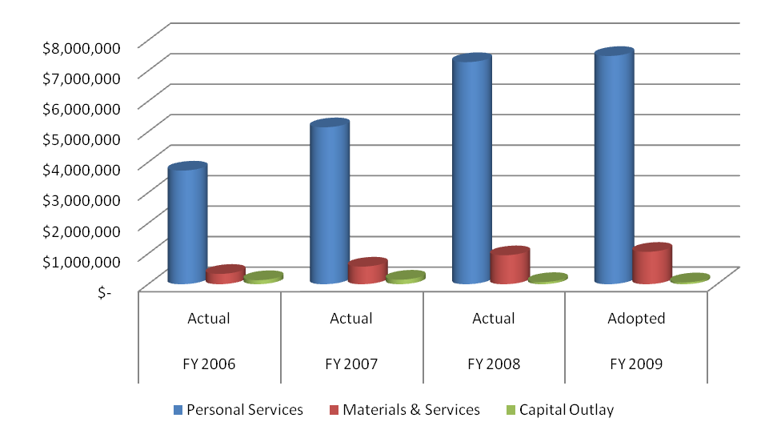

Fire / Rescue / Emergency Management (6545)
Program Description: Emergency Management for the City of Rio Rancho.
Goals and Objectives:

PUBLIC SAFETY GOAL: Assure a safe, secure, and healthful community through the efficient delivery of Public Safety services designed to be preventative, protective, and responsive.

- OBJECTIVE: Conduct training to meet Department of Homeland Security National Incident Management System criteria.
    - Conduct training for management staff to complete ICS-300 and ICS-400 courses.
    - Conduct training for supervisors to complete IS-200 and IS-800 courses.
- OBJECTIVE: Encourage community to be proactive during emergencies.
    - Conduct Community Emergency Response Team (CERT) training classes for citizens.

PARTNERSHIP GOAL: Partner with other levels and/or jurisdictions of Government, Schools, and other public and private entities to enhance area services and infrastructure.

- OBJECTIVE: Work with State and FEMA to recoup monies for 2006 flood disaster.
    - Ensure remaining projects are successfully completed so the City may be reimbursed the 75% FEMA and 18% State shares.
    - Obtain additional disaster mitigation funds for the City from FEMA Pre-disaster Mitigation Program and from Stafford Act 404 funds activated by our federal disaster.
- OBJECTIVE: Partner with adjoining jurisdictions, volunteer organizations active in disaster (VOADs) and local businesses to conduct joint disaster exercises.
    - Conduct joint Tabletop Exercise with Intel Corporation.
    - Conduct joint Tabletop Exercise with Albuquerque, Bernalillo County and Sandoval County also involving New Mexico VOAD and local amateur radio groups.

Performance Indicator (s):
Prior Year Accomplishments:

- By year end, 291 City employees and volunteers who support our emergency programs had completed ICS-100 or IS-100; 181 completed ICS-200 or IS-200; 305 completed IS- 700; 96 completed IS-800 and 372 completed AWR-160.
- Four people took the ICS-300/400 Train-the-Trainer course when offered so we can teach our own staff in FY09.
- As applicant Agent for the City for our 2006 flood disaster, identified mitigation actions totaling $228,000 which FEMA approved as part of our disaster recovery. To date, have received $1.75 million in state and federal reimbursements.
- We trained 72 citizens in our CERT program.

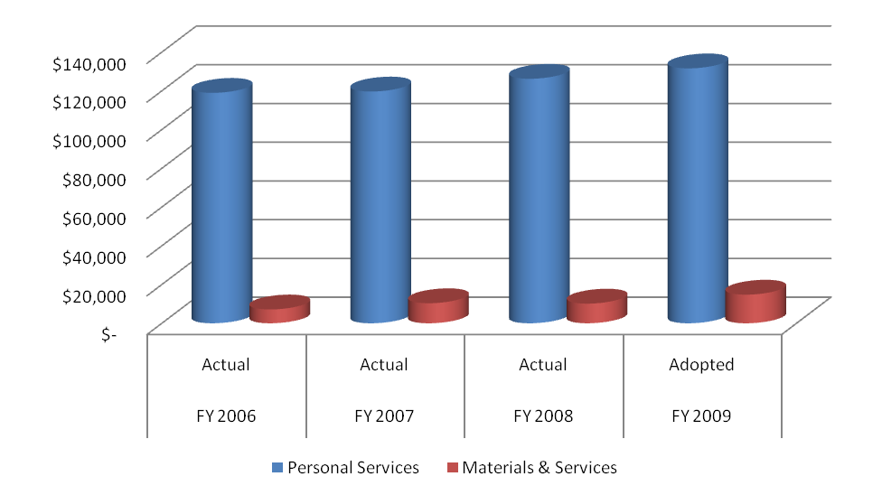

THIS PAGE LEFT INTENTIONALLY BLANK

