Official English

States with Official English Laws
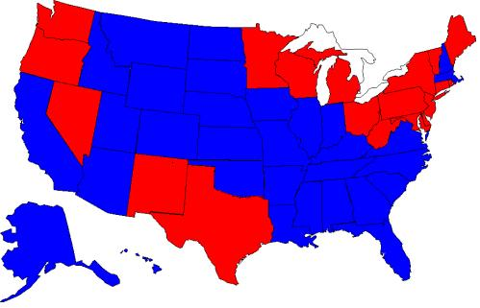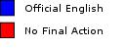
31 STATES WITH OFFICIAL ENGLISH LAWS
Alabama (1990) Louisiana (1812) PENDING STATES, Proposed in 2011
Alaska (1998) Massachusetts (1975) Washington DC (HB1769) English as the Official Language
Arizona (2006) Mississippi (1987) Texas (bill 81 &176) English as the official Language
Arkansas (1987) Missouri (1998 & 2008) Minnesota English the Official Language (H.F. 64) 1-13-2011
California (1986) Montana (1995)
Colorado (1988) Nebraska (1920)
Florida (1988) New Hampshire (1995)
Georgia (1986 & 1996) North Carolina (1987) Limit Drivers Licenses to be taken in English
Hawaii (1978) North Dakota (1987) Montana HB 302 (to require drivers license exams
Idaho (2007) Oklahoma (2010) conducted in English) Passed 62-38. 2-8-2011
Illinois (1969) South Carolina (1987) Arkansas passed proposal requiring Drivers license
Indiana (1984) strengthen 1-18-11 South Dakota (1995) Exams be in English. 3-22-2011
Iowa (2002) Tennessee (1984) Missouri to limit Drivers License Exams in other than
Kansas (2007) Utah (2000) English (passes House 102-56) now goes on to the Senate.
Kentucky (1984) Virginia (1981 & 1996)
Wyoming (1996) Georgia & Tennessee is also considering

