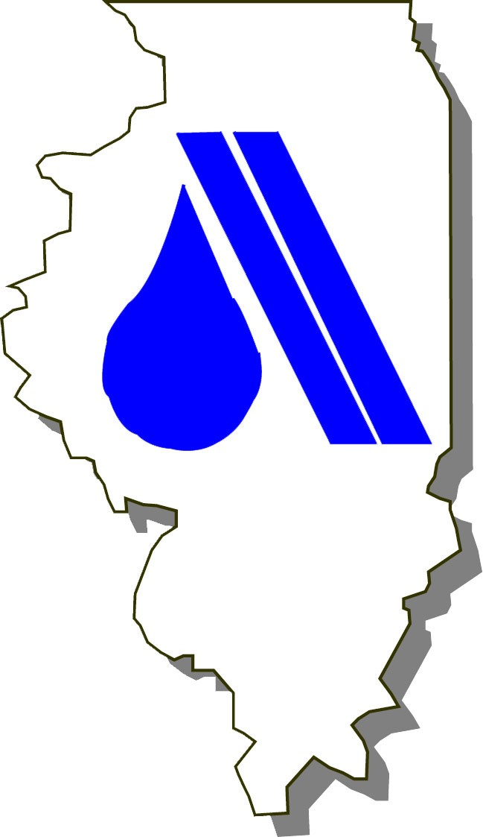
ISAWWA Educational Outreach
Water Cycle Bead Project
Bill Soucie, Central Lake County Joint Action Water Agency

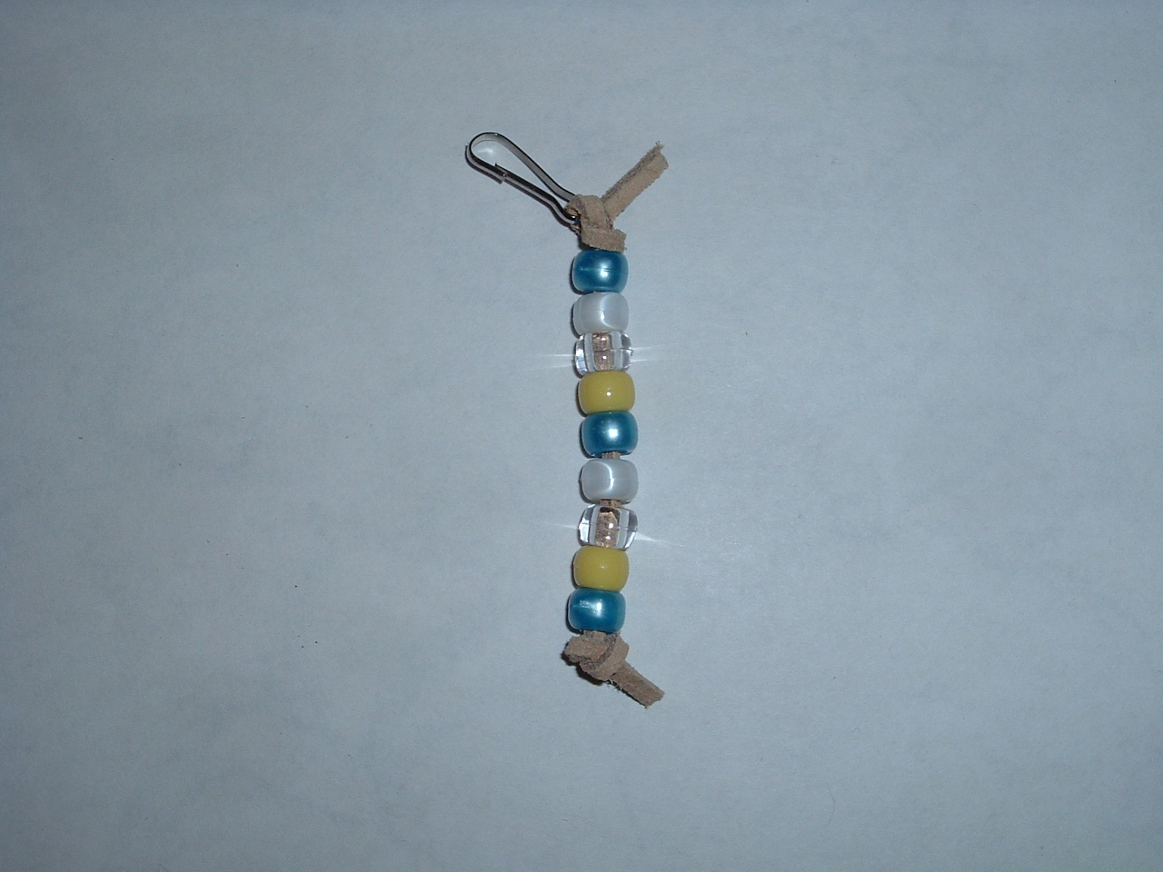
The Water Cycle – In Beads

Everyone loves to thread beads. This project is simple and can be expanded to suite your lesson plan. The supplies are inexpensive and may be purchased at stores like Wal-Mart.

What: A zipper pull or bracelet craft.

Why: Reinforces the steps of the water cycle.

How it Works: Starting at the bottom; there is water in a lake (blue), the sun (yellow), helps the water evaporate (clear), into the sky forming clouds (white), which turn to rain (blue) falling back down to earth. The colors used here minimized supplies and maximized simplicity. One could use a different shade of blue for rain and perhaps add a green bead to represent the earth. Use your imagination!

Who: For 1st through 4th graders (note that 1st and 2nd graders will need help with the knots).

When: At school, during scout events, open houses, etc…

Parts List:
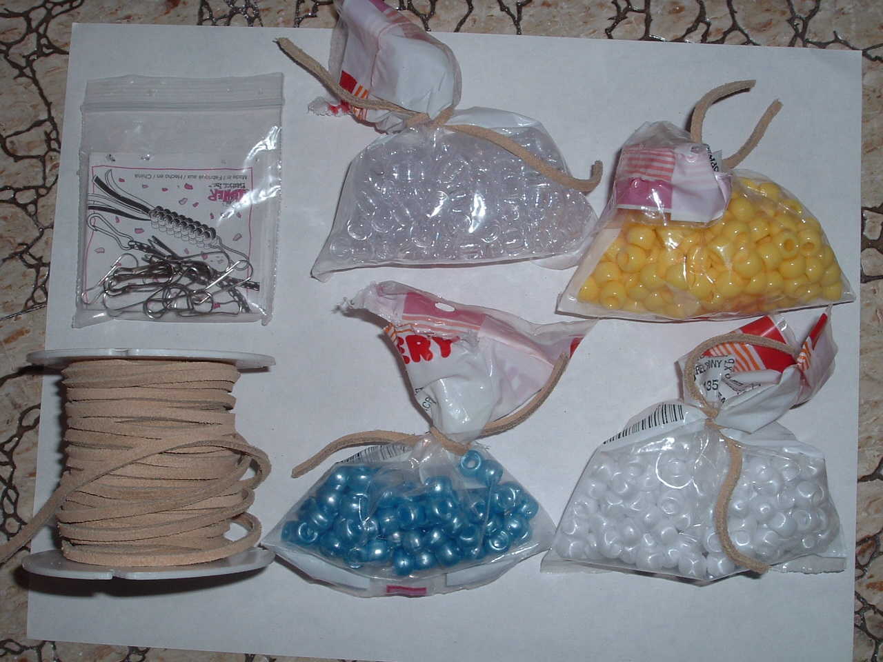
- Genuine Suede Lace – 1/8” x 25 yards. Threads easily and holds knots very well.

- Small metal clasp – 24 per bag.

- Barrel Pony Beads – 300 per bag. 9 x 6 mm.
  - White Pearl
  - Blue Pearl
  - Opaque Yellow
  - Crystal

