Other local support services that may
be of assistance to your family
and you:

Colbert County Department of Human Resources
Mailing Address:
P.O. Box 270
Tuscumbia, AL 35674
(256)-314-6870

Street Address
3105 George Wallace Blvd.
Muscle Shoals , AL 35661

Colbert County Health Dept
1000 S Jackson Hwy
Sheffield, AL 35660

(256) 383-1231

American Red Cross of Northwest Alabama
318 S Court Street
Florence, AL
(256) 764-2911

Salvation Army of the Shoals
1601 Huntsville Road
Florence, AL
(256) 764-4432

Loaves and Fishes Thrift Store
256-381-1119

Dental Assistance Community Health Association Clinic

256-760-4713
Colbert Caring Center
108 N. Water Street
Tuscumbia, AL 35674
(256) 381-8464

Riverbend Center for Mental Health
635 W. College Street
P.O. Box 941
Florence, AL 35630
(256) 764-6431

Center for Community Change
1-877-777-1536

Community Action Agency of Northwest Alabama, Inc.
528 E. Kelsey Ave.
Muscle Shoals, AL 35661
(256) 383-3832

For additional Information regarding our Homeless Program:

Dr. Carlos Nelson
Liaison for Homeless Children and Youth
(256) 383-0400
cnelson@scs.k12.al.us
www.scs.k12.al.us

Education for Homeless Children and Youth
Sheffield City Schools
“Success for Today, Preparation for Tomorrow, Learning for a Lifetime”

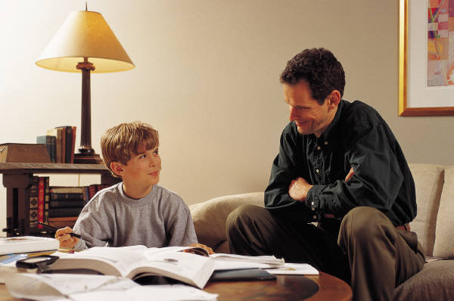

Keith Davis
Superintendent
300 West Sixth Street
Sheffield, AL 35660
256-383-0400 (O)
286-386-5704 (F)

Who is Homeless and what are their rights?
The McKinney-Vento Act (Section 725) defines "homeless children and youth" (school age and younger) as: Children and youth who lack a fixed, regular, and
adequate nighttime residence, including children and youth who are:
- sharing the housing of other persons due
- to loss of housing, economic hardship, or
- a similar reason (i.e. "doubled up")
- living in motels, hotels, trailer parks or
- camping grounds due to lack of
- alternative adequate accommodations
- living in emergency or transitional shelters
- abandoned in hospitals
- awaiting foster care placement
- Children and youth who have a primary nighttime residence that is a public or private place not designed for, or ordinarily used as, a regular sleeping accommodation for human beings.
- Children and youth who are living in cars, parks, public spaces, abandoned buildings, substandard
housing, bus or train stations, or similar settings.
- Migrant children who qualify as homeless if they are living in circumstances described above. The term unaccompanied youth includes a young person not in the physical custody of a parent or guardian.
- This would include runaways living in runaway shelters, abandoned buildings, cars, on the streets or in other inadequate housing; children and youth denied housing by their families (sometimes referred to as "throwaway children and youth"); and school-age unwed mothers living in homes for unwed mothers because they have no other housing available.

Determination of homelessness will be made on a case-by-case basis by the homeless education department. We will use the definition above but also consider the relative permanence of the living arrangements.

Parents of Homeless Children:
Your child has the right to:
- go to school, no matter where they live or how long they have lived there
- attend either the local school or the school of origin, if this is in their best interest; the school of origin is the school the child attended when he/she was permanently housed or the school in which the child was last enrolled
- receive transportation to and from the school of origin
- enroll in school immediately, even if missing records and documents normally required for enrollment such as a birth certificate, proof of residence, previous school records, or immunization/medical records
- enroll, attend classes, and participate fully in all school activities while the school arranges for the transfer of records
- have access to the same programs and services that are available to all other students, including transportation and supplemental education services (if available)
- attend school with children not
- experiencing homelessness; segregation based upon a student's status as homeless
- is prohibited
- receive free meal eligibility through the Child Nutrition Program (CNP).
- obtain a student identification number in the event that a social security card/number is not available.

(ref. National Center for Homeless Education)


