Palestine-Wheatley School District
Disaster Recovery Plan
2014-2015


“Expect More-Achieve More”
Jon Estes, Superintendent
Created: 5-23-2013
Updated: 6-2-14

TABLE OF CONTENTS

PLAN OVERVIEW 3

ADMINISTRATIVE TEAM 4
ADMINISTRATIVE TEAM TASKS 5
ADMINISTRATIVE TEAM PROCESS 5
ADMINISTRATIVE TEAM PROCESS SOFTWARE SUMMARY 8
ADMINISTRATIVE PROCESS TEAM SUPPLIES SUMMARY 8
ADMINISTRATIVE PROCESS TEAM VITAL RECORDS 9

FACULTY/STAFF TEAM 9
FACULTY/STAFF TEAM TASKS 10
FACULTY/STAFF TEAM PROCESS 10
FACULTY/STAFF TEAM PROCESS SOFTWARE SUMMARY 11
FACULTY/STAFF TEAM PROCESS SUPPLIES SUMMARY 11
FACULTY/STAFF TEAM PROCESS VITAL RECORDS 11

FOOD SERVICES TEAM 12
FOOD SERVICES TEAM TASKS 12
FOOD SERVICES TEAM PROCESS 13
FOOD SERVICES TEAM PROCESS SOFTWARE SUMMARY 13
FOOD SERVICES TEAM PROCESS SUPPLIES SUMMARY 13
FOOD SERVICES TEAM PROCESS VITAL RECORDS 13

INFORMATION TECHNOLOGY TEAM 14
INFORMATION TECHNOLOGY TEAM TASKS 14
INFORMATION TECHNOLOGY TEAM PROCESS 14
INFORMATION TECHNOLOGY TEAM PROCESS SOFTWARE SUMMARY 16
INFORMATION TECHNOLOGY TEAM PROCESS SUPPLIES SUMMARY 16
INFORMATION TECHNOLOGY TEAM PROCESS VITAL RECORDS 17

CUSTODIAL/MAINTENANCE TEAM 18
CUSTODIAL/MAINTENANCE TEAM TASKS 18
CUSTODIAL/MAINTENANCE TEAM PROCESS 18
CUSTODIAL/MAINTENANCE TEAM PROCESS SOFTWARE SUMMARY 19
CUSTODIAL/MAINTENANCE TEAM PROCESS SUPPLIES SUMMARY 19
CUSTODIAL/MAINTENANCE TEAM PROCESS VITAL RECORDS 20

TRANSPORTATION TEAM 20 TRANSPORTATION TEAM TASKS 20
TRANSPORTATION TEAM PROCESS 21
TRANSPORTATION TEAM PROCESS SOFTWARE SUMMARY 22
TRANSPORTATION TEAM PROCESS SUPPLIES SUMMARY 22
TRANSPORTATION TEAM PROCESS VITAL RECORDS 22

APPENDIX
- DISTRICT-WIDE CRITICAL VENDOR LIST
- 2013-2014 PALESTINE-WHEATLEY SCHOOL DISTRICT CRISIS MANAGEMENT PLAN
- EMPLOYEE INFORMATION
- PANDEMIC FLU EPIDEMIC PLAN
- DEVOLUTION PLAN
- CONTINUITY PLAN TEST
- MEDIA STATEMENT
- EMERGENCY ACTION PLAN
- MEMORANDUM OF UNDERSTANDING
- ORDER OF SUCCESSION

Plan Overview
This document is the Disaster Recovery Plan for the Palestine-Wheatley School District. The information present in this plan guides cooperative administration and staff in the recovery of necessary data and provides an organizational framework in the event that a disaster destroys all or part of the facilities and/or data.
The primary focus of this document is to provide a plan to respond to a disaster that destroys or severely cripples the cooperatives facilities and/or its computer network or computer systems. The intent is to restore operations as quickly as possible with the latest and most up-to-date data available.
Various threats, both natural and human, against the cooperative and its resources exist. The school districts IT Security Policy documents preventative measures the technology department has implemented and/or is implementing as precautions and the Technology Disaster Recovery Plan documents responses specifically to IT-related recovery. However, we need to take into account natural disasters and disasters out of our control to prevent. At a minimum, this document will detail the backup procedures, secondary locations, and emergency contact information.
Hard-copies of this continuity of operations plan are located in the Palestine Police Department, Palestine City Hall and the Great Rivers Educational Cooperative.
Agency-Level Criticality and Sequence
The most critical issue in regards to a disaster lies in the safety and well-being of the students and staff. As that is assessed and handled, the next most critical issue becomes stability and soundness of the physical assets. These would be assessed at the building’s external features followed by examination of internal structures. Once the facilities are deemed safe, priority turns to restoring telecommunication and network connectivity such that business can be conducted with as little interruption as possible. This also includes hardware assessment of both core and employee equipment. Each department coordinator is then responsible for the overall recovery of their area with the aid of available personnel.
Plan-Level Criticality and Sequence
The Superintendent ultimately decides which sections of this plan get implemented and to what extent. Once the agency-level assessments (as mentioned above) are started, the teams outlined within this document will perform their assigned tasks. Any questions that arise during the implementation of this plan shall be directed to the Superintendent or other appointed personnel, as determined by the Superintendent. The sequence of execution of the plan shall be determined based on the nature and severity of the disaster which caused the execution of the plan.
Administration Team/Disaster Planning and Recovery Team
First Name | Last Name | Position | Phone # | Email Address
Jon | Estes | Superintendent | 870-581-2646 | pwsdestes@gmail.com
Kristi | Wilson | Federal Coordinator  Curriculum Coordinator | 870-581-2246 | pwsdwilson@gmail.com
Randy | Cannon | High School Principal | 870-581-2425 | pwsdcannon@gmail.com
Zenna | Smith | Middle School Principal | 870-457-2121 | pwsdsmithz@gmail.com
Patty | Hernandez | Elementary Principal | 870-581-2588 | pwsdhernandez@gmail.com
Adam | Kennedy | Technology Coordinator | 870-317-6197 | pwsdstanbery@gmail.com
Jedonne` | Clarkson | High School Counselor | 870-581-3794 | pwsdclarkson@gmail.com
Don | Waldrip | Elementary Counselor | 870-581-2588  870-581-2246 | pwsdwaldrip@gmail.com
Sandra | Thorne | District Nurse | 870-581- | pwsdlawson13@gmail.com
Debbie | Loewer | District Treasurer | 870-581-2646 | pwsdloewer@gmail.com
Palestine Fire Department |  |  | 870-581-2639
Palestine Police Department |  |  | 870-581-2489
Great Rivers Educational Cooperative |  |  | 870-338-6461

Administrative Team Tasks
1. Determine cause of disaster and contact insurance company. (Jon Estes)
2. Establish secure perimeter around all recovery site and alternate location. (Police/Fire Department)
3. Initiate the call list and emergency notification system. (Adam Kennedy)
4. Notify alternative administration site. (Kristi Wilson)
5. Notify Vendors to stand by. (Debbie Loewer)
6. Notify local media. (Jon Estes)
7. Checklist of usable resources remaining. (Don Waldrip)
8. Notify vendors of resources needed in all affected areas of district. (Debbie Loewer)
9. Start setting up alternate location. (Jedonne` Clarkson, Randy Cannon)
10. Move administration operations and available resources to alternate site. (Jon Estes, Debbie Loewer)
11. Report to personnel on status of recovery effort. (Jon Estes, Kristi Wilson)
12. Provide support in the cleanup of the administration area following the disaster. (Police/Fire Departments)
13. Interpret state policy governing such issues as teaching standards, school lunches, and student transportation. (Zenna Smith, Patty Hernandez)
14. Notify parents/guardians of recovery status. (Sandra Thorne)
Administrative Team Process
Administration Process: Interpret state policy governing such issues as teaching standards, school lunches, and student transportation
Software Microsoft Office
Software Anti-Virus
APSCN
Adobe
Cognos
Window 7
Window XP Professional
APSCN GUI
LINUX
Equipment Conference (Table and Chairs)
Fire Proof Filing Cabinets
Intercom System
8 computers w/ APSCN
Printers
8 Telephones
Telephone System
Copy Machine
Fax Machine
APSCN Printer
Hand Held Radios

Supplies Hand Sanitizer
Water Buckets
Payroll Checks
Accounts payable checks
Student Activity Checks
Paper Supply
DVDs/CDs
Pens/pencils/markers
File Folders
3 ring Binders
Post-it notes
Paper clips
Flash Drives
Dollies
Receipt Books
Deposit Slips
Stapler
Staples
Envelopes
Window Envelopes
Scissors
Purchase order forms
1099's
First AID Kits
Flash Lights
Batteries
Weather Radio
Bottled Water
Tractor feed paper
W2's
Contract forms
Vital Records Monthly Payroll Check list
Out-lines, Tax, Insurance, TR, Benefit and Deduction folders
Vendor List
Revenue Folders
APSCN Account List
Budget Book
APSCN Print-Out
Fixed Asset Binder
Employee Evaluations
Employee Records
Employee Contracts
Student Records
AUDIT Records

Criticality The most critical issue in regards to a disaster lies in the safety and well-being of Palestine/-Wheatley School District's personnel and students. As that is assessed and handled, the next most critical issue becomes stability and soundness of the physical assets. These would be assessed at the building's external features followed by examination of internal structures. Once the facilities are deemed safe, priority turns to restoring telecommunication and network connectivity such that business can be conducted with as little interruption as possible. This also includes hardware assessment of both core and employee equipment. Each department coordinator is then responsible for the overall recovery of their area.
Sequence The Superintendent ultimately decides which sections of this plan get implemented and to what extent. Once the agency-level assessments (as mentioned above) are started, the teams outlined within this document will perform their assigned tasks. Any questions that arise during the implementation of this plan shall be directed to the Superintendent or other appointed personnel, as determined by the Superintendent. The sequence of execution of the plan shall be determined based on the nature and severity of the disaster which caused the execution of the plan.
Internal Dep. Personnel must be forthcoming in generating a list of usable resources. Status updates are dependent upon the Superintendent or designee.
External Dep. Call list initiation and other notifications are dependent upon availability of telecommunication services. Alternate administrative site cannot be set up until that site makes appropriate.

Process Software Summary
Administrative
Software | Quantity Required | Day 1 | Day 2 | Day 3 | Day 4 | Day 5 | WK2 | WK3 | WK4
Microsoft Office | 1 | X
Anti-Virus | 1 | X
APSCN Gui | 1 | X
Adobe | 1 |  |  |  |  | X
Cognos | 1 |  |  |  |  | X
Windows XP Professional | 1 | X

Process Supplies Summary
Administrative
Supplies | Quantity Required | Day 1 | Day 2 | Day 3 | Day 4 | Day 5 | WK2 | WK3 | WK4
Hand Sanitizers | 50 |  |  |  |  | X
Water Buckets | 10 |  |  |  |  | X
Car Batteries | 5 |  |  |  |  | X
Payroll Checks | 200 |  |  |  |  | X
Accounts Payable Checks | 150 |  |  |  |  | X
Student Activity Checks | 25 |  |  |  |  |  |  | X
Paper Supply | 10 Cases |  |  | X
DVDs/CDs | 50 |  |  | X
Pens/Pencils/Markers | 20 | X
File Folders | 100 |  |  |  | X
3 Ring Binders | 20 |  |  |  | X
Post-it notes | 20 |  |  |  | X
Paper clips | 10 boxes |  |  |  | X
Flash Drives | 20 |  |  |  | X
Dollies | 2 |  | X
Receipt Books | 50 | X
Deposit Slips | 10 books |  |  | X
Staplers | 10 | X
Envelopes | 200 |  |  | X
Scissors | 10 |  |  |  | X
Purchase Order Forms | 100 |  | X
1099’s | 20 |  |  |  |  |  |  | X
First aid kits | 15 | X
Flashlights | 20 | X
Batteries | 20 | X
Weather Radio | 2 | X
Bottled Water | 10 cases | X
W2’s | 100 |  |  |  |  |  | X
Contract Forms | 100 |  |  |  |  |  | X

Process Vital Records
Administrative
Program | Location | Media Type | Archived | Backup Available
APSCN | DIS |  |  | Y
Contracts | Fire Proof File Cabinet/Vault |  |  | Y
Financial Records | DIS |  |  | Y
Health Records | DIS |  |  | Y
Insurance Records | DIS |  |  | Y
School Dude | WEB-BASED |  |  | Y
Transcripts | Fire Proof File Cabinet/Vault |  |  | Y

Faculty/Staff Team (P/WHS)
Name | Phone # | Location | Position | Call List (A-Z)
Randy Cannon | 870-581-2425 | P/WHS | Principal | A-B
Anthony Simmons | 870-581-2425 | P/WHS | Teacher | C-D
Andrew Lowe | 870-581-2425 | P/WHS | Coach/Teacher | E-F
Adam Kennedy | 870-581-2425  870-581-3552 | P/WHS | Technology Coordinator | G-H
Jedonne Clarkson | 870-581-2425 | P/WHS | Counselor | I-J
Sandar Thorne | 870-581- | P/WHS | Nurse | K-L
Angela Teal | 870-581-2425 | P/WHS | Librarian | M-N
Hannah Baskins | 870-581-2425 | P/WHS | Teacher | O-P
Charles Sartin | 870-581-2425 | P/WHS | Teacher/Coach | Q-R
Sherry Burrow | 870-581-2425 | P/WHS | Teacher | S-T
Rebecca Lee | 870-581-2425 | P/WHS | Teacher | U-V
Jessica Ward | 870-581-2425 | P/WHS | Teacher | W-X
Keelin O’Connell | 870-581-2425 | P/WHS | Teacher | Y-Z

Faculty/Staff Team (P-W Upper Elem)
Name | Phone # | Location | Position | Call List (A-Z)
Zenna Smith | 870-581-2246 | P/WMS | Principal | A-D
Willette Jeffers | 870-581-2246 | P/WMS | Teacher | E-H
Benny Tunstall | 870-581-2246 | P/WMS | Teacher | I-K
Don Waldrip | 870-581-2246 | P/WMS | Counselor | L-N
Lisa Hill | 870-581-2246 | P/WMS | Teacher | O-Q
Annette Sparkman | 870-581-2246 | P/WMS | Teacher | R-T
Mary Luker | 870-581-2246 | P/WMS | Librarian | U-W
Richard Havner | 870-581-2246 | P/WMS | Teacher/Coach | X-Z

Faculty/Staff Team (P/WES)
Name | Phone# | Location | Position | Call List (A-Z)
Patty Hernandez | 870-581-2588 | P/WES | Principal | A-D
Don Waldrip | 870-581-2588 | P/WES | Counselor | E-H
Terry Hobson | 870-581-2588 | P/WES | Teacher | I-K
Emily Medford | 870-581-2588 | P/WES | Teacher | L-N
Doris Shafer | 870-581-2588 | P/WES | Reading  Interventionist | O-Q
Becky Todd | 870-581-2588 | P/WES | Teacher | R-T
Henderrine Ingram | 870-581-2588 | P/WES | Teacher | U-W
Lorraine Coppage | 870-581-2588 | P/WES | Teacher | X-Z

Faculty/Staff Team Tasks
1. Continue call list if specified
2. Checklist of usable resources still available in classrooms
3. Report to administration essential materials needed to maintain a learning environment
4. Help move remaining usable resources to alternate site
5. Provide support in the cleanup of facilities following the disaster
6. Educating, developing and motivating students

Faculty/Staff Team Process
Faculty Staff Process Making knowledge accessible to all students, developing students cognitive capacity and respect for learning, fostering students' self-esteem, motivation and sense of responsibility
Software Faculty/Staff Windows XP
Office
APSCN
Anti-Virus Protection

Equipment Faculty/Staff Science Lab Equipment
Art Equipment
Music/Band Equipment
Business Classes Equipment
Choir Class Equipment
Student Desks
Student Chairs
Supplies Faculty/Staff Hand Sanitizer
Text books
Student Supplies (Science Classroom)

Vital Records Faculty/Staff APSCN
Criticality Faculty/Staff
Sequence Faculty/Staff
Internal Dep. Faculty/Staff Availability and accessibility to priority personnel for reporting purposes
External Dep. Faculty/Staff Availability of equipment, vehicles, and communication devices
Availability of supplies for providing clean-up

Process Software Summary
Faculty/Staff
Software | Quantity Required | Day 1 | Day 2 | Day 3 | Day 4 | Day 5 | WK2 | WK3 | WK4
Window XP | 1 |  |  |  |  | X
APSCN | 1 |  |  |  |  | X
Anti-Virus | 1 |  |  |  |  | X

Process Supplies Summary
Faculty/Staff
Supplies | Quantity Required | Day 1 | Day 2 | Day 3 | Day 4 | Day 5 | WK2 | WK3 | WK4
Hand Sanitizer | 60 |  |  | X
Textbooks | 20 |  |  | X
Student Supplies | 450 |  |  | X

Process Vital Records
Faculty/Staff
Program | Location | Media Type | Archived | Backup Available
APSCN | DIS |  |  | Y

Food Services Team
Name | Phone # | Location | Position | Call List
Elonda Love | 870-581-2646  Ext. 15 | P/WE/HS | Child Nutrition Director | Contact Cooks
Venola Baker | 870-581-2646  Ext. 15 | P/WE/HS | Cook
Ruth McDaniel | 870-581-2646  Ext. 15 | P/WE/HS | Cook
Betty Harris | 870-581-2646  Ext. 15 | P/WE/HS | Cook
Ethel Parchia | 870-581-2646  Ext. 15 | P/WE/HS | Cook
 | 870-457-4025 | P/WMS | Manager
Melinda Barnes | 870-457-4025 | P/WMS | Cook
June Hill | 870-457-4025 | P/WMS | Cook
Geredine Hancock | 870-457-4025 | P/WMS | Cook

Food Services Team Tasks
1. Continue call list if specified
2. Checklist of remaining usable resources in cafeteria
3. Report to administration essential materials needed to maintain a safe eating environment
4. Help move remaining usable resources to alternate site
5. Provide support in the cleanup of facilities following the disaster
6. Food prep, compliance of state sanitation, follow food prep policies
Food Services Team Process
Food Service Process Responsible for the preparation and serving of food complying with all
applicable state sanitation, health standards.

Software Food Services APSCN GUI
Equipment Food Services Cafeteria Chairs
Cafeteria Tables
Copier
Industrial Kitchen Equipment
Desktop Computer
Telephone

Supply Food Services Commodities
Kitchen Utensils
Cleaning Supplies
Trash Cans
Garbage Bags
Trays
Boxes

Vital Records Food Services APSCN
Criticality Food Services
Sequence Food Services
Internal Dep. Food Services Availability and accessibility to Priority One personnel for reporting processes
Availability of useable resources (Tables, chairs, commodities)

External Dep. Food Services Availability of equipment utilities (water, electricity, gas and plumbing) and kitchen utensils
Availability of commodities
Availability of cleaning supplies
Process Software Summary
Food Services
Software | Quantity Required | Day 1 | Day 2 | Day 3 | Day 4 | Day 5 | WK2 | WK3 |  | WK4
APSCN Gui | 1 |  |  |  |  | X

Process Supplies Summary
Food Services
Supplies | Quantity Required | Day 1 | Day 2 | Day 3 | Day 4 | Day 5 | WK2 | WK3 | WK4
Commodities | 200 | X
Kitchen Utensils | 20 | X
Cleaning Supplies | 15 | X
Trash cans | 5 |  |  | X
Garbage Bags | 50 |  |  | X
Trays | 400 |  |  | X

Vital Records
Food Services
Program | Location | Media Type | Archived | Backup Available
APSCN | DIS |  |  | Y

Information Technology Team
Name | Cell Phone # | Location | Position | Call List
Adam Kennedy | 870-270-1350 | P/WHS | Technology Coordinator | GREC

Information Technology Team Tasks
1. Initiate the call list if necessary
2. Initiate the crisis management plan if necessary
3. Check network connectivity and electricity
4. Power down and unplug all machines
5. Notify administration of extent of the damages
6. Notify alternate IT site
7. Contact DIS APSCN Team
8. Notify Vendors to stand by
9. Checklist of usable resources still available
10. Notify vendors of resources needed
11. Move IT operations and available resources to alternate site
12. Start setting up alternate location
Information Technology Process
Information Tech Process Directs and coordinates the school district's information management systems and other technology based services.

Software Info Tech MS Office Suite
MS Exchange 2003
MS Windows 2003 Server
MS MOSS 2007
MS SQL 2005
MS ISA
APSCN
Time Clock Software

Equipment Info Tech Conference Table and Chairs
Fire Proof Filing Cabinets
Intercom System
Servers
Managed Switches
Throw Rod
Wireless Access Points
Line Testers

Supply Info Tech Router
10/100 MB Switch
CATS Cable
Punch down tool, crimpers, R145 ends, etc.
Telephone Service
Telephone Equipment
Wireless Access Point
Fax Machine
Copier
Standard Office Supplies including stapler, staples, paper clips, pens, pencils, paper, post-its,
tape dispenser, tape, white-out, calendars, rubber bands, acco clips, CD's, highlighters,
markers, sharpies
Computer Repair kit
DVDs
Toner
Ink Cartridges
Toner Cartridges for printers
Patch Cables
Extra Computer Parts
Switches
USB Cables
Fishing Tapes
Surge Protectors
Laser Printer Mono
Laser Printer Color
Sonic Wall
Spam Filter

Vital Records Info Tech APSCN
Criticality Info Tech
Sequence Info Tech
Internal Dep. Info Tech Accessibility of buildings in order to determine damage and connectivity.
External Dep. Info. Tech Stability and soundness of facilities may hinder accessibility to check equipment and connectivity.
Availability of power and telecommunications for notifications.
DIS APSCN support response time may determine connectivity timeframe. External IT site availability will be determined by the speed at which alternate accommodations can be provided and set up

Process Software Summary
Information Technology
Software | Quantity Required | Day 1 | Day 2 | Day 3 | Day 4 | Day 5 | WK2 | WK3 | WK4
MS Office Suite | 1 |  | X
APSCN | 1 |  | X
Novell 6.5 | 1 |  | X

Process Supplies Summary
Information Technology
Supplies | Quantity Required | Day 1 | Day 2 | Day 3 | Day 4 | Day 5 | WK 2 | WK3 | WK4
Router | 30 |  | X
10/100 mb switch | 30 |  | X
CATS Cable | 20 boxes |  | X
Punch down tool, crimpers, r145 ends, etc.
Telephone service | 1 | X
Telephone Equipment | 1 | X
Wireless Access | 1 |  | X
Fax machine | 1 |  | X
Copier | 1 |  | X
Standard Office supplies | 1 |  | X
Process Vital Records
Information Technology
Program | Location | Media Type | Archived | Backup Available
APSCN | DIS |  |  | Y

Off Site Storage
Arrangements have been made to store non-APSCN documentation on the Great Rivers Educational Service Cooperative server for offsite protection and restoration in case of any type of local disaster. We have also made arrangements to store non-APSCN documentation that are non-automated in a safe deposit box at First National Bank of Eastern Arkansas located in Forrest City, Arkansas.
IT/Server backup storage procedures are automated and copied to a hard drive stored at the Great Rivers Education Service Cooperative (GRESC) by Technology Coordinator, Tim Vent, in case of any type of local disaster and GRESC’s server backup storage is located in the West Memphis and Clarendon School Districts of Arkansas.
Program | Media Type | Record Type | City | Distance from Site | Location of Data at Offsite | Contact Person at Offsite
Accelerated Reader | Application |  | Helena-West Helena, AR | 43 miles | GREC | Tim Vent
Microtype | Application |  | Helena-West Helena, AR | 43 miles | GREC | Tim Vent
Smart Notebook | Application |  | Helena-West Helena, AR | 43 miles | GREC | Tim Vent
Star Reader | Application |  | Helena-West Helena, AR | 43 miles | GREC | Tim Vent
APSCN | Application |  | Helena-West Helena, AR | 43 miles | GREC | Tim Vent
Sametime | Application |  | Helena-West Helena, AR | 43 miles | GREC | Tim Vent
A+LS | Application |  | Helena-West Helena, AR | 43 miles | GREC | Tim Vent
Microsoft Office Suite | Application |  | Helena-West Helena, AR | 43 miles | GREC | Tim Vent
Success Maker | Application |  | Helena-West Helena, AR | 43 miles | GREC | Tim Vent

Custodial/Maintenance Team
Name | Phone # | Location | Call List
Travis Reeves | 870-261-2345 | District
Carl Sparkman | 870-261-4022 | District

Custodial/Maintenance Team Tasks
1. Continue call list if specified
2. Checklist of usable resources remaining in maintenance areas
3. Report to administration essential materials needed to maintain a workable facility
4. Help prepare the alternate site for incoming material
5. Help move remaining usable resources to alternate site
6. Provide support in the cleanup of facilities following the disaster
7. Maintain all building facilities, resolve safety concerns
Custodial/Maintenance Team Process
Maintenance Process Maintain internal and external facilities for students, staff and public in safe operating condition; Perform maintenance task (Plumbing, Electrical, HAVC Systems, Alarms, Intercom Systems, Bell Systems, and Custodial) for operational and/or safety concerns
Software Maintenance APSCN
School Dude
MS Office

Equipment Maintenance Floor Cleaning Supplies
Electrical Tester
Ladders
Lawn Equipment
Saws
School Vehicles
Vacuums
Supply Maintenance Cleaning Supplies
Trash Cans
Garbage Bags
Brooms and Dust Pans
Paper Supplies
Bathroom Supplies
Safety Signs
First AID Kits

Vital Records Maintenance School Dude
APSCN
Criticality Maintenance
Sequence Maintenance
Internal Dep. Maintenance
External Dep. Maintenance Contingent upon the specific task of duties as determined by Priority One personnel
Availability of supplies provided for clean up
Availability of utilities (electricity, gas, water, Internet, Wireless communication devices)
Process Software Summary

Custodial/Maintenance
Software | Quantity Required | Day 1 | Day 2 | Day 3 | Day 4 | Day 5 | WK2 | WK3 | WK4
APSCN | 1 |  |  |  | X
School Dude | 1 |  |  |  | X
MS Office | 1 |  |  |  | X

Process Supplies Summary
Custodial/Maintenance
Supplies | Quantity Required | Day 1 | Day2 | Day 3 | Day 4 | Day 5 | WK1 | WK2 | WK3
Cleaning Supplies | 4 |  |  | X
Trash Cans | 50 | X
Garbage Bags | 100 | X
Brooms & Dust pans | 5 | X
Paper Supplies | 50 | X
Bathroom Supplies | 10 |  | X
Safety Signs | 10 |  | X
First Aid Kits | 10 | X

Process Vital Records
Custodial/Maintenance
Program | Location | Media Type | Archived | Backup Available
APSCN | DIS |  |  | Y

Transportation Team
Name | Phone # | Location | Call List
Travis Reeves | 870-261-2345 | Bus Garage | Call Transportation Team Members
Carl Sparkman | 870-261-4022 | Bus Garage
Don Waldrip | 870-581-2588  870-457-2121 | P/WE&MS
Heidi Ferguson | 870-581-2588 | P/WES
Lenard McKissick | 870-581-2646

Transportation Team Tasks
1. Provide district-wide transportation for bus drivers.
2. Establish and maintain plans for the emergency transport of Palestine-Wheatley School District personnel and students
3. Coordinate transportation plans with State Police and other law enforcement personnel, as appropriate
4. Continue call list if specified
5. Checklist of usable resources remaining in bus shop
6. Report to administration essential material needed to maintain essential transportation services
7. Help transport district wide materials to alternate sites
8. Provide support in the cleanup of facilities following the disaster
9. Transportation of all students.
Transportation Team Process
Transportation Process Provide division-wide transportation for bus drivers.
Establish and maintain plans for the emergency transport of the Palestine-Wheatley School District personnel and students
Coordinate transportation plans with State Police and other law enforcement personnel, as appropriate
Continue call list if specified
Checklist of usable resources remaining in bus shop
Report to administration essential material needed to maintain essential transportation services
Help transport district wide materials to alternate sites
Provide support in the cleanup of facilities following the disaster

Equipment Transportation Buses
Cars

Supply Transportation First Aid Kit/Supplies
Fuel
Purchase order forms

Vital Records Transportation APSCN
Criticality Transportation
Sequence Transportation
Internal Dep. Transportation Availability and accessibility of Priority Level-One personnel
reporting purposes

External Dep. Transportation Availability of equipment and vehicles for moving usable resources.
Availability of supplies for providing cleanup.

Process Software Summary
Transportation
Software | Quantity Required |  | Day 1 |  | Day 2 |  | Day 3 | Day 4 |  | Day 5 |  | WK2 |  | WK3 | WK4
NA

Process Supplies Summary
Transportation
Supplies | Quantity Required | Day 1 | Day 2 | Day 3 | Day 4 | Day 5 | WK1 | WK2 | WK4
First aid Kits | 6 | X
Fuel | 500 gallons | X
Purchase Order Forms | 20 |  |  |  | X

Process Vital Records
Transportation
Program | Location | Media Type | Archived | Backup Available
APSCN | DIS |  |  | Y

APPENDIX A

District-wide Critical
Vendor List

Critical Vendors Needed For Disaster Recovery
Vendor Name  Representative | Vendor Services | Vendor Email Address or Mailing Address | Vender Contact Number
Aflac | Payroll Services | 1932 Wynnton Road  Columbia, GA 31999-0797 | 870-633-3629
Amazon.com | Books | Box 9020  Des. Moines, IA 50368-9020 | www.amazon.com
American Red Cross Central Arkansas Chapter | Emergency Relief Services | 401 South Monroe  Little Rock, AR 72205 | 800-372-4110
APERS  Arkansas Public Employee | Payroll Services | 124 W. Capitol  Suite 400  Little Rock, AR 72201 | 800-682-7377
AR Child Support Clearing House | Payroll Services | Box 8125  Little Rock, AR 72203 | 501-338-3087
AR Dept. of Corrections | Printing Services | 2403 E. Harding Ave.  Pine Bluff, AR 71601 | 870-850-8458
AR Dept. of Ed. Child Nutrition | Food Services | 2020 W. Third,  Suite 404  Little Rock, AR 72205 | 501-324-9502
AR Teacher Retirement System | Payroll Services | 1400 West Third  Little Rock, AR 72201 | 501-324-9501
Arkansas School Board Association | Insurance | 808 Dr. Martin Luther King Dr.  Box 165460  Little Rock, AR 72216 | 501-372-1415  (Phone)  501-375-2454  (Fax)
AT&T | Telephone Service | P.O. Box 105068  Atlanta, GA 30348-5068 | 800-499-7928
Auto Chlor | Food Services | 746 Poplar Avenue  Memphis, TN 38105 | 901-523-0136
Ben E. Keith | Food Services | 1200 Pike Avenue  P.O. Box 637  North Little Rock, AR  72115 | 501-978-5000
Bimbo Bakeries | Food Services | P.O. Box 841364  Dallas, TX 75284-1364 | 800-922-0611
Boston Mutual | Payroll Services | P.O. Box 241700  Little Rock, AR 72223 | 800-225-8602
Brain Pop | Curriculum Online | 71 W. 23rd Street  17th Floor  New York, NY 10010 | 866-542-7246
Brazil, Adlong, & Winningham | Legal Services | 1315 Main  Conway, AR 72032 | 501-327-4457
Centerpoint Entergy-ARKLA c/o Monica Tiner | Gas, Utilities, and Appliances | 613 South West Drive  Jonesboro, AR 72401 | 800-888-9675
Central States Bus Sales, Inc. | Transportation for Students | 420 Lake Lane  North Little Rock, AR 72117 | 800-375-2649
Centurylink | Telephone Service | P.O. Box 4300  Carol Stream, IL 60197-4300 | 800-201-4102
City of Palestine Water/Sewer | Water Utilities | P.O. Box 536  Palestine, AR 72372 | 870-581-2585
City of Wheatley Water/Sewer | Water Utilities | P.O. Box 179  Wheatley, AR 72392 | 870-457-3411
Crowley’s Ridge Educational Services | Staff Development | 1606 Pine Grove Lane  Box 377  Harrisburg, AR 72432 | 870-567-3011
Cummings Heat and Air | Heating and Cooling Service | P.O. Box 91  Forrest City, AR 72335 | 870-630-0330
Delta Dental | Payroll Services | P.O. Box 1789  Lowell, AR 72745 | 501-834-4990
Department of Finance and Administration | Individual Income Tax Section | Box 3861  Little Rock, AR 72203-3861 | 501-372-9506
Discount Ag Center | Misc Tools and Supplies | Box 188  Marvell, AR 72366 | 870-829-2786
Edline, LLC | Curriculum Software | P.O. Box 06290  Chicago, IL 60606 | 800-491-0010
Educators Book Depository | Books | 6700 Sloane Drive  Little Rock, AR 72201 | 501-490-0007
Employees Benefits Division | Payroll Services | Box 15610  Little Rock, AR 72331-5610 | 501-374-9608
Entergy | Electricity Services | P.O. Box 8101  Baton Rouge, LA 70891-8101 | 800-368-3749
Faber & Brand | Payroll Services Garnishments | P.O. Box 10110  Columbia, MO 65205-4000 | 888-233-3141
First National Bank of Eastern Arkansas | Banking | 101 N. Washington  Forrest City, AR 72335 | 870-633-3112

Forrest City Diesel Services  Bret Hartman | School Bus Repair | 42 SFC 704  Forrest City, AR 72335 | 870-261-2922
GAG Builders | Rebuilding Infrastructure | 6785 Hwy 89 South  Cabot, AR 72023 | 501-676-6996
Great River Educational Cooperative | Staff Development and Networking Services | Box 2837  West Helena, AR 72390 | 870-338-6461
Humana | Payroll Services | 614 Center Street  Little Rock, AR 72201 | 501-376-0544
Integration Services Corporation | Computers/ Printers | P.O. Box 680579  Franklin, TN 37068 | 615-661-5692
Joyce Bradley Babin | Payroll Services Garnishment | 1401 West Capitol Suite 400  P.O. Box 8064  Little Rock, AR 72203-8064 | 501-537-2500
Kreb’s | Food Service Equipment | P.O. Box 56139  Little Rock, AR 72215 | 501-664-5233
Legal Services | Payroll Service | P.O. Box 2629  Ada, OK 74821-2629 | 870-219-0239
Mark T. McCarty | Payroll Service Garnishment | P.O. Box 190120  Little Rock, AR 72219-0120 | 501-374-1572
Martin Industrial Supplies | Cleaning and Maintenance Supplies | 916 East Lincoln Street  Searcy, AR 72143 | 800-343-4421
Mike’s Electric  Mike Spath | Electrical Repairs | 130 Mulberry St.  Marianna, AR 72360 | 870-295-5969
Minnesota Life | Payroll Service | 400 Robert St. North  St. Paul, MN 55101-2098 | 888-826-2734
Times Herald | Local Newspaper  Announcements and Advertisements | P.O. Box 1699  Forrest City, AR 72336-1699 | 870-633-3130
Novell, Inc | Server Software | Box 31001-0024  Pasadena, CA 91110-0024 | 408-434-2300
Palestine Fire Department | Fire Protection | 101 Higgins Ave.  Palestine, AR 72372 | 870-581-2489
Performance Food Group (PGP) | Food Services | P.O. Box 4908  4901 Asher Avenue  Little Rock, AR 72204 | 800-568-3141
Powerhouse Electric | Electrical Contractor | P.O. Box 1052  Forrest City, AR 72336 | 1-870-633-7575
Quill Office Supplies | Office Supplies and Equipment | Box 94081  Palatin, IL 60096-4081 | 800-789-1331 (phone)  800-789-8955 (fax)

Realistar Life | Payroll Services | P.O. Box 3080  New York, NY  10116 | 877-882-5050
Renaissance Learning Inc. | Online Curriculum | Box 64910  St. Paul, MN 55164-0910 | 866-391-5182
Ross Plumbing | Plumbing Repairs | 159 Lee 743  Marianna, AR 72360 | 870-633-3121
Store Services | Heating and Cooling Services | P.O. Box 448  Forrest City, AR 72336 | 870-633-3636
Texas Life | Payroll Services | P.O. Box 2209  Waco, TX 76703-2209 | 800-283-9233
Tiger Direct | Technology Supplies | c/o 548 Services  P.O. Box 449001  Miami, FL 33144-9001 | 888-237-6696
Times Herald | Local Newspaper Announcements and Advertisements | P.O. Box 1699  Forrest City, AR 72336-1699 | 870-633-3130
Transamerica | Payroll Services | P.O. Box 8063  Little Rock, AR 72203-8063 | 866-242-2806
Turner | Food Services | P.O. Box 1000, Dept 395 Memphis, TN 38148-0395 | 800-238-5684
USAble | Payroll Services | P.O. Box 1861  Little Rock, AR 72203-1861 | 800-648-0271
US Department of Education | Payroll Services  Garnishment | P.O. Box 105081  Atlanta, GA 30348-5081 | 888-231-9393
Vaccarro Lumber Company | Maintenance Supplies | P.O. Box 2015  Forrest City, AR 72336 | 870-633-1141
Valic | Payroll Services | 2929 Allen Pkwy.  Houston, TX 77019-7100 | 713-342-7300
Verizon | Wireless Telephone Services | P.O. Box 105378  Atlanta, GA 30348 | 800-373-6888
Video Reality | Technology Equipment for Classrooms | Box 721730  Oklahoma City, OK 73172-1730 | 405-721-3764
Wheatley Fire Department | Fire Protection | P.O. Box 179  Wheatley, AR 72392 | 870-457-2221  870-457-3411
CDWG | Technology Equipment | 50 LaSalle St.  Chicago, IL 60675 | 800-808-4239

APPENDIX B

2014-2015
Palestine/Wheatley
School District
Crisis Management Plan
Palestine-Wheatley School District

Crisis Management-Terrorist Response Plan

2014– 2015

Jon Estes, Superintendent

Palestine-Wheatley School District
Crisis Management-Terrorist Response Committee

Jon Estes, Superintendent
Kristi Wilson, Federal Coordinator
Patty Hernandez, Elementary Principal
Zenna Smith, Middle School Principal
Randy Cannon, High School Principal
Anthony Simmons, Teacher
Don Waldrip, Elementary & Middle School Counselor
Jedonne` Clarkson, High School Counselor
Sandra Thorne, District Nurse
CRISIS PLAN
PALESTINE/WHEATLEY SCHOOL DISTRICT
Code Blue These words will signal an emergency that requires all teachers to hold students in the rooms and keep classroom doors closed (locked if possible) until further notice. Have children get low to the ground, make no movement and be very quiet. If the door opens, the students need to remain still and quiet. If the emergency involves a criminal act, the police will be called immediately. When the police arrive on campus, they will take charge and we will act according to their directions.
Other emergency situations will be communicated using either the bells for fire or tornado, the intercom, or the bullhorns as outlined on the following pages.
All students must remain in their classrooms. DO NOT LEAVE YOUR STUDENTS AT ANY TIME UNATTENDED. DO NOT LET STUDENTS COME TO THE OFFICE TO MAKE PHONE CALLS.
Teachers must keep a class roll, sign out sheet, contact names and phone numbers and the classroom first-aid kit readily available. Teachers will call roll and account for all students. Teachers may check out students with the principal’s permission.
All staff that is not supervising students will report to the office, for instructions. The attendance unit secretary will be responsible for calling the police and central office. The custodians/maintenance personnel will turn off electricity and gas in case of a natural disaster.
The nurse will determine what emergency medical services are needed and call 911 if necessary. Other first-aid/CPR trained personnel will assist the nurse. We will ask East Arkansas Medical Clinic for assistance if the nurse feels the need exist.
Teachers who carry cellular phones are asked to have them ready in an emergency to provide additional means of communication.
HOSTAGE, ARMED/DANGEROUS INTRUDER SITUATIONS
- Contact the Police:
Hostage-taking or endangering the safeties of others are criminal offenses.
- Secure All Classrooms:
The more closely contained the intruder can be kept, the less the danger there is to others, and the easier it is for the police to apprehend the individual.
- Notification:
- The Superintendent’s Office should be contacted as soon as possible.
- The Principal will handle all media and community inquiries.
- The staff should be well informed. The Superintendent will notify the Transportation Department of the need for dismissal.
- The Transportation Department will provide buses for evacuation of students to a safer location or to their home.
- The students will be able to deal with the situation by being informed of the facts as soon as possible, rather than receiving their “facts” through rumors.
- The other schools should be given the basic information as soon as possible since siblings/neighbors will quickly learn of the disturbance.
- The parents of the school community will need to learn about the safety of their own children, to be informed where to pick them up if needed, and to learn the real facts to reduce the rumor factor.
- After the crisis is over, the Superintendent may wish to arrange a special press conference to give the media the same information that has been shared with the parents.
- Staff to Keep Students in Present Areas: Students should not be released for any reason until told to do so by the police.
- No Personnel Circulating: For the same reason as #4, all staff should be protected from involvement in the crisis where possible.
- Telephone Answerer:
Prepare a statement to be read by the individuals who answer the telephones. Instruct them that any further inquiries should be made to the Superintendent. Give them the telephone number for the caller to call.
- Keep Phone Lines Open: The police and other public safety personnel will need access to the phones with highest priority. Even the pay phones need to be available to the police.
- Maps in More Than One Location: School maps will be most helpful to the police in locating the intruder and planning strategies for the apprehension. More than one area should house current maps in case the intruder has taken over the area where the maps would usually be found.
- I.D. Persons Familiar with the Facility: Persons familiar with the entire building should be available to discuss the interior room arrangements, etc. These individuals should be available at the chosen school map location away from the scene.
- Written Memo for Staff and Parents: As soon as the immediate crisis/danger is over, the staff and parents will need to know, not only what occurred, but why you took the action you did.
- Guidance counselors can provide counseling for students and staff.
- Call emergency staff meeting.

TORNADO SAFETY PROCEDURES
- A weather radio will be in the principal’s office for listening to weather information.
- When tornadoes are in the area, the principal and support staff will be responsible for keeping a close watch for forming tornadoes.
- If there is a warning on the radio or a tornado is sighted, all pupils will be moved into the inner corridors of the building.
- Each teacher will be informed of the plan for the movement of all students and be responsible for preparing students for this movement.
The students will move immediately upon alert of a tornado into the inner corridors and line up along the walls away from the doors.
Pupils will be taught to take the following position: sit flat on the floor, face the wall, knees to chest, and head on knees with hands over head.
- The teacher will be the last person to leave the room, checking to see that all windows and doors have been closed.
- The teacher will be responsible for having his/her roll book on hand and checking the roll immediately after securing his/her children in place.
- The support staff will be responsible for checking the bathrooms to see that all children get out and with their own group.
- The signal for a tornado alert will be emergency bell tone, or if the power is off by the ringing of a hand bell.
- Tornadoes usually travel from a southwesterly to a northeasterly direction.
- The custodians/maintenance personnel will be responsible for turning off gas supply to the building at the pipeline valve outside the building. A wrench will be kept in the boiler room to turn off the valve. The custodians will also be responsible for turning off electrical current.
- Students will be permitted to leave school during a tornado warning ONLY when the parent calls for them at the school and checks them out through the office.
- If a storm is approaching at dismissal time and it is believed that the students will not have time to reach home before it strikes, they should be kept in the building until it is deemed safe to dismiss them.
- If the tornado should strike:
- The nurse will assess injuries and advise the principal to secure medical assistance.
- The principal/designees will be responsible for getting word to the police department and central office.
- Teachers must stay with their assigned group/class.
- Injured students should not be moved. Teachers should move the classes to dry areas-away from the injured once emergency medical help arrives for the injured.
- Make the injured students as comfortable as possible until medical help arrives.
- Release students to the parents after making record of who picked them up and at what time.

All staff not involved in supervising children and taking care of the injured must be ready to help with checking out students as parents come to pick them up. Four clipboards are ready in the office to provide homeroom teacher’s names and to give parents a place to sign students out. We must do our best to know who checks out each student and when so that we can account for all students. Teachers must keep a check out sheet in their roll book of students who are signed out, the adult who signed them out, and the time that they were signed out.

It will be absolutely necessary that we stay calm and keep the children calm during any emergency. All staff must stay on duty until dismissed by the principal or the principal designee or the superintendent.

If the media calls or comes on campus, the principal or acting principal will act as spokesman. The media will not be allowed to come in the building or set up outside on school property. We will not allow media to interview children.

Immediately following the emergency, principal/s counselors, and teachers will assess need for crisis counseling services for students. Jon Estes, Superintendent, and Kristi Wilson, Federal Coordinator, and Debbie Loewer, District Treasurer will be responsible for calling all school district counselors, Mid-South counselors, and other personnel to provide services as needed.

RESPONSIBILITY OF STAFF MEMBERS

All classroom teachers are responsible for their homeroom students.

Teachers who do not have homerooms will be asked to help with supervision.

This plan is intended to outline staff responsibilities in a crisis situation. Obviously, flexibility is necessary to adjust to the specific crisis circumstances.

TORNADO DRILL PROCEDURES

The signal for a tornado alert will be an emergency bell tone, or if the power is off by ringing of a hand bell. Quickly move students out of the classroom to a designated area. Also, you may have to monitor and adjust according to how much room you have at the spot that was assigned to your students (use your own judgment). If you have other teachers’ students in your room at the time, take them to your assigned area. Take your grade book and a checkout sheet.

BOMB AND FIRE DRILL PROCEDURES

The signal for the fire drill will be the tone sound when the alarm is pulled. This is a very loud continuous tone. The all clear signal will be one long ring of the bell.

Each teacher will assemble his/her students in a group on the playground or parking lot away from the building. The teacher will take his/her roll book and call the roll. Each teacher will assign two students from his/her room to make sure all the windows and doors are closed and the lights are off. The teacher will be the last person to leave the room. The support staff will check the restrooms to see that all children are out of the building. See attachments for exit plans.

All bomb calls will be considered legitimate until proven otherwise. The building will be evacuated immediately, using the same procedures as the fire drill. All teachers are to take their roll books and call roll. Each teacher will
appoint two students from his/her class to make sure that windows are open during the bomb threat. The police department will be notified immediately upon receiving a bomb call. The custodians will be responsible for turning off gas valves and electric service. If a bomb explodes, the principal will be responsible for securing medical help.

EARTHQUAKE RESPONSE PLAN

- PROCEDURES FOR POST-EARTHQUAKE BUILDING EVACUATION

Use fire drill evacuation plan. Students will quickly and orderly exit the building using the fire drill exit plan or safest route. Teachers will explain to the students that it may be hard to maneuver through the debris that has fallen in their path.

Student and Staff Safety (search and rescue, first-aid, and record keeping) Teachers with CPR and first-aid training will apply first-aid to injured students. Search and rescue is done by the principal and support staff. Records are kept by each classroom teacher.

Building security (utilities check, damage assessment) the secretary and custodians will shut-off water, gas valves, and electrical power switch and also check for the building damage.

Communication (on and off site)
Battery-powered megaphone
Battery-powered portable radios to receive information from emergency officials
Telephone if in service

- STAFF ROLES AND RESPONSIBLITIES

Teacher – Education of students and drill procedures.
Follow earthquake response guidelines.
Check for injuries and keep records.

Resource personnel (secretary, office aide, school nurse, counselor, librarian, teachers, aides and custodians)
Check for injured students and other injured personnel.
Apply first-aid treatment and assist wherever help is needed.

Custodians – Perform utilities check and damage assessment.

- EDUCATION

Earthquake drills periodically.

EARTHQUAKE RESPONSE GUIDELINES

IF INDOORS:

Stay inside, move away from windows, shelves, and heavy objects and furniture that may fall. Take cover under a table or desk, in a corner, or in a strong doorway.

In hall or other areas where no cover is available, move to the interior wall, kneel with back to wall, place head close to knees, cover sides of head with elbows and clasp hands firmly behind neck.

In library, immediately move away from where books and bookshelves may fall, and take appropriate cover.

In cafetorium, move away from windows and take cover under a table.

IF OUTDOORS:

Move to an open space, away from buildings and overhead power lines. Lie down or crouch to the ground (legs will not be steady). Keep looking around to be aware of dangers that may demand movement.

Teachers will take the class record books and first-aid kits with them when evacuating the building.

Indoors or outdoors, when and earthquake occurs:

TAKE ACTION AT THE FIRST INDICATION OF GROUND SHAKING!!!

BUS/AUTO ACCIDENT ON TRIPS AWAY FROM DISTRICT

Precautionary Measures Before Leaving District

- School buses, by law, are required to carry first aid kits. Check to see if it is in place.
- Take along in all automobiles a first aid kit on all field trips.
- Take along a list of students in attendance. Include for each a home telephone number, names of parents, parents’ work telephone, home address, and any health or medical information.
- Take along a list of emergency phone numbers (listed below).
- Take along a list of chaperones and teachers who are in attendance on the trip, their home addresses and home phone numbers, name and work telephone of spouse or nearest relative and medical health information on each.
- Follow School Board policy and administrative regulations on field trips.

In the event of an Accident
- Remain calm.
- If threat of fire exists, move children to safe place.
- Call emergency vehicles/services: police, fire, ambulance, highway patrol for locality and begin administration of first aid.
- Call principal of school.
- Call Superintendent of Schools.
- Provide emotional support for the injured.
- Do not issue statements to the press. Refer press to the civil authorities in charge or to the Superintendent.

BUS ACCIDENT

Goals:
- Safety
- Containment
- Effective communication
- Mobilization
- Assessment and follow-up

Prevention:
Maintain a bus accident folder including a list of each bus number, names and emergency telephone numbers of all occupants.
Intervention:
In the event that a bus accident occurs and the school has been contacted for assistance, the principal or designee determines and coordinates the appropriate responses. Interventions may include:
At the scene
- Provide emotional support.
- Be available and attend to the injured, as directed by emergency medical personnel.
- Be available and attend to the uninjured and account for all.

At the school
- Provide emotional support for the injured and their families.

Post Accident:
- Send letter to parents.
- Assess the response and arrange follow-up activities as needed.

SUICIDE THREATS

Crisis Intervention Procedures for Potentially Suicidal Students

Referral

Go to the principal and counselor.
Students at risk can self-refer or be referred by school staff, parent, friend, neighbor, or other person from the community. Students at risk range from those talking of hopelessness, to those writing poems with suicidal intent, to students telling someone of planning to harm themselves. The person receiving the referral should gather pertinent information from the referral source.

Crisis Interview

Conduct Interview
The principal and counselor should interview the student on the day of referral and determine the extent of suicidal thinking, the potential plan of suicide, the lethality of the plan, and the history of the student’s suicidal thinking and attempts. For severe cases, insure the safety of the student through adult supervision.

Outside Contacts

Parents Notified
The principal will contact parents of all interviewed students on the same day of referral and interview. Parents will be told of the reason for referral, and the outcome of the interview. When the suicide potential is significant, the principal needs to ascertain that the parents accept responsibility. If the student is dangerous to self and the parents cannot be located, then the principal contacts the Crisis Intervention Unit of the Mental Health Department. In extremely dangerous situations, the police may be called first to ensure the safety of the student.

PALESTINE-WHEATLEY SCHOOL DISTRICT

CRISIS INFORMATION CHART

LEVEL 1 – HOSTAGE INCIDENT
EXPLANATION: A PERSON ON CAMPUS HAS A WEAPON OR HAS TAKEN A HOSTAGE.

- LOCK YOUR DOOR.
- PLACE STUDENTS ON THE FLOOR AWAY FROM DOORS AND WINDOWS.
- REMAIN IN YOUR ROOM UNTIL INSTRUCTED TO EVACUATE.

(ALWAYS TAKE YOUR RECORD BOOK WITH YOU IN AN EMERGENCY.)

LEVEL 2 – BOMBING OR BOMB THREAT
EXPLANATION: A BOMB THREAT HAS BEEN CALLED INTO THE SCHOOL OR A BOMB HAS EXPLODED.

BOMB THREAT:
- EVACUATE THE BUILDING VIA THE FIRE EVACUATION ROUTES.
- REMAIN OUTSIDE UNTIL TOLD TO RETURN.

BOMBING:
- EVACUATE THE BUILDING VIA THE FIRE EVACUATION ROUTES.
- TAKE ALTERNATE ROUTE IF DAMAGE HAS OCCURRED IN YOUR AREA.
- ONCE OUTSIDE THE BUILDING, CHECK FOR INJURIES.
- REMAIN OUTSIDE THE BUILDING.

(ALWAYS TAKE YOUR RECORD BOOK WITH YOU IN AN EMERGENCY.)

LEVEL 3 – EARTHQUAKE
EXPLANATION: AN EARTHQUAKE HAS OCCURRED OF SUFFICIENT MAGNITUDE TO BE FELT.
- REMAIN IN THE ROOM AND PLACE STUDENTS UNDER THEIR DESKS UNTIL THE EARTHQUAKE IS OVER.
- EVACUATE THE BUILDING VIA FIRE EVACUATION ROUTES.
- CHECK FOR INJURIES.
- STAY AWAY FROM ANY STRUCTURES OR POWER LINES.

(ALWAYS TAKE YOUR RECORD BOOK WITH YOU IN AN EMERGENCY.)

LEVEL 4 – TORNADO
EXPLANATION: A TORNATO WARNING HAS BEEN ISSUED FOR THIS AREA.

- MOVE ALL STUDENTS TO THEIR DESIGNATED AREAS.
- ONCE IN THE DESIGNATED AREA, STUDENTS WHOULD SIT ON THE FLOOR AND COVER THEIR FACES.
- STUDENTS SHOULD REMAIN ON THE FLOOR UNTIL TOLD TO RETURN TO THEIR ROOMS.

(ALWAYS TAKE YOUR RECORD BOOK WITH YOU IN AN EMERGENCY.)

LEVEL 5 – FIRE
EXPLANATION: A FIRE OCCURS IN THE BUILDING OR THE FIRE ALARM SOUNDS.
- EXIT THE BUILDING VIA THE FIRE EVACUATION ROUTES POSTED IN YOUR ROOM.
- REMAIN OUTSIDE UNTIL YOU ARE TOLD TO RETURN TO YOUR CLASSROOM.

(ALWAYS TAKE YOUR RECORD BOOK WITH YOU IN AN EMERGENCY.)

LEVEL 6 – SUICIDE OR ATTEMPT
EXPLANATION: A STUDENT HAS ATTEMPTED SUICIDE

- A DESIGNATED CRISIS TEAM MEMBER SHOULD REMOVE THE IDENTIFIED STUDENT FROM CLASS TO A QUIET AND SECURE OFFICE TO CONDUCT THE ASSESSMENT INTERVIEW.

EXPLANATION: A STUDENT HAS COMMITTED SUICIDE.

- FOLLOW #1 AND ALL STUDENTS ARE TO REMAIN IN THEIR CLASSROOMS AND IGNORE ALL BELLS UNTIL FURTHER NOTICE BY INTERCOM.
- REFER TO CRISIS INTERVENTION PLAN FOR MORE INFORMATION.

(ALWAYS TAKE YOUR RECORD BOOK WITH YOU IN AN EMERGENCY.)

LEVEL 7 – NUCLEAR EVACUATION
EXPLANATION: A NUCLEAR POWER PLANT DISASTER HAS OCCURRED.

- SCHOOL WILL BE DISMISSED AND STUDENTS WILL BE TAKEN HOME.

(ALWAYS TAKE YOUR RECORD BOOK WITH YOU IN AN EMERGENCY.)
LEVEL 8 – UNSPECIFIED
- REMAIN IN THE ROOM UNTIL NOTIFIED.
- LOCK DOORS.
- IGNORE ALL BELLS.

LEVEL 9 – ABDUCTION
EXPLANATION: AN UNFAMILIAR PERSON AT CLASSROOM DOOR
- DIRECT PERSON TO GO TO THE OFFICE, BEFORE ACKNOWLEDGING ANY PERSON BEING IN THE ROOM.

EXPLANATION: ACTUAL ABDUCTION FROM CLASSROOM
- NOTIFY OFFICE AND SAY “LEVEL 9 __________________’S ROOM.”

EXPLANATION: ACTUAL ABDUCTION FROM PLAYGROUND

- REPORT INCIDENT TO THE OFFICE.

LEVEL 10 – SHOOTING ON PLAYGROUND

EXPLANATION: SHOOTING ON PLAYGROUND

- HIT GROUND, COVER HEAD & ROLL.
- TAKE COVER, IF COVER IS AVAILABLE.
- CONTACT POLICE.

CPR Trained Personnel AED Trained Personnel
Sandra Thorne, District Nurse Sandra Thorne, District Nurse
Charles Sartin, High School Charles Sartin, High School
Richard Havner, Elementary Richard Havner, Elementary
Tommy Wells, Elementary Tommy Wells, Elementary
Hedi Ferguson, Elementary School Hedi Ferguson, Elementary Nurse
Debbie Matthews, Elementary School Debbie Matthews, Elementary School
Terri Jo Knowlton, Preschool Terri Jo Knowlton, Preschool
Lisa Alldredge, Preschool Lisa Alldredge, Preschool
Belinda Anderson, Preschool Belinda Anderson, Preschool
APPENDIX C

Employee Information
Palestine-Wheatley Elementary School Staff Information

Teacher Name | Address | Email Address | Phone Number | Degree | Certification
Buie, Ashley | 491 CR 333  Cherry Valley, AR 72324 | ashbu0101@yahoo.com | 870-208-5777 | MSE | Early Childhood  P-4
Clayton, Katie | 1316 E Hamilton Ave  Wynne, AR 72396 | clayton.katelyn@gmail.com | 870-588-5352 | BSE | Early Childhood  P-4
Coppage, Lorraine | 1606 Goodwin Ave  West Memphis, AR, 72301 | smithrain4@yahoo.com | 870-494-5757 | BSE | Early Childhood  P-4
du Celliee Muller, Alex | 411 Pearl St.  Marianna, AR 72360 | ducellieemuller@gmail.com | 209-747-2380 | BA | K-12 Art
Hernandez, Patty | 436 Blanton Dr. Trumann, AR 72472 | pwsdhernandez@gmail.com | 870-284-7329 | MSE + 21 | Educational Leadership  K-8  Elementary Education  K-6  Social Studies
Hobson, Terry | P.O. Box 561  Palestine, AR 72372 | pwsdhobson@gmail.com | 870-581-2907 | BSE  + 12 | Elementary  1-6
Ingram, Henderrine | 320 SFC 840  Palestine, AR 72372 | pwsdingram@gmail.com | 870-581-2321 | BSE | Elementary  1-6
McClendon, Debbie | 1682 Lee 810  Palestine, AR 72372 | Debbie1981@wildblue.net | 870-295-3061 | MSE | Early Childhood  P-4
Medford, Emily | 1757 Woodruff 570  Brinkley, AR 72021 | pwsdmedford@gmail.com | 870-734-6411 | BSE | Early Childhood  P-4
Nichols | 1301 Stratford Dr. West Memphis, AR 72301 | pwsdnichols@gmail.com | 901-647-4955 | BSE | Early Childhood  K-6
Oltmann, Mary | 8591 Mo Pac Rd  Brinkley, AR 72021 | maryoltmann@hotmail.com | 870-734-1762 | BA | Special Education  K-12
Rowen, Jenny | 42 Lee 179  Marianna, AR 72360 | pwsdrowen@gmail.com | 870-734-6932 | BSE | Early Childhood  P-4
Shafer, Doris | P.O. Box 212  Palestine, AR 72372 | djhshafer@yahoo.com | 870-317-5778 | MSE | Early Childhood  K-6  Social Studies  5-8  Reading  K-12
Todd, Becky | 239 SFC 356  Forrest City, AR 72335 | becky.todd2010@gmail.com | 870-261-3815 | MAT | Early Childhood  P-4
Vincent, Crystal | 209 Sulcer St.  Palestine, AR 72372 | mrsvincent7683@yahoo.com | 870-317-9322 | BA | Early Childhood  P-4
Waldrip, Don | 1283 Hwy 238  Moro AR 72368 | pwsdwaldrip@gmail.com | 870-768-4206 | MS | Counseling  K-12

Palestine-Wheatley Upper Elementary School Staff Information

Name | Address | Email | Phone Number | Degree | Certification
Barber, Marla | P.O. Box 122  Wheatley, AR 72392 | pwmsBarber@gmail.com | 870-270-2585 | BSE | Elementary  1-6
Bianchi, Maria | 77 Cherry Street Marianna, AR 72360 | msbianchipwms@gmail.com | 716-908-5617 | BA | Early Childhood & Middle Childhood  K-8
Chaney, Morgan | 319 Pearl St. Marianna, AR 72360 | morganchaney@rocketmail.com | 870-662-1608 | BA | Life Science  7-12
Jeffers, Willette | 814 N. New York Ave.  Brinkley, AR 72021 | jefferswh@hotmail.com | 870-734-4247 | BSE + 12 | Elementary  K-6  Adult Education  Social Studies
Jumper, Robin | 913 SFC 102  Palestine, AR 72372 | pwsdjumper@gmail.com | 870-261-3479 | BSE | Mid Level  Minor Math/Science
Linker, Pamela | 210 Fronabarger Rd. Atkins, AR 72823 | Horserider72823@yahoo.com | 479-886-0130 | MSE | Early Childhood  K-6  Social Studies  5-8  Gifted and Talented  K-12
Luker, Mary | P.O. Box 105  Colt, AR 72326 | pwsdluker@gmail.com | 870-630-0645 | MLS | Elementary Education  1-6  Library Science  Art
Markey, Dale | 855 Dillard Ave.  Forrest City, AR 72336 | pwsdmarkey@gmail.com | 870-248-1277 | BA | Secondary  ELA
McConnon, Lorrie | 435 N. Forrest  Forrest City, AR 72336 | Lamcc57@yahoo.com | 870-270-7417 | MSE | English  5-12  Oral Communications
McNair, Karen | 1111 E. Forrest  Wynne, AR 72396 | kmcnair1111@yahoo.com | 870-238-9637 | BSE | Elementary  1-6  Reading  1-12  Career Orientation  8th  Business  Middle School
Sparkman, Annette | 810 Hwy 302  Clarendon, AR 72029 | annette-sparkman@hotmail.com | 870-372-4093 | BSE | Special Education  K-12
Thurmond, Rosie | P.O. Box 385  Forrest City, AR 72336 | rosiethurmond@yahoo.com | 870-630-2113 | BSE | Elementary  1-6  Social Studies  5-8
Tunstall, Benny | P.O. Box 211  Pocahontas, AR 72455 | coachall2000@yahoo.com | 870-810-0154 | MSE | Math  4-8  Science  4-8  English  4-8  Social Studies  4-8  Physical Education  K-12  Earth Science  7-12  Coaching Endorsement
Zachary, Hannah | 203 Higgins St.  Palestine, AR 72372 | ms.zacharypw@gmail.com | 917-593-6085 | BA | Math  7-12

Palestine-Wheatley High School Staff Information

Baker, Leigh Ann | 528 Lee 912 Moro, AR 72368 | pwsdbaker@gmail.com | 870-261-3871 | MS | Math/English/Social Studies/Science  4-8  FACS  4-12
Brewer, Julie | 2929 Cross Village Cove  Germantown, TN 38138 | jbrewer80@hotmail.com | 901-757-2063 | BS | English  9-12  Spanish  7-12
Clarkson, Jedonne` | 4499 Lee 814  Palestine, AR 72372 | pwsdclarkson@gmail.com | 870-768-4768 | MS | Elementary  1-6  Middle School  5-8  Guidance & Counseling  PK-12
Crossley, Jonathan | 495 SFC 843  Palestine, AR 72372 | jonathancrossley88@gmail.com | 864-838-3887 | BA | ELA, Oral Comm. & Drama  7-12
du Celliee Muller, Alex | 411 Pearl St.  Marianna, AR 72360 | ducellieemuller@gmail.com | 209-747-2380 | BA | Art  K-12
Erwin, Rachel | 203 Higgins St.  Palestine, AR 72372 | rchlerwin@yahoo.com | 361-523-9292 | BA | English  7-12
Feigel, Amber | 34 East Bowen St. Frnakfort, IL 60423 | afeigel2@gmail.com | 815-325-4476 | BA | Choral & Instrumental  K-12
Fogg, Rhonda | 1730 Trenton Rd.  Forrest City, AR 72335 | pwsdfogg@gmail.com | 870-633-2668 | BS | English & Journalism  5-12  Math  8-12
Ivory, Annette | 1035 Scenic Dr. #8  Forrest City, AR 72335 | annetteivory@rocketmail.com | 870-633-4849 | BS | Special Education  K-12
Lee, Becki | 329 SFC 117  Palestine, AR 72372 | pwsdlee@gmail.com | 870-261-8764 | BSE | Social Science  7-12
O’Connell, Keely | 5278 Lee 225  Marianna, AR 72360 | keely.m.oconnell@gmail.com | 870-295-3679 | BA | Mathematics & English  7-12
Price, Rebecca | Box 404  Biscoe, AR 72017 | bprice_pwsd@yahoo.com | 870-998-1292 | MSE | Business  7-12
Riffle, Ronald | P.O. Box 94  Palestine, AR 72372 | ronriff2000@yahoo.com | 870-581-2972 | BA | Math & Science  5-8  Science & P.E.  7-12
Sartin, Charles | 338 Concord  Forrest City, 72335 | chnek_angelasartin@att.net | 870-270-6128 | BSE | Physical Education  &  Health  7-12  General Science  7-12  Biology  7-12
Simmons, Anthony | 1315 N 1 Yard Apt. 3  Forrest City, AR 72335 | anthonysimmonsii@gmail.com | 501-339-7435 | MA | Social Studies  7-12
Sims, Curtis | 1714 SFC 255  Palestine, AR 72372 | pwsdsims@gmail.com | 501-551-3409 | BA | Physical Education  PK-12
Smith, Daniel | 954 Victor St./P.O. Box 28  Forrest City, AR 72336 | Kenfonda@yahoo.com | 870-494-3322  870-270-0654 | BS | Agriscience  7-12
Stanbery, Miranda | 229 SFC 214  Forrest City, AR 72335 | pwsdstanbery@gmail.com | 870-494-6201 | BSE | Business Education  7-12
Teal, Angela | 12 Hwy 238  Brinkley, AR 72021 | amtdotcom@yahoo.com | 501-454-5454 | MLS | Elementary  1-6  Library Media Specialist  K-12
Wamsley, Thomas | 347 Hillcrest  Marianna, AR 72360 | tawams@gmail.com | 404-245-2172 | BA | Mathematics  7-12

APPENDIX D

Pandemic Flu Epidemic Plan

PALESTINE-WHEATLEY SCHOOL DISTRICT
PANDEMIC FLU PLAN

AIMS OF THE PLAN
This plan has been developed to allow Palestine-Wheatley School District to think ahead and implement an effective plan should there be a pandemic flu outbreak in the Phillips County area that directly affects the students in our school district. Our aims are:
- To ensure minimal interruption in the event of a pandemic flu outbreak
- To maintain control of the situation and prevent the spread of infection
- To increase staff, parents’ and pupils’ awareness

WHAT IS PANDEMIC FLU?
Pandemic flu is a type of influenza that occurs every few decades and which spreads rapidly to affect most countries and regions around the world. The symptoms of pandemic flu are similar to those of ‘ordinary’ flu but are usually more severe.
Flu viruses are constantly changing, producing new strains. Pandemics occur when a virus develops that is so different from previously circulating strains that few, if any, people have any immunity to it. This allows it to spread widely and rapidly, affecting many hundreds of thousands of people. A new pandemic virus may emerge through the mixing of human flu virus with an animal flu virus (usually a bird (avian) flu virus).
It may affect around 25% of the population and people of every age may be at risk of serious illness.

COMMUNICATION
Clear communication is critical in providing staff, parents and pupils with a full understanding of their role in the plan. It will also alleviate fears and prevent uncoordinated and hasty decision making.
- The Pandemic Flu Plan will be given to the school nurse and all staff and be posted on the school website.
- The school website will provide a link to the Arkansas Department of Health and
official U.S. Government websites which will contain the most current up to date information on a state/national level.
- An e-platform on the school’s website will communicate the pandemic status and channel messages if the need arises. In the event that Mrs. Denson becomes ill then communication will be via e-mail, telephone tree and then posted as a last resort.

EARLY PLANNING
- In the event of the President of the Board of Directors or Superintendent contracting the virus, leadership will pass to the following personnel in the following order: Randy Cannon, Zenna Smith, Patty Hernandez and thereafter as indicated in the Disaster Recovery Order of Succession Plan.
- Plastic bags, soap, tissues, face masks and antiseptic solution or wipes will be ordered and stored until required for use.
- The School District Crisis Management Plan is updated each year with the participation of a number of parents, staff and community leaders along with contact details for the local community.
- Miranda Stanbery, Technology Coordinator will train members of the staff in order to properly use the website.

SCHOOL CLOSURE
- Children are highly efficient ‘spreaders’ of respiratory infections, both among themselves and to adults in their families. Evidence suggests that such infections spread less in holiday periods than when school is in regular session. So, closing schools for a period might significantly reduce the number of children infected.
- The Arkansas Department of Health will advise whether schools in affected areas should stay open or close, on the basis of scientific advice. If the Arkansas Department of Health were to advise closure, the district would communicate the message to staff and parents, but schools would not close at that point. Arkansas Department of Health – acting on local health information – would inform schools when their area is affected and the advice to close applies. If there is advice to close all schools in an area; the ADH would tell schools when this advice will be
reviewed; after such a review, the ADH would advise schools whether to remain closed or to reopen, and, if they are to reopen, whether any specific conditions should apply.

The decision to close/reopen Palestine-Wheatley Schools will be taken by the President of the Board of Directors and the Superintendent when notified by ADH.
SCHOOL REMAINS OPEN – STEPS TO TAKE:
- The school will operate as normal as possible but plan for staff absences at a much higher level. A list of substitute teachers that can be called upon for help can be retrieved from Sub Teach. There may be disruptions in any area of the school and staff should be prepared to cover absenteeism and may have to perform jobs beyond the call of duty, i.e. cleaning, extra duties.
- Should the kitchen staff fall ill, we may ask parents and staff to provide packed lunches.
- Children who become sick during the day will be cared for in the school nurse’s office, thus being separated from other pupils and minimizing contact with staff until they are picked up by their parents/guardians. Siblings of children who become sick should remain at home.
- Parents are asked to be extra vigilant in watching for flu symptoms in their children and if they are concerned they should keep them at home.
- Bringing them to school may greatly increases the risk of spreading the virus.
- If any staff member shows signs of infection they will be sent home immediately. If members of immediate family of staff become ill, the staff member should remain at home.
- The school nurses will provide the ADH with any information requested, i.e. absence rates, etc.
- After school activities may be postponed.

BASIC MEASURES TO REDUCE THE RISK OF INFECTION
All staff and pupils should adhere to the following guidelines to prevent the spread of infection:
- Cover your mouth and nose when coughing or sneezing, using a tissue whenever possible.
- Dispose of dirty tissues promptly and carefully – bag and bin them. Plastic bags will be available in all classrooms which should be regularly tied up and disposed of in the dustbins.
- Maintain good hygiene – washing hands frequently with soap and water protects against picking the virus up from surfaces and passing it on. Pupils will be instructed to wash their hands with soap at break, before and after lunch and before going home.
- Extra supplies of bags, soap and tissues are kept in the nurse’s office on the second floor of the academic block. As well as the above we will introduce extra cleaning measures.
- Regularly wiping door handles and phones – the custodians will do this each evening but staff should ensure their area/classroom is as clean as possible during the day and may have to step in to clean during the evening in the event the custodians are infected by the virus. Supplies of antiseptic wipes will be made available and stored in the school nurse’s office.
- Daily washing of desks – as above.

SCHOOL CLOSES – STEPS TO TAKE:
- If the ADH orders the school to close the President of the Board of Directors and the Superintendent will inform the Disaster Recovery Team, staff and parents accordingly.
- Staff should not come to school, when ill, caring for dependents or authorized to work elsewhere.
- We have a duty to provide education for children of compulsory school age who are out of school. The staff not affected by the virus should set and mark work which will be sent to pupils via our website, email or social workers.
- Should the ADH introduce limitations on the movement of people which affect our pupils, the school will continue to set and mark work via the website, email or social workers.
- Parents will be advised to watch for notices and information placed on the website.
- The school will reopen when authorized by the ADH, the President of the Board of Directors and the Superintende
APPENDIX E

Devolution Document

Procedure Documentation
Procedure documentation for APSCN can be found at http://www.apscn.org/ or by calling 1-800-435¬7969.
Devolution Plan
Devolution planning addresses how the Palestine-Wheatley School District will operate following a disaster in which operations from any of the school district sites is no longer possible. Devolution allows Palestine-Wheatley School District to transfer its essential responsibilities to personnel at a different office or location that offers a safe and secure environment.
The devolution sites for Palestine-Wheatley School District include facilities that can house educational support staff and or students with which the school district has signed Memorandums of Understanding (MOU). Following is a list of functions and tasks facilitating devolution, should the need arise:
Essential Functions – Identify only the most essential functions to transfer to devolution site to encourage immediate, seamless transition. Priority Level-One staff handles this.
Determine Devolution Site – Identify devolution site(s) with resources to carry out essential functions. MOU’s are signed and are available at the school district as well as at the devolution site(s).
Critical Resources – List the minimum necessary resources (people, equipment, and materials) to perform essential functions at the devolution site.
Critical Personnel Resources – Develop a roster identifying fully equipped and trained personnel at designated devolution site who have the authority to perform essential functions when the devolution option is activated.
Process and Procedures – Identify the likely triggers that would initiate or activate the devolution option.
Process and Procedures – Specify how and when direction and control of agency operations will be transferred to the devolution site.
Process and Procedures – Establish reliable processes and procedures to acquire resources necessary to continue essential functions and sustain operations for extended periods.
Reconstitution Plan
As operations, cleanup, and the replacement of damaged resources fill any voids left in the wake of the disaster, Palestine-Wheatley School District will resume normal operations. When physically ready and as communications allow, Palestine-Wheatley School District will cease operations at any and all alternate locations in order to return to the primary location. Staff will assist in the return of functioning resources to the primary location as directed by the Superintendent or designee.
Upon full return to the facilities, the Superintendent (or designee) will debrief the staff regarding the status of any outstanding commitments left to address. The Superintendent may also take that time to address exemplary achievements and/or areas of improvement and concern realized during the recovery process.

APPENDIX F

Continuity Plan Test

Continuity Plan Test

TEST DATE | TEST RESULTS | PLAN CHANGES
5/16/2014 | Called multiple employees to ensure correct numbers were provided. All employees answered and were informed of the reason for the test. | Made changes to employee address and phone list.  Appendix C
5/1/2014 | Plan discussed at District Leadership Team Meeting | Employee Emergency Contacts : Appendix C
5/1/14 | Revised plan given to all employees | TBA  Pending changes…
4/14/2014 | Addressed Audit Findings; Post date plan was created and updated, provide vendor name to purchase computers and other technology equipment | See supply list
5/30/2014 | District wide Meeting/Plan revisions discussed | Discussed changes made such as employee information and vendor information
6-2-2014 | District Administrators Meeting | Discussed revision of plan, portion tested, and determined next part of plan to be tested

APPENDIX G

Media Statement
Media Statement
The communications officer Jon Estes is responsible for media contact.
Example 1:
At this time, the Palestine-Wheatley School District, is not releasing any information concerning the incident that occurred today. A formal press conference will be held at a later time.
Example 2:
The Palestine-Wheatley School District experienced a (fire, flood, tornado, school violence event) today. We know the following information:
Student involved:
Faculty involved:
Injuries:
Deaths:
School will be postponed until further notice.
Example 3:
Due to poor weather conditions, the Palestine-Wheatley School District, all administrative staff will work from home today.
APPENDIX H

Emergency Action Plan
Emergency Action Plan
Palestine-Wheatley School District
7950 HWY 70 W
Palestine, AR 72372
In the event of emergency, employees will be alerted by:
The sounding of an Alarm
Verbal Announcement
Description of a Verbal Announcement for a Terrorist Incident or Hazardous Material Incident:
“A Terrorist Incident has occurred in the area. Please stay away from open windows and do not leave the building.”
Description of a Verbal Announcement for a Fire is similar to:
“There is a problem in the building. Everyone must vacate the building.
Description of a Verbal Announcement for a TORNADO:
“A tornado warning has been issued for Palestine or Wheatley, St. Francis County. All employees and students proceed to the area designated in the drill procedure.
In case of a TERROIST or HAZARDOUS INCIDENT involving chemical, biological, or radiological agents, the employees and students are to remain in the building and use shelter-in-place procedures.
In the event of a TORNADO or EARTH QUAKE, employees and student are to remain in the building and locate to a safe area. The safest areas are away from windows and potential falling hazards such as bookshelves and machinery.
In case of a TORANADO, the safest evacuation area is the hallways of the buildings away from windows.
Personnel must monitor television or radio broadcasts if available. Two battery operated radios, as well as NOAA Weather radios are available and on the premises.
The following employees are to perform rescue or medical duties during an emergency:
All Trained CRR and AED trained personnel as indicated in the attached 2011-2012 Crisis Management Plan located in the appendix.
Any employee who has knowledge of first-aid is authorized to assist hurt or injured employees.
After an emergency, employees are to gather in the following location(s):
- Terrorist Incident or Hazardous Material Incident (Gymnasium)
- Tornado (Gymnasium)
- Fire or Earthquake (Gymnasium)
The names and possible location of the missing employees will be given to the fire or police departments by the Superintendent or his representative.
Employees are not allowed to leave the area or go home until accountability measures have been completed.
Building Plans are indicated in the attached 2013-2014 Crisis Management Plan located in the Appendix.
APPENDIX I

Memorandum of Understanding
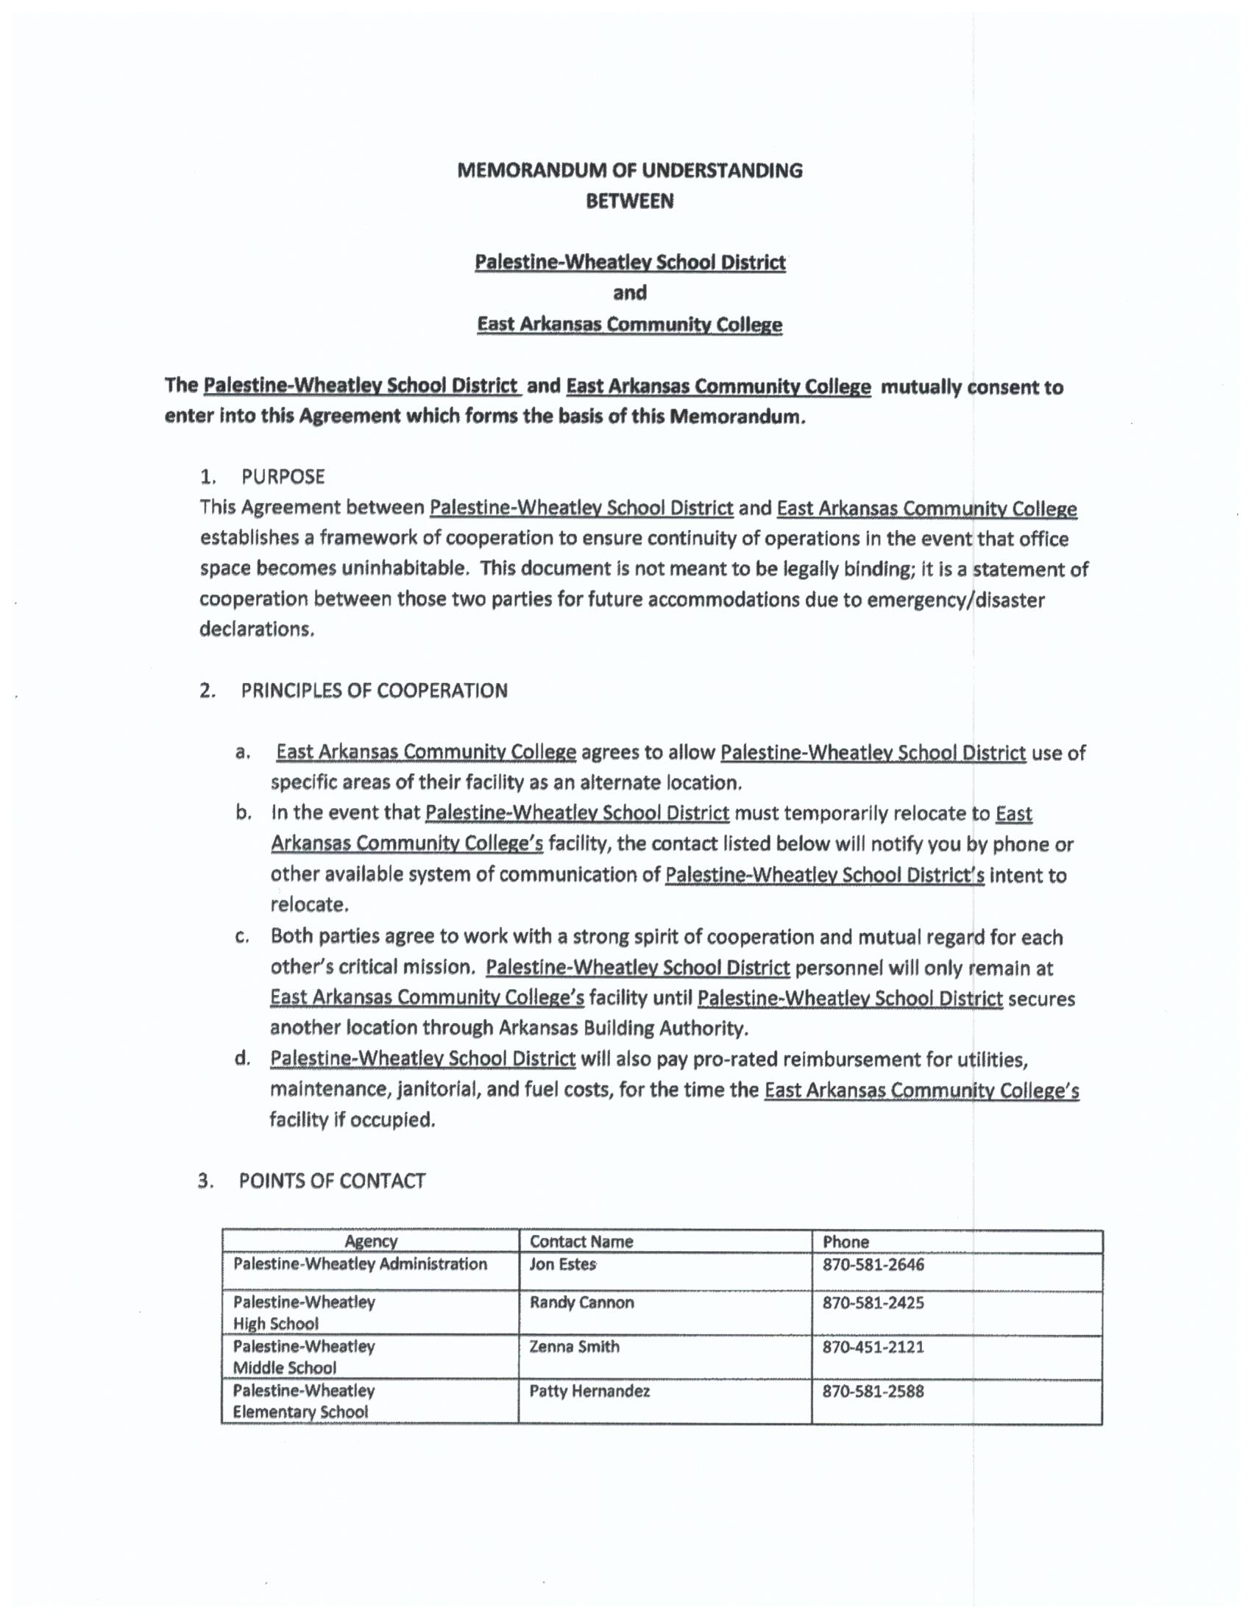
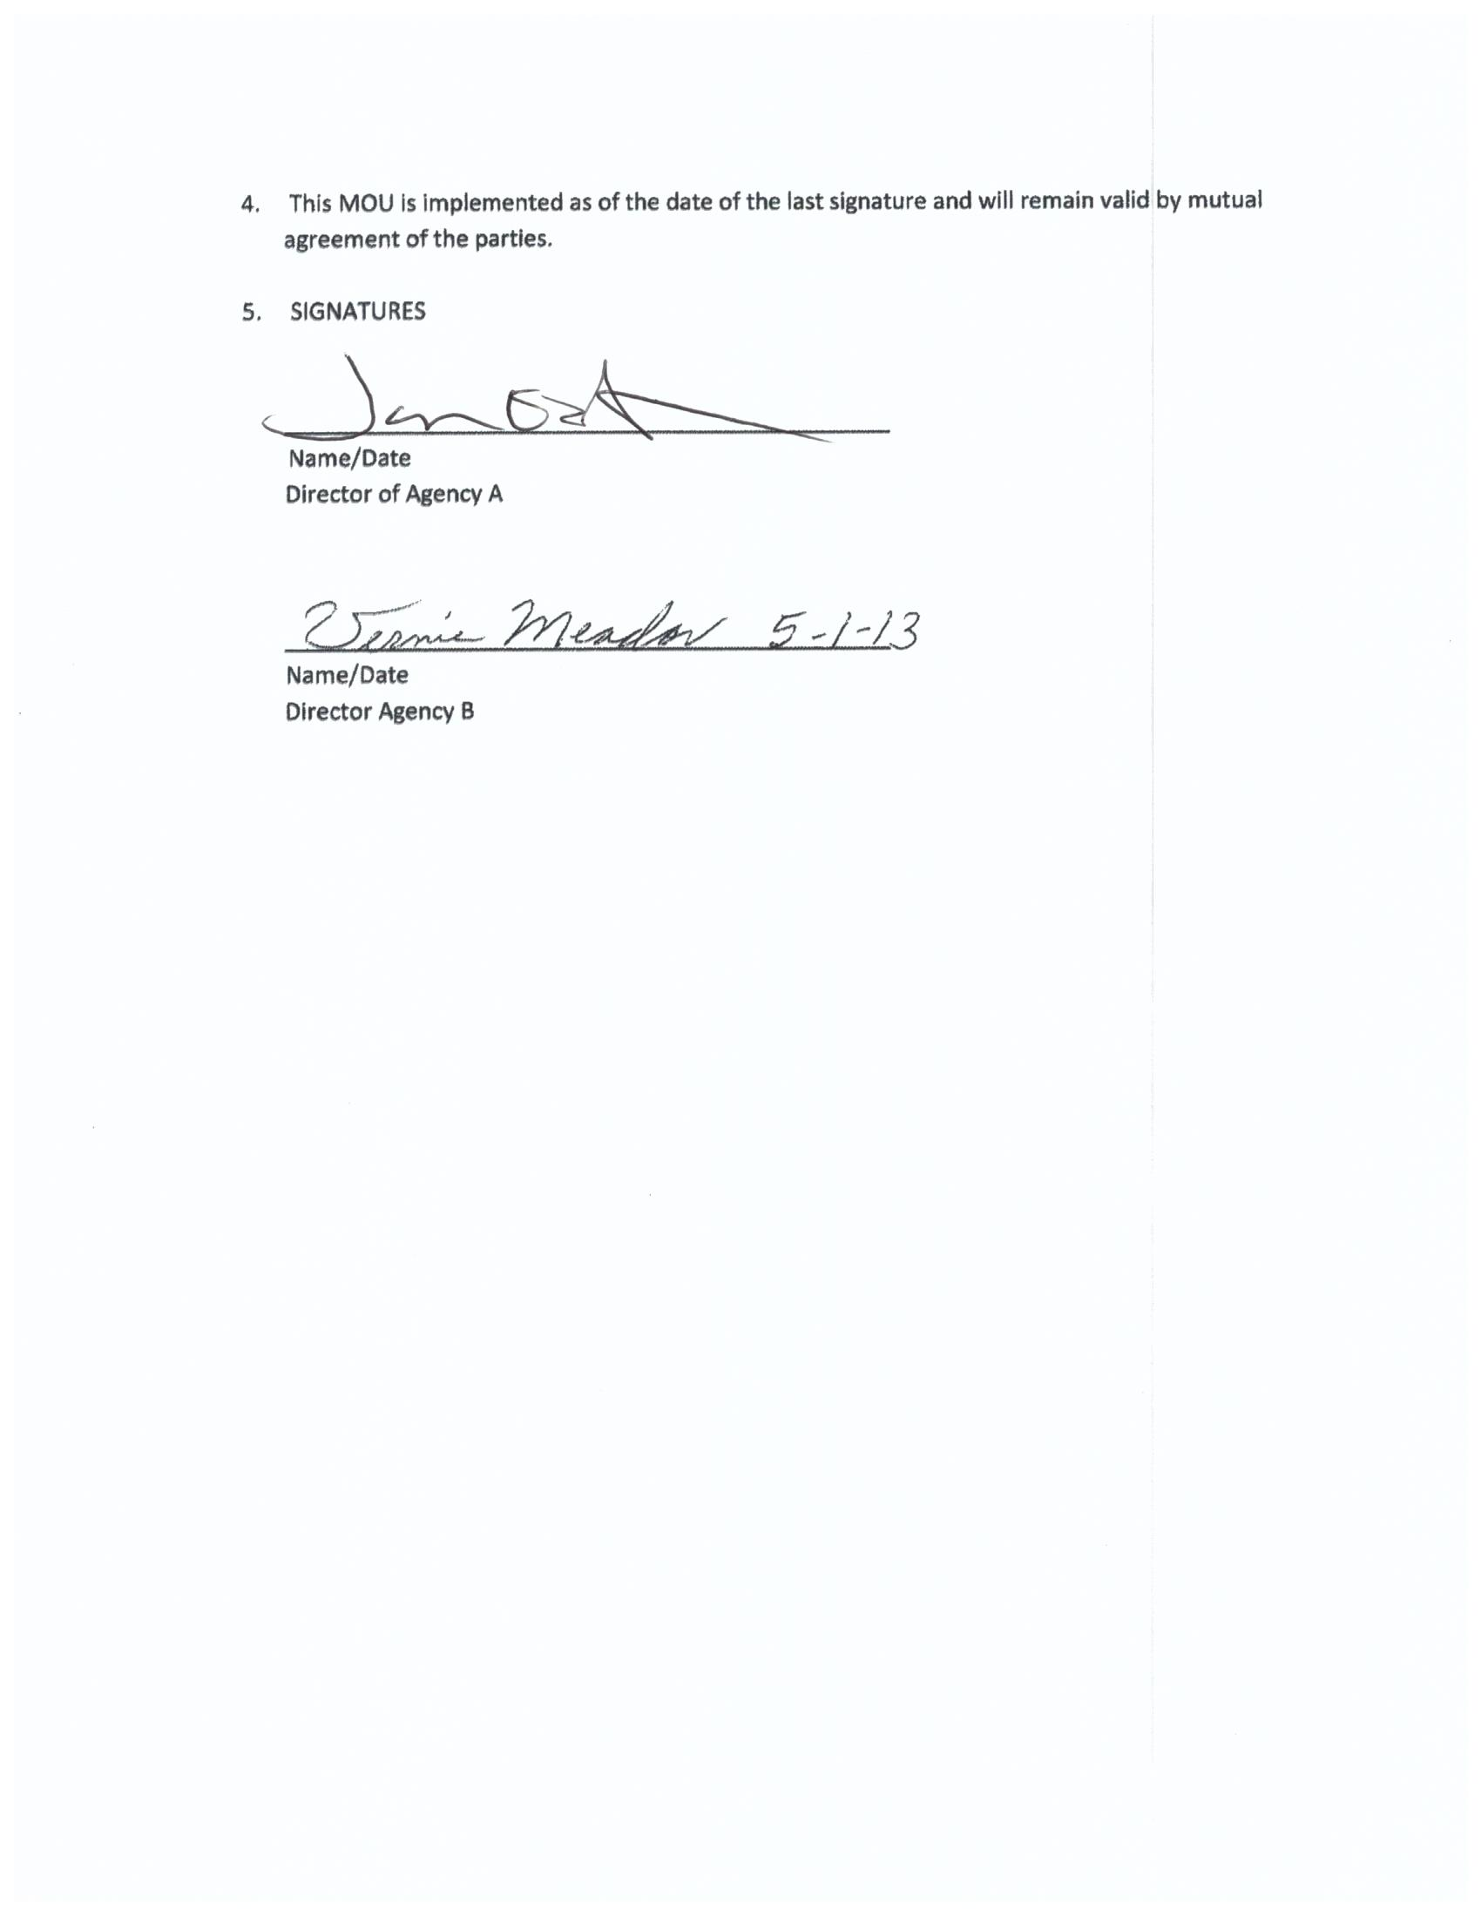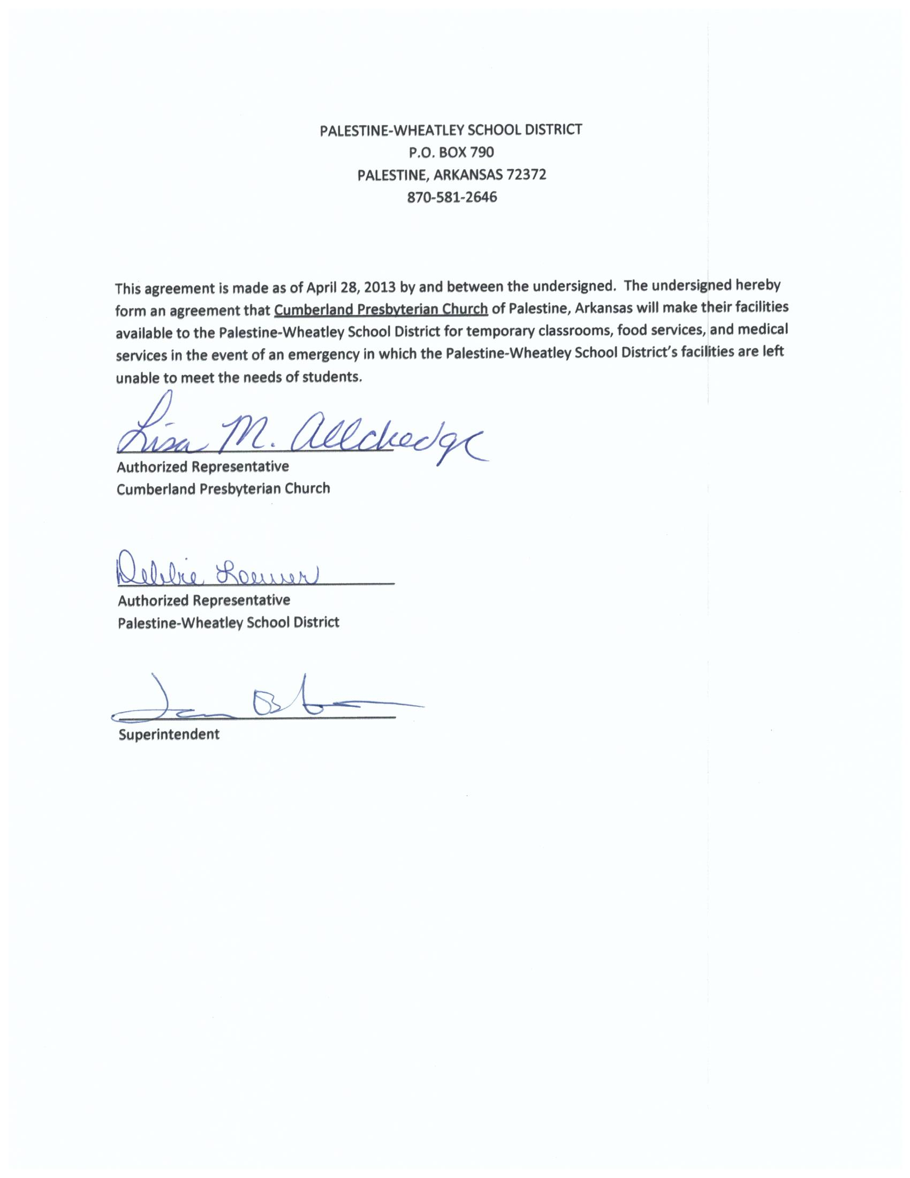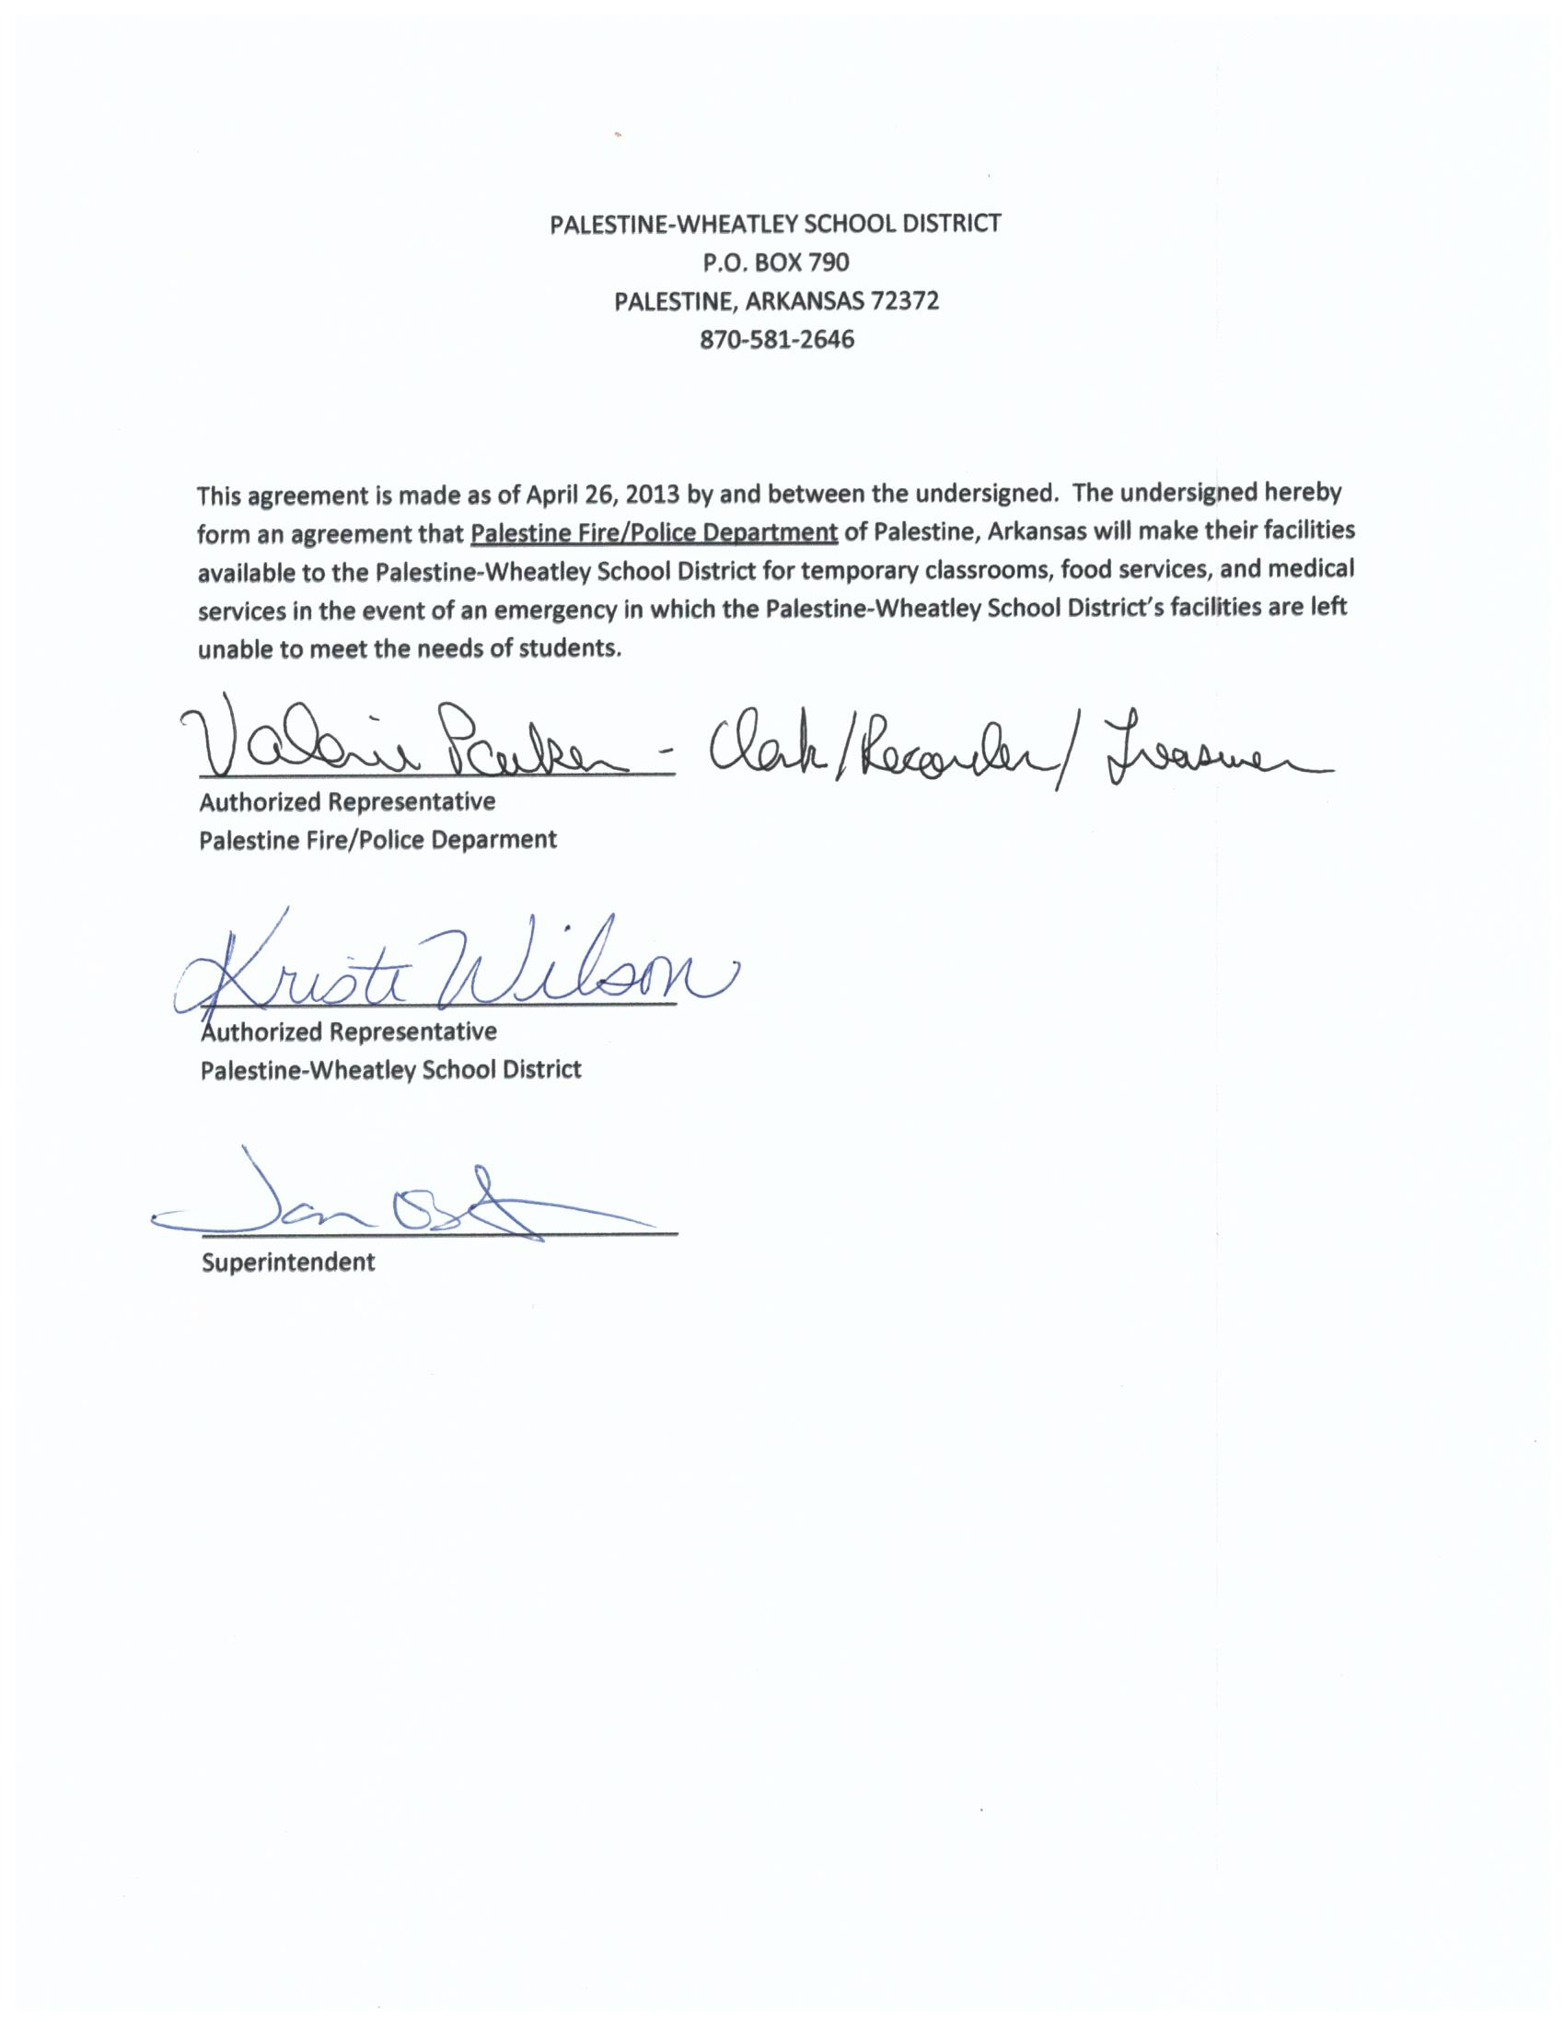
APPENDIX J

ORDER OF SUCCESSION
Order of Succession

Jon Estes, Superintendent
Randy Cannon, High School Principal
Zenna Smith, Middle School Principal
Patty Hernandez, Elementary Principal
Kristi Wilson, Curriculum Coordinator

In the case of total equipment loss, please contact the following company for replacements:
CDWG
50 LaSalle St.
Chicago, IL 60675
800-808-4239

