Information for Cub Scouts,
Boy Scouts and
Girl Scouts

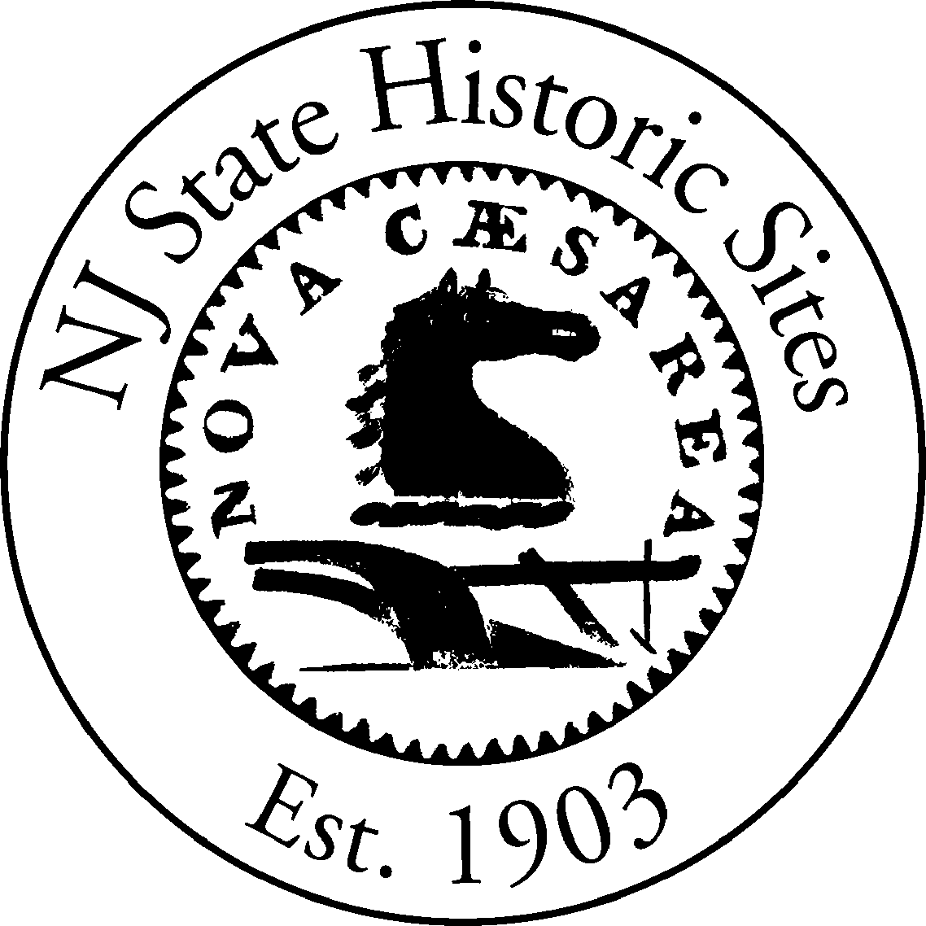

SPIRIT OF THE JERSEYS
STATE HISTORY FAIR

Saturday, May 7, 2011

Allaire Village
Allaire State Park
Farmingdale, New Jersey

www.njhistoryfair.org

Cub Scout, Boy Scout & Girl Scout Programs
Many activities at The Spirit of the Jerseys State History Fair (the Fair) can help fulfill badge requirements for Cub Scouts, Boy Scouts and Brownie and Junior Girl Scouts. This Guide only lists the requirements that can be met at the Fair and does not list all requirements that are needed for a particular Badge, Belt loop, pin, award, etc. It is up to the group leader, parent or guardian to work with the Scout to ensure the requirements are met.

How to Use This Guide

1. Find your scouting program.
Cub Scouts section
Boy Scouts section
Girl Scouts section

2. Locate the requirements for the badge, award, Achievement, Elective or belt loop, etc. Each requirement is listed on the left in the number or number/letter format found in the current scout handbook.

3. The bold-faced letter(s) at the end of the requirement description indicates the location of the exhibit within the Fair (see Fair map). Please note, historical characters can be found throughout Allaire Village and will not be stationed at a fixed location.

Cub Scouts

Cub Scout Outdoor Activity Award

2 Have a picnic at the Fair.

13 Explore Allaire State Park.

Cub Scouting Leave No Trace Awareness Award

2 Practice the frontcountry guidelines of Leave No Trace on this outing.

Academics and Sports Program

Academics Program

Citizenship: Pin

10 The Fair is many events in one. Attend an antique car show with the Mid Jersey Antique Car Club, watch a 1864 baseball game between the Flemington Neshanocks and the Elizabeth Resolutes or observe Revolutionary War, Civil War & World War II reenactors.

Collecting: Belt Loop

3 Many exhibits feature historical collections such as World War II memorabilia and NJ archaeological artifacts.

Heritages: Pin

7 Learn about tracing family records with the Genealogical Society of New Jersey.

Music: Belt Loop

3 Listen to the 19th century sounds of the Hammered Dulcimer or old-time Blue Grass music.

Music: Pin

6 The Fair offers numerous musical performances throughout the day.

Wildlife Conservation: Pin

8 The Spirit of the Jerseys Fair takes place at one of New Jersey’s State Parks, Allaire State Park in Farmingdale.

Sports Program

Marbles: Belt Loop

2 Practice playing marbles in one of our historic game areas.

3 Play a game of marbles in the 19th or 20th century game area.

Marbles: Pin

5 Play a game of marbles in our 19th or 20th century game area.

Tiger Cubs

Achievements

1G Visit Allaire Village where you can see live demonstrations of 19th century domestic arts.

3G Watch a 19th century Baseball Game between the Flemington Neshanocks and the Elizabeth Resolutes. The rules from 1864 will be explained before the game and children will get an opportunity to hit a pitched ball after the game.

5G Take a walk through the historic village or hike one of the park trails. Allaire has three easy hiking trails for pedestrians: The yellow trail at 0.5 miles, the red trail at 1.5 miles and the green trail at 4.5 miles.

Electives

3 Fun and Games: Participate in the Who’s Who in History Scavenger Hunt. Ask for a Scavenger Hunt form which has clues about famous people associated with NJ’s history. Each of these people will be portrayed by actors and will be wandering throughout the Fair. Collect autographs and you can win a prize. (Prizes for children).

22 Picnic Fun: What better place to have a picnic than a beautiful park. Dens and families can bring their own food or purchase food from one of our food vendors.

35 There are many outdoor playing opportunities in our 19th century and 20th century game areas. Come roll a hoop with a stick, play graces with a friend or participate in a sack race.

Wolf Cubs

Achievements

4f Visit Allaire Village where you can see live demonstrations of 19th century domestic arts.

10c Take a walk through the historic village or hike one of the park trails. Allaire has three easy hiking trails for pedestrians: The yellow trail at 0.5 miles, the red trail at 1.5 miles and the green trail at 4.5 miles.

Electives

4c/e Play a Game: Play ring toss and marbles in the games area.

18a/b Outdoor Adventure: What better place to have a picnic than a beautiful park. Dens and families can bring their own food or purchase food from one of our food vendors. Help plan your family or den’s outing with information on the website at www.njhistoryfair.org.

Bear Cubs

Achievements

3b The Fair includes actor portrayals of several famous Americans. You can learn about George Washington, Jonathan Edwards, Ben Franklin, Molly Pitcher and others. Collect “signatures” and you can win a prize.

3c Visit the 19th c. Gardener’s Cottage and Foreman’s Residence. Both will be open for visitation.

3d Visit Allaire Village where you can see live demonstrations of 19th century domestic arts.

8d Learn about Genealogy with the Genealogical Society of New Jersey.

8e Learn how people used to put out the fires in your community. Take part in a bucket brigade with the NJ Fire Engine and Equipment Museum.

10a Spend a day exploring four centuries of NJ’s History at the Spirit of the Jerseys Fair.

12c What better place to have a picnic than a beautiful park? Dens and families can bring their own food or purchase food from one of our food vendors.

12d The Spirit of the Jerseys Fair is many events in one. Attend an antique car show with the Mid Jersey Antique Car Club, watch a 1864 baseball game between the Flemington Neshanocks and the Elizabeth Resolutes, take part in the “Who’s Who in History” scavenger hunt (see 3b above) or observe military reenactment groups from the American Revolution, Civil War or World War II.

12e Help plan your family’s outing with information on the website at www.njhistoryfair.org.

21e View a model of the historic Howell Ironworks. It is on display in the Enameling Building.

Electives

24a Participate in a program on Native American Indians from central New Jersey.

Webelos

Activity Badge

Citizen

11 Learn about Presidents George Washington and Grover Cleveland. You can even learn Mr. Cleveland’s connection to the Baby Ruth candy bar.

Communicator

4 Try your hand at Morse Code with Historic Speedwell’s hands-on exhibit.

Boy Scouts

The Spirit of the Jerseys State History Fair offers several opportunities for Boy Scouts to meet requirements for Merit Badges. It is up to the Scout to work with his Scout Master and Counselor to ensure the requirements are met.

American Business

1b. Learn about people who played a part in the Industrial Revolution: Alfred Vail (Historic Speedwell) and Thomas Edison (Edison Memorial Tower and Edison National Historical Park).

American Cultures

1e. Participate in a program on Native American Indians from central New Jersey.

American Heritage

2a. The Fair includes actor portrayals of several famous Americans. You can learn about George Washington, Jonathan Edwards, Ben Franklin, Molly Pitcher and others. Additional exhibits highlight President Grover Cleveland, Thomas Edison and others.

3c. Learn about Genealogy with the Genealogical Society of New Jersey.

4b. Historical societies and museums from throughout the state will be represented at the Fair. You should be able to find a group that deals with your local history.

4e. Take a walk through the historic village or hike one of the park trails. Allaire has three easy hiking trails for pedestrians: The yellow trail at 0.5 miles, the red trail at 1.5 miles and the green trail at 4.5 miles. There is also the moderate 16.5 mile multi-use orange trail.

5c. Listen to the 19th century sounds of the Hammered Dulcimer or old-time Blue Grass music.

American Labor

1. Learn about the labor movement and workers concerns at the American LaborMuseum/Botto House exhibit

Citizenship in the Community

6. State Historic Sites and State Parks are services provided by the community and funded by taxpayers. Allaire State Park is the setting for the Spirit of the Jerseys State History Fair.

Citizenship in the Nation

2a Allaire Village is listed on the National Register of Historic Places and the New Jersey Register of Historic Places.

Genealogy

5a. Learn about Genealogy with the Genealogical Society of NJ

5c. Meet descendents of Dr. James Still –the Black Doctor of the Pines – and the Still Family Society.

5e. Visit the New Jersey State Archives exhibit and learn about their archival records collection.

8a. See the Genealogical Society of NJ & the NJ State Archives use computers and the internet in genealogical research.

Indian Lore

1. Participate in a program on Native American Indians from central New Jersey.

Journalism

4. Use the Fair as a basis for your news story, radio presentation or photographic record. Publicity materials and Calendar listing information is available on our website www.njhistoryfair.org on the Publicity Materials button on the menu.

Music

3a. Listen to the 19th century sounds of the Hammered Dulcimer or old-time Blue Grass music.

Railroading

8b. Visit the Friends of the New Jersey Transportation Heritage Center exhibit to learn about NJ’s railroads. Take a ride on the Pine Creek Railroad (additional fee).

Girl Scouts

The Spirit of the Jerseys State History Fair offers an opportunity for Girl Scouts to earn a special patch for Allaire Village. It is up to the Scout to work with her parent, leader or group chaperone to ensure the requirements are met.

Information on patch requirements and application forms will be available at the fair. Allaire Village, Inc. requests a $2.50 fee for the patch and shipping.

Family Living Skills (Juniors)

5 Speak with guides at the Allaire Mansion and learn how chores have changed

United We Stand (Juniors)

8 Visit Allaire: Allaire Village is listed on the National Register of Historic Places and the New Jersey Register of Historic Places

9 Play games or help with chores from the 19th century

American Patriot Interest Award (Cadettes)

Skill Builders
2 Visit Allaire: Allaire Village is listed on the National Register of Historic Places and the New Jersey Register of Historic Places

3 Participate in a program on Native American Indians from central New Jersey.

Career Exploration
1 Learn about jobs that were available in the 1700s an 1800. Visit the Village Baker or meet with Rev. Tanser.

3 Government employers are well represented at the Fair: see genealogists from the State Archive, meet with a variety of people who work in the states historic sites and parks.

Wave the Flag Try-its (Brownies)

5 Participate in a program on Native American Indians from central New Jersey and learn about who lived here in the past.

Computer Smarts Try-its (Brownies)

6 See the Genealogical Society of NJ & the NJ State Archives use computers and the internet in genealogical research.

