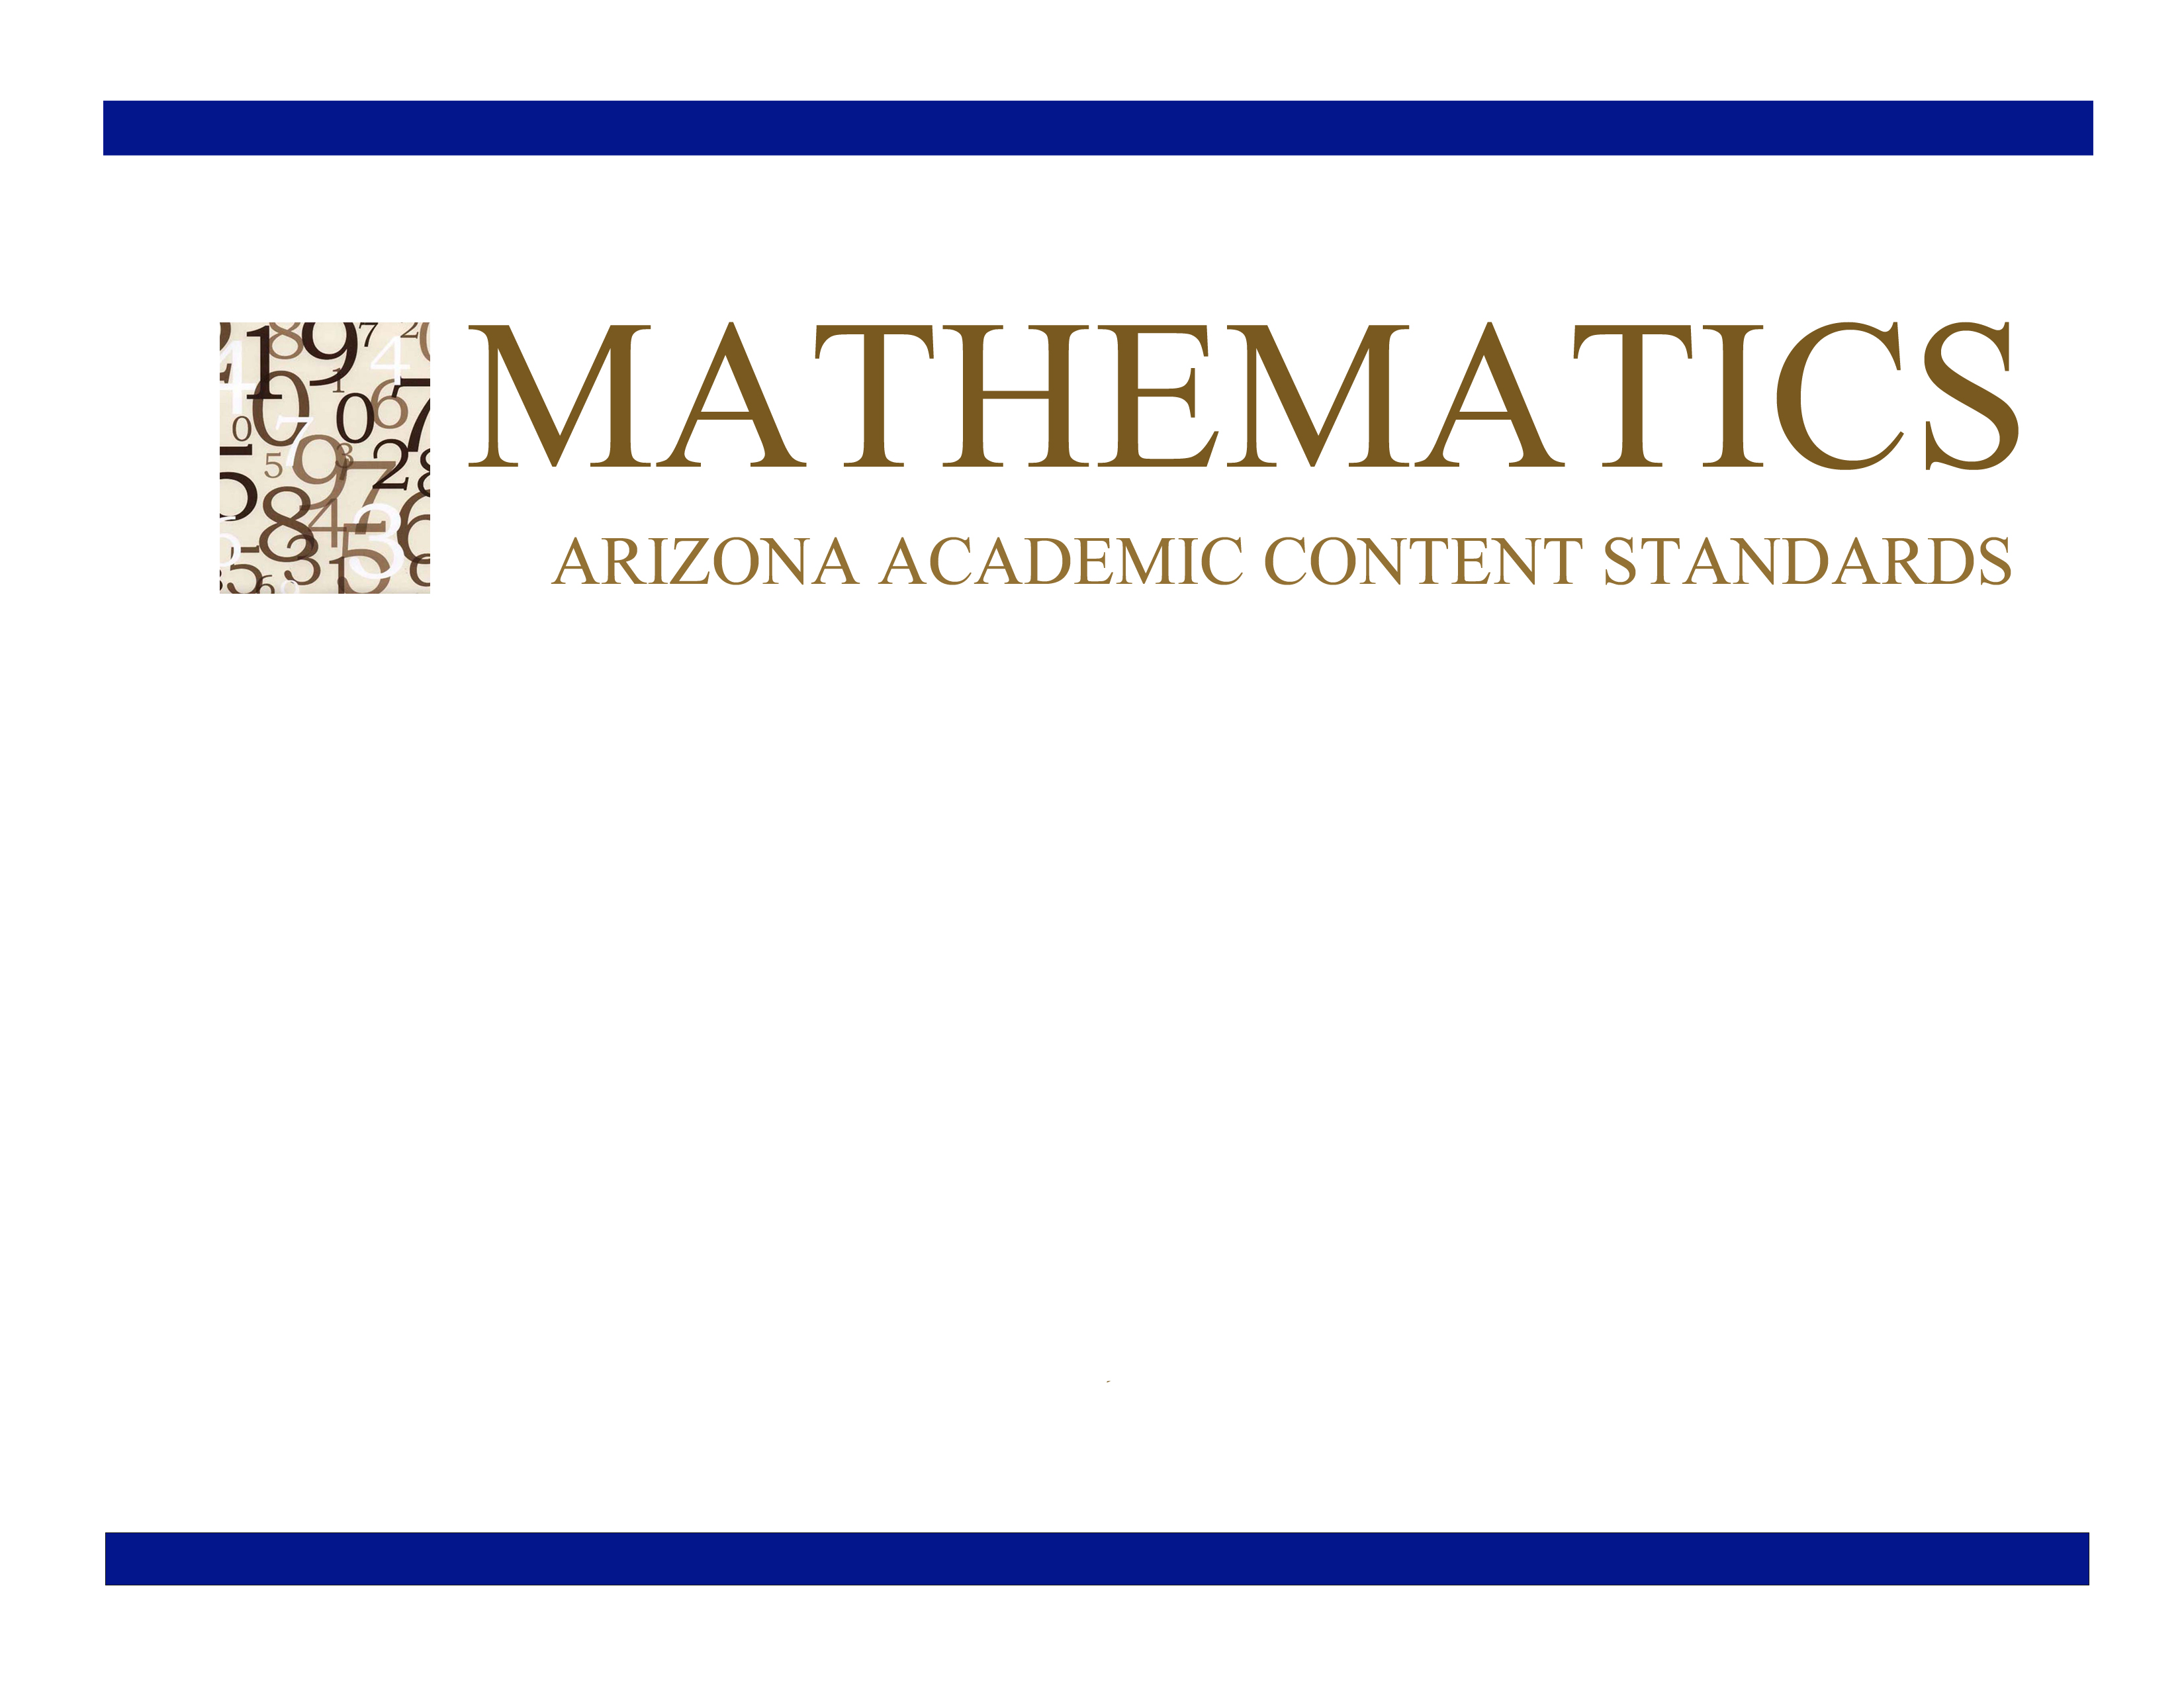
Grade 7

Approved by the Arizona State Board of Education
June 28, 2010

h

Grade 7

Grade 7 Overview

Ratios and Proportional Relationships (RP)  - Analyze proportional relationships and use them to solve real-world and mathematical problems.  The Number System (NS)  - Apply and extend previous understandings of operations with fractions to add, subtract, multiply, and divide rational numbers.  Expressions and Equations (EE)  - Use properties of operations to generate equivalent expressions.  - Solve real-life and mathematical problems using numerical and algebraic expressions and equations.  Geometry (G)  - Draw, construct and describe geometrical figures and describe the relationships between them.  - Solve real-life and mathematical problems involving angle measure, area, surface area, and volume.  Statistics and Probability (SP)  - Use random sampling to draw inferences about a population.  - Draw informal comparative inferences about two populations.  - Investigate chance processes and develop, use, and evaluate probability models. | Mathematical Practices (MP)  - Make sense of problems and persevere in solving them.  - Reason abstractly and quantitatively.  - Construct viable arguments and critique the reasoning of others.  - Model with mathematics.  - Use appropriate tools strategically.  - Attend to precision.  - Look for and make use of structure.  - Look for and express regularity in repeated reasoning.

In Grade 7, instructional time should focus on four critical areas: (1) developing understanding of and applying proportional relationships; (2) developing understanding of operations with rational numbers and working with expressions and linear equations; (3) solving problems involving scale drawings and informal geometric constructions, and working with two- and three-dimensional shapes to solve problems involving area, surface area, and volume; and (4) drawing inferences about populations based on samples.

(1) Students extend their understanding of ratios and develop understanding of proportionality to solve single- and multi-step problems. Students use their understanding of ratios and proportionality to solve a wide variety of percent problems, including those involving discounts, interest, taxes, tips, and percent increase or decrease. Students solve problems about scale drawings by relating corresponding lengths between the objects or by using the fact that relationships of lengths within an object are preserved in similar objects. Students graph proportional relationships and understand the unit rate informally as a measure of the steepness of the related line, called the slope. They distinguish proportional relationships from other relationships.

(2) Students develop a unified understanding of number, recognizing fractions, decimals (that have a finite or a repeating decimal representation), and percents as different representations of rational numbers. Students extend addition, subtraction, multiplication, and division to all rational numbers, maintaining the properties of operations and the relationships between addition and subtraction, and multiplication and division. By applying these properties, and by viewing negative numbers in terms of everyday contexts (e.g., amounts owed or temperatures below zero), students explain and interpret the rules for adding, subtracting, multiplying, and dividing with negative numbers. They use the arithmetic of rational numbers as they formulate expressions and equations in one variable and use these equations to solve problems.

(3) Students continue their work with area from Grade 6, solving problems involving the area and circumference of a circle and surface area of three-dimensional objects. In preparation for work on congruence and similarity in Grade 8 they reason about relationships among two-dimensional figures using scale drawings and informal geometric constructions, and they gain familiarity with the relationships between angles formed by intersecting lines. Students work with three-dimensional figures, relating them to two-dimensional figures by examining cross-sections. They solve real-world and mathematical problems involving area, surface area, and volume of two- and three-dimensional objects composed of triangles, quadrilaterals, polygons, cubes and right prisms.

(4) Students build on their previous work with single data distributions to compare two data distributions and address questions about differences between populations. They begin informal work with random sampling to generate data sets and learn about the importance of representative samples for drawing inferences.

Ratios of Proportional Relationships (RP)
Analyze proportional relationships and use them to solve real-world and mathematical problems.
Standards | Mathematical Practices | Explanations and Examples
Students are expected to:
7.RP.1. Compute unit rates associated with ratios of fractions, including ratios of lengths, areas and other quantities measured in like or different units. For example, if a person walks ½ mile in each ¼ hour, compute the unit rate as the complex fraction ½/¼ miles per hour, equivalently 2 miles per hour.  Connections: 6-8.RST.7; SC07-S1C2-04;  ET07-S1C1-01 | 7.MP.2. Reason abstractly and quantitatively.  7.MP.6. Attend to precision.
7.RP.2. Recognize and represent proportional relationships between quantities.  - Decide whether two quantities are in a proportional relationship, e.g., by testing for equivalent ratios in a table or graphing on a coordinate plane and observing whether the graph is a straight line through the origin.  - Identify the constant of proportionality (unit rate) in tables, graphs, equations, diagrams, and verbal descriptions of proportional relationships.  - Represent proportional relationships by equations. For example, if total cost t is proportional to the number n of items purchased at a constant price p, the relationship between the total cost and the number of items can be expressed as t = pn.  - Explain what a point (x, y) on the graph of a proportional relationship means in terms of the situation, with special attention to the points (0, 0) and (1, r) where r is the unit rate.  Connections: 6-8.WHST.2c-f; 6-8.WHST.1c;  6-8.RST.7; 6-8.RST.4; ET07-S6C2-03;  ET07-S1C1-01; SC07-S1C4-01;  SC07-S2C2-03 | 7.MP.1. Make sense of problems and persevere in solving them.  7.MP.2. Reason abstractly and quantitatively.  7.MP.3. Construct viable arguments and critique the reasoning of others.  7.MP.4. Model with mathematics.  7.MP.5. Use appropriate tools strategically.  7.MP.6. Attend to precision.  7.MP.7. Look for and make use of structure.  7.MP.8. Look for and express regularity in repeated reasoning. | Students may use a content web site and/or interactive white board to create tables and graphs of proportional or non-proportional relationships. Graphing proportional relationships represented in a table helps students recognize that the graph is a line through the origin (0,0) with a constant of proportionality equal to the slope of the line.  Examples:  - A student is making trail mix. Create a graph to determine if the quantities of nuts and fruit are proportional for each serving size listed in the table. If the quantities are proportional, what is the constant of proportionality or unit rate that defines the relationship? Explain how you determined the constant of proportionality and how it relates to both the table and graph.  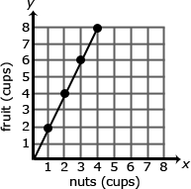  The relationship is proportional. For each of the other serving sizes there are 2 cups of fruit for every 1 cup of nuts (2:1).  Continued on next page  The constant of proportionality is shown in the first column of the table and by the slope of the line on the graph.  - The graph below represents the cost of gum packs as a unit rate of $2 dollars for every pack of gum. The unit rate is represented as $2/pack. Represent the relationship using a table and an equation.  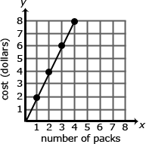  Table:  Equation: 2g = d, where d is the cost in dollars and g is the packs of gum  A common error is to reverse the position of the variables when writing equations. Students may find it useful to use variables specifically related to the quantities rather than using x and y. Constructing verbal models can also be helpful. A student might describe the situation as “the number of packs of gum times the cost for each pack is the total cost in dollars”. They can use this verbal model to construct the equation. Students can check their equation by substituting values and comparing their results to the table. The checking process helps student revise and recheck their model as necessary. The number of packs of gum times the cost for each pack is the total cost  (g x 2 = d).
  Serving Size | 1 | 2 | 3 | 4
  Cups of Nuts (x) | 1 | 2 | 3 | 4
  Cups of Fruit (y) | 2 | 4 | 6 | 8
  Number of Packs of Gum (g) | Cost in Dollars (d)
  0 | 0
  1 | 2
  2 | 4
  3 | 6
  4 | 8
7.RP.3. Use proportional relationships to solve multistep ratio and percent problems. Examples: simple interest, tax, markups and markdowns, gratuities and commissions, fees, percent increase and decrease, percent error.  Connections: 6-8.RST.3; SS07-S5C3-01; SC07-S4C3-04; SC07-S4C3-05 | 7.MP.1. Make sense of problems and persevere in solving them.  7.MP.2. Reason abstractly and quantitatively.  7.MP.3. Construct viable arguments and critique the reasoning of others.  7.MP.4. Model with mathematics.  7.MP.5. Use appropriate tools strategically.  7.MP.6. Attend to precision.  7.MP.7. Look for and make use of structure.  7.MP.8. Look for and express regularity in repeated reasoning. | Students should be able to explain or show their work using a representation (numbers, words, pictures, physical objects, or equations) and verify that their answer is reasonable. Models help students to identify the parts of the problem and how the values are related. For percent increase and decrease, students identify the starting value, determine the difference, and compare the difference in the two values to the starting value.  Examples:  - Gas prices are projected to increase 124% by April 2015. A gallon of gas currently costs $4.17. What is the projected cost of a gallon of gas for April 2015?  A student might say: “The original cost of a gallon of gas is $4.17. An increase of 100% means that the cost will double. I will also need to add another 24% to figure out the final projected cost of a gallon of gas. Since 25% of $4.17 is about $1.04, the projected cost of a gallon of gas should be around $9.40.”  $4.17 + 4.17 + (0.24 • 4.17) = 2.24 x 4.17  100%  $4.17  100%  $4.17  24%  ?  - A sweater is marked down 33%. Its original price was $37.50. What is the price of the sweater before sales tax?  37.50  Original Price of Sweater  33% of 37.50  Discount  67% of 37.50  Sale price of sweater  The discount is 33% times 37.50. The sale price of the sweater is the original price minus the discount or 67% of the original price of the sweater, or Sale Price = 0.67 x Original Price.  Continued on next page  - A shirt is on sale for 40% off. The sale price is $12. What was the original price? What was the amount of the discount?  Discount  40% of original price  Sale Price - $12  60% of original price  Original Price (p)  0.60p = 12  - At a certain store, 48 television sets were sold in April. The manager at the store wants to encourage the sales team to sell more TVs and is going to give all the sales team members a bonus if the number of TVs sold increases by 30% in May. How many TVs must the sales team sell in May to receive the bonus? Justify your solution.  - A salesperson set a goal to earn $2,000 in May. He receives a base salary of $500 as well as a 10% commission for all sales. How much merchandise will he have to sell to meet his goal?  After eating at a restaurant, your bill before tax is $52.60 The sales tax rate is 8%. You decide to leave a 20% tip for the waiter based on the pre-tax amount. How much is the tip you leave for the waiter? How much will the total bill be, including tax and tip? Express your solution as a multiple of the bill.  The amount paid = 0.20 x $52.50 + 0.08 x $52.50 = 0.28 x $52.50

The Number System (NS)
Apply and extend previous understandings of operations with fractions to add, subtract, multiply, and divide rational numbers.
Standards | Mathematical Practices | Explanations and Examples
Students are expected to:
7.NS.1. Apply and extend previous understandings of addition and subtraction to add and subtract rational numbers; represent addition and subtraction on a horizontal or vertical number line diagram.  - Describe situations in which opposite quantities combine to make 0. For example, a hydrogen atom has 0 charge because its two constituents are oppositely charged.  - Understand p + q as the number located a distance |q| from p, in the positive or negative direction depending on whether q is positive or negative. Show that a number and its opposite have a sum of 0 (are additive inverses). Interpret sums of rational numbers by describing real-world contexts.  - Understand subtraction of rational numbers as adding the additive inverse, p – q = p + (–q). Show that the distance between two rational numbers on the number line is the absolute value of their difference, and apply this principle in real-world contexts.  - Apply properties of operations as strategies to add and subtract rational numbers.  Connections: 6-8.WHST.2f; 6-8.WHST.2b;  6-8.RST.3; 6-8.RST.7; ET07-S1C1-01;  SS07-S4C5-04 | 7.MP.2. Reason abstractly and quantitatively.  7.MP.4. Model with mathematics.  7.MP.7. Look for and make use of structure. | Visual representations may be helpful as students begin this work; they become less necessary as students become more fluent with the operations.  Examples:  - Use a number line to illustrate:  - p - q  - p + (- q)  - Is this equation true p – q = p + (-q)  - -3 and 3 are shown to be opposites on the number line because they are equal distance from zero and therefore have the same absolute value and the sum of the number and it’s opposite is zero.  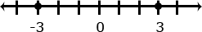  - You have $4 and you need to pay a friend $3. What will you have after paying your friend?  4 + (-3) = 1 or (-3) + 4 = 1  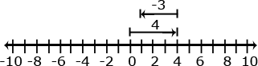
7.NS.2. Apply and extend previous understandings of multiplication and division and of fractions to multiply and divide rational numbers.  - Understand that multiplication is extended from fractions to rational numbers by requiring that operations continue to satisfy the properties of operations, particularly the distributive property, leading to products such as (–1)(–1) = 1 and the rules for multiplying signed numbers. Interpret products of rational numbers by describing real-world contexts.  - Understand that integers can be divided, provided that the divisor is not zero, and every quotient of integers (with non-zero divisor) is a rational number. If p and q are integers, then –(p/q) = (–p)/q = p/(–q). Interpret quotients of rational numbers by describing real-world contexts.  - Apply properties of operations as strategies to multiply and divide rational numbers.  - Convert a rational number to a decimal using long division; know that the decimal form of a rational number terminates in 0s or eventually repeats.  Connections: 6-8.RST.4; 6-8.RST.5;  SC07-S1C3-01; SS07-S5C3-04 | 7.MP.2. Reason abstractly and quantitatively.  7.MP.4. Model with mathematics.  7.MP.7. Look for and make use of structure. | Multiplication and division of integers is an extension of multiplication and division of whole numbers.  Examples:  - Examine the family of equations. What patterns do you see? Create a model and context for each of the products.
  Equation | Number Line Model | Context
  2 x 3 = 6 | 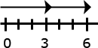 | Selling two posters at $3.00 per poster
  2 x -3 = -6 | 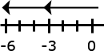 | Spending 3 dollars each on 2 posters
  -2 x 3 = -6 | 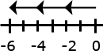 | Owing 2 dollars to each of your three friends
  -2 x -3 = 6 | 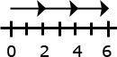 | Forgiving 3 debts of $2.00 each
7.NS.3. Solve real-world and mathematical problems involving the four operations with rational numbers. (Computations with rational numbers extend the rules for manipulating fractions to complex fractions.)  Connection: 6-8.RST.3 | 7.MP.1. Make sense of problems and persevere in solving them.  7.MP.2. Reason abstractly and quantitatively.  7.MP.5. Use appropriate tools strategically.  7.MP.6. Attend to precision.  7.MP.7. Look for and make use of structure.  7.MP.8. Look for and express regularity in repeated reasoning. | Examples:  - Your cell phone bill is automatically deducting $32 from your bank account every month. How much will the deductions total for the year?  -32 + -32 + -32 + -32 + -32 + -32 + -32 + -32 + -32 + -32 + -32 + -32 = 12 (-32)  - It took a submarine 20 seconds to drop to 100 feet below sea level from the surface. What was the rate of the descent?  $$\frac{−\text{100}\text{ feet}}{\text{20}\text{ seconds}}=\frac{−5\text{ feet}}{1\text{ second}}=\text{-5 ft/sec}$$

Expressions and Equations (EE)
Use properties of operations to generate equivalent expressions.
Standards | Mathematical Practices | Explanations and Examples
Students are expected to:
7.EE.1. Apply properties of operations as strategies to add, subtract, factor, and expand linear expressions with rational coefficients.  Connection: 6-8.RST.5 | 7.MP.2. Reason abstractly and quantitatively.  7.MP.6. Attend to precision.  7.MP.7. Look for and make use of structure. | Examples:  - Write an equivalent expression for $3\left(x+5\right)−2$.  - Suzanne thinks the two expressions $2\left(3a−2\right)+4a$and $\text{10}a−2$are equivalent? Is she correct? Explain why or why not?  - Write equivalent expressions for: $3a+\text{12}$.  Possible solutions might include factoring as in$3(a+4)$, or other expressions such as $a+2a+7+5$.  - A rectangle is twice as long as wide. One way to write an expression to find the perimeter would be $w+w+2w+2w$. Write the expression in two other ways.  Solution: $6w$ OR $2(w)+2(2w)$.  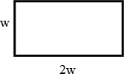  - An equilateral triangle has a perimeter of$6x+\text{15}$. What is the length of each of the sides of the triangle?  Solution:$3(2x+5)$, therefore each side is $2x+5$units long.
7.EE.2. Understand that rewriting an expression in different forms in a problem context can shed light on the problem and how the quantities in it are related. For example, a + 0.05a = 1.05a means that “increase by 5%” is the same as “multiply by 1.05.”  Connections: 6-8.WHST.1b,c; 6-8.WHST.2b-c; 6-8.RST.3; 6-8.RST.7; SS07-S5C2-09;  SC07-S2C2-03 | 7.MP.2. Reason abstractly and quantitatively.  7.MP.6. Attend to precision.  7.MP.7. Look for and make use of structure.  7.MP.8. Look for and express regularity in repeated reasoning. | Examples:  - Jamie and Ted both get paid an equal hourly wage of $9 per hour. This week, Ted made an additional $27 dollars in overtime. Write an expression that represents the weekly wages of both if J = the number of hours that Jamie worked this week and T = the number of hours Ted worked this week? Can you write the expression in another way?  Students may create several different expressions depending upon how they group the quantities in the problem.  One student might say: To find the total wage, I would first multiply the number of hours Jamie worked by 9. Then I would multiply the number of hours Ted worked by 9. I would add these two values with the $27 overtime to find the total wages for the week. The student would write the expression$9J+9T+\text{27}$.  Another student might say: To find the total wages, I would add the number of hours that Ted and Jamie worked. I would multiply the total number of hours worked by 9. I would then add the overtime to that value to get the total wages for the week. The student would write the expression $9(J+T)+\text{27}$  A third student might say: To find the total wages, I would need to figure out how much Jamie made and add that to how much Ted made for the week. To figure out Jamie’s wages, I would multiply the number of hours she worked by 9. To figure out Ted’s wages, I would multiply the number of hours he worked by 9 and then add the $27 he earned in overtime. My final step would be to add Jamie and Ted wages for the week to find their combined total wages. The student would write the expression $(9J)+(9T+\text{27})$  Continued on next page  - Given a square pool as shown in the picture, write four different expressions to find the total number of tiles in the border. Explain how each of the expressions relates to the diagram and demonstrate that the expressions are equivalent. Which expression do you think is most useful? Explain your thinking.  

Expressions and Equations (EE)
Solve real-life and mathematical problems using numerical and algebraic expressions and equations.
Standards | Mathematical Practices | Explanations and Examples
Students are expected to:
7.EE.3. Solve multi-step real-life and mathematical problems posed with positive and negative rational numbers in any form (whole numbers, fractions, and decimals), using tools strategically. Apply properties of operations to calculate with numbers in any form; convert between forms as appropriate; and assess the reasonableness of answers using mental computation and estimation strategies. For example: If a woman making $25 an hour gets a 10% raise, she will make an additional 1/10 of her salary an hour, or $2.50, for a new salary of $27.50. If you want to place a towel bar 9 3/4 inches long in the center of a door that is 27 1/2 inches wide, you will need to place the bar about 9 inches from each edge; this estimate can be used as a check on the exact computation.  Connections: 6-8.WHST.1b,c; 6-8.WHST2b;  6-8.RST.7; ET07-S6C2-03 | 7.MP.1. Make sense of problems and persevere in solving them.  7.MP.2. Reason abstractly and quantitatively.  7.MP.3. Construct viable arguments and critique the reasoning of others.  7.MP.4. Model with mathematics.  7.MP.5. Use appropriate tools strategically.  7.MP.6. Attend to precision.  7.MP.7. Look for and make use of structure.  7.MP.8. Look for and express regularity in repeated reasoning. | Estimation strategies for calculations with fractions and decimals extend from students’ work with whole number operations. Estimation strategies include, but are not limited to:  - front-end estimation with adjusting (using the highest place value and estimating from the front end making adjustments to the estimate by taking into account the remaining amounts),  - clustering around an average (when the values are close together an average value is selected and multiplied by the number of values to determine an estimate),  - rounding and adjusting (students round down or round up and then adjust their estimate depending on how much the rounding affected the original values),  - using friendly or compatible numbers such as factors (students seek to fit numbers together - i.e., rounding to factors and grouping numbers together that have round sums like 100 or 1000), and  - using benchmark numbers that are easy to compute (students select close whole numbers for fractions or decimals to determine an estimate).  Example:  - The youth group is going on a trip to the state fair. The trip costs $52. Included in that price is $11 for a concert ticket and the cost of 2 passes, one for the rides and one for the game booths. Each of the passes cost the same price. Write an equation representing the cost of the trip and determine the price of one pass.  x  x  11  52  2x + 11 = 52  2x = 41  x = $20.5
7.EE.4. Use variables to represent quantities in a real-world or mathematical problem, and construct simple equations and inequalities to solve problems by reasoning about the quantities.  - Solve word problems leading to equations of the form px+q=r and p(x+q)=r, where p, q, and r are specific rational numbers. Solve equations of these forms fluently. Compare an algebraic solution to an arithmetic solution, identifying the sequence of the operations used in each approach. For example, the perimeter of a rectangle is 54 cm. Its length is 6 cm. What is its width?  - Solve word problems leading to inequalities of the form px+q>r or px+q < r, where p, q, and r are specific rational numbers. Graph the solution set of the inequality and interpret it in the context of the problem. For example: As a salesperson, you are paid $50 per week plus $3 per sale. This week you want your pay to be at least $100. Write an inequality for the number of sales you need to make, and describe the solutions.  Connections: 6-8.SRT.3; 6-8.RST.4 | 7.MP.1. Make sense of problems and persevere in solving them.  7.MP.2. Reason abstractly and quantitatively.  7.MP.3. Construct viable arguments and critique the reasoning of others.  7.MP.4. Model with mathematics.  7.MP.5. Use appropriate tools strategically.  7.MP.6. Attend to precision.  7.MP.7. Look for and make use of structure.  7.MP.8. Look for and express regularity in repeated reasoning. | Examples:  - Amie had $26 dollars to spend on school supplies. After buying 10 pens, she had $14.30 left. How much did each pen cost?  - The sum of three consecutive even numbers is 48. What is the smallest of these numbers?  - Solve: $\frac{5}{4}n+5=\text{20}$  - Florencia has at most $60 to spend on clothes. She wants to buy a pair of jeans for $22 dollars and spend the rest on t-shirts. Each t-shirt costs $8. Write an inequality for the number of t-shirts she can purchase.  - Steven has $25 dollars. He spent $10.81, including tax, to buy a new DVD. He needs to set aside $10.00 to pay for his lunch next week. If peanuts cost $0.38 per package including tax, what is the maximum number of packages that Steven can buy?  Write an equation or inequality to model the situation. Explain how you determined whether to write an equation or inequality and the properties of the real number system that you used to find a solution.  - Solve$\frac{1}{2}x+3>2$and graph your solution on a number line.

Geometry (G)
Draw, construct, and describe geometrical figures and describe the relationships between them.
Standards | Mathematical Practices | Explanations and Examples
Students are expected to:
7.G.1. Solve problems involving scale drawings of geometric figures, such as computing actual lengths and areas from a scale drawing and reproducing a scale drawing at a different scale.  Connections: 6-8.RST.7; SC07-S1C2-04; SS07-S4C6-03; SS07-S4C1-01; SS07-S4C1-02; ET07-S1C1-01 | 7.MP.1. Make sense of problems and persevere in solving them.  7.MP.2. Reason abstractly and quantitatively.  7.MP.3. Construct viable arguments and critique the reasoning of others.  7.MP.4. Model with mathematics.  7.MP.5. Use appropriate tools strategically.  7.MP.6. Attend to precision.  7.MP.7. Look for and make use of structure.  7.MP.8. Look for and express regularity in repeated reasoning. | Example:  - Julie showed you the scale drawing of her room. If each 2 cm on the scale drawing equals 5 ft, what are the actual dimensions of Julie’s room? Reproduce the drawing at 3 times its current size.  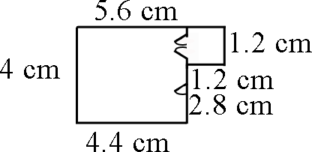
7.G.2. Draw (freehand, with ruler and protractor, and with technology) geometric shapes with given conditions. Focus on constructing triangles from three measures of angles or sides, noticing when the conditions determine a unique triangle, more than one triangle, or no triangle.  Connections: 6-8.RST.4; 6-8.RST.7;  6-8.WHST.2b,2f; SC07-S1C2-04;  ET07-S1C2-01; ET07-S6C1-03 | 7.MP.4. Model with mathematics.  7.MP.5. Use appropriate tools strategically.  7.MP.6. Attend to precision.  7.MP.7. Look for and make use of structure.  7.MP.8. Look for and express regularity in repeated reasoning. | Conditions may involve points, line segments, angles, parallelism, congruence, angles, and perpendicularity.  Examples:  Is it possible to draw a triangle with a 90˚ angle and one leg that is 4 inches long and one leg that is 3 inches long? If so, draw one. Is there more than one such triangle?  - Draw a triangle with angles that are 60 degrees. Is this a unique triangle? Why or why not?  - Draw an isosceles triangle with only one 80 degree angle. Is this the only possibility or can you draw another triangle that will also meet these conditions?  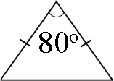  - Can you draw a triangle with sides that are 13 cm, 5 cm and 6cm?  - Draw a quadrilateral with one set of parallel sides and no right angles.
7.G.3. Describe the two-dimensional figures that result from slicing three-dimensional figures, as in plane sections of right rectangular prisms and right rectangular pyramids.  Connections: 6-8.WHST.1b; 6-8.WHST.2b | 7.MP.2. Reason abstractly and quantitatively.  7.MP.4. Model with mathematics.  7.MP.5. Use appropriate tools strategically.  7.MP.7. Look for and make use of structure. | Example:  - Using a clay model of a rectangular prism, describe the shapes that are created when planar cuts are made diagonally, perpendicularly, and parallel to the base.  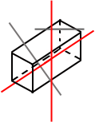
Geometry (G)
Solve real-life and mathematical problems involving angle measure, area, surface area, and volume.
Standards | Mathematical Practices | Explanations and Examples
Students are expected to:
7.G.4. Know the formulas for the area and circumference of a circle and solve problems; give an informal derivation of the relationship between the circumference and area of a circle.  Connections: 6-8.WHST.1d; SC07-S2C2-03; ET07-S6C2-03; ET07-S1C4-01 | 7.MP.1. Make sense of problems and persevere in solving them.  7.MP.2. Reason abstractly and quantitatively.  7.MP.3. Construct viable arguments and critique the reasoning of others.  7.MP.4. Model with mathematics.  7.MP.5. Use appropriate tools strategically.  7.MP.6. Attend to precision.  7.MP.7. Look for and make use of structure.  7.MP.8. Look for and express regularity in repeated reasoning. | Examples:  - The seventh grade class is building a mini golf game for the school carnival. The end of the putting green will be a circle. If the circle is 10 feet in diameter, how many square feet of grass carpet will they need to buy to cover the circle? How might you communicate this information to the salesperson to make sure you receive a piece of carpet that is the correct size?  - Students measure the circumference and diameter of several circular objects in the room (clock, trash can, door knob, wheel, etc.). Students organize their information and discover the relationship between circumference and diameter by noticing the pattern in the ratio of the measures. Students write an expression that could be used to find the circumference of a circle with any diameter and check their expression on other circles.  - Students will use a circle as a model to make several equal parts as you would in a pie model. The greater number the cuts, the better. The pie pieces are laid out to form a shape similar to a parallelogram. Students will then write an expression for the area of the parallelogram related to the radius (note: the length of the base of the parallelogram is half the circumference, or πr, and the height is r, resulting in an area of πr². Extension: If students are given the circumference of a circle, could they write a formula to determine the circle’s area or given the area of a circle, could they write the formula for the circumference?  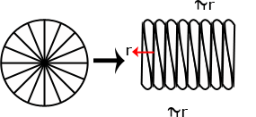
7.G.5. Use facts about supplementary, complementary, vertical, and adjacent angles in a multi-step problem to write and solve simple equations for an unknown angle in a figure.  Connection: ET07-S1C4-01 | 7.MP.3. Construct viable arguments and critique the reasoning of others.  7.MP.4. Model with mathematics.  7.MP.5. Use appropriate tools strategically.  7.MP.6. Attend to precision.  7.MP.7. Look for and make use of structure. | Angle relationships that can be explored include but are not limited to:  - Same-side (consecutive) interior and same-side (consecutive) exterior angles are supplementary.  Examples:  - Write and solve an equation to find the measure of angle x.  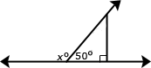  - Write and solve an equation to find the measure of angle x.  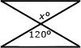
7.G.6. Solve real-world and mathematical problems involving area, volume and surface area of two- and three-dimensional objects composed of triangles, quadrilaterals, polygons, cubes, and right prisms.  Connections: 6-8.WHST.2a; ET07-S1C4-01 | 7.MP.1. Make sense of problems and persevere in solving them.  7.MP.2. Reason abstractly and quantitatively.  7.MP.3. Construct viable arguments and critique the reasoning of others.  7.MP.4. Model with mathematics.  7.MP.5. Use appropriate tools strategically.  7.MP.6. Attend to precision.  7.MP.7. Look for and make use of structure.  7.MP.8. Look for and express regularity in repeated reasoning. | Students understanding of volume can be supported by focusing on the area of base times the height to calculate volume. Students understanding of surface area can be supported by focusing on the sum of the area of the faces. Nets can be used to evaluate surface area calculations.  Examples:  - Choose one of the figures shown below and write a step by step procedure for determining the area. Find another person that chose the same figure as you did. How are your procedures the same and different? Do they yield the same result?  - A cereal box is a rectangular prism. What is the volume of the cereal box? What is the surface area of the cereal box? (Hint: Create a net of the cereal box and use the net to calculate the surface area.) Make a poster explaining your work to share with the class.  - Find the area of a triangle with a base length of three units and a height of four units.  - Find the area of the trapezoid shown below using the formulas for rectangles and triangles.  12  7  3
Statistics and Probability (SP)
Use random sampling to draw inferences about a population.
Standards | Mathematical Practices | Explanations and Examples
Students are expected to:
7.SP.1. Understand that statistics can be used to gain information about a population by examining a sample of the population; generalizations about a population from a sample are valid only if the sample is representative of that population. Understand that random sampling tends to produce representative samples and support valid inferences.  Connections: SS07-S4C4-04; SS07-S4C4-05;  SC07-S3C1-02; SC07-S4C3-04;  ET07-S4C2-01; ET07-S4C2-02;  ET07-S6C2-03; | 7.MP.3. Construct viable arguments and critique the reasoning of others.  7.MP.6. Attend to precision. | Example:  - The school food service wants to increase the number of students who eat hot lunch in the cafeteria. The student council has been asked to conduct a survey of the student body to determine the students’ preferences for hot lunch. They have determined two ways to do the survey. The two methods are listed below. Identify the type of sampling used in each survey option. Which survey option should the student council use and why?  - Write all of the students’ names on cards and pull them out in a draw to determine who will complete the survey.  - Survey the first 20 students that enter the lunch room.
7.SP.2. Use data from a random sample to draw inferences about a population with an unknown characteristic of interest. Generate multiple samples (or simulated samples) of the same size to gauge the variation in estimates or predictions. For example, estimate the mean word length in a book by randomly sampling words from the book; predict the winner of a school election based on randomly sampled survey data. Gauge how far off the estimate or prediction might be.  Connections: 6-8.WHST.1b; SC07-S1C3-04; SC07-S1C3-05; SC07-S1C3-06;  SC07-S1C4-05; SC07-S2C2-03;  ET07-S1C3-01; ET07-S1C3-02;  ET07-S4C2-02; ET07-S6C2-03 | 7.MP.1. Make sense of problems and persevere in solving them.  7.MP.2. Reason abstractly and quantitatively.  7.MP.3. Construct viable arguments and critique the reasoning of others.  7.MP.5. Use appropriate tools strategically.  7.MP.6. Attend to precision.  7.MP.7. Look for and make use of structure. | Example:  - Below is the data collected from two random samples of 100 students regarding student’s school lunch preference. Make at least two inferences based on the results.  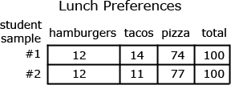

Statistics and Probability (SP)
Draw informal comparative inferences about two populations.
Standards | Mathematical Practices | Explanations and Examples
Students are expected to:
7.SP.3. Informally assess the degree of visual overlap of two numerical data distributions with similar variabilities, measuring the difference between the centers by expressing it as a multiple of a measure of variability. For example, the mean height of players on the basketball team is 10 cm greater than the mean height of players on the soccer team, about twice the variability (mean absolute deviation) on either team; on a dot plot, the separation between the two distributions of heights is noticeable.  Connections: 6-8.WHST.1b;  SC07-S1C4-01; SC07-S1C4-02;  SC07-S1C4-03; SS07-S4C1-01;  SS07-S4C1-02; SS07-S4C1-05;  SS07-S4C4-06; SS07-S4C6-03;  ET07-S1C3-01; ET07-S1C3-02;  ET07-S4C2-01; ET07-S4C2-02;  ET07-S6C2-03 | 7.MP.1. Make sense of problems and persevere in solving them.  7.MP.2. Reason abstractly and quantitatively.  7.MP.3. Construct viable arguments and critique the reasoning of others.  7.MP.4. Model with mathematics.  7.MP.5. Use appropriate tools strategically.  7.MP.6. Attend to precision.  7.MP.7. Look for and make use of structure. | Students can readily find data as described in the example on sports team or college websites. Other sources for data include American Fact Finder (Census Bureau), Fed Stats, Ecology Explorers, USGS, or CIA World Factbook. Researching data sets provides opportunities to connect mathematics to their interests and other academic subjects. Students can utilize statistic functions in graphing calculators or spreadsheets for calculations with larger data sets or to check their computations. Students calculate mean absolute deviations in preparation for later work with standard deviations.  Example:  Jason wanted to compare the mean height of the players on his favorite basketball and soccer teams. He thinks the mean height of the players on the basketball team will be greater but doesn’t know how much greater. He also wonders if the variability of heights of the athletes is related to the sport they play. He thinks that there will be a greater variability in the heights of soccer players as compared to basketball players. He used the rosters and player statistics from the team websites to generate the following lists.  Basketball Team – Height of Players in inches for 2010-2011 Season  75, 73, 76, 78, 79, 78, 79, 81, 80, 82, 81, 84, 82, 84, 80, 84  Soccer Team – Height of Players in inches for 2010  73, 73, 73, 72, 69, 76, 72, 73, 74, 70, 65, 71, 74, 76, 70, 72, 71, 74, 71, 74, 73, 67, 70, 72, 69, 78, 73, 76, 69  To compare the data sets, Jason creates a two dot plots on the same scale. The shortest player is 65 inches and the tallest players are 84 inches.  Continued on next page  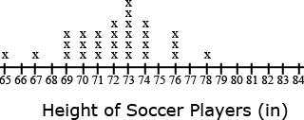  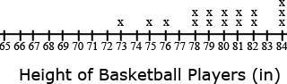  In looking at the distribution of the data, Jason observes that there is some overlap between the two data sets. Some players on both teams have players between 73 and 78 inches tall. Jason decides to use the mean and mean absolute deviation to compare the data sets. Jason sets up a table for each data set to help him with the calculations.  The mean height of the basketball players is 79.75 inches as compared to the mean height of the soccer players at 72.07 inches, a difference of 7.68 inches.  The mean absolute deviation (MAD) is calculated by taking the mean of the absolute deviations for each data point. The difference between each data point and the mean is recorded in the second column of the table. Jason used rounded values (80 inches for the mean height of basketball players and 72 inches for the mean height of soccer players) to find the differences. The absolute deviation, absolute value of the deviation, is recorded in the third column. The absolute deviations are summed and divided by the number of data points in the set.  The mean absolute deviation is 2.53 inches for the basketball players and 2.14 for the soccer players. These values indicate moderate variation in both data sets. There is slightly more variability in the height of the soccer players. The difference between the heights of the teams is approximately 3 times the variability of the data sets (7.68 ÷ 2.53 = 3.04).  Continued on next page  Mean = 2090 ÷ 29 =72 inches Mean = 1276 ÷ 16 =80 inches  MAD = 62 ÷ 29 = 2.14 inches MAD = 40 ÷ 16 = 2.53 inches
  Soccer Players (n = 29) |  |  |  | Basketball Players (n = 16)
  Height (in) | Deviation from Mean (in) | Absolute Deviation (in) |  | Height (in) | Deviation from Mean (in) | Absolute Deviation (in)
  65 | -7 | 7 |  | 73 | -7 | 7
  67 | -5 | 5 |  | 75 | -5 | 5
  69 | -3 | 3 |  | 76 | -4 | 4
  69 | -3 | 3 |  | 78 | -2 | 2
  69 | -3 | 3 |  | 78 | -2 | 2
  70 | -2 | 2 |  | 79 | -1 | 1
  70 | -2 | 2 |  | 79 | -1 | 1
  70 | -2 | 2 |  | 80 | 0 | 0
  71 | -1 | 1 |  | 80 | 0 | 0
  71 | -1 | 1 |  | 81 | 1 | 1
  71 | -1 | 1 |  | 81 | 1 | 1
  72 | 0 | 0 |  | 82 | 2 | 2
  72 | 0 | 0 |  | 82 | 2 | 2
  72 | 0 | 0 |  | 84 | 4 | 4
  72 | 0 | 0 |  | 84 | 4 | 4
  73 | +1 | 1 |  | 84 | 4 | 4
  73 | +1 | 1
  73 | +1 | 1
  73 | +1 | 1
  73 | +1 | 1
  73 | +1 | 1
  74 | +2 | 2
  74 | +2 | 2
  74 | +2 | 2
  74 | +2 | 2
  76 | +4 | 4
  76 | +4 | 4
  76 | +4 | 4
  78 | +6 | 6
  Σ = 2090 |  | Σ = 62 |  | Σ = 1276 |  | Σ = 40
7.SP.4. Use measures of center and measures of variability for numerical data from random samples to draw informal comparative inferences about two populations. For example, decide whether the words in a chapter of a seventh-grade science book are generally longer than the words in a chapter of a fourth-grade science book.  Connections: 6-8.WHST.1b;  ET07-S1C3-01; ET07-S1C3-02;  ET07-S4C2-01; ET07-S4C2-02;  ET07-S6C2-03; SC07-S1C3-01;  SC07-S1C3-05; SC07-S1C4-03;  SC07-S2C2-03; SC07-S4C3-04;  SS07-S4C2-01; SS07-S4C4-06;  SS07-S4C4-09 | 7.MP.1. Make sense of problems and persevere in solving them.  7.MP.2. Reason abstractly and quantitatively.  7.MP.3. Construct viable arguments and critique the reasoning of others.  7.MP.4. Model with mathematics.  7.MP.5. Use appropriate tools strategically.  7.MP.6. Attend to precision.  7.MP.7. Look for and make use of structure. | Measures of center include mean, median, and mode. The measures of variability include range, mean absolute deviation, and interquartile range.  Example:  - The two data sets below depict random samples of the housing prices sold in the King River and Toby Ranch areas of Arizona. Based on the prices below, which measure of center will provide the most accurate estimation of housing prices in Arizona? Explain your reasoning.  - King River area {1.2 million, 242000, 265500, 140000, 281000, 265000, 211000}  - Toby Ranch homes {5million, 154000, 250000, 250000, 200000, 160000, 190000}

Statistics and Probability (SP)
Investigate chance processes and develop, use, and evaluate probability models.
Standards | Mathematical Practices | Explanations and Examples
Students are expected to:
7.SP.5. Understand that the probability of a chance event is a number between 0 and 1 that expresses the likelihood of the event occurring. Larger numbers indicate greater likelihood. A probability near 0 indicates an unlikely event, a probability around ½ indicates an event that is neither unlikely nor likely, and a probability near 1 indicates a likely event.  Connections: 6-8.WHST.1b; SS07-S5C1-04; ET07-S1C3-01; ET07-S1C3-02 | 7.MP.4. Model with mathematics.  7.MP.5. Use appropriate tools strategically.  7.MP.6. Attend to precision.  7.MP.7. Look for and make use of structure. | Probability can be expressed in terms such as impossible, unlikely, likely, or certain or as a number between 0 and 1 as illustrated on the number line. Students can use simulations such as Marble Mania on AAAS or the Random Drawing Tool on NCTM’s Illuminations to generate data and examine patterns.  Marble Mania http://www.sciencenetlinks.com/interactives/marble/marblemania.html  Random Drawing Tool - http://illuminations.nctm.org/activitydetail.aspx?id=67  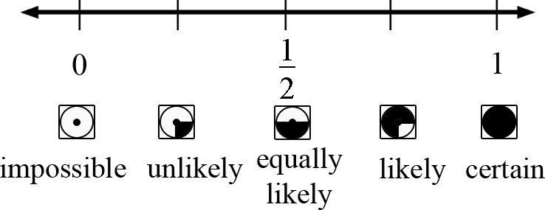  Example:  - The container below contains 2 gray, 1 white, and 4 black marbles. Without looking, if you choose a marble from the container, will the probability be closer to 0 or to 1 that you will select a white marble? A gray marble? A black marble? Justify each of your predictions.  
7.SP.6. Approximate the probability of a chance event by collecting data on the chance process that produces it and observing its long-run relative frequency, and predict the approximate relative frequency given the probability. For example, when rolling a number cube 600 times, predict that a 3 or 6 would be rolled roughly 200 times, but probably not exactly 200 times.  Connections: 6-8.WHST.1a; ET07-S1C2-01; ET07-S1C2-02; ET07-S1C2-03;  ET07-S1C3-01; ET07-S1C3-02  ET07-S4C2-01; ET07-S6C1-03;  ET07-S6C2-03; SC07-S1C2-03;  SC07-S1C2-05; SC07-S1C3-05;  SC07-S1C4-03; SC07-S1C4-05;  SC07-S2C2-03 | 7.MP.1. Make sense of problems and persevere in solving them.  7.MP.2. Reason abstractly and quantitatively.  7.MP.3. Construct viable arguments and critique the reasoning of others.  7.MP.4. Model with mathematics.  7.MP.5. Use appropriate tools strategically. | Students can collect data using physical objects or graphing calculator or web-based simulations. Students can perform experiments multiple times, pool data with other groups, or increase the number of trials in a simulation to look at the long-run relative frequencies.  Example:  Each group receives a bag that contains 4 green marbles, 6 red marbles, and 10 blue marbles. Each group performs 50 pulls, recording the color of marble drawn and replacing the marble into the bag before the next draw. Students compile their data as a group and then as a class. They summarize their data as experimental probabilities and make conjectures about theoretical probabilities (How many green draws would you expect if you were to conduct 1000 pulls? 10,000 pulls?).  Students create another scenario with a different ratio of marbles in the bag and make a conjecture about the outcome of 50 marble pulls with replacement. (An example would be 3 green marbles, 6 blue marbles, 3 blue marbles.)  Students try the experiment and compare their predictions to the experimental outcomes to continue to explore and refine conjectures about theoretical probability.
7.SP.7. Develop a probability model and use it to find probabilities of events. Compare probabilities from a model to observed frequencies; if the agreement is not good, explain possible sources of the discrepancy.  - Develop a uniform probability model by assigning equal probability to all outcomes, and use the model to determine probabilities of events. For example, if a student is selected at random from a class, find the probability that Jane will be selected and the probability that a girl will be selected.  - Develop a probability model (which may not be uniform) by observing frequencies in data generated from a chance process. For example, find the approximate probability that a spinning penny will land heads up or that a tossed paper cup will land open-end down. Do the outcomes for the spinning penny appear to be equally likely based on the observed frequencies?  Connections: 6-8.WHST.2d; SC07-S1C2-02;  ET07-S1C2-01; ET07-S1C2-02;  ET07-S1C2-03; ET07-S1C3-01;  ET07-S1C3-02; ET07-S4C2-01;  ET07-S4C2-02; ET07-S6C1-03;  ET07-S6C2-03 | 7.MP.1. Make sense of problems and persevere in solving them.  7.MP.2. Reason abstractly and quantitatively.  7.MP.3. Construct viable arguments and critique the reasoning of others.  7.MP.4. Model with mathematics.  7.MP.5. Use appropriate tools strategically.  7.MP.6. Attend to precision.  7.MP.7. Look for and make use of structure.  7.MP.8. Look for and express regularity in repeated reasoning. | Students need multiple opportunities to perform probability experiments and compare these results to theoretical probabilities. Critical components of the experiment process are making predictions about the outcomes by applying the principles of theoretical probability, comparing the predictions to the outcomes of the experiments, and replicating the experiment to compare results. Experiments can be replicated by the same group or by compiling class data. Experiments can be conducted using various random generation devices including, but not limited to, bag pulls, spinners, number cubes, coin toss, and colored chips. Students can collect data using physical objects or graphing calculator or web-based simulations. Students can also develop models for geometric probability (i.e. a target).  Example:  - If you choose a point in the square, what is the probability that it is not in the circle?  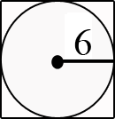
7.SP.8. Find probabilities of compound events using organized lists, tables, tree diagrams, and simulation.  - Understand that, just as with simple events, the probability of a compound event is the fraction of outcomes in the sample space for which the compound event occurs.  - Represent sample spaces for compound events using methods such as organized lists, tables and tree diagrams. For an event described in everyday language (e.g., “rolling double sixes”), identify the outcomes in the sample space which compose the event.  - Design and use a simulation to generate frequencies for compound events. For example, use random digits as a simulation tool to approximate the answer to the question: If 40% of donors have type A blood, what is the probability that it will take at least 4 donors to find one with type A blood?  Connections: 6-8.WHST.2d; ET07-S1C2-01; ET07-S1C2-02; ET07-S1C2-03;  SC07-S1C4-03; SC07-S1C4-05;  SC07-S1C2-02; SC07-S1C2-03 | 7.MP.1. Make sense of problems and persevere in solving them.  7.MP.2. Reason abstractly and quantitatively.  7.MP.4. Model with mathematics.  7.MP.5. Use appropriate tools strategically.  7.MP.7. Look for and make use of structure.  7.MP.8. Look for and express regularity in repeated reasoning. | Examples:  - Students conduct a bag pull experiment. A bag contains 5 marbles. There is one red marble, two blue marbles and two purple marbles. Students will draw one marble without replacement and then draw another. What is the sample space for this situation? Explain how you determined the sample space and how you will use it to find the probability of drawing one blue marble followed by another blue marble.  - Show all possible arrangements of the letters in the word FRED using a tree diagram. If each of the letters is on a tile and drawn at random, what is the probability that you will draw the letters F-R-E-D in that order? What is the probability that your “word” will have an F as the first letter?  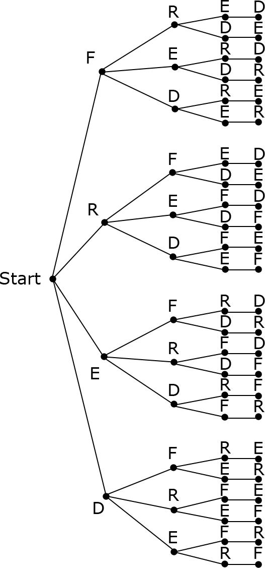

Standards for Mathematical Practice
Standards |  | Explanations and Examples
Students are expected to: | Mathematical Practices are listed throughout the grade level document in the 2nd column to reflect the need to connect the mathematical practices to mathematical content in instruction.
7.MP.1. Make sense of problems and persevere in solving them. |  | In grade 7, students solve problems involving ratios and rates and discuss how they solved them. Students solve real world problems through the application of algebraic and geometric concepts. Students seek the meaning of a problem and look for efficient ways to represent and solve it. They may check their thinking by asking themselves, “What is the most efficient way to solve the problem?”, “Does this make sense?”, and “Can I solve the problem in a different way?”.
7.MP.2. Reason abstractly and quantitatively. |  | In grade 7, students represent a wide variety of real world contexts through the use of real numbers and variables in mathematical expressions, equations, and inequalities. Students contextualize to understand the meaning of the number or variable as related to the problem and decontextualize to manipulate symbolic representations by applying properties of operations.
7.MP.3. Construct viable arguments and critique the reasoning of others. |  | In grade 7, students construct arguments using verbal or written explanations accompanied by expressions, equations, inequalities, models, and graphs, tables, and other data displays (i.e. box plots, dot plots, histograms, etc.). They further refine their mathematical communication skills through mathematical discussions in which they critically evaluate their own thinking and the thinking of other students. They pose questions like “How did you get that?”, “Why is that true?” “Does that always work?”. They explain their thinking to others and respond to others’ thinking.
7.MP.4. Model with mathematics. |  | In grade 7, students model problem situations symbolically, graphically, tabularly, and contextually. Students form expressions, equations, or inequalities from real world contexts and connect symbolic and graphical representations. Students explore covariance and represent two quantities simultaneously. They use measures of center and variability and data displays (i.e. box plots and histograms) to draw inferences, make comparisons and formulate predictions. Students use experiments or simulations to generate data sets and create probability models. Students need many opportunities to connect and explain the connections between the different representations. They should be able to use all of these representations as appropriate to a problem context.
7.MP.5. Use appropriate tools strategically. |  | Students consider available tools (including estimation and technology) when solving a mathematical problem and decide when certain tools might be helpful. For instance, students in grade 7 may decide to represent similar data sets using dot plots with the same scale to visually compare the center and variability of the data. Students might use physical objects or applets to generate probability data and use graphing calculators or spreadsheets to manage and represent data in different forms.
7.MP.6. Attend to precision. |  | In grade 7, students continue to refine their mathematical communication skills by using clear and precise language in their discussions with others and in their own reasoning. Students define variables, specify units of measure, and label axes accurately. Students use appropriate terminology when referring to rates, ratios, probability models, geometric figures, data displays, and components of expressions, equations or inequalities.
7.MP.7. Look for and make use of structure. |  | Students routinely seek patterns or structures to model and solve problems. For instance, students recognize patterns that exist in ratio tables making connections between the constant of proportionality in a table with the slope of a graph. Students apply properties to generate equivalent expressions (i.e. 6 + 2x = 2 (3 + x) by distributive property) and solve equations  (i.e. 2c + 3 = 15, 2c = 12 by subtraction property of equality; c=6 by division property of equality). Students compose and decompose two- and three-dimensional figures to solve real world problems involving scale drawings, surface area, and volume. Students examine tree diagrams or systematic lists to determine the sample space for compound events and verify that they have listed all possibilities.
7.MP.8. Look for and express regularity in repeated reasoning. |  | In grade 7, students use repeated reasoning to understand algorithms and make generalizations about patterns. During multiple opportunities to solve and model problems, they may notice that a/b ÷ c/d = ad/bc and construct other examples and models that confirm their generalization. They extend their thinking to include complex fractions and rational numbers. Students formally begin to make connections between covariance, rates, and representations showing the relationships between quantities. They create, explain, evaluate, and modify probability models to describe simple and compound events.

