2014-15 Precode Manual
for SC Testing Programs
(DRAC No. SCDE-08-0005)

Note: A number of text changes from last year’s precode manual are highlighted in pink.

The precode manuals have been available online the Tuesday after Labor Day for the last several years. Given the timing and changes in the 2014–15 assessment programs, the tentative plan for releasing 2015–16 precoding instructions involves two releases: (1) fall precoding instructions released prior to the beginning of the school year, and (2) spring precoding instructions released by the Tuesday after Labor Day.

The following table summarizes the status of precoding instructions in this manual by testing program.

Testing Program | Precoding Instructions  in this Manual
SCPASS (grades 4-8 science and social studies only) | Complete
EOCEP | Complete
SC-Alt (science and social studies only; ELA and Math will be tested using NCSC) | Complete
NCSC Fall 2014 Field Test | Complete (copy of instructions are in Appendix K)
NCSC Spring 2014 Field Test | To be determined—will likely have similarities to Fall 2014 field test precoding
South Carolina Performance Tasks | Contractor will contact districts directly (list of required fields are in Appendix A)
CogAT and IA | Not mentioned in the manual—Precode data collection was over by September 2, 2014.
NAEP | Complete (see Appendix A)
WorkKeys® | Incomplete (see Appendix L)
Early childhood (K4 and K5) readiness assessment: CIRCLE (for paper-and-pencil) and mCLASS:CIRCLE (for online) | Complete (see Appendix M)
Grades 3–11 assessment(s) | To be determined (see Appendix N)
Access for ELLs and Alternate ACCESS for ELLs | Incomplete (see Appendix O)

Contents

This year’s precode manual contains precoding instructions for pre-existing assessment programs in use last school year (2013–14).
  - SCPASS (grades 4-8 science and social studies only)
  - EOCEP
  - SC-Alt (science and social studies only; ELA and Math will be tested using NCSC)

The manual also contains descriptions of precode-related changes made to the PowerSchool database for the 2014–15 school year. The PowerSchool databases still have fields that refer to non-existent testing programs, such as HSAP and SCPASS (writing, ELA, math) due to the timing of the legislative changes to the assessment programs and the schedule with Pearson for submitting changes to the PowerSchool database.

The Office of Assessment is also responsible for the precoding of the following programs, each of which has its own deadline for receiving precode data from the state. The SCDE does anticipate that the precoding schedules for these programs, for the most part, will coincide or be very close to the precoding schedules for SCPASS, EOCEP, and SC-Alt. In addition, the precode data will likely only mostly involve basic identifying information for specific tests still being determined. Specific instructions for each program will be disseminated as soon as the information is available.

  - South Carolina Performance Tasks (a.k.a. Project STAR), the Cognitive Abilities Test (CogAT), and the Iowa Assessments (IA). Note that the Iowa Test of Basic Skills (ITBS) was replaced by IA. For questions related to SC Performance Tasks, contact Amelia Brailsford (803-734-0163; abrailsf@ed.sc.gov). For questions related to CogAT or IA, contact Carolyn Ray (803-734-8294; cray@ed.sc.gov). Unlike other testing programs, the contractor for the SC Performance Tasks collects the precoded information directly from the districts instead of through the SCDE. Appendix A contains a list of data elements required for SC Performance Tasks precoding.
  - National Assessment of Educational Progress (NAEP). Data collected in QDC1 are used for NAEP sampling and reporting (see Appendix E for precoding instructions). For questions related to NAEP data requirements, contact Chris Webster (803-734-5721; cwebster@ed.sc.gov).
  - NCSC Fall 2014 Field Test (ELA and math only). Precoding information was sent to the district test coordinator (DTC) for alternate assessment shortly after the school year began and prior to the release of this precode manual. See Appendix K for a copy of these precoding instructions.
  - WorkKeys® Assessment. See Appendix L for precoding instructions.
  - Early childhood (K4 and K5) readiness assessment. Specific test names will be known as soon as the contracts have been awarded. Precoding instructions are not currently available, but will be released as soon as possible. Appendix M has been set aside for these instructions.
  - Grades 3–11 assessment(s). Specific test names will be known as soon as the contracts have been awarded. Precoding instructions are not currently available, but will be released as soon as possible. Appendix N has been set aside for these instructions.
  - ACCESS for ELLs and Alternate Form of ACCESS for ELLs. ELDA was replaced by ACCESS for ELLs. The display names for the fields that used to refer to ELDA have been changed to say LEP instead of ELDA. See Appendix O for precoding instructions.

Definition of Precode

Precode refers to the student information in school databases that is shared with testing contractors for the purpose of pre-assigning answer documents and test booklets to students via scannable (barcoded) test documents or labels. When a school successfully participates in the precode project, the vast majority of test documents do not need to be manually coded by teachers and students, which saves time and labor and prevents errors. Observe all data quality control procedures and deadlines to ensure you receive correctly precoded materials.

The precode data include identifying and demographic information. In addition, the precode data allow schools to indicate, among other things:
- how school materials should be sorted,
- which customized materials students need,
- which students are eligible for alternate assessments (e.g., SC-Alt), and
- programs students have participated in.

This manual is not designed to answer questions related to state and federal accountability.
Any references to accountability emphasize the need for quality data entry because low quality data may adversely affect not just precoding but other SCDE initiatives related to federal and state reporting including accountability (e.g., alternate assessment field is used for precoding and for calculating the participation rate for accountability purposes).

WHERE IS THE LATEST VERSION OF THE PRECODE MANUAL?

The precode manual’s most current version is posted online via the “Precode” link at:
http://ed.sc.gov/agency/ac/Assessment/
or directly at: http://ed.sc.gov/agency/programs-services/46/

The manual should be interpreted together with any advisories and/or supplements, also listed on the same web page. Precode coordinators will be emailed whenever an advisory or supplement is posted online. The web page also contains links to precode training resources. District precode coordinators must complete online training by the end of September. The district precode coordinator, district test coordinator, and other district personnel (e.g., ESOL coordinator) are responsible for providing precode information or training to district and school personnel by the end of October.

Report any errors in the precode manual to Aaron Brown in the Office of Assessment via e-mail at arbrown@ed.sc.gov (with the subject line of “Precode Manual Error”) or by phone at (803) 734-0874. Always include your phone number in your e-mails.

Table of Contents
Note: You can press the Control button while clicking on an entry in the table of contents to take you to that part of the manual.

Summary of Changes for 2014–15 6
SCPASS, EOCEP, and SC-Alt Data Collection Schedule 8
Precode Fields that Matter During Print and Update Phases 9
EOCEP Precoding 10
EOCEP Precoding for VirtualSC 14
General Precode Process 15
General Print Phase Procedures 17
General Update Phase Procedures 17
Initialization of Precode Tab Fields 18
Troubleshooting Examples 18
Precode Project Inclusions and Exclusions 19
On School Identifying Numbers (SIDN), Student Names, State IDs, Birth Dates, and SSN 19
PowerSchool Mass Updates/Changes for Precoding Purposes 20
Procedures for Gaining Access to Data Validation Reports 20
Generated by the State 20
Where to Get Help for 2014–15 Precode 21
Section 1: SELECTED PRECODE FIELDS 22
1.1 Race and Ethnicity 22
1.2 Enrollment Date 22
1.3 Next School (SCPASS) 23
1.4 Free/Reduced Meals Program 23
1.5 Homeless Status 24
1.6 Migrant Status 25
Section 2: ENGLISH FOR SPEAKERS OF OTHER LANGUAGES (ESOL) FIELDS 26
2.1 Date Student Enrolled in School in the U.S. 26
2.2 Foreign Country Where Student Was Born 26
2.3 English Proficiency 26
2.4 Cohort Group and ESOL Instructional Models 28
2.4.1 Cohort Group (ESOL) 29
2.4.2 ESOL Instructional Models (ELLI) 29
2.5 First Language Spoken 30
Section 3: SPECIAL EDUCATION FIELDS 30
3.1 Alternate Assessment Eligibility 30
3.2 Alternate Assessment Exception 31
3.3 Alternate Assessment Test Administrator Name 32
3.4 LEP Alternate Assessment 32
3.5 504 Accommodations Plan 32
3.6 Instructional Setting 33
3.7 True Grade 34
Section 4: SPECIAL IEP DISABILITY FIELDS 35
4.1 Deaf-Blindness 35
4.2 Multiple Disabilities 35
Section 5: CUSTOMIZED TEST BOOKLETS 36
Section 6: ORAL/SIGNED ADMINISTRATION FIELDS 37
Section 7: Customized Test Booklet and Oral/Signed Administration Fields for EOCEP and SCPASS 38
Section 8: ONLINE ADMINISTRATION FIELDS 41
8.1 SCPASS ONLINE ADMINISTRATION FIELDS for Science and Social Studies 41
8.2 EOCEP ONLINE ADMINISTRATION FIELDS for Algebra, English, Biology, and USHC 41
Section 9: HOME ROOM 42
Section 10: How Paper-and-Pencil Test Materials Are Sorted 43
10.1 Order of SCPASS Test Materials 43
10.2 Order of EOCEP Test Materials 43
10.3 Order of SC-Alt Test Materials 43
Section 11: MATERIALS SORT FIELDS (SCPASS) 44
Section 12: PREVIOUS PROGRAM FIELD for 5-Year-Old Kindergarteners Only 45
Appendix A: PowerSchool Fields for Precode 46
Appendix B: 2014–15 Alternate Assessment Age and Birth Date Reference Sheet 55
Appendix C: 2014–15 PowerSchool Coding Rules for LEP Students 56
Appendix D: EFA Coding for Students with Disabilities 63
Appendix E: NAEP Precoding 65
Appendix F: Logging Into the SCDE’s Web Site 66
Appendix G: District Precode Project Best Practices 67
The Precode Coordinator 67
Collaboration With Stakeholders 67
Things You Need To Know 68
Create Timelines 68
Importance Of Data Quality 69
Data Quality Strategies 69
Strategies For Training District And School Personnel 70
Appendix H: Advanced Data Transfer System (ADTS) Site Tutorial 71
Appendix I: Alternative School Program List 73
Appendix J: Adult Education Program List 75
Appendix K: NCSC Fall 2014 Field Test Precoding 77
Appendix L: WorkKeys® Precoding 78
Appendix M: Early Childhood Readiness Precoding 78
Appendix N: Grades 3-11 Assessment(s) Precoding 78
Appendix O: ACCESS for ELLs Precoding 79

Summary of Changes for 2014–15

Note: A number of text changes from last year’s precode manual are highlighted in pink.

Notes:
  - IMPORTANT: The Office of Assessment will continue to use the following method for ordering materials. The precoded materials will depend on the EFA grade field values and not the true grade field values. Materials for students whose true grade value differs from the EFA grade value should be ordered through eDIRECT. For such students, be sure to set the applicable materials order fields in PowerSchool to 0 so that there will be no duplicate order.
  - There are coding changes in the English proficiency field.
  - If there are inconsistencies between SCPASS and SC-Alt orders, the SC-Alt materials order will prevail. (That is, if a student was coded to receive SCPASS and SC-Alt materials, only SC-Alt materials will be provided.)
  - The True Grade and Instructional Setting fields are now set to blank during precode initialization. Therefore, these fields need to be populated annually after precode initialization occurs. The Instructional Setting field also needs to be updated whenever a student’s instructional setting changes. Errors in these fields will complicate federal and state reporting efforts.
  - At the bottom of the precode data entry tab, there are fields reporting on students who did not test. The Office of Assessment does not use these data. Although these fields appear in the precode data entry tab and mention testing, they are primarily used for accountability purposes. If you have any questions regarding these fields, contact Lisa Woodard from the Office of Research and Data Analysis at (803) 734-8573 or lwoodard@ed.sc.gov.
  - For general questions related to accountability (state report card and ESEA waiver), contact Sylvia Sievers from the Office of Research and Data Analysis at (803) 734-8215 or ssievers@ed.sc.gov.
  - Appendix A has the list of PowerSchool fields collected by the Office of Assessment, followed by PowerSchool screen shots.
  - Appendix B contains the alternate assessment age and birth date reference sheet and has been updated for this school year.
  - Appendix C contains PowerSchool coding rules for LEP students and has been updated for this school year.
  - Appendix D provides an explanation of EFA coding.
  - Appendix E contains information regarding NAEP precoding.
  - Appendix F shows how to log into the SCDE’s Web site.
  - Appendix G shares district precode project best practices.
  - Appendix H describes how to use the Advanced Data Transfer System (ADTS), used in prior years to post data validation reports generated by the Office of Assessment. The Office of Assessment uses ADTS to transmit student-level and other data to selected districts, as needed, to explain why records are problematic, etc. Districts will be notified via e-mail through the precode coordinator when files are posted on ADTS.
  - Appendix I contains the school IDs for alternative school programs. Aveene Coleman ((803)734-3057, acoleman@ed.sc.gov) assigns school ID numbers to alternative school programs on an annual basis. These school IDs can be used for receiving EOCEP and SCPASS test materials but NOT for coding as the student’s home school for reporting purposes. Using these codes for reporting purposes will cause problems in reporting and later the district, via the district test coordinator, will be asked to provide the correct school IDs.
  - Appendix J contains the adult education school IDs that should be used for tests. Adult Education students do not receive precoded materials, but schools are required to use the school IDs in Appendix J for EOCEP.
  - NEW: Appendix K contains precoding information for NCSC.
  - NEW: Appendix L contains precoding information for WorkKeys®.
  - NEW: Appendix M contains precoding information for the childhood readiness assessments: CIRCLE (for paper-and-pencil) and mCLASS:CIRCLE (for online).
  - NEW: Appendix N is reserved for precoding information for the grades 3-11 assessment(s).
  - NEW: Appendix O contains precoding information for ACCESS for ELLs.
  - The SCDE’s data collection schedule is posted at: http://ed.sc.gov/agency/rda/Power-School-Administration/DataCollectionInformation.cfm (click the “Data Collection Schedule” link).

CHANGES:
- The Office of Exceptional Children has been renamed as the Office of Special Education Services.
- The SC Virtual School Program, known as SCVSP, has been renamed VirtualSC. The contact person for the EOCEP Precoding for EOCEP Precoding for VirtualSC section has been changed from Vicki Williams to Katina Montgomery, whose contact information is 803-734-8039 or kmontgomery@ed.sc.gov.
- Fred Edora replaces Lori James as the contact for the 504 Plan, Instructional Setting, and True Grade fields.
- Roy Stehle replaces Aaron Brown as the contact for the Meals field.
- Penny Danielson replaces Mellanie Jinnette as the contact for the Pre-Kindergarten Program field.
- Barbara Solomon is no longer at the SCDE. Donna Lewis is now in another office and is no longer working on PowerSchool. Kelly Wishert-Hoskins has joined the PowerSchool support team.
- Districts have the option to delegate responsibilities for a testing program for multiple people instead of a single district test coordinator (DTC) for all testing programs. Additional DTC categories have been added this year. This year’s categories are the primary DTC (Early Childhood Readiness, Assessment(s) for Grades 3-11, EOCEP, SCPASS, and WorkKeys®); DTC for ACCESS (assessment for English language learners); DTC for Alternate Assessment (SC-Alt and NCSC); and DTC for Gifted & Talented (IA, CogAT, and SC Performance Tasks).
- SCPASS is no longer administered to grade 3. SCPASS is administered only in science and social studies in grades 4-8.
- The display names for SCPASS fields have been updated from PASS to SCPASS; the precode tab screenshot shows the new display names. SCPASS is only being administered in science and social studies for 2014–15. References to SCPASS fields in writing, ELA, and mathematics should be ignored by PowerSchool users unless they are directed to use the field for a special purpose.
- Online administration of SCPASS is being offered this year. The SCPASS Online fields for Science and Social Studies on the precode tab should be used to designate which students will be tested online. It is critical that these fields have correct information because paper-and-pencil materials will be printed and shipped using data provided. Section 7 has been updated to reflect which customized materials are available for online administration. Sections 10 and 11 have been updated with information related to sorting physical materials and grouping students for online testing.
- PowerSchool fields that refer to HSAP and SCPASS (writing, ELA, and math only) should be ignored by PowerSchool users unless directed to use the fields for a special purpose.
- HSAP is no longer being administered. Fields referring to HSAP should be ignored. There is a new HSAP Graduation Express field on the Precode tab; however, this field should also be ignored.
- ELDA has been replaced by ACCESS for ELLs. References to ELDA in PowerSchool’s Precode tab were changed to LEP. Only the display names in PowerSchool were updated (i.e., the internal field names still refer to ELDA). Appendix A contains the new display names. The precode tab screenshot also shows the new display names.
- New fields were added for ACCESS for ELLs. These include LEP Alternate Assessment, customized materials (for Reading, Writing, Listening, and Speaking), and oral administration (for Writing only) fields. Appendix O contains information about the use of these fields.
- Many fields were collected for ELDA last year. With the timing of the transition to ACCESS for ELLs, the Office of Assessment is not certain if all of these fields will be required for ACCESS for ELLs or not. For this reason, these fields are now denoted as being collected for Title III.
- The Alternate Assessment field in the Precode has been updated and now has NEW codes. Beginning this year, just select Y if the student meets the eligibility requirement for alternate assessment regardless of age or grade designation. Select Y even if the eligible student is in a grade that is not to be tested or is overage for testing. Otherwise, select N. The field defaults to N. Last year’s codes were dependent on student age as detailed in the age and birth date reference sheet (see Appendix B). Henceforth, the SCDE will calculate the student’s age and determine who is age-eligible to be tested.
- The Alternate Assessment Teacher Administrator in the Precode tab is NEW. The teacher administrator’s name will be recorded in two fields: first name and last name. This field is used to sort SC-Alt materials instead of the Home Room field.
- The Alternate Assessment Exception fields in the Precode tab is NEW. Jill Christmus, a new member of the SCDE Office of Assessment, is the contact person for this field.
- The schedule for PowerSchool data extractions are implemented by the Office of Research and Data Analysis. Due to unavoidable circumstances, these dates are subject to change. Therefore the reader is referred to an online page, which lists the most recent dates for the quarterly and other data collections, including precode data extractions:
http://ed.sc.gov/agency/rda/Power-School-Administration/DataCollectionInformation.cfm

SCPASS, EOCEP, and SC-Alt Data Collection Schedule

A copy of this year’s data collection schedule is available online at
http://ed.sc.gov/agency/rda/Power-School-Administration/DataCollectionInformation.cfm

All schools must participate in both phases of the precode project:
- The print phase produces preprinted test booklets or answer documents and determines the quantity of printed materials to be sent to schools.
- In general, the update phase produces labels that are applied to test booklets or answer documents for new students who were not in the print phase. Corrections to print phase demographic data are made in time for this submission. The contractor will update their database with these corrections.

Strictly observe the deadlines:
- Whenever applicable, districts that fail to meet the deadline for the print phrase will receive labels for new students printed by the testing contractor. Districts will have to apply these labels to the answer documents manually.
- Districts that fail to meet the deadline for the update phase will have to manually code answer documents.
- Districts that fail to meet deadlines may have to pay the testing contractor for any late material orders.

The precode coordinators, technology coordinators, and various District Test Coordinators (DTCs) should work together since the data should be loaded into PowerSchool BEFORE the data are transmitted by the Technology Coordinators to the SCDE. The SCDE currently does not have the ability to retrieve remotely, on its own, district data. Therefore, the SCDE only has data that are transmitted from the districts.

 | Event | SCPASS | EOCEP | SC-Alt
Fall | Early Validation | NA | NA | NA
Fall | Print Data Extraction | NA | NA (Submit print counts through eDirect) | NA
Fall | Update Data Extraction | NA | Yes | NA
Spring | Early Validation | Yes | Yes | Yes
Spring | Print Data Extraction | Yes | Yes | Yes
Spring | Update Data Extraction | Yes | Yes | Yes

General Data Collection Notes
- Take advantage of early validation reports. USE the validation tools to identify data that are wrong AND fix the data prior to your final transmission.
- QDC2/P uploads are not date-specific–the district does NOT have to wait until its 90th day to submit its data.
- For help with PowerSchool-related questions, using SWEET, or general QDC 2/P questions, contact District Services through http://ed.sc.gov/agency/rda/Power-School-Administration/TechnologySupportTeam.cfm (select the “Contact District Services Support” link).
- Instructions regarding PowerSchool’s South-Carolina-defined pages and precode data collection requirements are also mentioned in the PowerSchool manuals and reference materials at: http://ed.sc.gov/agency/rda/Power-School-Administration/PowerSchoolManualsforS.C.Pages.cfm.
- Districts have been concerned that, if they receive materials for students who did not need to be tested, this would count against their participation rate; such is not the case. The data for precoding is not used for participation rates. If you have any questions, please contact Cynthia Hearn from the Office of Research and Data Analysis at chearn@ed.sc.gov.

Precode Fields that Matter During Print and Update Phases

This section contains information for SCPASS, EOCEP, and SC-Alt. The following two tables show which fields that affect the shipping of materials should be updated for each precode phase. Fields marked ‘+’ will be used; fields marked ‘X’ will not be used. Fields marked ‘NA’ do not apply to the testing program.

SC-Alt tests are shipped to students with an Alternate Assessment field value of Y.

Fields | SCPASS Print  (Science and Social Studies) | SCPASS Update  (Science and Social Studies) | Fall EOCEP Print | Fall EOCEP Update | Spring EOCEP Print | Spring EOCEP Update | SC-Alt Print | SC-Alt Update
Customized Test Booklets | + | +  See note A | X | +  see note B | +  see note C | +  see note D | NA | NA
Oral/Signed Administration | + | +  See note A | X | +  see note B | +  see note C | +  see note D | NA | NA
Online Administration | + | +  See note A | X | +  see note B | +  see note C | +  see note D | NA | NA
Materials Sort | + see sections 10 and 11 | + see sections 10 and 11 | NA | NA | NA | NA | NA | NA
Home Room | + see sections 10 and 11 | + see sections 10 and 11 | NA | NA | NA | NA | NA | NA
Alternate Assessment | If SC-Alt materials are ordered, SCPASS materials are not provided. | If SC-Alt materials are ordered, SCPASS materials are not provided. | NA | NA | NA | NA | + | See note E
Alternate Assessment Test Administrator Name | NA | NA | NA | NA | NA | NA | +  See sections 10 and 11 | See note E

- SCPASS: During the spring update phase, the customized test booklets and oral/signed administration materials fields can be used to order materials for students who have no prior test materials order from the spring print phase; for these new students, precode labels will be generated only where online administration = N. This only includes students who were not in the spring print phase.
Districts should also make sure that the Customized Test Booklets and Oral/Signed Administration fields are current for the Update Phase for all students since this data will be used to populate online test sessions.
- Fall EOCEP: Precode labels will be generated for records where online administration = N based on fall update phase data; if online administration = Y, precode labels will not be printed. Districts are responsible for determining numbers of paper materials and entering these counts into eDIRECT for pencil-and-paper testers. Online test sessions will be populated with student data based on the fall update phase data.
- Spring EOCEP: If the districts elect to order spring materials via QDC2/P, they will receive over-printed answer documents based on the QDC2/P file and new student labels based on the spring update file for students testing paper/pencil (Online Administration = N). If the districts decide to order spring materials via eDIRECT, they will receive pre-ID labels based on the spring update file for students testing paper/pencil (Online Administration = N).
- Spring EOCEP: Update phase data will not be used to order paper materials. However, districts should make sure that the Customized Test Booklets and Oral/Signed Administration fields are current for the Update Phase since this data will be used to populate online test sessions.
- SC-Alt: Data collected during the update phase is only used to update demographic data. Due to timing, new materials are not issued.

EOCEP Precoding

The online administration fields need to be populated for the fall and spring so that labels for just the paper-and-pencil testers will be printed. Labels will be printed only for students who are enrolled in the EOCEP courses and with N in the corresponding online administration fields. All precode data, whether marked for online test administration or not, are used to populate the online testing system.

Fall EOCEP “Print” Phase

This phase only involves printed material counts collected through eDIRECT and does not involve student-level precoding. The counts will help the contractor determine the print counts for paper-and-pencil materials. In the past, student-level data for printing labels were collected in September, but the data were not timely and eventually student-level data were only collected during QDC1 (see Fall EOCEP “Update” Phase below).

Fall EOCEP “Update” Phase

QDC1 data are used to print precode labels for paper-and-pencil tests, while all precode data are used to populate the online testing system.

The customized test booklet and oral administration fields do NOT need to be populated for paper-and-pencil tests. For online test-takers, any customized test, oral administration, or sign language administration information should be populated.

Spring EOCEP Print Phase and Update Phase

All schools within a district must use QDC2/P or eDIRECT but not both to specify their spring print counts. This option is allowed because, as school year start dates vary across districts, the QDC2/P collection is too early for certain districts.

If the districts decide to order spring materials via QDC2/P, they will receive over-printed answer documents based on the QDC2/P file and new student labels for paper/pencil testers based on the spring update file.

If the districts decide to order materials via eDIRECT, they will receive pre-ID labels for paper/pencil testers based on the spring update file.

Online testers should have their information entered into PowerSchool in time for the Spring Update collection; this is the case even if the district decides to use eDIRECT for ordering materials.

Corrections to print phase demographic data are made in time for this submission. The contractor will update their database with these corrections.
The following fields are collected for EOCEP precoding:

Student Information  - District Code  - School Code  - School Name  - Student ID  - State ID  - Student Last Name  - Student Middle Name  - Student First Name  - Date of Birth  - Ethnicity  - Race | - Gender  - Grade  - True Grade  - Meals Status  - Homeless Status  - Migrant Status  - ESL  - EFAPrimary, EFA02 – EFA10  - IEP-DB  - IEP-MD  - Plan504  - Instructional Setting  - EIA01 – EIA10 | Course Information  - Section ID  - Term ID  - Tested School ID  - Start Date  - End Date  - Teacher Number  - Teacher Certificate  Number  - Teacher Last Name  - Teacher First Name  - Teacher Middle Name  - VSP Teacher Name  - VSP Certificate Number  - VSP SSN

Only courses with standard course codes will be considered for precoding. A common precoding error is schools do not follow the instructions for assigning course codes.

Course | Standard Course Code
Algebra 1 | 4111
Mathematics for the Technologies 2 | 3142
Intermediate Algebra: Functions & Modeling | 4117
Common Core Algebra 1 | 4114
English 1 | 3011
Common Core English 1 | 3024
Biology 1 | 3221
Applied Biology 2 | 3227
U.S. History and the Constitution | 3320
Advanced Placement U.S. History | 3372
International Baccalaureate History of Americas HL-2 | 336D
Dual Enrollment American History 1877 to Present (HIS 202) | 3322

EOCEP Frequently Asked Questions (FAQ)

Q: Why are we missing precoded materials for students?
A: A number of things could cause this:
- The course code used for the student did not belong to the list of codes used to select records for precoding. Although the course code is supposed to be standard for courses, districts make mistakes or don’t always follow instructions.
- The student’s course information was not entered into PowerSchool prior to the data extraction.

Q: Our database allowed us to enter 780995 as the tested school number for several students. Why did the materials arrive labeled for 780 instead of 780995.
A: The SCDE only uses the first three digits of the school number provided in PowerSchool. The school number is supposed to be the school number for one school and not a combination code of two school numbers.

Q: We used SEAL1, SEAL2, and SEAL3 as section numbers. When our materials arrived, the students in the SEAL1, SEAL2, and SEAL3 sections were all under the SEAL section. Why is the section number just SEAL instead of the original SEAL1, SEAL2, and SEAL3.
A: The SCDE only uses the first FOUR characters of the section number. The EOCEP class header on paper only has space for four characters for the section number.

Q: The SCDE told us that we can use letters in the section numbers. Letters are very useful in making the section numbers more understandable. When we use letters, why do we then start having problems with PowerScheduler?
A: Section numbers can be any 4-character combination of letters from A to Z and numbers from 0 to 9. However, PowerScheduler cannot function properly when there are letters in the section numbers. This problem and its solution are documented below.

Problem: PowerScheduler does not function as expected when there are letters in the section numbers. Using alpha characters in the section number will stop the Automated Walk-in (AWI) application from functioning properly.
Solution:
- If PowerScheduler needs to be run through certain classes, assign the section numbers to these classes without alpha characters.
- Commit the schedule for these classes in PowerScheduler.
- Add the letters to the section numbers on the live or production side of PowerSchool.
Q: Every now and then we have non-public school students (e.g., home school, private school, adult education) who need to take the EOCEP. Since they are not precoded, what do we use as their PowerSchool student numbers and their state IDs when they don’t have either number?
A: You may opt to use the Social Security Number as one of the numbers, but using the SSN is neither required nor recommended.
- If the student is tested on paper, you are able to leave both ID numbers blank.
- To use the online system, you must enter a PowerSchool number. For students not in PowerSchool databases, the SCDE recommends using 1 for your first student in this situation, then 2, then 3, and so on. It is helpful to use these numbers so that we can differentiate between real PowerSchool numbers and those entered for students without PowerSchool numbers. You do not need to enter a State ID, so this field can be left blank. This information will also be included in the Test Setup portion of the TAM.
- The Office of Assessment is working with VirtualSC to include VirtualSC non-public students in the precode data file given to the contractor. The end result will be that VirtualSC students from private or home schools who have to take the EOCEP test at a district will be loaded into an online EOCEP test session for that district and coded as Virtual School students, thereby eliminating the need for districts to enter information for the student.
- If the students are successfully entered into the precode file, the SCDE will assign PowerSchool numbers to the students, beginning with 1, then 2, then 3, and so on. In the unlikely event that these students are precoded but another student shows up who needs to take EOCEP, assign them the next available PowerSchool number. For example, if the SCDE assigned PowerSchool numbers to ten students (1-10), assign this student the number 11.

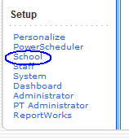
All EOCEP materials will be sorted according to the tested school identification number (SIDN), which is the school ID for where the student took the course. The tested school ID can be specified in PowerSchool through the “School” link at the main PowerSchool page.

Under “School”, select Courses, then the number of Sections for the course, then the section number for the class in question.

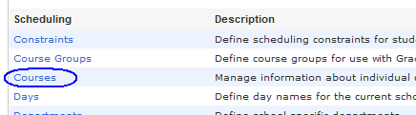
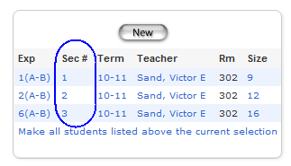

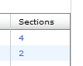

There, you can enter the tested school ID into the “School Where Taught” field.
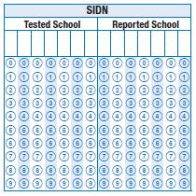
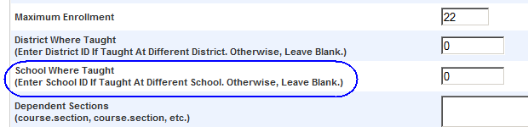

The Office of Assessment refers to the base school’s ID as the “reported school ID.” For students who take the course in the base school, the tested school ID is the base school’s ID. The scores of the student will be reported under the “reported school ID” even if they took the course or EOCEP test elsewhere.

For paper-and-pencil test takers, the header should reflect the correct school ID values. The values from the header will prevail regardless of what was submitted as precode data.

Because the “tested school ID” is sometimes an unofficial ID number used mainly for the shipping and distribution of materials, test administrators must remember to use the “reported school ID” on the header or indicate the correct reported school ID in the online testing system.

EOCEP Precoding for VirtualSC
This section only applies for districts that have students participating in the VirtualSC. If students are successfully flagged during precode as taking a VirtualSC course that requires EOCEP results, the EOCEP results will be automatically sent to VirtualSC administrators for determining the final course grades. For any questions, contact Katina Montgomery (803-734-8039; kmontgomery@ed.sc.gov).

- The SCDE is investigating methods for simplifying the data entry process for VirtualSC.
- No Child Left Behind requirements include publication of the percent of core academic classes taught by non-Highly Qualified teachers on school, district, and state report cards. Accurate coding in PowerSchool for classes taught by Highly Qualified VirtualSC teachers positively affects these percentages. Coding other school personnel as the teachers can have a negative impact on the reported percentages.

For detailed information related to the fields described below, see the PowerSchool Specific Fields Manual, available online at http://ed.sc.gov/agency/rda/Power-School-Administration/PowerSchoolManualsforS.C.Pages.cfm.

The VirtualSC will provide the guidance counselor with VirtualSC teacher information required for PowerSchool:
- VSP Teacher’s Last Name, First Name, and Middle Initial (Enter the instructor’s data exactly as provided since a difference will cause a mismatch.)
- VSP Instructor’s Certificate Number
- VSP Instructor’s Social Security Number

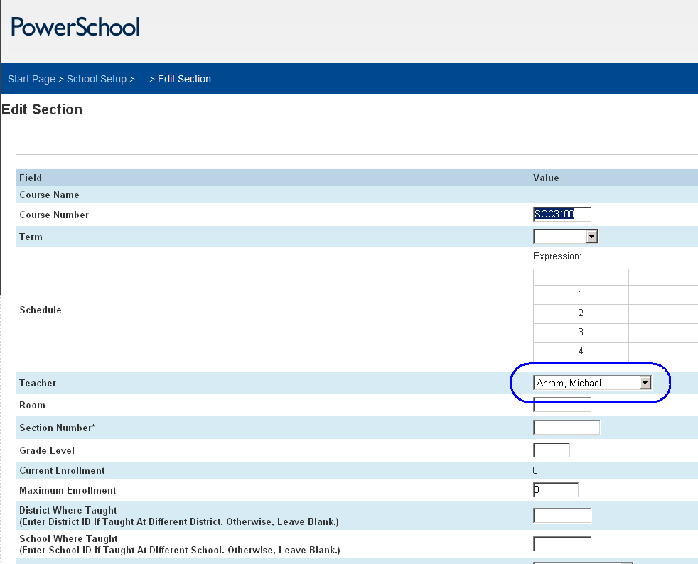
All VirtualSC students will be tested at the base school (i.e., the “brick-and-mortar” school). The school should assign a teacher at the base school to be the principal for each gateway course offered at VirtualSC. Within each school, all paper-and pencil EOCEP materials will be sorted by subject and principal. The student will be listed under the principal in the online testing system.

- Enter the course code information in the Edit Section of PowerSchool. Enter the principal as the teacher of record at the brick-and-mortar school; select this name in the “Teacher” field’s drop-down list. (For consistency across the state, do not enter the VirtualSC class teacher as the teacher of record at the brick-and-mortar school because this can create problems in certain district payroll systems.)
- Instruction type should be B – SC Virtual School Program, as shown below, so that the EOCEP scores are automatically sent to VirtualSC for final course grade computation. It is the instruction type value that will ensure these students are precoded. The students will be precoded under the principal’s name in terms of any paper-and-pencil materials and in the online system. Selecting the B value is critical because this will flag students as enrolled in VirtualSC regardless of whether the VSP teacher information fields are blank or contain any values.
- Enter the VSP Teacher Name, Certificate Number, and Social Security Number into the appropriate fields (shown below).
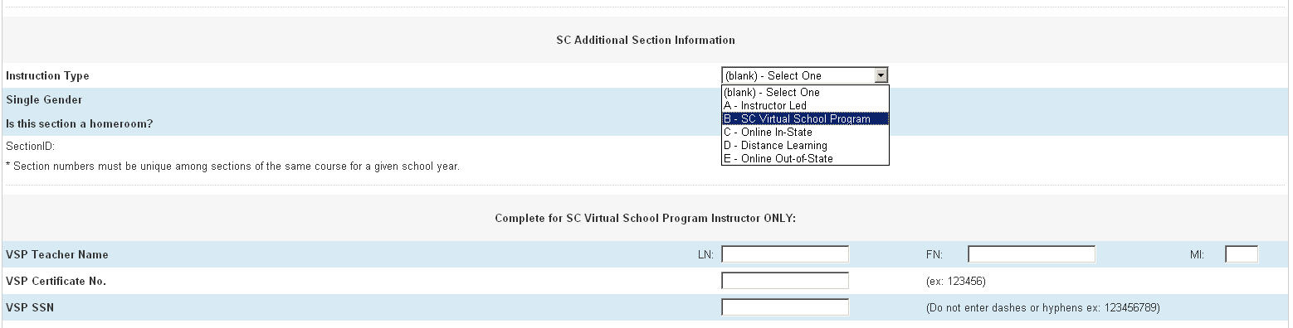
- All students listed for this section will be flagged as students enrolled in VirtualSC.

General Precode Process

- Checking data quality vigilantly cannot be overemphasized. Check your data using the data verification and validation tools as soon as possible. If you do not check the data, errors will likely be undetected. Be aware of how errors occur so that you can prevent them from happening.
- For optimal results, transmit correct data to the SCDE before the precode collections end. This ensures getting the highest quality individual student and district/school/class reports from the testing contractors and the most accurate accountability results. Although changes/corrections to certain demographic data can still be made on answer documents during testing, the precode data dominate the final data used for a number of summary reports and longitudinal databases.
- If you realize that incorrect data were transmitted during precoding, you can still, as a last resort, correct the data in the databases in time for your district’s first-day-of-testing data transmission to the SCDE. The SCDE uses the first-day-of-testing demographic data as the basis for accountability data processing. Corrections made after precode and before first-day-of-testing data collections may affect the matching of student data with test data because of differences in demographic data values. Avoid changes to the state ID, student ID, date of birth, and name during this time as it will cause problems in matching.
- Once the data are received at the SCDE, it takes several hours to a few business days in total to process the data from the entire state. Several programs are run through the data to check for errors, make corrections, and exclude records. The Office of Research and Data Analysis produces a file, against which the Office of Assessment runs its own checks. After the Office of Assessment conducts quality control procedures on the file, the file is transmitted to the testing contractor. The QDC2/P deadline cannot be set any later; otherwise there will be adverse consequences in materials production.

Here are examples of consequences of poor data quality:
- If the wrong materials are ordered for a student, the school has to go through the inconvenience of correcting the situation. Costs may be incurred if additional materials must be ordered.
- If the materials are not sorted in the desired order, the school has to expend valuable man-hours to rearrange the materials.
- Some of the data values are rolled over from year to year (e.g., race and ethnicity fields). Bad data from one year can just get passed on to another year. The problems that arise are compounded by affecting data from more than one year.
- The demographic data are used to calculate performance statistics. Poor quality data can introduce errors in the calculations that can make the school performance look worse or better than it really is.
- Poor data even after the first-day-of-testing data extraction lead to inaccurate state and federal accountability results. Poor data unnecessarily complicate the data review and appeals process for accountability initiatives.

Data are entered or corrected at the school level.
Initiate a SWEET transmission at the district level.
Use Data Quality and Reporting Application’s Data Validation Reports.
Are the data clean?
START
END
Yes
No
POWERSCHOOL PRECODE DATA CYCLE
Important Note:
Districts get access to their data validation reports from the state through the Data Quality and Reporting Application.
District superintendents designate district precode coordinators.
(August)

District precode coordinators are trained.
(September)
District technology personnel prepare the databases before school opens.
(June, July)
District precode coordinators train their district/school personnel. (October)

District precode coordinators work with their school personnel, district test coordinator, and district technology coordinator to complete the precode project.
General Precode Process

General Print Phase Procedures

#1 Multiple transmissions during the print phase are allowed.
PRECODE will be collected using a SWEET extract, which allows districts to transmit their data multiple times during the data collection period. Transmit your data early to allow for resubmissions that revise previously submitted data. Each day during the collection period, data validation reports that list all errors still existing in the PRECODE data will be posted to a secure page in the Data Quality and Reporting Application. You must log in to www.ed.sc.gov to view these reports. These edit reports will be broken down by school within district.

#2 There can be multiple transmissions per day.
If you transmit a file and then discover that some of the data are incorrect, make the necessary corrections in the database. Notify your district technology coordinator so that he/she may resend data to the SCDE.

#3 Check the Data Quality and Reporting Application for feedback.
District personnel who have an ed.sc.gov account can obtain feedback for previously transmitted data. Access to the data submission feedback reports require an account registration at www.ed.sc.gov. To create an account, contact your district web access coordinator.
Errors will be listed on data validation reports. Data may be corrected and resubmitted during the data collection period.

General Update Phase Procedures

The print phase procedures (#1–#3) still apply for the update phase.
- The update and print phase records are matched by school ID and student database number. After that, the SCDE will mark records for new students within a school (i.e., records not in the print phase but in the update phase). The contractor may print labels and/or generate other materials for the new students. (What actually happens will depend on the testing program.)
- For student records that are not new and in both the print and update phase data, the contractor will update the information for print phase records with the update phase data. This updating occurs in the background; prepared materials from the print phrase are not reprinted.
- Preprinted test materials vary in appearance depending on the testing program. In general, only basic identifying information, such as the name, is printed on them. Most other information is not printed.
- What happens if the data change for the same student between the print and update phases?
- If in the update phase the student or homeroom teacher name changes, the preprinted material will have the old name(s). The new name(s) and any other new data will be applied to that student record in the background. The preprinted material with the old name(s) can still be used. Materials with the new name(s) will not be printed.
- Materials distribution will be based on print phase data.
- Certain changes to student records made after the print phase submission will not affect testing materials sent by the contractors. This depends on the testing program.
- Students coded for regular materials (code 0) in the print phase will not receive customized materials even if these fields are changed to customized materials (codes 1–4) during the update phase. To order customized materials, refer to the appropriate testing program’s ordering instructions.
- The materials sort field values should be checked and validated prior to the end of the print phase. Once the materials are printed and sorted, they will not be reprinted or resorted even if all of the field values are changed for the update phase.
- In general, the latest precode data will appear in the test data files that districts receive. The exceptions occur when selected data from a hand-coded answer document overrides precode data. This will vary depending on the testing program and the fields involved.
- If the student was in the print phase but is no longer in the update phase, you will generally still receive materials for the student because the materials production is controlled by print phase data.
- There might be exceptions to the actions listed above depending on the testing program, the timing of the materials production, and the timing of the data transmissions to the contractor.

Initialization of Precode Tab Fields

At the beginning of a new school year, District Technology Directors should run PowerSchool’s Precode Initialization, which sets every field in the precode tab to its default value. This process should be run one time only at the beginning of the school year. Done a second time, it will overwrite any data in the precode tab fields with their default values. Therefore, only start entering data in the precode fields after the initialization.

Troubleshooting Examples

Whenever you report problems to the SCDE, ensure you have already taken the following steps:
- Read what the precode manual has to say about the fields. You can use a search for the key words to be able to read everything about the topic.
- If the precode manual content does not resolve the issue, be prepared to send a detailed account of what the problem is, what variables are involved, etc. The most common e-mail message we receive is one with insufficient details to troubleshoot immediately. To expedite troubleshooting, please provide enough details in your message and include a phone number should we need to call you.

The following examples are provided to help you troubleshoot or determine the course of action when certain situations are encountered.

Scenario 1: The precoded materials do not reflect the materials ordered.
“The data don’t have the values we entered.”
“Students are missing from our data.”

The questions that will be asked are “When were the data entered and when did the district transmit the data?” In most cases that have been investigated by the SCDE, the data were not entered BEFORE the district transmitted data. The most common reason for this complaint is that the data were entered AFTER the data transmission.

Anyone involved with data entry should be informed of WHEN the district will send its FINAL transmission for a particular data collection since districts can send data repeatedly. There is no way in PowerSchool to record all the values that have been entered into a field. If for today a value of 0 is transmitted and then tomorrow someone changes it to a 1 and retransmits the data, then 1 will be the value given to the contractor. Sometimes school personnel insist that they entered certain values and later the SCDE determines that someone else changed the value between the time the value was first entered and the final transmission. Another example is from 2010–11: districts were certain they followed the correct procedure, but the data at the state level were incorrect. One district helped uncover the PowerSchool error causing the problems. It helped that the district documented their work and kept records of data transmission times.

Scenario 2: A district did not submit all of its PowerSchool tables during a print phase data collection.
“Our data were not transmitted.”
“Variables are missing from our data.”

PowerSchool is a relational database, and data from many tables are linked together. A district sometimes fails to transmit all of its data tables. The consequences vary depending on which tables/data were not transmitted. The district’s technology director should make sure all the necessary tables were transmitted.

Scenario 3: The errors in the DQR reports are no longer in the database.

DQR reports are generated using data from a specific point in time. Sometimes the SCDE has callers who are puzzled that their DQR reports do not reflect the data currently in the database. It could be that someone changed the data after the DQR reports were generated.

Scenario 4: Data from several schools are missing.
“Schools are missing from our data.”

Now that PowerSchool is a district-wide database, when data are missing for schools, this could indicate an incomplete transmission caused perhaps by technical difficulty either at the district or SCDE end.

Precode Project Inclusions and Exclusions
For the precode project master data file, the SCDE collects all active grades PK–12 (Grade Level is ‘-1’ through ‘12’) records in instructional schools. The SCDE then creates the vendor file, a subset of the master file, that testing contractors use to generate precoded materials. Only students from active and instructional schools are considered.

The project excludes the following types of students:
- Graduated students (Grade Level 99)
- Inactive, preregistered, and transferred-out students
- Home school students
- Private school students
Private school students might be attending a public school to receive special education services. They are identified using an Eei value in PowerSchool (Entry Code field). (EntryCode = ‘Eei’)
- No-show students (ExitCode = ‘NS’)
- Inferred no-show students (EntryDate = ExitDate)
- Students not to be included in SC reporting (SC_IncludeInReporting = 1 for No [do not include], 0 for Yes [include]) (Caution: An entire school was excluded from precoding because someone, probably with good intentions, changed the value of the field to Y for all students. The value that will include the student is a 0 and not Y.]
- Students who already transferred or dropped out but are still marked as actively enrolled and future students with active enrollment (current date is between EntryDate and ExitDate)

On School Identifying Numbers (SIDN), Student Names, State IDs, Birth Dates, and SSN

School Identifying Numbers (SIDN) (a.k.a. BEDS Codes)
- A district is responsible for submitting student records with correct school-identifying numbers. District personnel should carefully report changes in school information (e.g., name changes) to the SCDE’s Office of Federal and State Accountability. In the past, school names and SIDNs have been interchanged accidentally, creating a problem that persisted throughout the school year.
Student Names
- Enter the student’s full legal name as it appears on the student’s birth certificate or subsequent legal document.
- If a student’s name changes, make the changes to the existing student record in PowerSchool. Do not enroll the student a second time with their new name.
- The Last Name, First Name, and Middle Name fields in PowerSchool should not contain a student’s nickname, generation code, or any information other than the student’s legal names.
State ID
- When you see the message—“State ID is retired. Contact SCDE for assistance.”—what do you do? Each student should have a unique state ID. However, there are always students who have duplicate IDs. The SCDE periodically checks for and retires duplicate IDs. If a student receives precoded documents with a retired ID, the document can still be used. Student records with retired state IDs require special attention by the district technology coordinator. That is why schools should be careful not to make mistakes in entering the state ID or request a state ID for a student who already has one. Retired state IDs also complicate the matching process for accountability purposes. However, the SCDE keeps a record of retired IDs and provides them to the offices that match data for accountability and other purposes.
- The SCDE has noticed that there are state ID fields with a value that exceeds the 10-digit length maximum. This is due to human error and the fact that PowerSchool accepts an entry with up to 13 numbers even if the state ID is only supposed to have 10 numbers. In such cases, the SCDE will truncate the values to the first 10 digits.
Date of Birth
- Double check the student’s date of birth, particularly the birth year. During busy school openings, it is easy to transpose birth month and birth day or to enter the current year as the student’s birth year.
Social Security Number (SSN)
- A student Social Security number is not required for enrollment in PowerSchool. However, if you are provided with the student’s SSN, you may enter it; if entered, please verify its accuracy. If you do not have the SSN for a student, please leave the SSN field BLANK. (Note: The SCDE does not use the SSN for precoding purposes.)

PowerSchool Mass Updates/Changes for Precoding Purposes

Sometimes it is easier to assign all records in a school a specific field value and to modify it for the few exceptional records. The process of assigning such a value to a set of records is a mass update/change.

Because the mass update procedure can affect many records in a district’s database, making a mistake can be very dangerous. Therefore, districts that want to perform mass updates require additional training. Please contact your district’s technology director (who might already have sufficient training) or contact District Services through the following link to request the training required to perform mass updates: http://ed.sc.gov/agency/rda/Power-School-Administration/TechnologySupportTeam.cfm (select the “Contact District Services Support” link).

Procedures for Gaining Access to Data Validation Reports

Generated by the State

District and school staff log into the SCDE Web site in order to access specific applications and/or information (e.g., district staff need to access SWEET). Precode coordinators will need to log into the Web site to access data validation reports via the Data Quality and Reporting Application for PowerSchool.

To create a new account:
- Go to www.ed.sc.gov.
- Click the login link at the top left corner of the page.
- On the login page, click “Create Account.”
- Enter your information and click submit.
- Your information will be sent to your District’s Web Access Coordinator (WAC) to be approved. Upon approval, you will receive an e-mail with your account information.

If you experience trouble logging into your current account or forget your password, click the “reset password” button. The system will take you through a series of steps to reset your password.

Ensure your WAC uses the Web Access application to assign the “precode coordinator” role to the district’s precode coordinator. This will provide the district precode coordinator with automatic access to the data validation reports. That is, the link to the appropriate Web application will appear automatically upon logging into the Member Center at www.ed.sc.gov. School-level users who will be checking their school’s DQR reports should be assigned the “school DQR coordinator” role. You may contact your district’s technology department to find out who is your district’s WAC.

See Appendix F for screenshots related to creating a new account on the SCDE’s Web site.

Where to Get Help for 2014–15 Precode

For help with PowerSchool-related questions, using SWEET, or general QDC 2/P questions, contact District Services through http://ed.sc.gov/agency/rda/Power-School-Administration/TechnologySupportTeam.cfm (select the “Contact District Services Support” link). For inquiries not related to the fields listed below, contact Aaron Brown in the Office of Assessment via e-mail at arbrown@ed.sc.gov (with the subject line of “Precode”) or by phone at (803) 734-0874. Please always include your phone number in your e-mails.

Field Description | PowerSchool  Field Name | PowerSchool Location | Assessment Programs  Affected by this Field | Contact Person
Enrollment Date | School Entry Date | Transfer Information | All Programs * | SCDE Technology Services
Next School | Next School Indicator | Scheduling Setup | SCPASS | SCDE Technology Services
Free/Reduced Meals Program | Lunch Status | Lunch (under Administration) | All Programs * | Roy Stehle
Homeless Status | Homeless | Homeless Student Information | All Programs * | Linda Mirabal-Pace
Migrant Status | Migrant | Additional Student Information | All Programs * | Jennifer Almeda
Date student enrolled in school in the U.S. | US Sch Entry Date | Additional Student Information | SCPASS, Title III | Crystal Fields
Foreign country where student was born | Birth Country | Additional Student Information | SCPASS | Crystal Fields
English Proficiency | English Prof | Additional Student Information | All Programs * | Crystal Fields
Cohort Group | Program Names in the dropdown list are ELLI01–ELLI09; ESOL01–ESOL14 | ESOL and ELLI values are found on the same dropdown list.  Special Programs (under Enrollment; click ‘Add’ if none already there) | Title III | Crystal Fields
ESOL Instructional Models
First Language Spoken | 1st Lang Spoken | Additional Student Information | Title III | Crystal Fields
Alternate Assessment Eligibility | Alternate Assessment | Precode | SC-Alt | Suzanne Swaffield
Alternate Assessment Exception | Alternate Assessment Exception | Precode | SC-Alt | Suzanne Swaffield
Alternate Assessment Test Administrator Name (First and Last) | Alternate Assessment Test Administrator | Precode | SC-Alt | Suzanne Swaffield
504 Accommodations Plan | 504 Plan | Student Supplemental | All Programs * | Fred Edora
Standard EFA Classification | EFA Primary,  EFA 2-9 | EFA/EIA Classification – EFA Code Entry | All Programs * | Mellanie Jinnette
Profoundly Mentally (PMD)
Other Health Impair (OHI)
Traumatic Brain Inj (TBI)
Developmental Delay (DD)
Deaf-Blindness | Deaf-Blindness | Precode | All Programs * | Anne Mruz
Multiple Disabilities | Multiple Disabilities | Precode | All Programs * | Anne Mruz
True Grade | True Grade | Additional Student Information | All Programs * | Fred Edora
Instructional Setting | Instructional Setting | Additional Student Information | All Programs * | Fred Edora
Customized Test Booklet–ELA | ELA Custom Materials | Precode | EOCEP | Anne Mruz
Customized Test Booklet–Math | Math Custom Materials | Precode | EOCEP | Anne Mruz
Customized Test Booklet–Science | Science Custom Materials | Precode | SCPASS, EOCEP (Biology) | Anne Mruz
Customized Test Booklet–Social Studies | Soc Stu Custom Materials | Precode | SCPASS, EOCEP | Anne Mruz
Oral/Signed Administration for ELA | ELA/Signed Oral Administration | Precode | EOCEP | Anne Mruz
Oral/Signed Administration for Math | Math Oral/Signed Administration | Precode | EOCEP | Anne Mruz
Oral/Signed Administration for Science | Science Oral/Signed Administration | Precode | SCPASS, EOCEP | Anne Mruz
Oral/Signed Admin. For Social Studies | Social Studies Oral/Signed Administration | Precode | SCPASS, EOCEP | Anne Mruz
LEP Alternate Assessment Eligibility | LEP Alternate Assessment | Precode | Not Used This Administration | Jill Christmus
LEP Custom Materials–Reading | LEP Reading Custom Materials | Precode | See Appendix O | Anne Mruz
LEP Custom Materials–Writing | LEP Writing Custom Materials | Precode | See Appendix O | Anne Mruz
LEP Custom Materials–Listening | LEP Listening Custom Materials | Precode | See Appendix O | Anne Mruz
LEP Custom Materials–Speaking | LEP Speaking Custom Materials | Precode | See Appendix O | Anne Mruz
LEP Oral Administration for Writing | LEP Writing Oral Admin | Precode | See Appendix O | Anne Mruz
SCPASS Online Science | SCPASS Online – Science | Precode | SCPASS | Susan Creighton  and Sheila Graybeal
SCPASS Online Social Studies | SCPASS Online – Social Studies | Precode | SCPASS | Susan Creighton  and Sheila Graybeal
EOCEP Online Algebra | EOCEP Online - Algebra | Precode | EOCEP | Kirsten Hural
EOCEP Online English | EOCEP Online - English | Precode | EOCEP | Kirsten Hural
EOCEP Online Biology | EOCEP Online - Biology | Precode | EOCEP | Kirsten Hural
EOCEP Online USHC | EOCEP Online - USHC | Precode | EOCEP | Kirsten Hural
LEP Online Reading | LEP Online - Reading | Precode | Not Used This Administration | Leslie Dawes
LEP Online Writing | LEP Online - Writing | Precode | Not Used This Administration | Leslie Dawes
LEP Online Listening | LEP Online - Listening | Precode | Not Used This Administration | Leslie Dawes
LEP Online Speaking | LEP Online - Speaking | Precode | Not Used This Administration | Leslie Dawes
Sort Materials Sci | Science Sort ID | Precode | SCPASS | Susan Creighton  and Sheila Graybeal
Sort Materials Soc St | Social Studies Sort ID | Precode | SCPASS | Susan Creighton  and Sheila Graybeal
Previous Program–Grade K | Kindergarten-Previous Program | Precode | For research needs | Penny Danielson
Note: * see Appendix A for complete details
Contact Information
Name | Phone Number | E-mail Address | Fields Needed for the Precode Project
Almeda, Jennifer | (803) 734-8219  Cell: (803) 609-8361 | jmalmeda@ed.sc.gov | All programs: MIGRANT
Brown, Aaron | (803) 734-0874 | arbrown@ed.sc.gov | All programs: Home Room
Christmus, Jill | (803) 734-8048 | mchristmus@ed.sc.gov | Alternate ACCESS for ELLs: LEP Alternate Assessment field
Creighton, Susan | (803) 734-8535 | screight@ed.sc.gov | SCPASS: Sorting Science, Sorting Social Studies, SCPASS Online fields
Danielson, Penny | (803) 734-8251 | pdanielson@ed.sc.gov | For research needs: KDR
Dawes, Leslie | (803) 734-4944 | ldawes@ed.sc.gov | ACCESS for ELLs: precode questions
Edora, Fred | (803) 734-0388 | fedora@ed.sc.gov | All programs: 504, Instructional Setting, True Grade
Fields, Crystal | (803) 734-8306 | cfields@ed.sc.gov | All programs: ESL; Title III: Birth Country, FirstLangSp, US Sch Entry, ESOL, ELLI
Graybeal, Sheila | (803) 734-8649 | sgraybea@ed.sc.gov | SCPASS: Sorting Science, Sorting Social Studies, SCPASS Online fields
Hural, Kirsten | (803) 734-5981 | khural@ed.sc.gov | EOCEP: precoding questions
Jinnette, Mellanie | (803) 734-3605 | mjinnett@ed.sc.gov | All programs: EFA codes
Mirabal-Pace, Linda | (803) 734-6010 | lpace@ed.sc.gov | All programs: HOMELESS
Montgomery, Katina | (803) 734-8039 | kmontgomery@ed.sc.gov | EOCEP: VirtualSC precoding
Mruz, Anne | (803) 734-8034 | amruz@ed.sc.gov | All programs: DB, MD, Customized Materials, Oral/Signed Administration
Stehle, Roy | (803) 734-8118 | rstehle@ed.sc.gov | All programs: Meals
Swaffield, Suzanne | (803) 734-5721 | sswaffie@ed.sc.gov | Alternate assessments: Alternate Assessment, Alternate Assessment Exception, Alternate Assessment Test Administrator Name

Section 1: SELECTED PRECODE FIELDS

1.1 Race and Ethnicity

The fields used for precoding are located on the General Demographics page in PowerSchool. Ignore the race and ethnicity fields on the Additional Student Information page, which are locked (grayed out) and cannot be filled.

The 2010–11 school year is the first year the state started collecting race and ethnicity according to current federal guidelines. The SCDE collects this information only from the Ethnicity and Race fields shown below.

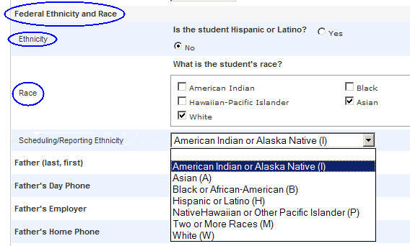

In 2011–12, the SCDE stopped collecting data from the separate Scheduling/Reporting Ethnicity field in PowerSchool.

1.2 Enrollment Date

PowerSchool Field Name | PowerSchool Location | Programs  Affected | Contact Person
School Entry Date | Transfer Information | See Appendix A | SCDE Technology Services

Promptly withdraw students who are no longer enrolled. A student should appear in a district’s database only once. Due to human error, sometimes a student will appear in a database twice. The enrollment date will help the SCDE resolve duplicates and determine which school to assign a student to.

Use the Entry Date found in the Transfer Information page. Although the entry date can be found on other screens, it is blocked (cannot be edited) in other locations.

1.3 Next School (SCPASS)

PowerSchool Field Name | PowerSchool Location | Programs  Affected | Contact Person
Next School Indicator | Scheduling Setup | SCPASS | SCDE Technology Services

The users will see a dropdown list with school names for their districts.

The Office of Assessment uses Next School values only as the fall assignment code for precoding grades 4-8 for SCPASS. Next school values from other grades are disregarded.

The field does not have to be populated in time for the precode print phase. However, it needs to be populated in time for the precode update phase for its intended use by the contractor.

When the data are transmitted to the contractor, the Next School field value is actually the last three digits of the 7-digit school ID instead of the school name. If the 3 digits do not correspond to the last 3 digits of a real school in the same district, the field will be treated as blank. If the field is blank, the testing contractor will assume the next school is the school the student is currently enrolled in. The field can be left blank for students who will remain in the same school the following school year. If the field was left blank and actually needs to be a non-blank value, the schools must provide the information by traditional means—manually coding the answer document or the answer document return forms with the appropriate fall assignment code.

1.4 Free/Reduced Meals Program

PowerSchool Field Name | PowerSchool Location | Programs Affected | Contact Person
Lunch Status | Lunch (under Administration) | See Appendix A | Roy Stehle

This field defaults to P (Full Pay).

Note: Migratory students who have a Certificate of Eligibility (COE) (i.e., those who have a check in the MIGRANT checkbox) automatically qualify for free meals (i.e., MEALS field value should be F). Homeless students (i.e., those who have a check in HOMELESS checkbox) automatically qualify for free meals (i.e., MEALS field value should be F).

- There are six codes that all PowerSchool users will see in the dropdown list. You will see the three codes from SASI (free, reduced, none), where None (N) is now listed as Full Pay (P). The three other codes will be used by districts that opt to use the PowerLunch application that works with PowerSchool.
- If your district does not use PowerLunch, indicate Free, Full Pay, or Reduced only. If you select the other codes by mistake, the SCDE will invalidate the values.
- If your district uses PowerLunch, contact the Office of Assessment (Aaron Brown, arbrown@ed.sc.gov, (803)734-0874) for precoding directions.

Full Description | Data File  Code | PowerSchool  Dropdown List  Description
The student is eligible for free meals status. | F | Free
The student is not eligible for free/reduced-price meals status. | P | Full Pay
The student is eligible for reduced-price meals status. | R | Reduced
For PowerLunch users only | E | Exempt
For PowerLunch users only | T | Temporary
For PowerLunch users only | FDC | Free-DC

1.5 Homeless Status

PowerSchool Field Name | PowerSchool Location | Programs Affected | Contact Person
Primary Nighttime Residence | Student Selection/Custom Screens/Homeless Student Information | See Appendix A | Linda Mirabal-Pace

PowerSchool access to the Homeless Student Information screen is restricted to designated employees. Contact your district’s Homeless Liaison for questions regarding access to this screen, homelessness eligibility, and unaccompanied youth identification. Your district’s Homeless Liaison is responsible for identifying homeless students and unaccompanied youth, and can authorize access to the Homeless Student Information screen.

Homeless status is based upon the following McKinney-Vento definition:
A homeless student is a child or youth who lacks a fixed, regular, and adequate nighttime residence. This includes:
- students who are sharing the housing of other persons due to loss of housing, economic hardship, or a similar reason; are living in motels, hotels, trailer parks, or camping grounds due to the lack of alternative adequate accommodations; are living in emergency or transitional shelters; are abandoned in hospitals; or are awaiting foster care placement;
- students who have a primary nighttime residence that is a public or private place not designed for or ordinarily used as a regular sleeping accommodation for human beings
- students who are living in cars, parks, public spaces, abandoned buildings, substandard housing, bus or train stations, or similar settings; and
- migratory students who qualify as homeless for the purposes of this subtitle because they are living in circumstances described above.

Unaccompanied homeless youth status is based upon the following definition:
- A homeless unaccompanied youth is a youth who is not in the physical custody of a parent or guardian and who meets the McKinney-Vento definition of homeless.
- There is no age range specified for an unaccompanied youth in the law. The upper age range is determined by what a state defines as school aged, unless the child is in special education in which case, the upper age range is twenty-one (21) years of age. There is no lower age range. As an example, a young child not in the physical custody of a parent or legal guardian, though living with a caregiver, and living in a situation that is not fixed, regular, and adequate, would be identified as a homeless unaccompanied youth.

Served by McKinney-Vento status is based on the following definition:
- The definition of “served” includes homeless children who have been served in any way through McKinney-Vento funds. Services would include both direct services, as outlined in the McKinney-Vento Act, and indirect services such as outreach activities completed by a staff member whose position is supported through McKinney-Vento funds.
- Include Age “Birth through 2” and Age “3 through 5-Not Kindergarten” children served by the subgrant program regardless of whether or not they were enrolled in a district-administered preschool program. While the children not in district preschool programs will not be in PowerSchool, the district McKinney-Vento Liaison will report this separate aggregate number to the McKinney-Vento State Coordinator for required federal reporting.

- Primary Nighttime Residence

Leave the field blank (default) for students who are not homeless. Upon homeless identification, enter the student’s initial primary nighttime residence. Do not update the field should the primary nighttime residence change or if the student is no longer homeless. It is important this field is entered for all homeless students since this field will be used to determine homeless status for federal and state reporting.

PowerSchool Dropdown List  Description | Full Description
S | Shelters, transitional housing, awaiting foster care
D | Doubled–up means sharing the housing of other persons due to economic hardship, loss of housing or other reasons (such as domestic violence).
U | Unsheltered includes cars, parks, campgrounds, temporary trailers including FEMA trailers, or abandoned buildings
H | Hotels/motels
The field defaults to blank.

- Unaccompanied Youth
PowerSchool Dropdown  List Description | Full Description
Blank | The student is NOT an unaccompanied youth.
Y | The student is an unaccompanied youth.
The field defaults to blank.

- Served by McKinney-Vento
PowerSchool Dropdown List  Description | Full Description
Blank | The student is NOT a homeless student.
Y | The student is a homeless student.
The field defaults to blank.

1.6 Migrant Status

PowerSchool Field Name | PowerSchool Location | Programs Affected | Contact Person
Migrant | Additional Student Information | See Appendix A | Jennifer Almeda

Checkbox | Full Description
Unchecked | The student is NOT a migratory student.
Checked | The student is a migratory student.
Note: DO NOT mass change this field except to clear it for all students.

Check the box to indicate a student is a migrant. A state-education-agency-reviewed (SEA-reviewed) and approved Certificate of Eligibility (COE) is required to determine eligibility for migrant status while resident and enrolled in a school district. The SEA may have a COE on a student, or a school district may obtain a COE. If the SEA has a COE on a student, the district will be notified via the Categorical eligibility list at the beginning of the school year. Districts should check if student names on that list are present within the district. If the students are present, their migrant field should be checked in PowerSchool. (Some students may have two last names and no middle name; be aware that such students may have been entered incorrectly with the first last name as a middle name.) If a school district obtains a COE on a student, the school district must provide the original, completed COE to the SEA Migrant Program. If you are unsure whether a student qualifies as a migrant, or if you need assistance in interviewing a child/family regarding their status and completing a COE, please contact Jennifer Almeda. Zachary Taylor may also be contacted at (803) 391-9393 or at ZTaylor@ed.sc.gov for help with completing a COE.

Categorical free meal service is automatic with migrant status (i.e., MEALS field value should be F). Eligibility for benefits while resident in the school district ends at the end of the third school year from the qualifying arrival date on the COE. The COE form is located on the Accountability Web site at http://ed.sc.gov/agency/programs-services/88/.

Migrant status is based on Federal law 107-110, Title I, Part C Section 1309(2), §200.81(e) of the Migrant Education Program (MEP) regulations, and the Office of Migrant Education (OME) Guidance Chapter II, Section A, and is defined as follows:
A migratory student is a student who is, or whose parent, spouse, or guardian is, a migratory agricultural worker, including a migratory dairy worker, or a migratory fisher, and who, in the preceding 36 months, in order to [seek or] obtain, or accompany such parent or spouse in order to obtain temporary or seasonal employment in agricultural or fishing work:
• has moved from one school district to another; or
• in a State that is comprised of a single school district, has moved from one administrative area to another within such district; or
• resides in a school district of more than 15,000 square miles, and migrates a distance of 20 miles or more to a temporary residence to engage in a fishing activity.

Qualifying work can include
- activities directly related to the production or processing of crops, dairy products, poultry or livestock for initial commercial sale or personal subsistence (this can include nursery work; picking, planting, preparing, weeding, pruning, etc. fields; working at a packing shed; etc.);
- activities directly related to the cultivation or harvesting of trees (this can include planting, pruning, weeding, collecting pine straw, etc.); or
- activities directly related to fish farms (this can include activities related to fishing and seafood catching, harvesting, cleaning, etc.).
For more details, see §200.81(a) and §200.81(i) of the MEP regulations and OME Guidance Chapter II, section G.

Section 2: ENGLISH FOR SPEAKERS OF OTHER LANGUAGES (ESOL) FIELDS

Read Appendix C on Coding Rules for LEP Students for further details.

2.1 Date Student Enrolled in School in the U.S.

PowerSchool Field Name | PowerSchool Location | Programs Affected | Contact Person
US Sch Entry Date | Additional Student Information | See Appendix A | Crystal Fields

The format for the date entry is mm/dd/yy with two digits for the month, date, and year (e.g., 02/02/06). This field should be left blank for students born in the United States, except for the RTN-US students selected in the “foreign country where student was born” field (see the next section below). Only students who were born in another country or U.S. territory should have a U.S. School Entry Date.

2.2 Foreign Country Where Student Was Born

PowerSchool Field Name | PowerSchool Location | Programs Affected | Contact Person
Birth Country | Additional Student Information | SCPASS | Crystal Fields

This field should be left blank for most students born in the United States. It is used for students born in a foreign country or U.S. territory, or for students who qualify as RTN-US. RTN-US identifies students who were born in the U.S., moved to the parents’ home country before entering school, and then returned to the U.S. and entered a U.S. school for the first time in third or higher grade.

2.3 English Proficiency

PowerSchool Field Name | PowerSchool Location | Programs Affected | Contact Person
English Prof | Additional Student Information | See Appendix A | Crystal Fields

IMPORTANT NOTES:
- This field must not be left blank. If PK students have 1–5 or A–D as their English Proficiency value, then their Cohort Group value must be “< 1 year of ESOL service” OR “at least 1 but < 2 yrs of ESOL service” and they must have an ESOL Instructional Models field value specified.
- For returning students, the “English Language Proficiency (ELP) assessment” is ACCESS for ELLs. For new students, it is the assessment used as an initial placement test (i.e., IPT, WMLS, LAS, W-APT).
- Beginning 2012–13, students who score as Fully English Proficient on an initial placement test do not need to take the English language proficiency assessment. See details in the table below.
- The value for a student in the current school year is not necessarily the same one as in prior school year. The values for students will be based on the last ELP assessment scores. It is the responsibility of the district test coordinator and/or the ESOL district coordinator to ensure the values are correct.
- If a student’s English Proficiency option is 1 through 5, you must select a decimal value from the field that displays to the right. You cannot submit the data entry until a decimal value from .1 to .9 is selected. If the English Proficiency option is 6 – 9 or A – D, the decimal field is not displayed. The same PowerSchool internal field stores the values 1.1 to 5.9 as well as 6 – 9 and A – D.
- ELDA scores from spring 2014 testing are whole numbers and are the score input in the language proficiency field for August. As PowerSchool is requiring a decimal places for values of 1 through 5, enter “.0” if the student’s score is a whole number. For example, enter “2.0” if the student’s score is 2.

Screenshot of a selection not requiring a decimal place (6-9; A-D) | Screenshot of a selection requiring a decimal place (1-5)

Data File Code | Full Description | Dropdown List  Description
Blank | NA | Select a value
1.0-1.9 | Student scored “Pre-functional” on an English language proficiency (ELP) assessment and is receiving ESOL services from mainstream or ESOL teacher(s).  - Used for any Kindergarten through 1st Semester First Grade Students scorning 26 or less on the W-APT  - Used for all 4K students with a language other than English on the Home Language Survey | Pre-functional
2.0-2.9 | Student scored “Beginner” on an ELP assessment and is receiving ESOL services from mainstream or ESOL teacher(s). | Beginner
3.0-3.9 | Student scored “Intermediate” on an ELP assessment and is receiving ESOL services from mainstream or ESOL teacher(s). | Intermediate
4.0-4.9 | Student scored “Advanced” on an ELP assessment and is receiving ESOL services from mainstream or ESOL teacher(s). | Advanced
5.0-5.9 | Student scored ELDA Level 5—may not be English Proficient at grade level. (Note: The level 5 score must be on a 3rd–12th grade ELDA test before a student can become Title III exited – ESL code 6.)  - A student could have a composite score higher than 5 on the W-APT but will result in the student not scoring FEP (A student must score a 5 in each of the four domains). | Initially Proficient
6 | Student scored proficient (Level = 5) once on a 3rd–12th grade ELDA test and is no longer funded by Title III—monitored and can receive accommodations on assessments.  - Used for any Kindergarten through 1st Semester First Grade Students scoring 27 or higher on the W-APT. The student will be monitored for two years. | 1st Year Exited
7 | Student is in second year of exited status—monitored and can receive accommodations on assessments.  - Used for any 2nd Semester First Grade Students through 12th Grade Student scoring at least 5 in each of the four domains of the W-APT. | 2nd Year Exited
8 | Former LEP student or Bilingual (student scored Fully English Proficient on an Initial Placement Test.) | English Speaker I
9 | Student is a native English speaker. | English Speaker II
A | Student scored “Pre-functional” on an ELP assessment and is not receiving direct ESOL services based on parent refusal. Served by mainstream teachers only. | Pre-Functional Waiver
B | Student scored “Beginner” on an ELP assessment and is not receiving direct ESOL services based on parent refusal. Served by mainstream teachers only. | Beginner Waiver
C | Student scored “Intermediate” on an ELP assessment and is not receiving direct ESOL services based on parent refusal. Served by mainstream teachers only. | Intermediate Waiver
D | Student scored “Advanced” on an ELP assessment and is not receiving direct ESOL services based on parent refusal. Served by mainstream teachers only. | Advanced Waiver
Note that LEP students should never be given an English Proficiency field value of 9.

The current ESEA Flexibility Waiver, which is used for accountability, can be found at:
http://ed.sc.gov/agency/lpa/documents/ESEA-Waiver-request-Final-amended-11-29-12.pdf.

2.4 Cohort Group and ESOL Instructional Models

PowerSchool Field Name | PowerSchool Location | Programs Affected | Contact Person
ELLI 01–09; ESOL 01–14 (listed under “Programs” when adding a new category) | ESOL and ELLI values are found on the same dropdown list.  Special Programs (under Enrollment; click ‘Add’ if none already there) | Title III | Crystal Fields

The Cohort Group (ESOL01–ESOL14) and ESOL Instructional Models (ELLI01–ELLI09) information are all in the Program dropdown list.

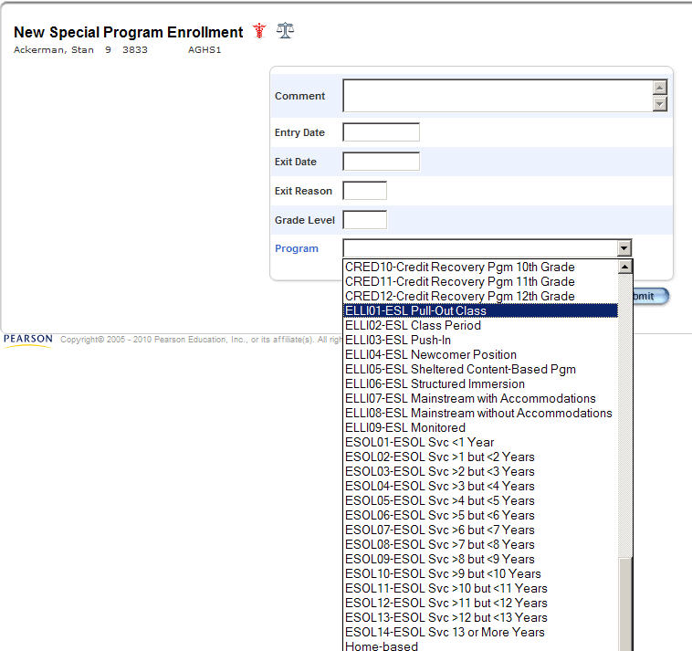

If you do not see the correct dropdown list, you must use the SCDE TECH NOTE #15 to correct the dropdown list entries (accessible through link below). Contact your district’s technology coordinator for more details.
http://ed.sc.gov/agency/rda/Power-School-Administration/PowerSchoolTechnologyNotes.cfm

2.4.1 Cohort Group (ESOL)

- This program service field is required for ESL 1–5 and A–D students and optional for ESL 6–8 students. The number of years of ESOL service time should be increased by one year at the start of each school year for every student still enrolled in the district.
- If PK students have 1–5 or A–D as their English Proficiency value, then their Cohort Group value must be “< 1 year of ESOL service” OR “at least 1 but < 2 yrs of ESOL service” and they must have an ESOL Instructional Models field value specified.

Data File Code | Dropdown List Description
A | < 1 year of ESOL service
B | at least 1 but < 2 yrs of ESOL service
C | at least 2 but < 3 yrs of ESOL service
D | at least 3 but < 4 yrs of ESOL service
E | at least 4 but < 5 yrs of ESOL service
F | at least 5 but < 6 yrs of ESOL service
G | at least 6 but < 7 yrs of ESOL service
H | at least 7 but < 8 yrs of ESOL service
I | at least 8 but < 9 yrs of ESOL service
J | at least 9 but < 10 yrs of ESOL service
K | at least 10 but < 11 yrs of ESOL service
L | at least 11 but < 12 yrs of ESOL service
M | at least 12 but < 13 yrs of ESOL service
N | 13 or more years of ESOL service

2.4.2 ESOL Instructional Models (ELLI)

Note: ELLI stands for English Language Learner Instruction.

- This program service field is required for ESL 1–5 and A–D students and optional for ESL 6–8 students. In the ELLI field, multiple choices can be made for one student, but the main purpose of this field is to record the primary way the student receives additional ESOL support.
- If PK students have 1–5 or A–D as their English Proficiency value, then their Cohort Group value must be “< 1 year of ESOL service” OR “at least 1 but < 2 yrs of ESOL service” and they must have an ESOL Instructional Models field value specified.

Data File Code | Dropdown List Description
1 | ESL Pull-out Class
2 | ESL Class Period
3 | ESL Push-In
4 | ESL Newcomer Program
5 | Sheltered Content-Based Program
6 | Structured Immersion
7 | Mainstream w/accom
8 | Mainstream w/o-accom
9 | Monitored

The Cohort Group (ESOL01–ESOL14) and ESOL Instructional Models (ELLI01–ELLI09) information are all in the Program dropdown list.

2.5 First Language Spoken

PowerSchool Field Name | PowerSchool Location | Programs Affected | Contact Person
1st Lang Spoken | Additional Student Information | Title III | Crystal Fields

Select the language the ESOL student first spoke. If the student was raised in a bilingual home with English as one language, select the other language. If the language is not listed on the drop down menu, select a language in the same linguistic family or select OTH (Other). This field should not be used for native English speakers. For Title III reporting, this field will be used rather than the Primary Language field.

Data File Code | Dropdown List  Description | Data File Code | Dropdown List  Description | Data File Code | Dropdown List  Description
blank | English | GRM | German | OTH | Other
ARB | Arabic | HMN | Hmong | PRT | Portuguese
CMB | Cambodian | HND | Hindi | RSN | Russian
CNT | Cantonese | JPN | Japanese | SPN | Spanish
FRN | French | KRN | Korean | TGL | Tagalog
GJR | Gujarati | MND | Mandarin | VTN | Vietnamese

Section 3: SPECIAL EDUCATION FIELDS

3.1 Alternate Assessment Eligibility

PowerSchool Field Name | PowerSchool Location | Programs Affected | Contact Person
Alternate Assessment | Precode | SC-Alt | Suzanne Swaffield

The field defaults to an N.

This is a new 2014–15 Y/N field that replaces last year’s alternate assessment codes which were based on the age and birth date reference sheet. This year, just select Y if the student meets the eligibility requirement for alternate assessment regardless of age or grade designation. Select Y even if the eligible student is in a grade that is not to be tested or is overage for testing. Otherwise, select N.

The SCDE will calculate students’ ages to that the proper test form is administered, but an age and birth date reference sheet is provided in Appendix B, for your convenience.

Data File Code | Full Description | Dropdown List Description
N, blank | N – No (not eligible for alternate assessment) | N – No
Y | Y – Yes (eligible for alternate assessment) | Y - Yes

The identification of students in the SC-Alt field in PowerSchool must be completed accurately for the January extraction. Errors in the coding of this field adversely affect the SC-Alt testing program and accountability calculations.

Frequently Asked Questions (FAQ)

Q: A student was inadvertently coded for SC-Alt during the print phase and was flagged as needing SC-Alt materials. What can we do to correct this?
A: Since SC-Alt materials are very expensive, report this error immediately to Aaron Brown (arbrown@ed.sc.gov; 803-734-0874). If the data have not yet been transmitted to the contractor, there is a chance the order can be dropped.

3.2 Alternate Assessment Exception

PowerSchool Field Name | PowerSchool Location | Programs Affected | Contact Person
Alternate Assessment | Precode | SC-Alt | Suzanne Swaffield

The field defaults to an N.

Data File Code | Dropdown List Description | Full Description
N | N – No | No exception
Y | Y – Yes | Exception

The values in this field will be ignored for 2014-15
because no student meets the 2014-15 exception criteria.

Details:
The 2014–15 exception criteria is defined relative to the 2014–15 alternate assessment High School age-eligibility criteria. In 2014–15, only students who are 16 need to take the alternate High School test. Therefore, the alternate assessment exception is: students who were not assessed with the high school form of the alternate assessment at age 16 last year (2013–14) due to district error may be assessed the following year (2014–15) at age 17. Because the 2013–14 SC-Alt High School age-eligibility criteria involved 15-year-old students and NOT 16-year-old students, the exception criteria does not apply to any students this year.

Age Eligibility Criteria for 2014–15 | Test Eligible For
The student requires alternate assessment and is 8–10 years old on September 1, 2014. | Alternate Elem School
The student requires alternate assessment and is 11–13 years old on September 1, 2014. | Alternate Middle  School
The student requires alternate assessment and is 16 years old on September 1, 2014. A student who is 17 years old may test under special circumstances described in the Details section above. | Alternate High  School
The student requires alternate assessment, and was younger than age 8, was age 14–15, or was age 17 or older on September 1, 2014. | Not age-eligible for alternate assessment

3.3 Alternate Assessment Test Administrator Name

PowerSchool Field Name | PowerSchool Location | Programs Affected | Contact Person
Alternate Assessment Test Administrator First Name | Precode | SC-Alt | Suzanne Swaffield
Alternate Assessment Test Administrator Last Name | Precode | SC-Alt | Suzanne Swaffield

These fields default to blank.

The first and last name of the test administrator for the alternate assessment should be entered into this free-form field. This field will be used to sort materials (see Section 10.3 for details). For students who do not test in an alternate assessment, this field should be left blank. It is possible to enter the name of the same teacher in several different ways, e.g., Jane Doe, J. Doe, Jan Doe. When this happens, the data will be alphabetized according to the name entered. Make every effort to make the data entry for this field consistent.

3.4 LEP Alternate Assessment

PowerSchool Field Name | PowerSchool Location | Programs Affected | Contact Person
Alternate Assessment | Precode | Not Used this Administration | Jill Christmus

The field defaults to an N.
Data File Code | Dropdown List Description | Full Description
Y | Y - Yes | The student will take the alternate LEP assessment.
N | N - No | The student will not take the alternate LEP assessment.
This field will not be used for this school year. Any values will be ignored.

3.5 504 Accommodations Plan

PowerSchool Field Name | PowerSchool Location | Programs Affected | Contact Person
504 Plan | Student Supplemental | See Appendix A | Fred Edora

Specify the substantially limited major life activity under which the student with a physical or mental impairment qualified for a 504 Accommodations Plan. The Office of Assessment transmits to testing contractors only overall Yes and No values to indicate whether a student has a 504 Plan.

Data File Code | Dropdown List Description
Blank | No Plan
BH | Breathing
CFO | Caring for Oneself
ET | Eating
HR | Hearing
IWO | Interacting with Others
LN | Learning
LT | Lifting
PMT | Performing Manual Tasks
SE | Seeing
SK | Speaking
THK | Thinking
WK | Walking
WOK | Working

3.6 Instructional Setting

PowerSchool Field Name | PowerSchool Location | Programs Affected | Contact Person
Instructional Setting | Additional Student Information | See Appendix A | Fred Edora

The Instructional Setting (IS) field should reflect the student’s current status at any given time during the school year. This, together with other fields, will be used to identify students receiving special education for state and federal accountability and reporting purposes. Incorrectly coding this field would complicate federal and state reporting.

- Each student, at any given time, will only be receiving one type of service: regular education (blank), special education (SE), or a 504 Plan (504).
- At the beginning of the year, use only blank, SE, or 504 with each student. If the student receives the same service throughout the school year, the code does not need to be changed.
- For any student that shifts from one type of service to another during the school year, use the SR, SP, RS, RP, PR, and RS codes where the first letter represents the current status and the second letter represents a prior status. For example, if a student was in regular education and then served through a 504 Plan, the code changes to PR.

Data File Code | Dropdown List Description | Full Description
Blank-default | Regular Ed – Full Yr. | The student received regular education for the entire school year.
504 | 504 Plan – Full Yr. | The student had a 504 Plan during the entire school year.
SE | Special Ed – Full Yr. | The student received special education for the entire school year.
SR | Currently SE, was Reg. Ed. | The student is currently in special education but had regular education immediately prior to the change in instructional setting.
SP | Currently SE, was 504 Plan | The student is currently in special education but had a 504 Plan immediately prior to the change in instructional setting.
RS | Currently Reg. Ed., was SE | The student is currently in regular education but had special education in the past during the current year.
RP | Currently Reg. Ed., was 504 Plan | The student is currently in regular education but had a 504 Plan immediately prior to the change in instructional setting.
PR | Currently 504 Plan, was Reg. Ed. | The student currently has a 504 Plan but had regular education immediately prior to the change in instructional setting.
PS | Currently 504 Plan, was SE | The student currently has a 504 Plan had special education in the past during the current year.

- For any student that shifts from one type to another more than once during the same school year, first look at the last two services received. Next, select the code that reflects the most recent change unless doing so removes any reference to special education in the sequence of services. Preserving reference to special education is the priority. Consider the following examples with the chronological sequence of services received by a student.

 | Chronological Sequence of Services | Sequence of Instructional Setting Field Values
Example 1 | regular education, 504, SE, 504 | Blank → PR → SP→PS
Example 2 | regular education, 504, regular education | Blank→ PR → RP
Example 3 | regular education, SE, regular education, 504 | Blank → SR → RS → PS (instead of PR)  If the first letter in the code is not S, always code S as the second letter once the student was receiving special education at any time during the school year.
Example 4 | SE, regular education, SE | SE → RS → SR  For the last code SR, the first letter S already indicates special education so the second letter can be an R.

3.7 True Grade

PowerSchool Field Name | PowerSchool Location | Programs Affected | Contact Person
True Grade | Additional Student Information | See Appendix A | Fred Edora

- The true grade reflects the grade level standards on which the student’s instruction is based or aligned. The true grade is populated when a student’s grade is not included in the school’s grade range in PowerSchool. This may occur when students are served at a location for administrative reasons rather than academic reasons. For example, a 7th grade student with special education services who is attending a K–5 school has a grade field value of 5 and a true grade field value of 7.
- State and federal accountability and reporting require the true grade value for special education students when the accurate grade level cannot be listed in the regular grade field or when a student remains until age 21 after completing instruction on or aligned to 12th grade. There are consequences for incorrectly coding this field.
- Populate true grade for students receiving special education (instructional setting field values of SE, SR, or SP) only when the regular grade field cannot represent the student’s actual grade level.
- The True Grade reflects age-level progression on grade level standards unless the student was retained in accordance with district policy for promotion/retention and the IEP team decision. For example, a student retained in the 2nd grade will repeat standards based on or aligned to the 2nd grade. In this case, the grade and true grade will remain 2nd grade for an additional year.
- Students are entitled to a Free and Appropriate Public Education (FAPE) until receipt of a regular high school diploma or reaching the maximum age of 21 prior to September 1 of the new school year. Therefore, students may be eligible to return for additional years after completing instruction on or aligned to the 12th grade. Use codes Z1–Z4 to designate additional years of attendance for students continuing in enrollment after completing the 12th grade. For example, a student received a district Employability Credential last year while in the 12th grade and returns this year to further develop his transition skills. He will be coded Z1 this year, Z2 next year, and so on. Such students should not be confused with students retained in the 12th grade. For example, a student who is retained due to failure of a required English credit and repeats this course in order to meet the requirements for a SC High School Diploma would remain in grade 12.

Data File Code | Dropdown List Description | Full Description
-2 | PK3 | Three-Year Preschool
-1 | PK4 | Four-Year Preschool
0 | K | Five-Year Kindergarten
1 | 1 | First Grade
2 | 2 | Second Grade
3 | 3 | Third Grade
4 | 4 | Fourth Grade
5 | 5 | Fifth Grade
6 | 6 | Sixth Grade
7 | 7 | Seventh Grade
8 | 8 | Eighth Grade
9 | 9 | Ninth Grade
10 | 10 | Tenth Grade
11 | 11 | Eleventh Grade
12 | 12 | Twelfth Grade
AE | Adult Education-ungraded | Adult Education- ungraded
Z1 | 1st yr. after 12th grade | First year of return after the 12th grade due to continued eligibility
Z2 | 2nd yr. after 12th grade | Second year of return after the 12th grade due to continued eligibility
Z3 | 3rd yr. after 12th grade | Third year of return after the 12th grade due to continued eligibility
Z4 | 4th yr. after 12th grade | Fourth year of return after the 12th grade due to continued eligibility

Section 4: SPECIAL IEP DISABILITY FIELDS

4.1 Deaf-Blindness

PowerSchool Field Name | PowerSchool Location | Programs Affected | Contact Person
Deaf-Blindness | Precode | See Appendix A | Anne Mruz

The field defaults to an N.

Data File Code | Dropdown List Description | Full Description
N | N – No | Does not apply to student
Y | Y – Yes | Deaf-Blindness

Deaf-blindness is defined as “concomitant hearing and visual impairments, the combination of which causes such severe communication and other developmental and educational needs that they cannot be accommodated in special education programs solely for children with deafness or children with blindness.”
(Reference: http://idea.ed.gov/explore/view/p/%2Croot%2Cregs%2C300%2CA%2C300%252E8%2C)

4.2 Multiple Disabilities

PowerSchool Field Name | PowerSchool Location | Programs Affected | Contact Person
Multiple Disabilities | Precode | See Appendix A | Anne Mruz

The field defaults to an N.

Data File Code | Dropdown List Description | Full Description
N | N – No | Does not apply to student
Y | Y – Yes | Multiple Disabilities

“Multiple disabilities” mean concomitant impairments, such as mental retardation-blindness, mental retardation-orthopedic impairment, etc., the combination of which causes such severe educational needs that students cannot be accommodated in special education programs solely for one of the impairments. The term does not include deaf-blindness.
(Reference: http://idea.ed.gov/explore/view/p/%2Croot%2Cregs%2C300%2CA%2C300%252E8%2C)

Section 5: CUSTOMIZED TEST BOOKLETS

To be used properly, the customized test booklet fields should be used in conjunction with the oral/signed administration fields. Consult the table in Section 7.
- These fields do not apply to SC-Alt.
- For ACCESS for ELLs, see Appendix O for information related to ordering materials.
- For Fall EOCEP, all paper orders must be submitted to the contractor through eDIRECT. Additional customized materials (i.e., those ordered after the eDIRECT deadline) should be ordered from the testing contractor. Use these PowerSchool fields for all testers, both paper and online; update phase data will be used to populate online test sessions for all students, enabling paper and pencil testers to test online if desired.
- For Spring EOCEP, only print phase data will count towards an order of paper customized materials at no cost to the district. Data from the update phase will not be used for ordering materials; additional customized materials (i.e., those ordered after print phase) should be ordered from the testing contractor. Update phase data will be used to populate online test sessions.
- For SCPASS Science and Social Studies, customized test booklet and oral/signed administration (student-level) materials will be provided automatically for new students who appear on the update precode file (no additional material order is necessary) at no cost to the district.
- On very rare occasions, a student might need more than one type of customized test booklet (e.g., loose leaf and large print). Only one type of material can be ordered through this field; the other type should be ordered through the contractor directly. Address the student’s needs through the contractor and district test coordinator.
- In cases where students will take more than one exam, e.g. SCPASS and EOCEP, material preferences indicated in these fields will apply for both testing programs.
- The fields for customized test booklets and oral/signed administration in the subject area are used across testing programs. A certain number of students may have to take SCPASS and EOCEP (e.g., 8th graders). For the vast majority of students, whatever materials are ordered for one testing program’s subject test will also apply for the other testing program’s corresponding test. Conflicts between these orders are extremely rare. In case of a conflict, contact the SCDE for further instructions.

PowerSchool Field Name | PowerSchool Location | Programs Affected | Contact Person
ELA Custom Materials | Precode | EOCEP (English) | Anne Mruz
Math Custom Materials | Precode | EOCEP (Algebra) | Anne Mruz
Science Custom Materials | Precode | EOCEP (Biology), SCPASS | Anne Mruz
Social Studies Custom Materials | Precode | EOCEP (USHC), SCPASS | Anne Mruz
LEP Reading Custom Materials | Precode | See Appendix O | Anne Mruz
LEP Writing Custom Materials | Precode | See Appendix O | Anne Mruz
LEP Listening Custom Materials | Precode | See Appendix O | Anne Mruz
LEP Speaking Custom Materials | Precode | See Appendix O | Anne Mruz

The field defaults to a 0.

SCPASS and EOCEP Dropdown List

Data File Code | Dropdown List Description | Full Description
0 | Not needed | No customized test booklet needed. Also, select this value for students who require a regular format (non-customized) Form A oral administration test booklet.
1 | Large print | Large Print (Form A). May also be used for a Form A oral administration.
2 | Loose leaf | Loose Leaf (Form A). May also be used for a Form A oral administration.
3 | Deaf/Hard of hearing | Test booklet for students who are deaf or hard of hearing (Form C/C-SL)
4 | Braille | Braille (Form C/C-BR)
Note: The Alternate Assessment Eligibility field should contain a value of N for all students testing SCPASS. If the Alternate Assessment Eligibility field contains a value of Y, any orders for SCPASS materials will NOT be fulfilled.

Section 6: ORAL/SIGNED ADMINISTRATION FIELDS

To be used properly, the oral/signed administration fields should be used in conjunction with the customized test booklet fields. Consult the table in Section 7.
- These fields do not apply to SC-Alt.
- For ACCESS for ELLs, see Appendix O for information related to ordering materials.
- For Fall EOCEP, all paper orders must be submitted through eDIRECT. Use these PowerSchool fields for all testers, both paper and online; update phase data will be used to populate online test sessions for all students, enabling paper and pencil testers to test online if desired.
- For Spring EOCEP, these fields should be used for both online and paper-and-pencil testers. Update phase data will be used to populate online test sessions.
- In cases where students will take more than one exam, e.g., SCPASS and EOCEP, material preferences indicated in these fields will apply for both testing programs.
- The fields for customized test booklets and oral/signed administration in the subject area are used across testing programs. A certain number of students may have to take SCPASS and EOCEP (e.g., 8th graders). For the vast majority of students, whatever materials are ordered for one testing program’s subject test will also apply for the other testing program’s corresponding test. Conflicts between these orders are extremely rare. In case of a conflict, contact the SCDE for further instructions.

PowerSchool Field Name | PowerSchool Location | Programs Affected | Contact Person
ELA Oral/Signed Admin | Precode | EOCEP (English) | Anne Mruz
Math Oral/Signed Admin | Precode | EOCEP (Algebra) | Anne Mruz
Science Oral/Signed Admin | Precode | EOCEP (Biology), SCPASS | Anne Mruz
Social Studies Oral/Signed Admin | Precode | EOCEP (USHC), SCPASS | Anne Mruz
LEP Writing Oral Admin | Precode | See Appendix O | Anne Mruz

The field defaults to a 0

SCPASS and EOCEP Dropdown List

Data File Code | Dropdown List Description | Full Description
0 | Not needed | No oral/signed administration materials are needed.
1 | Oral/Signed Administration Script | Oral/Signed Administration Script (Form A, C, C-BR, and C-SL). Signed administration script not available for EOCEP.
2 | Audio CD/CD-ROM | Audio CD/CD-ROM (Form A and C/C-BR) for paper/pencil and Human Voice Audio (HVA) for online.  Form A Audio CD-ROMs are now available for all grades of SCPASS;  Form C-BR CD-ROM not available for SCPASS.
3 | ASL DVD | ASL DVD (Form C/C-SL) for paper/pencil and Video Sign Language (VSL) for online.
4 | PSE DVD | PSE DVD (Form C/C-SL) for paper/pencil and Video Sign Language (VSL) for online.  Not available for SCPASS.
Note: The Alternate Assessment Eligibility field should contain a value of N for all students testing SCPASS. If the Alternate Assessment Eligibility field contains a value of Y, any orders for SCPASS materials will NOT be fulfilled.

Section 7: Customized Test Booklet and Oral/Signed Administration Fields for EOCEP and SCPASS

SCPASS/EOCEP Note: Students with an online testing designation as “N” are considered paper/pencil testers. However, student data will be loaded into Test Setup in eDIRECT and students will be placed into a test session. Students who test via paper/pencil do not have to be removed from the online test sessions.
EOCEP Note: For the spring administration, paper/pencil testers will receive test materials as ordered via precode or online enrollment, based on district ordering election.

Test  Materials | For the student who: | Customized Test Booklet Field | Oral/ Signed Administrat-ion Field | Online Testing Designation | SCPASS/EOCEP Action
Form A Test Booklet | needs a regular (non-customized) test booklet and does not need an oral administration | 0 | 0 | Y | Student will be placed into a test session as an online tester with a regular Form A test.
 |  |  |  | N | Student is considered a paper/pencil tester. Student will also be placed into an online test session and may test online if desired.
Form A Test Booklet  + Oral Administration Script | needs a regular or Form A oral administration test booklet and an oral administration (read aloud) by a test administrator (TA) | 0 | 1 | Y | Student will be placed into a test session as an online tester with an oral administration (HVA) accommodation and Form A oral administration test form.
 |  |  |  | N | Student is considered a paper/pencil tester. Student will also be placed into an online test session with above accommodations, and may test online if desired.
Form A Test Booklet  + Audio CD-ROM | needs a regular or Form A oral administration test booklet and an oral administration via computer | 0 | 2 | Y | Student will be placed into a test session as an online tester with an oral administration (HVA) accommodation and Form A oral administration test form.
 |  |  |  | N | Student is considered a paper/pencil tester. Student will also be placed into an online test session with above accommodations, and may test online if desired.
Form A Large-Print Test | needs large-print format (i.e., has difficulty reading standard size text) and does not need an oral administration | 1 | 0 | Y | Student will be placed into a test session as an online tester with a large-print accommodation and Form A test; student will also be given a paper copy of the Form A large-print test booklet.
 |  |  |  | N | Student is considered a paper/pencil tester. Student will also be placed into an online test session with above accommodations, and may test online if desired.
Form A Large-Print Test  + Oral Administration Script | needs large-print format (see above) and an oral administration by a TA | 1 | 1 | Y | Student will be placed into a test session as an online tester with large-print and oral administration (HVA) accommodations and Form A oral administration test form; student will also be given a paper copy of the Form A large-print test booklet.
 |  |  |  | N | Student is considered a paper/pencil tester. Student will also be placed into an online test session with above accommodations, and may test online if desired
Form A Large-Print Test  + Audio CD-ROM | needs large-print format (see above) and an oral administration via computer | 1 | 2 | Y | Student will be placed into a test session as an online tester with large-print and oral administration (HVA) accommodations and Form A oral administration test form; student will also be given a paper copy of the Form A large-print test booklet.
 |  |  |  | N | Student is considered a paper/pencil tester. Student will also be placed into an online test session with above accommodations, and may test online if desired.
Form A Loose-Leaf Test | needs loose-leaf format  (i.e., removable pages and/or 1 item per page)  and does not need an  oral administration | 2 | 0 | Y | Student will be placed into a test session as an online tester with a loose-leaf accommodation and Form A test; student will also be given a paper copy of the Form A loose-leaf test booklet.
 |  |  |  | N | Student is considered a paper/pencil tester. Student will also be placed into an online test session with above accommodations, and may test online if desired.
Form A Loose-Leaf Test + Oral Administration Script | needs loose-leaf format  (see above) and an oral administration by a TA | 2 | 1 | Y | Student will be placed into a test session as an online tester with loose-leaf and oral administration (HVA) accommodations and Form A oral administration test form; student will also be given a paper copy of the Form A loose-leaf test booklet.
 |  |  |  | N | Student is considered a paper/pencil tester. Student will also be placed into an online test session with above accommodations, and may test online if desired.
Form A Loose-Leaf Test + Audio CD-ROM | needs loose-leaf format  (see above) and an oral administration via computer | 2 | 2 | Y | Student will be placed into a test session as an online tester with loose-leaf and oral administration (HVA) accommodations and Form A oral administration test form; student will also be given a paper copy of the Form A loose-leaf test booklet.
 |  |  |  | N | Student is considered a paper/pencil tester. Student will also be placed into an online test session with above accommodations, and may test online if desired.
Form C Sign Language Test | is deaf or hard of hearing and does not need a signed administration | 3 | 0 | Y | Student will be placed into a test session as an online tester with the sign language (Form C/C-SL) test.
 |  |  |  | N | Student is considered a paper/pencil tester. Student will also be placed into an online test session with the accommodation above, and may test online if desired.
Form C Sign Language Test + Signed Administration Script | is deaf or hard of hearing and needs a signed administration by a TA | 3 | 1 | Y | NA for EOCEP  SCPASS student will be placed into a test session as an online tester with an ASL VSL accommodation and sign language (Form C-SL) test.
 |  |  |  | N | NA for EOCEP  SCPASS student is considered a paper/pencil tester. Student will also be placed into an online test session with the above accommodations, and may test online if desired.
Form C Sign Language Test + ASL DVD | is deaf or hard of hearing and needs a signed administration in ASL  via DVD | 3 | 3 | Y | Student will be placed into a test session as an online tester with an ASL VSL accommodation and sign language (Form C/C-SL) test.
 |  |  |  | N | Student is considered a paper/pencil tester. Student will also be placed into an online test session with the above accommodations, and may test online if desired.
Form C Sign Language Test + PSE DVD | is deaf or hard of hearing and needs a signed administration in PSE  via DVD | 3 | 4 | Y | EOCEP student will be placed into a test session as an online tester with a PSE VSL accommodation and sign language (Form C) test.  NA for SCPASS
 |  |  |  | N | EOCEP student is considered a paper/pencil tester. Student will also be placed into an online test session with above accommodations, and may test online if desired.  NA for SCPASS
Form C Braille Test Packet | reads classroom materials in Braille and does not need an oral administration | 4 | 0 | Y | Student will not be placed into a test session. Student is considered a paper/pencil tester.
 |  |  |  | N
Form C Braille Test Packet + Oral Administration Script | reads classroom materials in Braille and needs an oral administration by a TA | 4 | 1 | Y | Student will not be placed into a test session. Student is considered a paper/pencil tester.
 |  |  |  | N
Form C Braille Test Packet  + Audio CD/CD-ROM | reads classroom materials in Braille and needs an oral administration via computer (EOCEP) | 4 | 2 | Y | NA for SCPASS  EOCEP student will not be placed into a test session. Student is considered a paper/pencil tester.
 |  |  |  | N
INVALID Materials Combinations for Customized Test Booklet and Oral/Signed Administration Fields (EOCEP and SCPASS)

NOTE: If an invalid material combination occurs in the customized test booklet and oral/signed administration fields, the customized test booklet will be provided AND the oral/signed administration material will not be provided. For example, if a Braille test booklet (4 in the customized test booklet field) and an ASL DVD (3 in the oral/signed administration field) is ordered, the Braille test booklet will be provided, but the ASL DVD will not. Any additional materials that are needed as a result of invalid material combinations will be at the district’s expense. See the chart below for a list of possible INVALID material combinations for the testing programs indicated.

Customized Test Booklet | Oral/Signed Administration | Testing Programs | Additional Information
0, 1, 2 | 3, 4 | BOTH | ASL or PSE DVDs are not produced for Form A Test Booklets (regular, oral administration, large-print, and loose-leaf).  The test booklet will be provided. The ASL or PSE DVD will not be provided nor substituted.
3 | 1 | EOCEP only | Signed Administration Scripts are not available for EOCEP.  The Form C Deaf/Hard of hearing test booklet will be provided.  No oral/signed administration material will be provided.
3 | 2 | BOTH | Audio CDs/CD-ROMs are not produced for Form C/C-SL Deaf/Hard of hearing test booklets.  Form C/C-SL Deaf/Hard of hearing test booklet will be provided. The Audio CD/CD-ROM will not be provided nor substituted.
3 | 4 | SCPASS only | PSE DVDs are not available for SCPASS.  The Form C-SL Deaf/Hard of hearing test booklet will be provided.  No oral/signed administration material will be provided.
4 | 2 | SCPASS only | Form C-BR Audio CD-ROMs are not available for SCPASS.  The Form C-BR Braille test packet will be provided. No oral/signed administration material will be provided.
4 | 3, 4 | BOTH | ASL or PSE DVDs are not produced for Form C/C-BR Braille test booklets.  The Form C/C-BR Braille test packet will be provided. The ASL or PSE DVD will not be provided nor substituted.

Section 8: ONLINE ADMINISTRATION FIELDS

For the current school year, schools should ignore the HSAP Online and SCPASS Writing, ELA, and Math Online fields. ACCESS for ELLs is not available online this year, so LEP Online fields should be ignored as well. Any Y values for these fields will be ignored.

8.1 SCPASS ONLINE ADMINISTRATION FIELDS
for Science and Social Studies

PowerSchool Field Name | PowerSchool Location | Programs Affected | Contact Person
PASS Online - Science | Precode | SCPASS | Susan Creighton  and Sheila Graybeal
PASS Online - Social Studies | Precode | SCPASS | Susan Creighton  and Sheila Graybeal

The fields default to N.

Data File Code | Description | Full Description
Y | Yes | The student will take the test online.
N | No | The student will not take the test online.

These fields should be updated by the Spring Update phase in order to populate Test Setup for SCPASS online testing. It is critical that these fields have correct information during print phrase because paper-and-pencil materials will be printed and shipped using data provided. Students will be grouped for online administration according to the values in the Materials Sort field (see Section 11).

8.2 EOCEP ONLINE ADMINISTRATION FIELDS
for Algebra, English, Biology, and USHC

For Fall: These fields will be ignored for the print phase, but they will be used for the update phase. Districts must use eDIRECT for the fall.

For Spring: For the print phase, the districts will have the option to submit their counts for materials through eDIRECT or precode; if choosing precode, these fields must be completed for the print phase. These fields must be completed for the update phase, regardless of how counts are submitted.

These fields are ignored for any student who is not taking an EOCEP course. If a student is tested in the Spring but not the Fall, these fields are ignored during the Fall data collection.

PowerSchool Field Name | PowerSchool Location | Programs Affected | Contact Person
EOCEP Online - English | Precode | EOCEP (English) | Kirsten Hural
EOCEP Online - Algebra | Precode | EOCEP (Algebra) | Kirsten Hural
EOCEP Online - Biology | Precode | EOCEP (Biology) | Kirsten Hural
EOCEP Online - USHC | Precode | EOCEP (USHC) | Kirsten Hural

The field defaults to a Y since the majority of students take the tests online.

Data File Code | Description | Full Description
Y | Yes | The student will take the test online.
N | No | The student will not take the test online.

NOTE: An online administration value of ‘Y’ will be ignored if a value of ‘4’ is entered in the customized test booklet field.

Section 9: HOME ROOM

PowerSchool Field Name | PowerSchool Location | Programs Affected | Contact Person
Home Room | Modify Information | See Appendix A | Aaron Brown

This field can affect the way SCPASS materials are sorted. Read Section 10: How Materials Are Sorted and Section 11: Materials Sort Fields (SCPASS) for details. This field no longer impacts the sorting of SC-Alt materials.

The homeroom teacher information is in a free form field. That is, it is possible to enter the name of the same teacher in several different ways, e.g., Jane Doe, J. Doe, Jan Doe. When this happens, the data will be alphabetized according to the name entered. Make every effort to make the data entry for this field consistent. If you know that all the students have proper information in the Home Room teacher field and you approve of that sort order, then you need not do anything else. Leave the materials sort fields blank.

Enter the teacher’s last name, followed by a comma, and then the teacher’s first name (i.e., “last name, first name”). If a teacher’s name is entered inconsistently, the teacher will receive two or more different teacher rosters and test security checklists. The SCDE will use only the first twenty characters entered in this field.

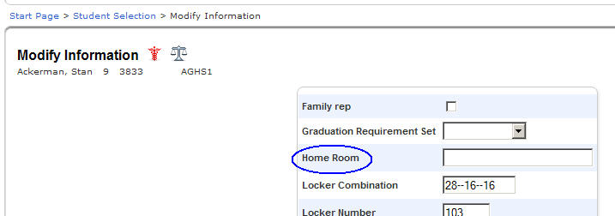

The Home Room field values for students remain the same from year to year unless the values are changed. Schools and districts have the option to reset the values to blank at the beginning of the school year by contacting District Services through http://ed.sc.gov/agency/rda/Power-School-Administration/TechnologySupportTeam.cfm (select the “Contact District Services Support” link). Resetting values eliminates the risk that values are not updated from prior school years. When names of teachers who are no longer with the school appear on the materials, this could be a sign that the Home Room field values were not updated properly.

In the past, there were two other homeroom-related fields in PowerSchool. These have been removed from the data entry portion of PowerSchool but are still in the database tables. Only the homeroom field described above is used for precoding purposes.

Section 10: How Paper-and-Pencil Test Materials Are Sorted

10.1 Order of SCPASS Test Materials

In order to complete these fields successfully for SCPASS at the school level, each school must first determine how each student will be tested (online or paper-and-pencil) for science and social studies.
Each student may test exclusively on paper-and-pencil, exclusively online, or a combination of both.

All students are loaded into the online testing system, regardless of their Online Administration fields.
Test sessions are according to the values in the Materials Sort fields as described below.

For online:
- Test session groups are determined by the science and social studies material sort field values.
Both the science and social studies material sort fields should be populated. (Regardless of how
the values are entered, each actual test session should not involve more than 50 students at a time according to the online testing contractor.)
  - If the science field is left blank, grouping for the science test will be determined by the
Home Room field.
  - If the social studies field is left blank, grouping for the social studies test will be determined by the Home Room field.
- You may, if you choose to, have the same value for both fields.

For paper-and-pencil:
- SCPASS uses the science materials sort field only because there is only one answer document for both tests. The following rules apply:
- If the science field is left blank, the social studies materials sort field will be used.
- If both the science and social studies materials sort fields are left blank, the Home Room field will be used.
- SCPASS uses these same sorting rules for students with labels generated from the update phase.

See section 11 for more information about the materials sort fields.

10.2 Order of EOCEP Test Materials

EOCEP paper-and-pencil materials are sorted alphabetically within each class.

10.3 Order of SC-Alt Test Materials

SC-Alt materials will be assigned and labeled for the teacher whose name is provided in the “Alternate Assessment Test Administrator Name” field (see Section 3.3). Enter the name correctly and consistently for each student. Any coding found in the SCPASS Materials Sort Fields will be ignored for students identified for alternate assessment.

Section 11: MATERIALS SORT FIELDS (SCPASS)

PowerSchool Field Name | PowerSchool Location | Programs Affected | Contact Person
Science Sort ID | Precode | SCPASS | Susan Creighton and Sheila Graybeal
Social Studies Sort ID | Precode | SCPASS | Susan Creighton and Sheila Graybeal
The field defaults to a blank.

SCPASS uses the Science and Social Studies materials sort fields. See section 10.1 for details. These fields will be used to sort materials for paper-and-pencil testing and to group students for online testing.

The data entered in these fields will determine the order and grouping of test materials and security checklists sent to schools for SCPASS. Pay special attention to the following information to ensure that materials are packaged appropriately.
- Use one of four options for the five sort fields:
- An alphanumeric entry up to 9 characters (e.g., 321, A12, AAA, etc.) to sort materials by teacher, test administrator, or other grouping;
- AWG to sort materials alphabetically within each grade; or
- blank to sort materials by home room field value.
Note: AWS (alphabetically within school) is no longer a valid sorting option.
- If information is entered in the materials sort fields, then these values will be used to sort materials.
- The SCDE removes leading spaces from the materials sort fields and uses only the first twenty characters of data. Therefore, leading spaces do not need to be entered.
- If no information is entered in the materials sort fields, then by default, the materials will be sorted and grouped according to home room field value. If you DO NOT want materials sorted by homeroom teacher, you MUST enter the necessary information in the materials sort fields.
- If ALL values (materials sort and home room fields) are blank, materials will be sorted alphabetically within grade.

Scenarios:
- If the school does not want its materials to be sorted according to the home room field value, then complete the materials sort fields. For example, if the materials are to be sorted alphabetically within grade, then put AWG in the materials sort fields.
- If you know all the students have proper information in the home room field and you approve of that sort order, then you need not do anything else. Leave the materials sort fields blank.
- If ALL values (materials sort and home room fields) are blank, materials will be sorted alphabetically within grade.

PACKAGING MATERIALS BY ALTERNATIVE SCHOOLS
- An entry (e.g., ALT) in the materials sort fields can be used to have materials packaged by alternative schools. By using this option, answer documents for students testing in ‘alternative’ sites would be packaged together to allow for easier distribution from the reported school (where materials are assigned and packaged) to the tested (e.g., alternative) school.

Section 12: PREVIOUS PROGRAM FIELD for 5-Year-Old Kindergarteners Only

PowerSchool Field Name | PowerSchool Location | Programs Affected | Contact Person
Kindergarten-Previous Program | Precode | For research needs | Penny Danielson

The field defaults to NA.
- For 5-year-old kindergarten students only, indicate the previous program the student was enrolled in as a four-year-old during the last school year. If there was more than one program, code the one in which the most time was spent. This field is required because it is the only way to identify Head Start program students from last year.
- For all other students, the value should be NA.

Data File Code | Dropdown List Description | Full Description
Hd | Head Start | The student was enrolled in Head Start last year.
N | None | The student was not enrolled in any 4-year-old program last year.
NA | Not in 5 yr Kdrgtn | Not applicable; the student is not currently enrolled in 5-year-old kindergarten.  That is, use NA for all students not in kindergarten.
O | Other | The student was enrolled in another type of pre-kindergarten program.
Prv | Private | The student was enrolled in a private program last year.
St | State | The student was enrolled in a state program last year.
Unk | Unknown | The student was enrolled in an unknown program last year.

Appendix A: PowerSchool Fields for Precode

This table summarizes the precoding requirements for the Office of Assessment by testing program. Precode data are used for a variety of purposes, including accountability and research. For example, Kindergarten-Previous Program is only used for research. Fields that are marked by an asterisk are used for the indicated testing program.
PowerSchool Display Name | PowerSchool Table | PowerSchool Internal Field Name | Assessment  Field Name | SCPASS | EOCEP | NAEP | ACCESS for ELLs | SC-Alt | SC Perf. Tasks | CogAT/IA
School Number | Schools(39) | School_Number | SchoolID | * |  | * | * | * |  | *
NA | Schools(39) | District_Number | District | * |  | * | * | * |  | *
School Name | Schools(39) | Name | School | * |  | * | * | * |  | *
Grade Level | Students(01) | Grade_Level | Grade | * |  | * | * | * |  | *
True Grade | Students(01) | SC_TrueGrade | True Grade | * | * | * | * | *
Name(Last, First MI) | Teachers(05) | Varies in PowerSchool | TeachName | * |  | * |  | *
State ID | Students(01) | State_StudentNumber | StateID | * |  |  | * | * |  | *
Student Number | Students(01) | Student_Number | StudentID | * |  |  | * | *
Name | Students(01) | Last_Name | LName | * |  | * | * | * |  | *
Name | Students(01) | First_Name | FName | * |  | * | * | * |  | *
Name | Students(01) | Middle_Name | MName | * |  | * | * | * |  | *
Gen (Jr., III, etc.) | Students(01) | SC_StudentGeneration | Generation | * |  |  | * | *
DOB | Students(01) | DOB | DOB | * |  | * | * | * |  | *
Gender | Students(01) | Gender | Gender | * |  | * | * | * |  | *
Ethnicity | Students(01) | FedEthnicity | Hispanic | * |  | * | * | * |  | *
Race | StudentRace(201) | RaceCD | RaceI, RaceA, RaceB, RaceP, RaceW | * |  | * | * | * |  | *
EFA Code Entry | VirtualTablesData2 | Varies in PowerSchool | EFA1 – EFA10 | * |  | * | * | * |  | *
Deaf-Blindness | Students(01) | SC_DeafBlindlnd | IEP_DB | * | * | * | * | * | *
Multiple Disabilities | Students(01) | SC_MultiDisablnd | IEP_MD | * | * | * | * | * | *
504 Plan | Students(01) | SC_Plan504Code | Plan504 | * |  | * | * | *
Instructional Setting | Students(01) | SC_InstrSetting | InstrSetting | * | * | * | * | *
EIA Code Entry | VirtualTablesData2 | Varies in PowerSchool | EIA1 – EIA10 | * | * |  | * | * | *
Lunch Status | Students(01) | LunchStatus | Meals | * | * | * | * | * | * | *
Primary Nighttime Residence | Students(01) | SC_Night_Residence | Homeless | * | * | * | * | *
Migrant | Students(01) | SC_Migrant | Migrant | * | * |  | * | * | *
Engl Prof | Students(01) | SC_Engl_Prof | English | * | * | * | * | * | *
Birth Country | Students(01) | SC_Student_BirthCntry | COB | * |  |  |  | *
1st Lang Spoken | Students(01) | SC_First_Lang_Spoken | FirstLang |  |  |  | * | *
US Sch Entry Date | Students(01) | SC_USSchEntryDate | USEntry | * |  |  | * | *
New Special Program Enrollment | SpEnrollments(41) | Varies in PowerSchool | ESOLCohort, ESOLModel |  |  |  | * | *
Alternate Assessment | Students(01) | SC_AltAssessCde | AltAssess |  |  |  |  | *
Alternate Assessment Exception | Students(01) | SC_AltAssessException | AltExcept |  |  |  |  | *
Alternate Assessment Test Administrator (First, Last) | Students(01) | SC_AltAssessTA_FirstName,  SC_AltAssessTA_LastName | AltTAFName, AltTALName |  |  |  |  | *
Home Room | Students(01) | Home_Room | TeachName | *
Science Sort ID | Students(01) | SC_ScienceSortID | SciSort | *
Social Studies Sort ID | Students(01) | SC_SocStudiesSortID | SocSort | *
ELA Custom Materials | Students(01) | SC_CustomELACde | ELACustom | * | *
Math Custom Materials | Students(01) | SC_CustomMathCde | MathCustom | * | *
Science Custom Materials | Students(01) | SC_CustomSciCde | SciCustom | * | *
Soc Stu Custom Materials | Students(01) | SC_CustomSocStuCde | SocCustom | * | *
ELA Oral/Signed Admin | Students(01) | SC_OralELA | ELAOralAdmin | * | *
Math Oral/Signed Admin | Students(01) | SC_OralMath | MathOralAdmin | * | *
Science Oral/Signed Admin | Students(01) | SC_OralScience | SciOralAdmin | * | *
Social Studies Oral/Signed Admin | Students(01) | SC_OralSocStudies | SocOralAdmin | * | *
LEP Alternate Assessment | Students(01) | SC_LEPAltAssess | LEPAltAssess
LEP Reading Custom Materials | Students(01) | SC_CustomLEPRead | ReadCustom |  |  |  | See Appendix O
LEP Writing Custom Materials | Students(01) | SC_CustomLEPWrit | WritCustom |  |  |  | See Appendix O
LEP Listening Custom Materials | Students(01) | SC_CustomLEPListen | ListenCustom |  |  |  | See Appendix O
LEP Speaking Custom Materials | Students(01) | SC_CustomLEPSpeak | SpeakCustom |  |  |  | See Appendix O
LEP Writing Oral Admin | Students(01) | SC_OralLEPWrit | WritOralAdmin |  |  |  | See Appendix O
SCPASS Online – Science | Students(01) | SC_PASSOnlineSci | SciOnline | *
SCPASS Online – Social Studies | Students(01) | SC_PASSOnlineSoc | SocOnline | *
EOCEP Online - Algebra | Students(01) | SC_EOCEPOnlineAlg | AlgerbraOnline |  | *
EOCEP Online - English | Students(01) | SC_EOCEPOnlineEng | EnglishOnline |  | *
EOCEP Online - Biology | Students(01) | SC_EOCEPOnlineBio | BiologyOnline |  | *
EOCEP Online - USHC | Students(01) | SC_EOCEPOnlineUSHC | USHCOnline |  | *
LEP Online -Reading | Students(01) | SC_ELDAOnlineRead | ReadOnline
LEP Online -Writing | Students(01) | SC_ELDAOnlineWrit | WritOnline
LEP Online -Listening | Students(01) | SC_ELDAOnlineListen | ListenOnline
LEP Online -Speaking | Students(01) | SC_ELDAOnlineSpeak | SpeakOnline
Next School | Students(01) | Next_School | NextSch | * |  |  |  | *
Entry Date | Reenrollments(18) | EntryDate | EnterDate | * | * |  | * | * | *
Entry Code | Reenrollments(18) | EntryCode | EnterCode | * |  |  |  | *
Zip Code | Students(01) | Zip | ZipCode |  |  | *

General Demographics (click “Demographics” under Information)
Precode Length | Power School Field Name | Field Description
40 | Name (last, first MI) | Three fields for last name, first name, and middle initial are after the same label. This field is for the last name.
20 | Name (last, first MI) | First Name
13 | Name (last, first MI) | Middle Initial
10 | Zip | Student Zip Code for Home Address
8 | DOB | Date of Birth
1 | Ethnicity | Latino question
1 each | Race | This contains the five Race codes.
1 | Gender | Gender
2 | Grade Level | Grade (Note: Cannot be edited on this page)
12 | Student Number | Student ID number in PowerSchool

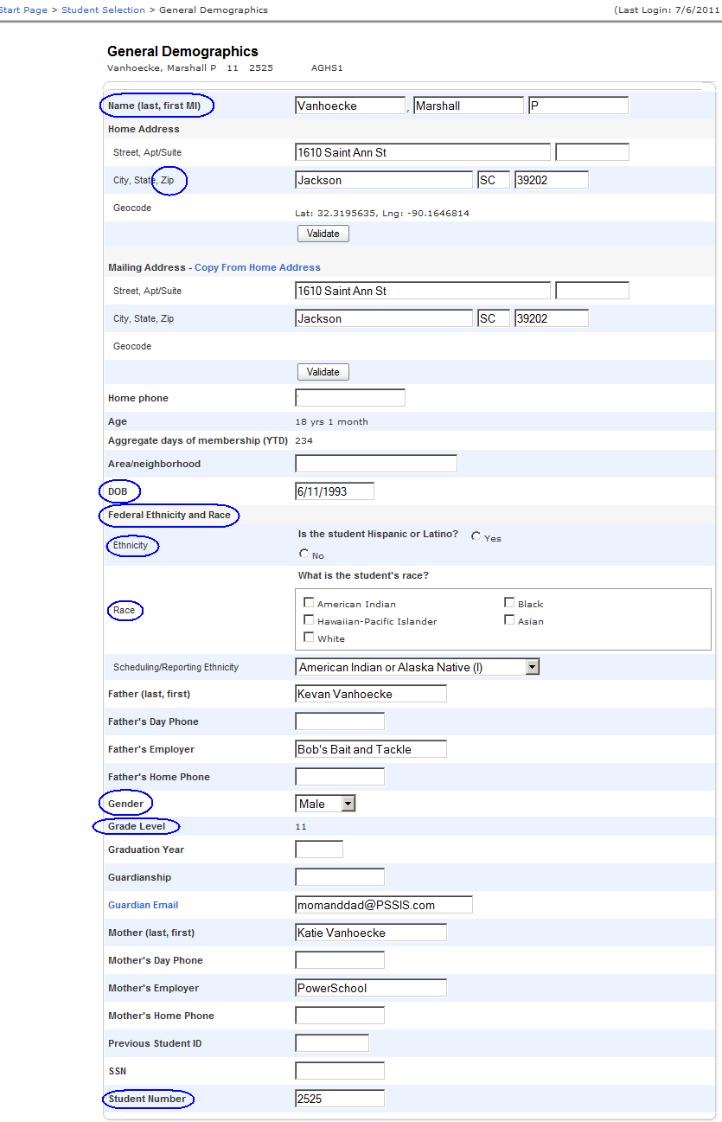

Modify Information (click “Modify Information” under Information)
Precode Length | Power School Field Name | Field Description
20 | Home Room | Homeroom teacher (last name, first name)

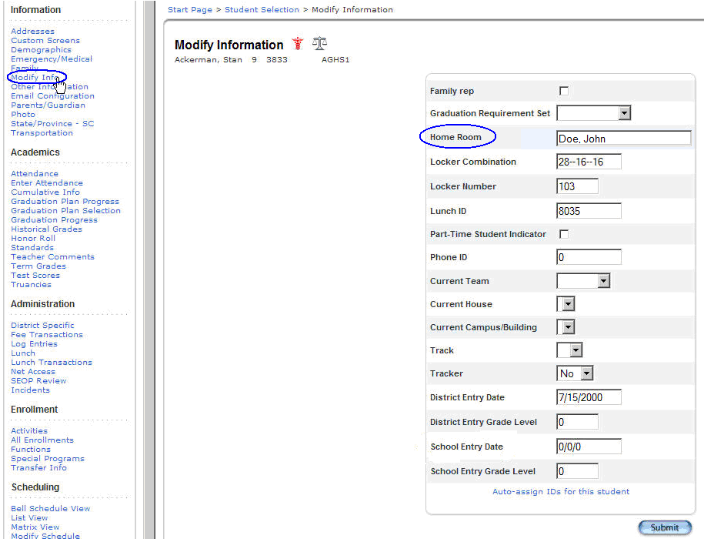

South Carolina State Information (click “State/Province – SC” under Information)
Precode Length | Power School Field Name | Field Description
10 | State ID | State ID number (Student Unique Numbering System [SUNS])

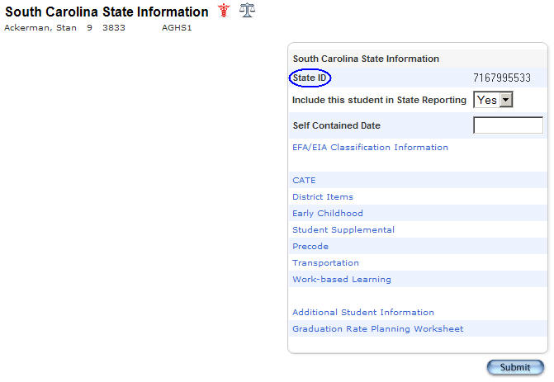

Additional Student Information (click “State/Province – SC” under Information)
Precode Length | Power School Field Name | Field Description
4 | Gen (Jr., III, etc.) | Student generation
8 | US School Entry Date | Date student enrolled in school in the U.S.
3 | English Prof | Proficiency level in English
3 | 1st Lang Spoken | First language spoken
5 | Birth Country | Birth country
2 | Instructional Setting | Instructional Setting
2 | True Grade | True Grade
1 | Migrant | Migrant status

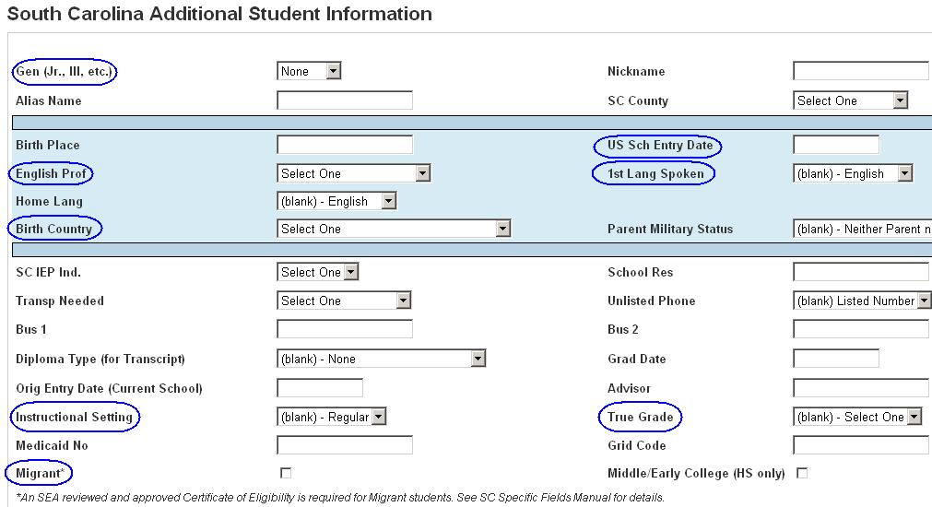

Student Supplemental Data Entry (click “State/Province – SC” under Information)
Precode Length | Power School Field Name | Field Description
1 | 504 Plan | 504 accommodations plan

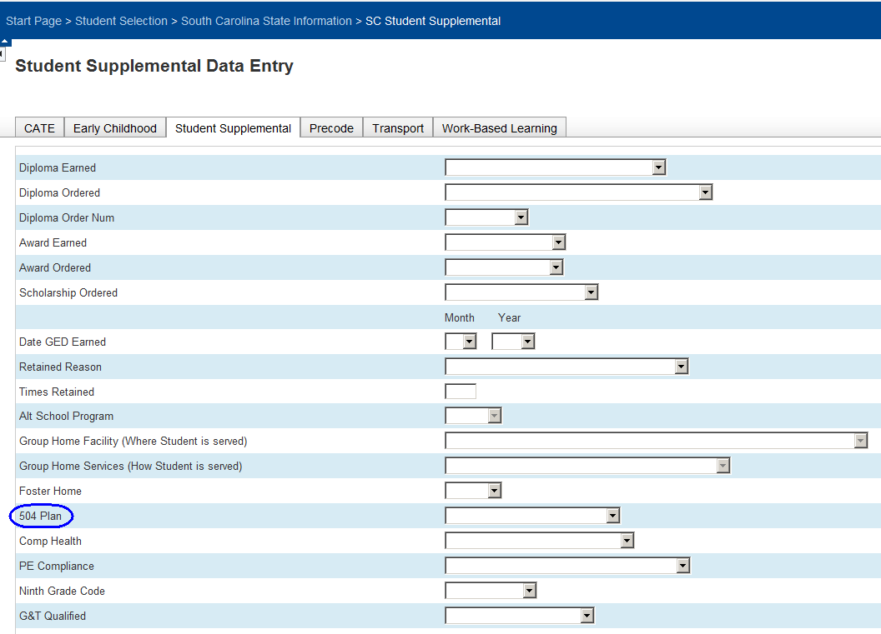

Precode Data Entry (click “State/Province – SC” under Information)
Fields on the precode tab that are not being precoded this year are highlighted grey in the table below.
At the time of this manual’s publication, it is uncertain if the LEP Custom Materials and Oral Admin fields will be used this school year; see Appendix O for details.
Precode Length | Power School Field Name | Field Description
1 | Alternate Assessment | Alternate assessment eligibility
1 | Alternate Assessment Exception | Alternate assessment: students requires alternate assessment but is not age-eligible
20 | Alternate Assessment Test Administrator First Name | Alternate assessment test administrator’s first name
20 | Alternate Assessment Test Administrator Last Name | Alternate assessment test administrator’s last name
1 | LEP Alternate Assessment | Alternate assessment eligibility for LEP test
1 | LEP Reading Custom Materials | Customized test booklet – Reading for LEP test
1 | LEP Writing Custom Materials | Customized test booklet – Writing for LEP test
1 | LEP Listening Custom Materials | Customized test booklet – Listening for LEP test
1 | LEP Speaking Custom Materials | Customized test booklet – Speaking for LEP test
1 | LEP Writing Oral Admin | Oral administration – Writing for LEP test
1 | Writing Custom Materials | Customized test booklet – Writing
1 | ELA Custom Materials | Customized test booklet – ELA
1 | Math Custom Materials | Customized test booklet – Mathematics
1 | Science Custom Materials | Customized test booklet – Science
1 | Social Studies Custom Materials | Customized test booklet – Social Studies
1 | Writing Oral/Signed Admin | Oral/Signed administration – Writing
1 | ELA Oral/Signed Admin | Oral/Signed administration – ELA
1 | Math Oral/Signed Admin | Oral/Signed administration – Mathematics
1 | Science Oral/Signed Admin | Oral/Signed administration – Science
1 | Social Studies Oral/Signed Admin | Oral/Signed administration – Social Studies
1 | PASS Online – Writing | SCPASS Online – Writing
1 | PASS Online – ELA | SCPASS Online – ELA
1 | PASS Online – Math | SCPASS Online – Math
1 | PASS Online – Science | SCPASS Online – Science
1 | PASS Online – Social Studies | SCPASS Online – Social Studies
1 | HSAP Materials | HSAP materials – ELA and/or mathematics
1 | HSAP Graduation Express | HSAP graduation express flag
1 | HSAP Online – ELA | HSAP Online – ELA
1 | HSAP Online – Math | HSAP Online – Math
1 | EOCEP Online – English | EOCEP Online – English
1 | EOCEP Online – Algebra | EOCEP Online – Algebra
1 | EOCEP Online – Biology | EOCEP Online – Biology
1 | EOCEP Online – USHC | EOCEP Online – USHC
1 | LEP Online – Reading | LEP Online – Reading
1 | LEP Online – Writing | LEP Online – Writing
1 | LEP Online – Speaking | LEP Online – Speaking
1 | LEP Online – Listening | LEP Online – Listening
3 | Kindergarten – Previous Program | 4-year-old program the 5-year-old kindergartener was enrolled in last school year
1 | Deaf-Blindness | Deaf-blindness
1 | Multiple Disabilities | Multiple disabilities
9 | Writing Sort ID | Writing materials sort field
9 | ELA Sort ID | ELA materials sort field
9 | Math Sort ID | Mathematics materials sort field
9 | Science Sort ID | Science materials sort field
9 | Social Studies Sort ID | Social studies materials sort field

Ignore the fields circled in red. They are not used for precoding this school year.

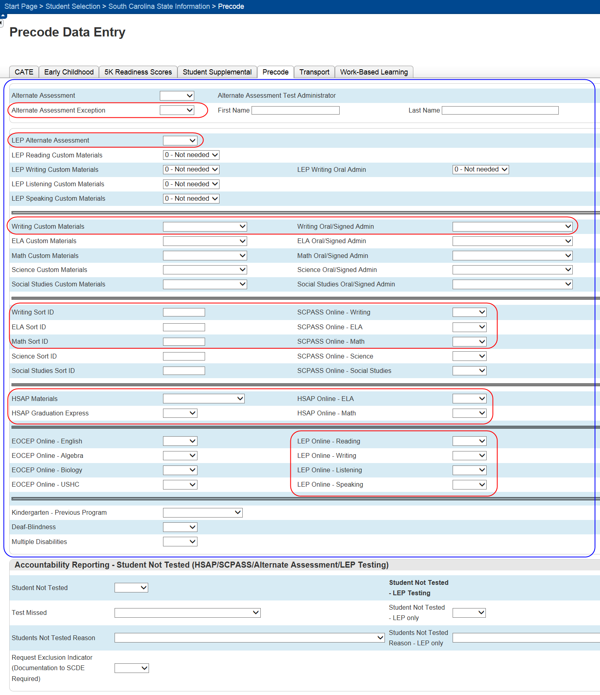

EFA Code Entry (click “State/Province – SC” under Information, click EFA/EIA Classification)
Precode Length | Power School Field Name | Field Description
4 each | EFA Primary, EFA 2-10 | Primary EFA code, second through tenth EFA codes

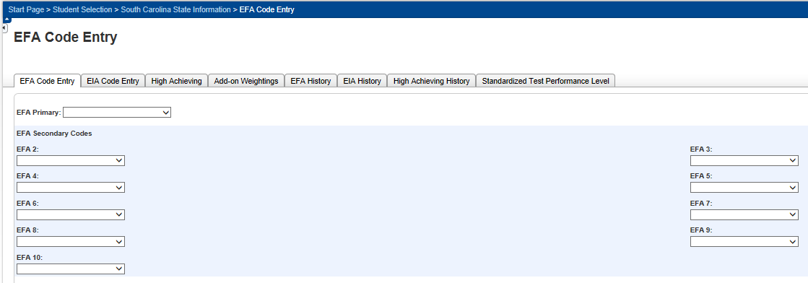

EIA Code Entry (click “State/Province – SC” under Information, click EFA/EIA Classification)
Precode Length | Power School Field Name | Field Description
5 each | EIA 1-10 | First through tenth EIA codes

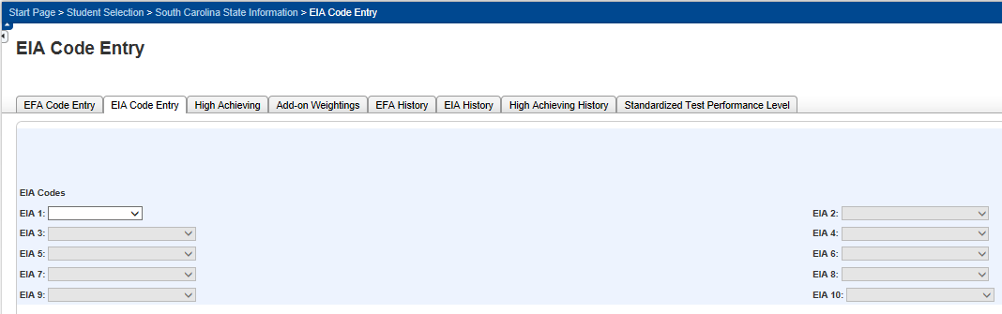

Lunch (accessed by clicking “Lunch” under Administration)
Precode Length | Power School Field Name | Field Description
1 | Lunch Status | Participation in the free and reduced meals program

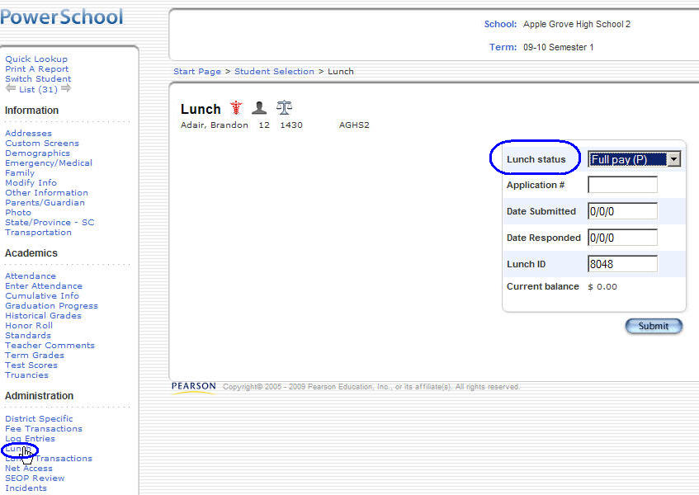

Special Programs (click “Special Programs” under Enrollment)
Precode Length | Power School Field Name | Field Description
1+10 | ELLI 01 – 09; ESOL 01-14 (listed under “Programs” when adding a new category) | In PowerSchool, the ESOL and ELLI values are found on the same dropdown list.

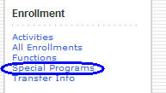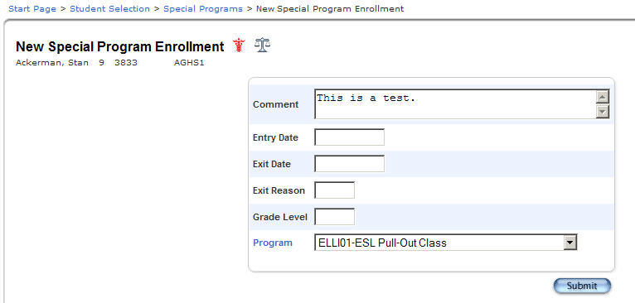

Transfer Information (click “Transfer Info” under Enrollment)
Precode Length | Power School Field Name | Field Description
3 | Entry Code | Enter code
8 | School Entry Date | Enrollment Date

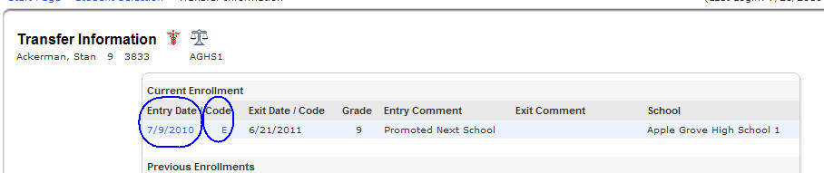

Scheduling Setup (click “Scheduling Setup” under Scheduling)
Precode Length | Power School Field Name | Field Description
3 | Next School Indicator | Next School Indicator
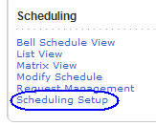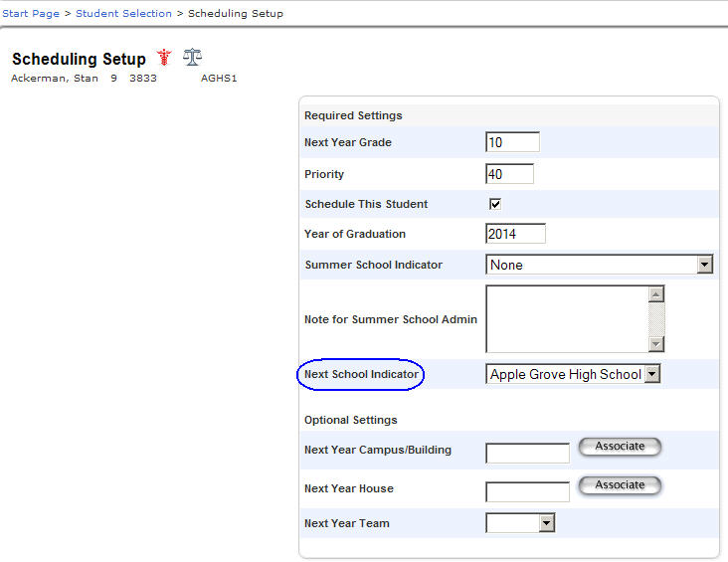

Staff: Edit Information (under Staff, not under Student data)
Precode Length | Power School Field Name | Field Description
20 | ID | Teacher number for the teacher currently assigned to a student
36 | Name (Last, First MI) | Teacher name associated with the teacher number (ID).

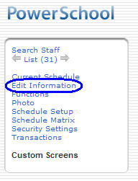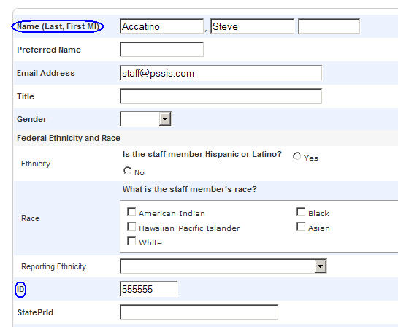

Appendix B: 2014–15 Alternate Assessment
Age and Birth Date Reference Sheet

Identifying Students for Alternate Assessment during the 2014–15 School Year and Required Precode Project Coding (Alternate Assessment field)

This chart pertains only to students who meet the participation criteria for alternate assessment and who are not participating in SCPASS.

See the 2014–15 Precode Manual
for Alternate Assessment Eligibility Coding Instructions

Age as of 9/1/14 | Corresponding  Birth Date Range |  | Alternate Assessment Required  2014–15
Age as of 9/1/14 | Beginning DOB | Ending DOB | Alternate Assessment Required  2014–15
5 | 9/2/08 | 9/1/09 | none
6 | 9/2/07 | 9/1/08 | none
7 | 9/2/06 | 9/1/07 | None
8 | 9/2/05 | 9/1/06 | Elem
9 | 9/2/04 | 9/1/05 | Elem
10 | 9/2/03 | 9/1/04 | Elem
11 | 9/2/02 | 9/1/03 | Middle
12 | 9/2/01 | 9/1/02 | Middle
13 | 9/2/00 | 9/1/01 | Middle
14 | 9/2/99 | 9/1/00 | none
15 | 9/2/98 | 9/1/99 | none
16 | 9/2/97 | 9/1/98 | High*
17 | 9/2/96 | 9/1/97 | none
18 | 9/2/95 | 9/1/96 | none
19 | 9/2/94 | 9/1/95 | none
20 | 9/2/93 | 9/1/94 | none
21 | 9/2/92 | 9/1/93 | none
*Students who were not assessed with the high school form of the alternate assessment at age 16 due to district error may be assessed the following year at age 17. This exception does not apply to any students in 2014-15.

Appendix C: 2014–15 PowerSchool Coding Rules for LEP Students

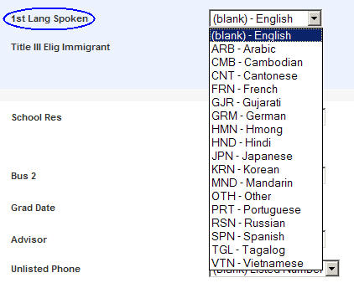
ESOL/LEP Students
Every student must have an English Proficiency (English Prof) code. Valid English Prof codes are 1–9 and A–D.
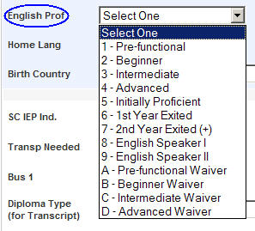
First Language Spoken
If the English Prof code is 1–8 or A–D, then the First Language Spoken field must have a valid value other than English.

The majority of English Prof 9’s (native English speaker) will have a blank First Language Spoken field value. (Blank is equivalent to English.) The few truly bilingual students fluent in both English and another language should have an English Prof code of 8 and First Language Spoken field value other than English. An ESOL and ELLI entry should not be present for a student with an English Prof code of 9.
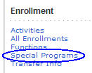
ESOL and ELLI (Student Program Services Atom)
If the English Proficiency code is 1–5 or A–D, then a current ESOL and one or more current ELLI entries are required. (Note: “Current” means the entry has a program Entry Date from the current school year and there is no Exit Date yet.)
- There may be only one current ESOL entry per student per school year. There may be more than one current ELLI entry.
Entry and Exit Dates
- The program Entry Date for active ESOL and ELLI entries must be later than the last day of school for the last school year.
- The SCDE will use the following rules to check for errors.
- Any current ESOL or ELLI entry with a program Entry Date from last school year (i.e., no later than the close of school for the last school year) will not be considered current.
- The ESOL and ELLI exit dates should not exceed the latest date that any school closes in S.C.

Bilingual, Exited, and Former LEP Students
For bilingual, exited, and former LEP students (English Prof code is 6, 7, or 8), ESOL and ELLI entries are optional but, when present, must follow the rules for those entries.

Immigrant Students
For immigrant students from English-speaking countries, the English Prof code is 9 and the US School Entry Date (US Sch Entry Date) and Birth Country fields must have values. Students born in the United States should not have a US Sch Entry Date or Birth Country. (A blank Birth Country and US Sch Entry Date field value is equivalent to the United States.)

Birth Country

Beginning in 2009–10, US Territory (e.g., American Samoa, Guam, Puerto Rico, U.S. Virgin Islands) is an option in the Birth Country dropdown list.
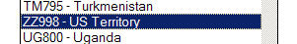

Note: The option RTN-US has been added to the dropdown list for Birth Country. This option is used to identify students who were (1) born in the US, (2) moved to parents’ home country before entering school, and (3) returned to the U.S. and entered a US school for the first time in grade three or higher. Select RTN-US and enter the correct date in the US Sch Entry Date field. Students in this specific circumstance might qualify for the first-year AYP exemption. The Title III office will closely scrutinize students in this category to insure that the RTN-US code is not misused.

DEFINITIONS

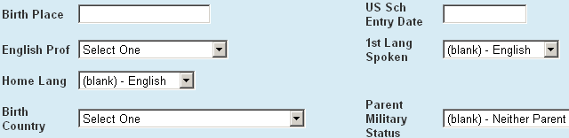

The US School Entry Date is the earliest date a student enters any US school. The first date does not change as students enter, exit, and re-enter US schools. For example, Juan was born in Mexico and entered a US school for the first time on October 3, 2001. He stayed in school for six months and then returned to Mexico. Six months later he returned to a US school. His US School Entry Date remains October 3, 2001.

A Title III-Eligible Immigrant has a birth country other than the US or a US Territory, and has been in US schools for three years or less. While there is a PowerSchool Title III Elig Immigrant checkbox for such students, SCDE does not use it and instead uses the U.S. School Entry Date to determine eligibility.

Mass Data Enrollment for ESOL and ELLI
Note: This process applies to all Special Programs.

This section provides instructions on how to mass enroll a group of students in existing Special Programs data.

This process may be accomplished at either the district or school level. Obviously, the process at the district level will allow the user to choose the special enrollment programs for all students served in the district versus those in any one particular school. Exceptions, such as students who are no longer served, must be handled on an individual basis.

- Login to PowerSchool.
- Select a particular school or choose to run the procedure from the district level.
- From the left hand menu, click on Special Functions.
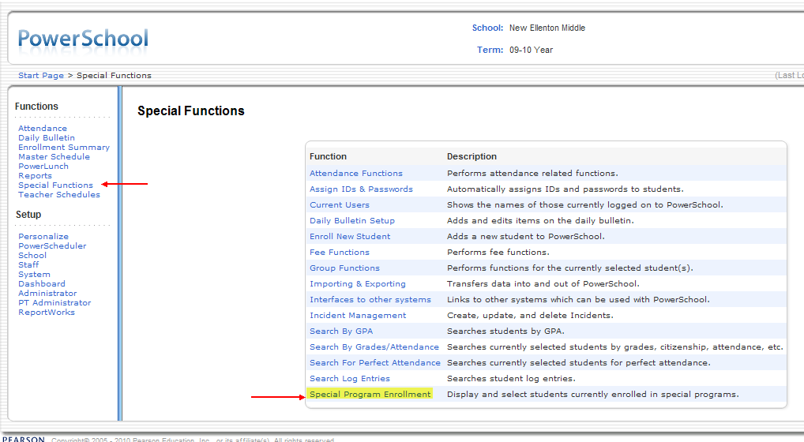

- Select Special Program Enrollment.

- Display the students of a particular special program.

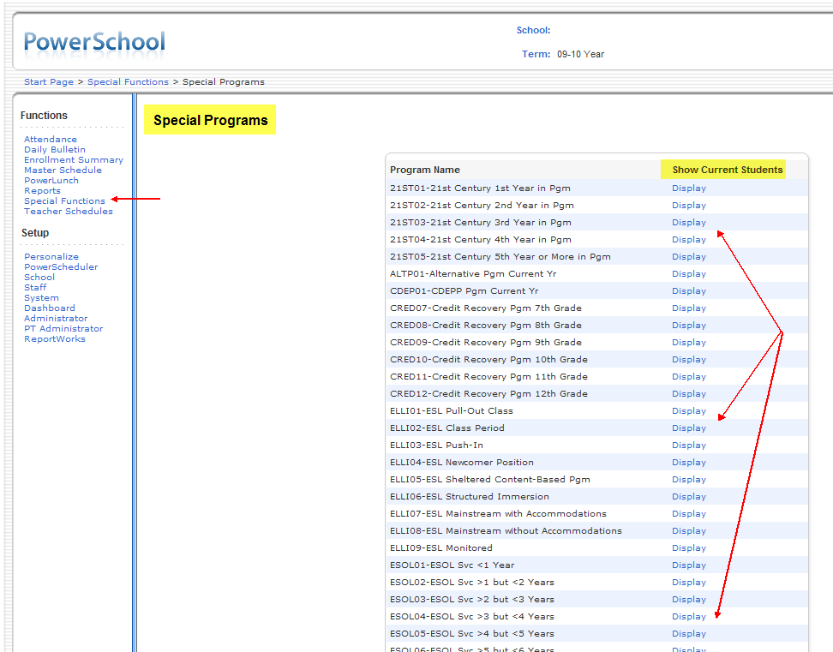

- Note: All students in the district served by that program or students served at a particular school will display dependent on login choices.

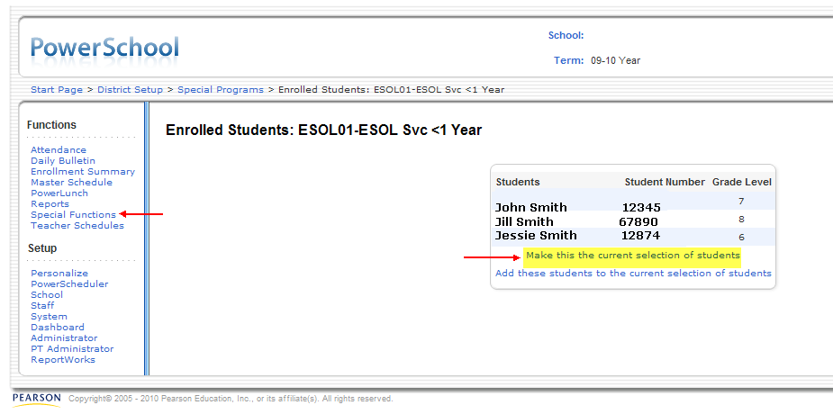
- Click Make this the current selection of students.

- You can now choose which students to group together within the desired program.

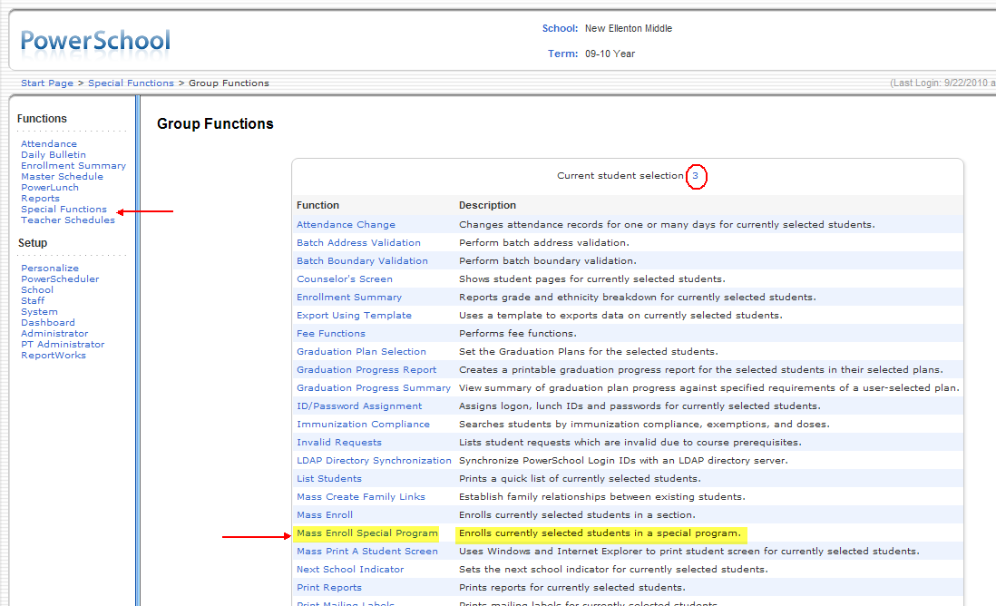

- Select the option to Mass Enroll Special Program.

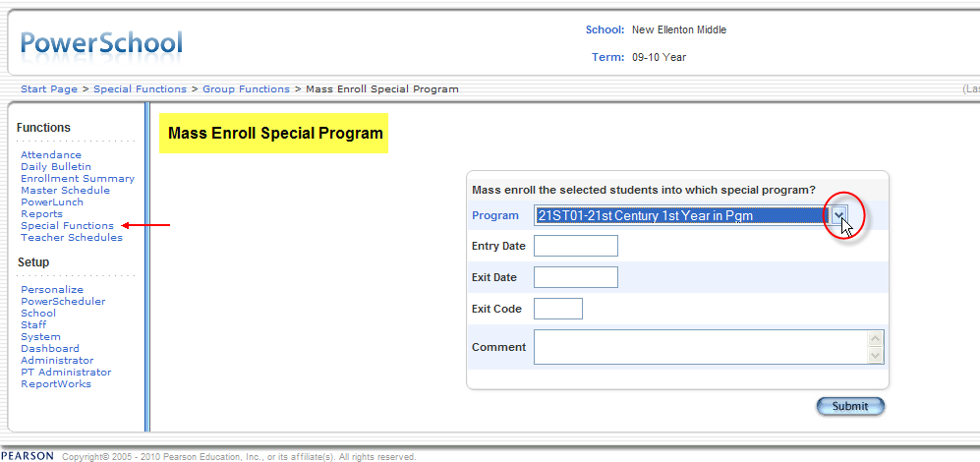

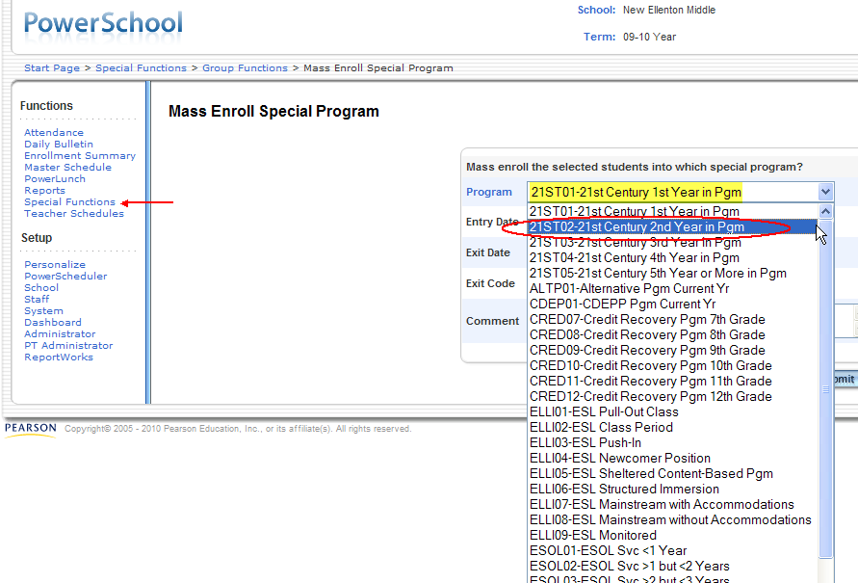

10. You may now mass populate the group of students’ Program, Entry Date, and other information as appropriate. Be sure to Click Submit.

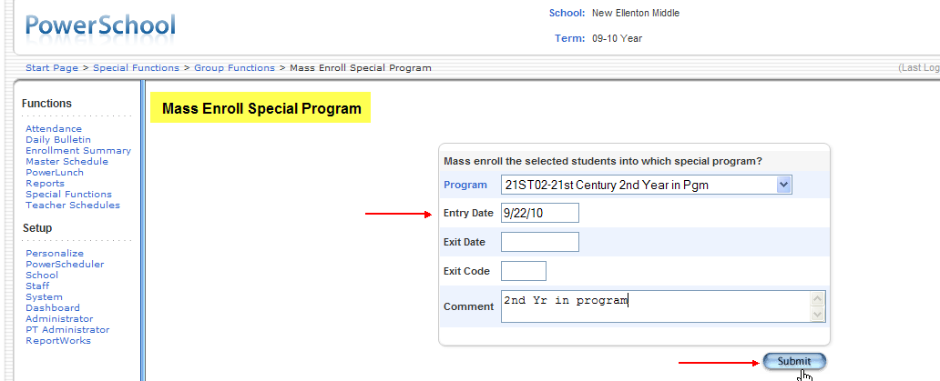

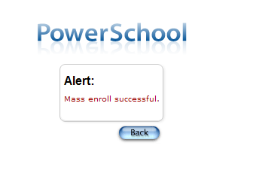

Instructions on how to input Special Program Enrollment Exit Dates for Students is available on the Technology Services Web page:
http://ed.sc.gov/agency/rda/Power-School-Administration/PowerSchoolManualsforS.C.Pages.cfm

Appendix D: EFA Coding for Students with Disabilities

There are ten EFA fields (the EFA Primary code, plus EFA Secondary codes from EFA 2 through EFA 10).
- K, P, EL, HS, HO, and VOC are not considered disabilities.
- For the beginning of a new school year, the EFA fields are emptied and defaulted to the student’s EFA designation based on grade value (e.g., K, PR for primary (grades 1-3), EL (grades 4-8), and HS (grades 9-12). All EFA codes should just reflect the codes for the current school year.
- If HO is used as the EFA Primary code and the student also has a disability, include the student’s disability code(s) in the EFA Secondary codes fields. The Office of Assessment needs to determine what the disability codes are for HO students.
- *OHI, *TBI, *PMD, and *DD do not have specific funding weights associated with them. These codes will be rolled into other EFA codes for funding purposes as specified in the EFA pupil classifications weighting table in the Pupil Accounting System Manual. For example, the *PMD code would be rolled into TM.

Each student in grades K–12 must have an EFA Primary code.
- Students in PK can only have one of two EFA code values: HH or VH.

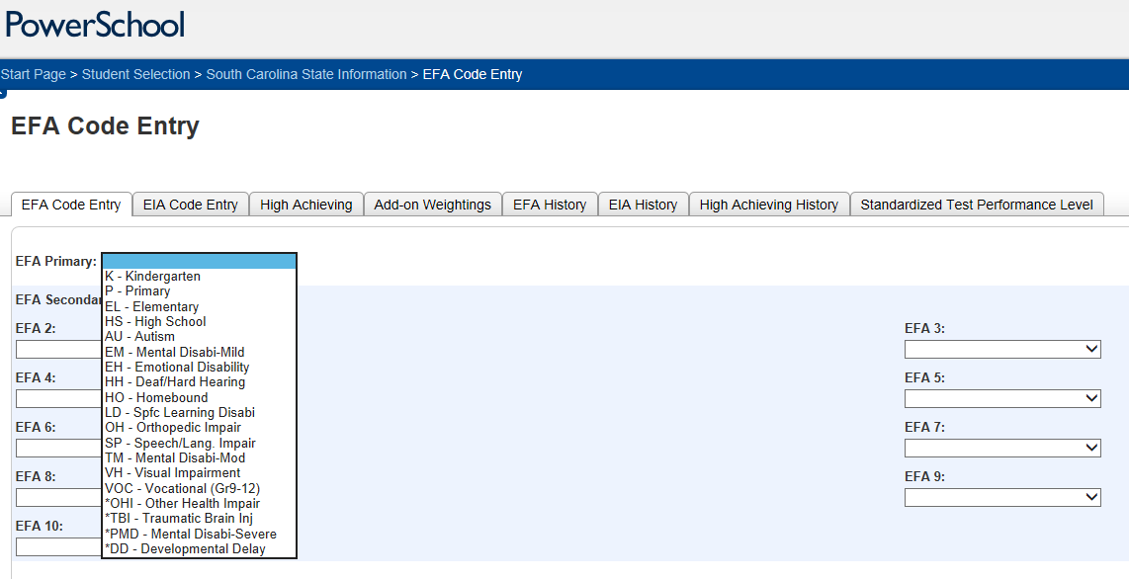

The EFA Primary code’s weight should have the highest funding weight among all EFA codes for the student. If a student has one or more active disability codes in addition to the EFA Primary code, enter the additional codes in the EFA Secondary Codes fields.

The table below provides a few of the common examples of the EFA coding for students who have one or more active disability codes other than the EFA Primary Code.
Example | EFA Primary Code | EFA2 | EFA3 | EFA4 | Description / Notes
Student 1 | HO | TM |  |  | A homebound student (HO) also has a disability of TM.
Student 2 | HO |  |  |  | Student is HO but does not have an EFA disability.
Student 3 | AU | EM |  |  | Student is both AU and EM.
Student 4 | VH | PMD |  |  | A VH student is also PMD.
Student 5 | VH | HH | PMD |  | A VH student is also HH and PMD.
Student 6 | SP | EMD |  |  | An EMD student is in Speech (SP).
Student 7 | SP | LD |  |  | A LD student is in Speech (SP).

EFA codes do not automatically roll over in PowerSchool from year to year. Students should only have as EFA codes for a particular school year those codes that apply and are currently active during that school year. The SCDE discourages maintaining inactive eligibility codes in the EFA fields; however, if it is necessary for a district to maintain this information, these inactive codes may be entered into EFA 6 through EFA 10.
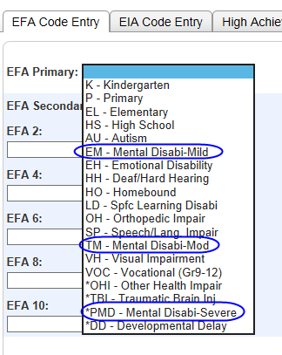
There has been a change in terminology which is not reflected in PowerSchool. The Office of Special Education Services uses the term Intellectual Disability instead of Mental Disability. If a student has an Intellectual Disability (mild, moderate, or severe), Mental Disability (mild, moderate, or severe) should be entered into PowerSchool.

Appendix E: NAEP Precoding

In the spring of 2015, a sample of students in grades 4, 8, and 12 will participate in NAEP. District test coordinators are notified of NAEP school selections each year in June. For each school selected for the sample, the SCDE is responsible for providing student demographic data to the NAEP sampling contractor.

Because the data are due to the contractor in November, the SCDE must use data collected during QDC1. If you have questions regarding data required for NAEP, contact Chris Webster at cwebster@ed.sc.gov or (803) 734-5721.

The following fields are collected for NAEP during QDC1:

School Information
- District
- SchoolID (School ID)
- School
- Home Room (Homeroom Teacher)

Student Information
- LName (Last Name)
- FName (First Name)
- MName (Middle Name)
- DOB (Date of Birth)
- Gender
- Latino Question
- five Race fields
- Grade
- Instructional Setting
- True Grade
- EFA1–EFA10
- Deaf-Blindness
- Multiple Disabilities
- Meals (Lunch Status)
- English Prof (English Proficiency)
- Student ZIP Code

Appendix F: Logging Into the SCDE’s Web Site

To create a new account:
- Go to www.ed.sc.gov.

- Click the login link at the top right corner of the page.

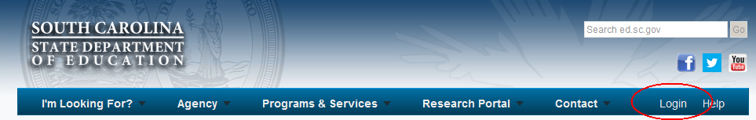

- On the login page, click “Create Account”

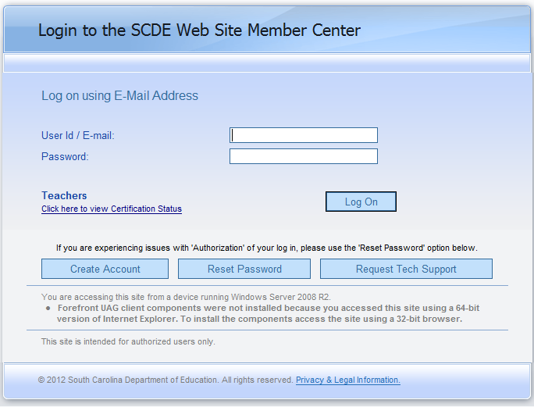

- Enter your information and click submit.

- Your information will be sent to your District’s Web Access Coordinator (WAC) to be approved. Upon approval, you will receive an e-mail with your account information.

If you experience trouble logging into your current account or forgot your password, click the “Reset Password” button (see image under step 3, above). The system will take you through a series of steps to reset your password.

Appendix G: District Precode Project Best Practices

This appendix contains tips and insights for both new and experienced precode coordinators. A few district staff members were surveyed in 2007–08 in order to compile this material. We thank them and their colleagues for sharing their district experiences with us.
- Lynn Liebenrood, Dillon Two
- Debi Gilliam and Dale Alston, Dorchester Two
- Diane Wingate, Georgetown
- Diane Dogan and Jim Dugan, Greenville
- Herbert Shrieves, Horry
- Russ Bowling, Lexington One
- Gregg Bibb, Oconee

If you wish to contribute to this appendix, contact Aaron Brown in the Office of Assessment via e-mail at arbrown@ed.sc.gov with the subject line of “Precode Best Practices.”

Note: The state began its transition to PowerSchool (PS) in 2008–09. References in this appendix to the SASI coordinator were changed to SIS (student information system) coordinator in 2009–10.

The Precode Coordinator

The precode coordinator is typically a person who does not exclusively work on the precode project but manages the precode project in addition to his/her (often many) other duties. Districts vary in size and capabilities and have a variety of configurations. There are districts where:
- Only the SIS coordinator is in charge of precode. The Director of Technology sometimes serves as the SIS coordinator. (Larger districts may have more than one SIS coordinator.)
- Only the district test coordinator is in charge of precode. (In larger districts, the district test coordinator may have several people assisting him/her.)
- The SIS coordinator (a technology representative usually) and the district test coordinator work together.
- Other (e.g., the PS, precode, and district test coordinators are the same person)

Collaboration With Stakeholders
The precode project is a partnership and team effort between assessment and technology (PS, precode, and test coordinators; PS school-level operators), with additional support from the accountability coordinator and student program experts (e.g., guidance counselors, special education teachers, ESOL teachers). Program coordinators are responsible for data within their area.
- Create lines of communication between the stakeholders in order to develop a robust system so that each person has a working knowledge of the others’ duties.
- Understand and communicate how report cards and AYP are dependent on QDC, precode, assessment, and data quality. The “big picture” view will help you convey the importance of the project and justify the effort required. Helping constituents understand the process may be one of the most difficult challenges districts face.

Things You Need To Know

If you are new to PS and the precode project, it helps to work with someone who knows PS and to have an experienced precode coordinator in a nearby district to call. It is helpful if the precode coordinator knows about the following:

- how your district has handled the precode project in the past
- the different areas the precode project has an impact on (Tip: Create a precode reference book that has assessment, accountability, and student program services [e.g., special education, ESOL] resources that help you see how the pieces fit together.)
- assessments and how data are used for state and federal accountability (Tip: Know who your district report coordinator is and read data advisories from that person and ask questions.)
- various coordinators in your district (ESOL, Special Education, etc.) and how to request their assistance with the precode project as needed
- who works with PS/Precode Project in schools (Tip: Create a list by school of PS and/or Precode contacts. Ask principals to identify their school’s contact person.)
- PS (Tip: Be able to navigate within PS and find the fields that are part of the precode project. Keep up-to-date with PS since its template or appearance can change from year to year.)
- PS fields that are part of the precode project and their correct codes (Tip: Read the precode manual and take advantage of training provided by the SCDE.)
- how districts should validate their PS data prior to submitting data to the SCDE
- how districts submit PS data to the SCDE
- how to use the Data Quality and Reporting Application
- types of customized test booklets and oral/signed administration materials (Tip: Have a copy of the test administration manuals available online in PDF form. School personnel may also contact their school’s test coordinator or their school’s special education contact person for this information.)

Create Timelines
Develop a plan for how your district wishes to manage the precode project and create a timeline. Start the process early and do not wait until the last minute. The SCDE only recommends the following general timeline due to differences in district calendars.
- District Precode Coordinators finish training no later than September.
- School-level personnel are trained no later than the end of October.
- Data are entered and checked periodically from November until the precode project ends.
Here are ideas from a few districts:
- The first meeting about precode is in October when the district is getting ready for the 45-day report.
- The district sends out data quality reports listing number of precode errors by school to district administrators and principals for visibility of issues. Weekly reports are sent out in November/December and daily during the last ten days.
- The district communicates with the schools daily during the precode window in January and the update window in March. However, weekly communication and school visits start in December in an attempt to help the district be ready in January.

Importance Of Data Quality

“Pay now or pay later.” In the areas of precode, testing, and accountability, this motto reminds us that data quality is critical. Plan ahead, check your data constantly, and your efforts will be worth it in the end.
- Understand the process. Don’t just assume certain things are true. If you are not absolutely sure, ask questions and investigate.
- Check and recheck the data periodically. If you do not check your data, do not assume your data are correct. Errors go undetected when data are not checked. When you catch errors, study how they occurred so that you will be better equipped to prevent similar errors in the future.
- Emphasize the importance of data quality to your stakeholders. Explain what, when, and why things need to be done. Also explain the consequences of poor data quality.

Data Quality Strategies

Your district’s data quality is an indicator of how ready your district is to submit its final precode data. Data quality control, an ongoing process, can be checked through the following means:
- Perform multiple extracts for precode and have several rounds of data validation.
- Use the error-checking reports.
- Get a list of students and the values that need to be entered into PS. Make sure the values are entered. Keep track of students whose data have already been entered so that you do not need to enter the same data repeatedly.
- Check the frequency of the responses for each variable. For example, if you know you have many alternative school program students and yet no one appears to be coded as such, then there is an error.
- Spot check randomly selected student records.
- Run data checks prior to QDC extractions, examine the data, and distribute the SCDE data validation reports with error feedback to the schools.
- Send the error feedback reports to the schools several times (weekly or daily as the need arises) during the precode window.
- In smaller districts, members of the district office may each take a school and check that school’s precode data.
- One district sends each principal the error report. The principal goes over the file with the school’s data team and signs off that it is correct or that they made the necessary changes in PS. They must also report what changes were made in PS.
- The SIS coordinator analyzes the precode data extractions, reviews the data, and reminds the schools to check their reports. Principals are constantly reminded of the importance of correct data when extraction times are nearing. The superintendent also provides reminders during principal meetings.
- In one district, the contract for PS system operators was extended to 245 days per year.
- Some districts have their own computer programs that check for errors in their PS data.
- Some districts are able to view their precode data in Excel and Access. They might provide Microsoft Excel and Access training for PS data personnel clerks to enable them to filter and query PS data for omissions and errors.

Strategies For Training District And School Personnel

Do not assume that stakeholders understand the precode project. Train them every time like they have never heard it before. Communicate with them regularly throughout the school year.
- Training
  - District leaders train school PS data entry personnel and test coordinators and go through the state’s precode manual and review requirements and procedures. Answer questions about assessment-related issues and PS fields.
  - One district requires all PS system operators, guidance counselors, ESOL teachers, and special education liaisons from each school to attend the annual precode meeting. The district test coordinator conducts the meeting, 2 to 3 hours long, and answers testing- and accountability-related questions with the district SIS coordinators at hand to answer PS questions.
  - In another district, the training includes each school’s data team (the principal, PS operator, school test coordinator, guidance counselors, and special education chairperson). The training lasts from 3 to 3½ hours. Follow-up school visits are made as needed.
- E-mail (information and reminders, especially about deadlines)
- Other mechanisms
  - Reminders are announced during all testing in-service days.
  - Reminders are included in district’s online bulletin or electronic newsletter that is e-mailed to its constituents.
- Meetings
  - Hold regular, monthly, or quarterly general PS meetings. (Some districts meet with all levels at the same time or divide their meetings for elementary, middle, and high school groups.)
  - If someone else organizes PS meetings, request to be included on the agenda for those meetings.
  - Try to get on the agenda of the district’s principal meeting to inform principals of what the precode project requires. It is important to gain the support of the principal for this process.
- Create a district version of the precode manual if you do not wish to use the state’s precode manual as is.
  - You may annotate or revise the state’s precode manual to suit your district’s needs.
  - Distribute the precode manual as soon as possible. If you use a district version, send only the district version to avoid confusion.
  - Examples of additions include a timeline of tasks with dates, participation guidelines for HSAP and alternative assessment, and a form for ESOL teachers to use.
  - Some districts add the syntax for PS queries that assist in data checking for every precode field. Strategies for mass data changes may also be presented. Mass updates are convenient. However, users must be careful not to introduce invalid values using this method. For example, although PS limits gender values to M and F, another value can enter the gender field accidentally via a mass update query.

Appendix H: Advanced Data Transfer System (ADTS) Site Tutorial

If you need access to ADTS, please contact your district Web Access Coordinator (WAC).

1. Login to the SCDE website.

2. Click on “Advanced Data Transfer System” under Web Applications
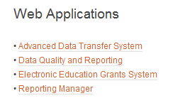

3. You may need to enter your login information again to enter ADTS.

4. Once you are logged in, click on “Browse Data Files” button in the upper lefthand corner.
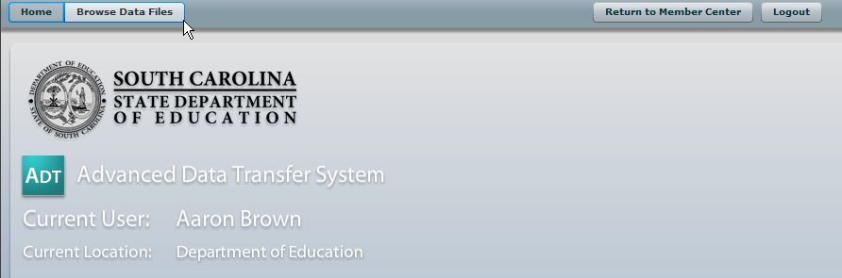

5. From here you can look at the files you have access to, likely your district and/or school. The Location Selector on the left lets you choose which district or school’s folder you are looking in. The Data File Browser on the right lets you look at individual files. Note that the Office of Assessment will post files to your Assessment folder; other offices may post files to other folders.
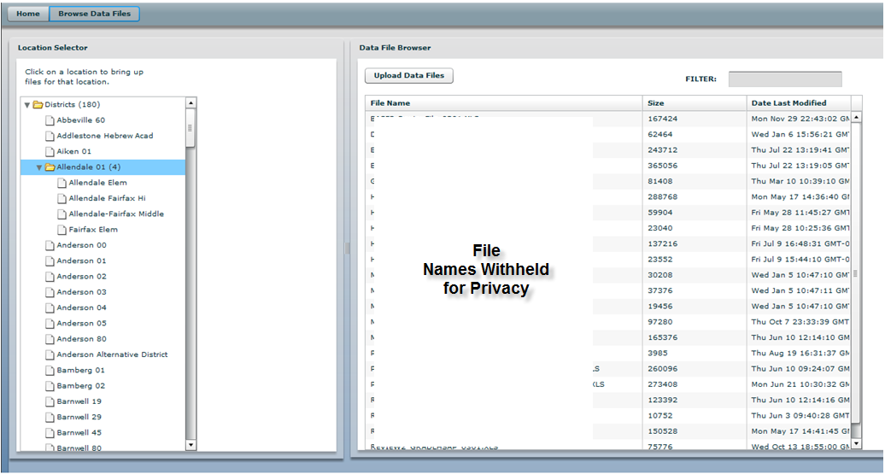

6. Click the “Upload Data Files” button to load data files. ADTS has been updated to allow users to upload a number of file types, including .csv, .txt, .xls, .xlsx, .doc, and .docx. However, if you receive an error message after trying to upload a file, please resave it as a different file type and attempt to upload again.
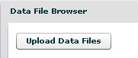

7. You can open or download a data file by clicking on it. (It sometimes takes a few seconds after your click for the options to appear. Please be patient.)

Appendix I: Alternative School Program List

These numbers should only be used for site identification. All student-level data should be reported to the student’s home school. If you have questions regarding the alternative school list, contact Aveene Coleman at acoleman@ed.sc.gov or (803) 734-3057.

District | Alternative School Program | Number
Abbeville | - Abbeville County Alternative School | 0160750
Aiken | - The Center for Innovative Learning at Pinecrest | 0201750
Allendale | - Allendale-Fairfax Learning Center | 0301750
Anderson 1-5 | - Anderson County Alternative School | 0470750
Barnwell 19 | - Blackville-Hilda Alternative School | 0619750
Barnwell 29 (Williston) | - Williston School District Alternative Learning Center | 0629750
Barnwell 45 | - Guinyard Bulter Middle School Alternative School | 0645750
Beaufort | - Right Choices | 0701750
Berkeley | - Berkeley Alternative School | 0801750
Calhoun | - Calhoun County Opportunity School | 0901750
Charleston | - Daniel Jenkins Creative Learning Center  - CCSD Summit Program | 1001755  1001750
Cherokee | - Copeland Academy | 1101750
Chester County School | - The Learning Center | 1201750
Chesterfield County School District | - Palmetto Learning Center | 1301750
Clarendon 1 | - Clarendon One Alternative School | 1401750
Clarendon 2 | - Outdoor Youth Development Program | 1402750
Clarendon 3 | - Youth Learning Institue | 1403750
Colleton | - Colleton County Alternative Program | 1501750
Darlington | - Darlington County Intervention School | 1601750
Dillon 3, & 4 | - Dillon County Academy for Academic and Career Advancement | 1704750
Dorchester 2 | - Givhans Alternative Program | 1802750
Dorchester 4 | - Odyssey Educational Center Jenkins Hill Campus | 1804750
Edgefield | - Edgefield County School District Alternative Program | 1901750
Fairfield | - Gordon Odyssey Academy | 2001750
Florence 1 | - Alfred Rush Academy | 2101750
Florence 2 | - HPEM Career Education Alternative Program (CEAP) | 2102750
Florence 3 | - Alternative Center for Education | 2103750
Florence 4 | - Timmonsville Alternative Learning Center | 2104750
Florence 5 | - Florence School District 5 Alternative Program | 2105750
Georgetown | - Howard Optional Program | 2201750
Greenville | - Sullivan Center High School Alternative Program  - West Greenville Middle School Program  - Donaldson Middle School Program  - Bonds Middle School Program | 2301752  2301758  2301753  2301750
Greenwood 50 | - Genesis Education Center | 2450750
Greenwood 51 | - Alternative School Program of Ware Shoals | 2451750
Greenwood 52 | - Ninety Six Learning Center | 2452750
Hampton 1 | - Hampton One Academy for Success | 2501750
Hampton 2 | - The Host Learning Center | 2502750
Horry | - Horry County Education Center | 2601751
Jasper | - JCAP-Jasper County Alternative Program | 2701750
Kershaw | - Continuous Learning Center | 2801750
Lancaster | - Barr Street Learning Center | 2901750
Laurens 55 | - Preparatory Academy | 3055750
Laurens 56 | - Institute for Student Advancement | 3056750
Lee | - Lee County Academic Learning Center Alternative School Program | 3101750
Lexington 1 | - FOCUS Program | 3201750
Lexington 2 | - Pair Education Center | 3202750
Lexington 3 | - Lexington III SIR Program | 3203750
Lexington 4 | - Swansea High School Alternative Program | 3204750
Lexington/Richland 5 | - Academy for Success | 3205750
Marion County | - Success Academy | 3410750
Marlboro | - AMIkids Infinity School Marlboro | 3501750
McCormick | - The REAL Academy | 3301750
Newberry | - Newberry Alternative School (NAS) | 3601750
Oconee | - Code Academy Middle/High | 3701750
Orangeburg 3 | - Students Actively Fostering Effective Change (SAFE-C) | 3803750
Orangeburg 4  Bamberg 1 & 2 | - STAR Center for Learning | 3804750
Orangeburg 5 | - Nelson C. Nix Educational Center for Excellence | 3805750
Pickens | - C3-Career, College and Citizenship | 3901750
Richland 1 | - Olympia Learning Center | 4001750
Richland 2 | - Blythewood Academy  - Anna Boyd School | 4002750  4002751
Saluda | - Saluda Opportunity Academy | 4101750
Spartanburg 1-7 | - Spartanburg County Alternative School Program | 4207750
Sumter County | - Brewington Academy | 4301750
Union | - Union County Achievement Academy | 4401750
Williamsburg | - HOPE Academy | 4501750
York 1 | - York One Academy | 4601750
York 2 | - Blue Eagle Academy | 4602750
York 3 | - Renaissance Academy  - Phoenix Academy  - Rebound Alternative Program | 4603750  4603751  4603752
York 4 | - Fort Mill Alternative School Programs | 4604750

Appendix J: Adult Education Program List

The following is a complete list of adult education sites, sorted by the fiscal agent district ID.
- The districts in bold are the fiscal agent for the adult education site; this is relevant for certain sites which serve multiple districts. For example, Bamberg 1 is the fiscal agent for the Bamberg/Barnwell Adult Education site (0501551), which serves Bamberg 1, Bamberg 2, Barnwell 19, Barnwell 29, and Barnwell 45.
- The Site SIDN column contains the ship-to site IDs. This value should be entered as the tested and reported school IDs for EOCEP. In most cases, this SIDN corresponds to the fiscal agent (ex. 0160551 is the site SIDN for 0160); exceptions are noted in the table below.
- The SC Charter School District (4701), as well as special districts (SIDN begins with 5) besides Palmetto Unified (5209), do not have adult education programs and are not listed below.
- It is possible for the adult education school list to change from year to year.

If you have questions regarding the adult education school list, contact Jennifer Cooper-Keels at jckeels@ed.sc.gov or (803) 734-8070.

District ID | District Name | Site Name | Site SIDN
0160 | Abbeville | Abbeville Adult Education | 0160551
0201 | Aiken | Aiken Adult Education | 0201551
0301 | Allendale | Allendale Adult Education | 0301551
0401 | Anderson 1 | Anderson 1 & 2 Adult Education | 0401551
0402 | Anderson 2 | Anderson 1 & 2 Adult Education | 0401551
0405 | Anderson 5 | Anderson 3, 4, & 5 Adult Education | 0405551
0403 | Anderson 3 | Anderson 3, 4, & 5 Adult Education | 0405551
0404 | Anderson 4 | Anderson 3, 4, & 5 Adult Education | 0405551
0501 | Bamberg 1 | Bamberg/Barnwell Adult Education | 0501551
0502 | Bamberg 2 | Bamberg/Barnwell Adult Education | 0501551
0619 | Barnwell 19 | Bamberg/Barnwell Adult Education | 0501551
0629 | Barnwell 29 | Bamberg/Barnwell Adult Education | 0501551
0645 | Barnwell 45 | Bamberg/Barnwell Adult Education | 0501551
0701 | Beaufort | Beaufort Adult Education | 0701551
0801 | Berkeley | Berkeley Adult Education | 0801551
1001 | Charleston | Charleston Adult Education | 1001551
1101 | Cherokee | Cherokee Adult Education | 1101551
1201 | Chester | Chester Adult Education | 1201551
1301 | Chesterfield | Chesterfield Adult Education | 1301551
1401 | Clarendon 1 | Clarendon Adult Education  (This site has its materials shipped to Clarendon 2 instead of the fiscal agent.) | 1402551  (Clarendon 2 SIDN)
1402 | Clarendon 2 |  | 1402551  (Clarendon 2 SIDN)
1403 | Clarendon 3 |  | 1402551  (Clarendon 2 SIDN)
1501 | Colleton | Colleton Adult Education | 1501551
1601 | Darlington | Darlington Adult Education | 1601551
1704 | Dillon 4 | Dillon Adult Education | 1704551
1703 | Dillon 3 | Dillon Adult Education | 1704551
1802 | Dorchester 2 | Dorchester Adult Education | 1802551
1804 | Dorchester 4 | Dorchester Adult Education | 1802551
1901 | Edgefield | Edgefield Adult Education | 1901551
2001 | Fairfield | Fairfield Adult Education | 2001551
2101 | Florence 1 | Florence 1, 4, & 5 Adult Education | 2101551
2104 | Florence 4 | Florence 1, 4, & 5 Adult Education | 2101551
2105 | Florence 5 | Florence 1, 4, & 5 Adult Education | 2101551
2103 | Florence 3 | Florence 2 & 3 Adult Education | 2103551
2102 | Florence 2 | Florence 2 & 3 Adult Education | 2103551
2201 | Georgetown | Georgetown Adult Education | 2201551
2301 | Greenville | Greenville Adult Education | 2301551
2450 | Greenwood 50 | Greenwood Adult Education | 2450551
2451 | Greenwood 51 | Greenwood Adult Education | 2450551
2452 | Greenwood 52 | Greenwood Adult Education | 2450551
2501 | Hampton 1 | Hampton/Jasper Adult Education | 2501551
2502 | Hampton 2 | Hampton/Jasper Adult Education | 2501551
2701 | Jasper | Hampton/Jasper Adult Education | 2501551
2601 | Horry | Horry Adult Education | 2601551
2801 | Kershaw | Kershaw Adult Education | 2801551
2901 | Lancaster | Lancaster Adult Education | 2901551
3055 | Laurens 55 | Laurens Adult Education | 3055551
3056 | Laurens 56 | Laurens Adult Education | 3055551
3101 | Lee | Lee Adult Education | 3101551
3201 | Lexington 1 | Lexington 1 Adult Education | 3201551
3202 | Lexington 2 | Lexington 2 & 4 Adult Education | 3202551
3204 | Lexington 4 | Lexington 2 & 4 Adult Education | 3202551
3203 | Lexington 3 | Lexington 3 Adult Education | 3203551
3205 | Lexington 5 | Lexington 5 Adult Education | 3205551
3301 | McCormick | McCormick Adult Education | 3301551
3410 | Marion | Marion Adult Education | 3410551
3501 | Marlboro | Marlboro Adult Education | 3501551
3601 | Newberry | Newberry Adult Education | 3601551
3701 | Oconee | Oconee Adult Education | 3701551
3803 | Orangeburg 3 | Orangeburg/Calhoun Adult Education  (This site has its materials shipped to Orangeburg 5 instead of the fiscal agent.) | 3805551  (Orangeburg 5 SIDN)
0901 | Calhoun |  | 3805551  (Orangeburg 5 SIDN)
3804 | Orangeburg 4 |  | 3805551  (Orangeburg 5 SIDN)
3805 | Orangeburg 5 |  | 3805551  (Orangeburg 5 SIDN)
3901 | Pickens | Pickens Adult Education | 3901551
4001 | Richland 1 | Richland 1 Adult Education | 4001551
4002 | Richland 2 | Richland 2 Adult Education | 4002551
4101 | Saluda | Saluda Adult Education | 4101551
4207 | Spartanburg 7 | Spartanburg Adult Education | 4207551
4201 | Spartanburg 1 | Spartanburg Adult Education | 4207551
4202 | Spartanburg 2 | Spartanburg Adult Education | 4207551
4203 | Spartanburg 3 | Spartanburg Adult Education | 4207551
4204 | Spartanburg 4 | Spartanburg Adult Education | 4207551
4205 | Spartanburg 5 | Spartanburg Adult Education | 4207551
4206 | Spartanburg 6 | Spartanburg Adult Education | 4207551
4301 | Sumter | Sumter Adult Education | 4301551
4401 | Union | Union Adult Education | 4401551
4501 | Williamsburg | Williamsburg Adult Education | 4501551
4602 | York 2 | Tri-District Adult Education | 4602551
4601 | York 1 | Tri-District Adult Education | 4602551
4604 | York 4 | Tri-District Adult Education | 4602551
4603 | York 3 (Rock Hill) | Rock Hill Adult Education | 4603551
5209 | Palmetto Unified Schools | Palmetto Unified Schools Adult Education | 5209551

Appendix K: NCSC Fall 2014 Field Test Precoding

The information below was sent to the districts on August 19, 2014.

Precode Requirements for the NCSC Alternate Assessment Pilot Fall 2014

For students who meet the criteria to participate in alternate assessment, the fields listed below must be entered into PowerSchool in time for your district’s end-of-August data submission. Please confirm with your technology coordinator that the precode tab has already been initialized since this needs to be done before data entry can begin for your district.
- School ID (SIDN, a.k.a., BEDS Code)
- District Name
- School Name
- State ID
- Student Number (PowerSchool ID)
- Student First Name
- Student Middle Name
- Student Last Name
- Grade Level
- Date of Birth (DOB) (Note: Be sure to check the accuracy of the date of birth since the grade tested is based on age.)
- Gender
- Ethnicity (Latino Question)
- Race (Mark all that apply.)
  - American Indian
  - Asian
  - Black
  - Hawaiian- Pacific Islander
  - White
- Deaf-Blindness
- Multiple Disabilities
- Disability (Code all EFA disability codes that apply)
- English Proficiency (in the Additional Student Information section)
- First Language Spoken (in the Additional Student Information section)

New
- Alternate Assessment in the Precode tab. This is a new 2014–15 Y/N field that replaces last year’s alternate assessment codes which were based on the age and birth date reference sheet. This year, just select Y if the student meets the eligibility requirement for alternate assessment regardless of age or grade designation. Select Y even if the eligible student is in a grade that is not to be tested or is overage for testing. Otherwise, select N. The field defaults to N.)
- Alternate Assessment Test Administrator in the Precode tab (The teacher administrator’s name will be recorded in two new 2014–15 fields: first name and last name.)

New Fields in the Precode Tab
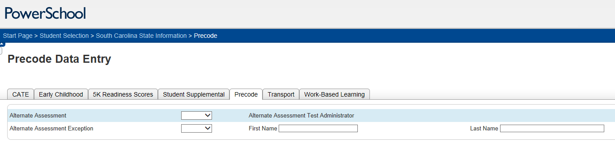
Important Note
Do not use the Alternate Assessment Exception field. Complete only the Alternate Assessment (Y/N) field and the Alternate Assessment Test Administrator fields.

Appendix L: WorkKeys® Precoding

The decision to administer WorkKeys via paper-and-pencil or online testing is pending. For paper-and-pencil tests only, below are the student-level fields which are collected for WorkKeys® precoding.

Length for  WorkKeys®  Precoding | WorkKeys®  Precoding  Field
6 | ACT HS Code
12 | Last Name
9 | First Name
1 | Middle Initial
2 | Grade Level
6 | Date of Birth
13 | Student State ID

ACT requires that the test be administered using an ACT HS Code instead of South Carolina’s 7-digit school IDs (SIDNs). This field is not collected through PowerSchool; the SCDE will add this field to the precode file submitted to ACT based on the SIDNs submitted by the district through PowerSchool.

The WorkKeys® assessment is a nationally-administered test. Precoding specifications were determined by ACT and are limited: names are truncated, only the State ID (not the PowerSchool ID) will be transmitted, and no other demographic information is transmitted.

For questions related to the WorkKeys® assessment, contact Kevin Fatica at KJFatica@ed.sc.gov or (803) 734-8282.

Appendix M: Early Childhood Readiness Precoding

The early childhood readiness tests are CIRCLE (for paper-and-pencil) and mCLASS:CIRCLE (for online). Precoding data were already collected from PowerSchool via the August collection. For questions related to these tests, contact Kevin Fatica at KJFatica@ed.sc.gov or (803) 734-8282.

Appendix N: Grades 3-11 Assessment(s) Precoding

Specific test names will be known as soon as the contracts have been awarded. Precoding instructions are not currently available, but will be released as soon as possible.

Appendix O: ACCESS for ELLs Precoding

The Office of Assessment anticipates that many of the fields collected for Title III will be used for ACCESS for ELLs. Known precoding information is listed below; additional information will be released as soon as possible.

Students are identified to test ACCESS for ELLs if they have an English Proficiency value of 1.0-5.9 or A-D.

The precode tab in PowerSchool contains new fields ((1) and (2)) that were added for the LEP assessment.
- How, if at all, the customized materials and oral administration fields will be used is still under discussion.
- The following fields will not be used in the Spring 2015 administration. Any values will be ignored.
- The LEP Online fields should be left blank. ACCESS for ELLs does not have online administration this year.
- The LEP Alternate Assessment field is not being used this year.

Contact Information
- If you have questions regarding the ACCESS for ELLs precoding, contact Leslie Dawes at ldawes@ed.sc.gov or (803) 734-4944.
- For questions related to the alternate assessment, Alternate ACCESS for ELLs, contact Jill Christmus at mchristmus@ed.sc.gov or (803) 734-8048.
- For questions related to customized materials, contact Anne Mruz at amruz@ed.sc.gov or (803) 734-8034.
- For questions directly related to Title III, contact Crystal Fields at cfields@ed.sc.gov or (803) 734-8306.

