Sullivan County School District
Chapter 339
K-12 Comprehensive Counseling Plan
Ellen Koschak and Laura Fiester
2017-2018





Sullivan County School District
777 South Street PO Box 240
Laporte, PA 18626
www.sulcosd.k12.pa.us

Sullivan County School District Chapter 339 Counseling Plan

Table of Contents | Page
School Counselors and Assignments | 2
School Counseling Department Mission Statement | 3
Program Goals
Elementary | 4
High School | 5
Stakeholders
Students | 6
Parents | 6
Educators | 6
Business/Community | 6
Post-Secondary | 7
Stakeholder Action Plans | 8
Role of the School Counselor
Leader | 12
Advocate | 12
Collaborator | 13
Agent of Systemic Change | 13
Advisory Council
Advisory Council Members | 14
Program Calendar
Elementary | 16
High School | 22
Program Delivery
Elementary | 28
High School | 31
Curriculum Action Plan | 34
Organizing Career Resources | 56
Individualized Academic/Career Plan
Strategy | 61
Planner/Bio Pages Grades K-12 | 62
K-12 Career Development Intervention Matrix | 81
Career & Technology Center Strategy | 91
Job Descriptions | 93
Appendix A
Appendix B
SCHOOL COUNSELORS, ASSIGNMENTS, AND RATIOS

Laura Fiester K-6 Sullivan County Elementary School 351:1
fieslaur@sulcosd.k12.pa.us 570-946-7471

Ellen Koschak 7-12 Sullivan County High School 275:1
chamelle@sulcosd.k12.pa.us 570-946-7001

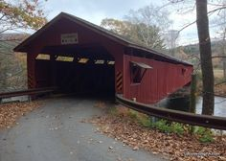
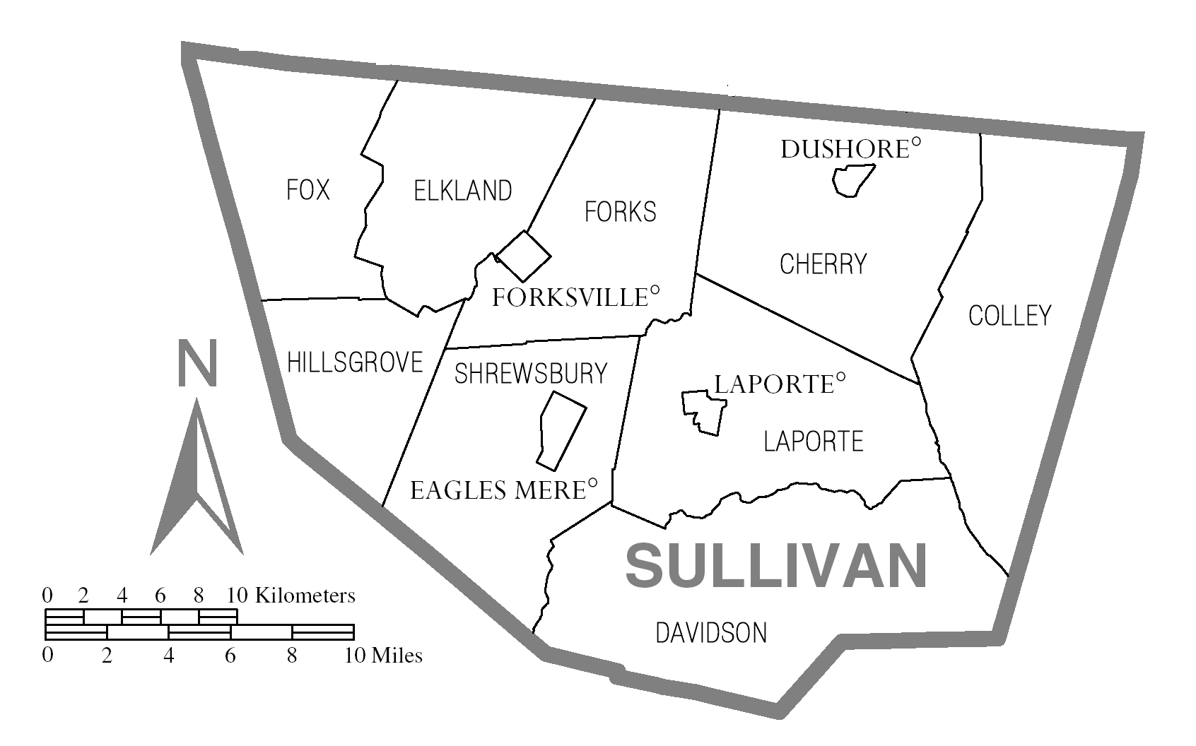

SCHOOL COUNSELING DEPARTMENT MISSION STATEMENT

The mission of the Sullivan County School District Counseling Program, in partnership with parents, teachers, business/community, and post-secondary institutions, is to educate, engage, and empower all students to be life-long learners and responsible citizens that will become productive members of society. All students will have access to a comprehensive counseling program that will provide proactive support to build the social/emotional, academic, and career skills necessary to cope with life issues, reach their full potential, and lead happy, fulfilled lives by accomplishing their personal goals.
Teachers
Students
Post -Secondary
Parents
Business / Community
Administration

PROGRAM GOALS

Elementary Career Goal:
It is the goal of the elementary school counseling curriculum to provide comprehensive, standards-based career awareness activities to all students, grades K-6. Before we implement additional career activities, we need to answer the question: “How are we currently addressing the CEW standards?” That will determine what additional career activities we implement in following years. In the fall of 2016, a gap analysis of the Pennsylvania Career Education and Work Standards was conducted with 100% of elementary grade levels. This information will be used to help determine program goals in future years. As a result of that gap analysis, the following goal was created:
- 85% of 5th grade students will be able to define the term entrepreneurship, as well as name at least 2 character traits of entrepreneurs.

Elementary Academic Goal:
In an effort to raise awareness of the multitude of options available after students graduate from high school, the school counselor will implement a new lesson that will focus on the available options for post-secondary training. As a result of that lesson, the academic goal will be:
- As a result of a lesson on post-secondary training options, 90% of all 5th grade students will be able to identify multiple options for post-secondary training.

Elementary Personal/Social Goal
At the start of the process of developing this plan, the elementary school counselor started using the SCUTA (School Counselor Use of Time Analysis) program. Over the course of approximately eight months, daily activities were logged into the program calendar. The results are shown in the program delivery chart of this plan, along with the ASCA (American School Counselor Association) recommended percentages. In examining the data from the SCUTA program, the following goal was developed:
- The elementary school counseling program will increase developmental guidance lesson delivery for all students from a minimum of four lessons to a minimum of six lessons in every homeroom.

Jr/Sr High School Career Goal:

- 100% of 8th grade students will begin their Career Portfolio.

- 90% of seniors will have an individual career plan with a career objective by November of their senior year.

Jr/Sr. High School Academic Goal:

- 90% of all 8th grade students will be able to identify at least three post-secondary education/training options

- 90% of all 11th grade students will be able to identify at least two post-secondary training/education options available in Pennsylvania.

- 50% of all students will earn honor roll.

Jr/Sr. High School Personal/Social Goal:

- 80% of junior high school students will complete Life Skills Training

- 95% of students grades 7 – 12 will take part in a school wide anti-bullying presentation or a motivational program bi-annually.

STAKEHOLDERS
(See attached action plans for the four stakeholders).
Students
- Students benefit from the counseling program by receiving academic, social/emotional and career development counseling.
- Students help with the delivery of the program by incorporating the skills learned in academic, social, emotional and career development lessons into their learning and personal growth.
Parents
- Parents benefit from the counseling program by receiving collaborative services, tools, and progress information enabling them to help their children with academic, social/emotional, and career development.
- Parents help with the delivery of the program by utilizing the information provided to help their children develop into thriving and positive community members.
- Parents will be engaged by sending home letters at the beginning of the year, at scheduling time, and following various career related guidance lessons in the classroom. Parents will be invited to attend the Open House at NTCC, and selected parents will be invited to serve on the advisory council. Parents will be educated about the counseling program and the K-12 plan via the school district website.

Educators
- Educators benefit from collaboration with the counseling department, receiving assistance with individual student progress as well as classroom wide goals.
- Educators help with the delivery of the program by delivering guidance curriculum, making student referrals for services, collaborating with the guidance department, parents, the community, other educators and staff, and supporting the academic, emotional, social and career development of students.
- Educators will be educated about the K-12 Comprehensive Guidance Plan, as well as the Career Ed and Work Standards. Educators will be connected to the local career and technical center through invitations to tour NTCC as a chaperone for the NTCC sophomore field trip.

Business/Community
- Business and Community benefit from the development of positive and productive citizens and employees.
- Business and Community help with the delivery of the program by partnering with the counseling department and school district to provide meaningful learning experiences to students, supply resources to support guidance department curriculum and providing future opportunities to Sullivan County High School graduates.
- Business/Community leaders will be invited to serve on the advisory council to increase our collaboration with available community resources.
Post-Secondary
- Post-Secondary institutions benefit from the development of college-ready students who have researched their educational options and made informed, responsible decisions for their future.
- Post-Secondary institutions help with the delivery of the program by partnering with the counseling department and school district to provide meaningful learning experiences to students, supply resources to support guidance department curriculum, and provide relevant training opportunities to faculty and staff.
- Post-Secondary representatives will be invited to serve on the K-12 advisory council.

Action Plan for 3 Goals in the Career Domain: Business/Community
Program  Goal | Standards Addressed  CEW | Grade  Level | Activities /Event Description | Data Used  to Measure  Impact | Start/End  Dates |  | Contact  Person
Develop a new career activity for students. | 13.1  13.2  13.3  13.4 | 4-6 | Several times a year, a guest speaker will be invited to circulate through the 4th, 5th, and 6th grade lunch and talk to students about their career. | Student feedback | 2018-2019 | Ongoing | Laura Fiester
Build a career network and meet to give you resources. | 13.1  13.2  13.3  13.4 | K-12 | Business and community leaders will be invited to serve on the advisory council to increase our collaboration with available community resources. | Number of business & community leaders on Advisory Council | 2016-2017 | Ongoing | Ellen Koschak & Laura Fiester
Wild Card – what would help you build your network?  (Use community resources to expand career lessons?) | 13.1  13.2  13.3  13.4 | K-12 | Advisory Council members from the business/community stakeholder group will be invited to present their career journey to classrooms. | Number of classroom visits | 2017-2018 | Ongoing | Ellen Koschak & Laura Fiester

School District: _____________________________________Level: ___Elem. ____Middle _____HS
Teacher Names: ____________________________________________________________________________

Action Plan for 3 Goals in the Career Domain: Educators

Program  Goal | Standards Addressed  CEW | Grade  Level | Activities /Event Description | Data Used  to Measure  Impact | Start/End  Dates |  | Contact  Person
Connect an outside resource to staff to build more career development program. | 13.1  13.2  13.3  13.4 | K-12 | Provide all faculty a list of local resources for potential classroom guest speakers from area colleges and businesses. | Number of teachers that host an outside speaker.  Number of teachers that participate. | 2017-2018  2016-2017 | Ongoing  Ongoing | Guidance Counselors
 | 13.1  13.2  13.3  13.4 | K-12 | Encourage participation in Educator Programs offered by local colleges and universities.
Connect the staff to the local career and technical center. | 13.1  13.2  13.3  13.4 | K-12 | Teachers will tour NTCC and cycle through the various shops to learn what they offer. To accomplish this, one elementary, jr. high , and sr. high teacher will be invited to serve as a chaperone for the NTCC sophomore field trip. | Number of teachers that tour NTCC. | 2015-2016 | Ongoing | Guidance Counselors
Figure out how to meet as a counseling team and what to do to educate staff. | 13.1  13.2  13.3  13.4 | K-12 | The elementary and high school counselor will meet monthly. | Number of meetings  Professional Development Survey | 2015-2016  2016-2017 | Ongoing  Ongoing | Guidance Counselors  District Act 48 Coordinator
 | 13.1  13.2  13.3  13.4 | K-12 | In-service teachers on the K-12 Comprehensive Guidance Plan.

School District: _____________________________________Level: ___Elem. ____Middle _____HS
Teacher Names: ____________________________________________________________________________

Action Plan for 3 Goals in the Career Domain: Parent

Program  Goal | Standards Addressed  CEW | Grade  Level | Activities /Event Description | Data Used  to Measure  Impact | Start/End  Dates |  | Contact  Person
Educate parents about the plan and the K-12 program. | 13.1  13.2  13.3  13.4 | K-12 | Parents will be invited to serve on the advisory council, which will increase their understanding of the K-12 program. | Number of parents appointed to advisory council.  Number of visitors to web pages.  Number of parents that receive parent letter. | 2016-2017 school year | Ongoing | Laura Fiester  and  Ellen Koschak
Educate parents about the plan and the K-12 program. | 13.1  13.2  13.3  13.4 | K-12 | Parents will be educated about the counseling program and the K-12 plan via the school district website.
Educate parents about the plan and the K-12 program. | 13.1  13.2  13.3  13.4 | K-12 | A letter will be sent home to parents at the beginning of the school year, explaining the counseling program. It will note that the K-12 plan is available on the district website.
Educate parents about career & technical ed. and all post-secondary options. | 13.1  13.2  13.3 | 7-12 | A letter will be sent home at scheduling time, and the power point will be posted to the district website. | Number of visitors to web pages.  Number of parents attending.  Number of parents that receive parent letter. | 2015-2016 school year | Ongoing | Ellen Koschak
 | 13.1  13.2  13.3 | 7-12 | Parents will be invited to attend the Open House at NTCC.
Connect an outside resource representing local career opportunities. | 13.1  13.2  13.3 | 7-12 | A career day will be held with local careers being emphasized. | Survey with students.  Quarterly reports from P & G.  Quarterly report cards. | 2015-2016 school year | Ongoing | Ellen Koschak
 | 13.1  13.2  13.3 | 7-12 | Students will have an opportunity to participate in a youth apprenticeship program with P & G.
 | 13.1  13.2  13.3 | 7-12 | Students will have an opportunity to participate in the Diversified Occupations and Co-Op with NTCC.

School District: Sullivan County School District Level: ___Elem. ____Middle _____HS
Teacher Names: ____________________________________________________________________________

Action Plan for 3 Goals in the Career Domain: Post-Secondary

Program  Goal | Standards Addressed  CEW | Grade  Level | Activities /Event Description | Data Used  to Measure  Impact | Start/End  Dates |  | Contact  Person
Increase parent & staff awareness of post-secondary options | 13.1  13.2  13.3  13.4 | K-12 | “Success in the New Economy” will be posted on the school district website. | Number of visitors to web pages  Post-secondary options quiz  Number of staff members that attend | 2015-2016  2016-2017  2015-2016 | Ongoing | Laura Fiester and Ellen Koschak
Increase parent & staff awareness of post-secondary options | 13.1  13.2  13.3  13.4 | K-12 | Staff will be invited to participate in the 5th grade post-secondary lesson & students will be encouraged to discuss it with parents.
Increase parent & staff awareness of post-secondary options | 13.1  13.2  13.3  13.4 | K-12 | Staff will be invited to chaperone field trips to college campuses & career days.
Create student awareness of an unfamiliar post-secondary option | 13.1  13.2  13.3  13.4 | 5th &  10th | All 5th grade students will participate in an activity addressing the range of post-secondary options. | Post-secondary options quiz  Number of students participating in lesson | 2016-2017  2015-2016 | Ongoing | Laura Fiester and Ellen Koschak
 | 13.1  13.2  13.3  13.4 | 5th &  10th | All 10th grade students will receive a lesson on “Success in the New Economy” and post-secondary options.
Wild Card –  What can make the connections stronger | 13.1  13.2  13.3  13.4 | K-12 | Post-Secondary representatives will be included in the K-12 advisory council. | Number of post-secondary reps appointed to advisory council | 2016-2017 | Ongoing | Laura Fiester and Ellen Koschak

School District: _____________________________________Level: ___Elem. ____Middle _____HS
Teacher Names: ____________________________________________________________________________

ROLE OF THE SCHOOL COUNSELOR

Leadership

As a leader, the school counselor:

- Effectively implements, manages, and analyzes a comprehensive developmental school counseling program.
- Serves on school-based student focused teams, such as Child Study, Community and School Based Behavioral/Mental Health Team, SAP, Suicide Prevention, PLC, Act 48, and/or SWPBS.
- Collaborates with other professionals in the school to influence system-wide changes and implement school reform, such as implementation of the Bucket Filling program, SWPBS, Ineligibility Improvement Program, Career Day.
- Supports the school as a safe and welcoming learning environment, through programs such as Griffin Greeters, Bucket Fillers, and the Rachel’s Challenge New Student Program.
- Serves as the mental health liaison and/or referral sources by providing referral resources to parents when necessary, by serving on committees such as SAP and/or Suicide Prevention.

Advocacy

As an Advocate, the school counselor:
- Works to ensure access and success in a rigorous academic curriculum for every student.
- Works to remove barriers that prevent student success, by serving on school-based teams such as SAP, Child Study, Community and School Based Behavioral/Mental Health Team, and/or attending quarterly staffing meetings.
- Works to ensure the academic, social, emotional and career development of all students, through individual counseling and the K-12 school counseling curriculum.
- Collaborates with school and community agencies to help meet the needs of all students.
- Promotes a school environment in which all students feel safe and connected.

Collaboration

As a Collaborator, the school counselor:
- Works with faculty, staff, administration, parents, community organizations, agencies and businesses to enhance student learning and personal growth.
- Offers parents/guardians information to enhance the educational opportunities for students and families.
- Works with the special education department to provide and enhance academic and/or emotional services provided by the school district.
- Teams with all members of the educational community to create an environment that promotes success for all students.
- Maintains an atmosphere of open communication to help foster teamwork among school staff members.

Agent of Systemic Change

As an Agent of Systemic Change, the school counselor:
- Examines data such as grades, attendance, and office discipline referrals to develop intervention strategies for individual and school-wide concerns.
- Researches and promotes new programs, procedures, events, and curriculum to enhance student learning and personal growth.
- Identifies realistic goals and establishes action plans to meet those goals.
- Works with a K-12 School Counseling Advisory Council to seek ways to improve the School Counseling Program.
- Participates in school level committees to promote programming that will enhance the educational experience for all students.
ADVISORY COUNCIL

The purpose of the Advisory Council is to strengthen the partnership between the school counseling staff and community in order to fulfill the district’s mission and to better meet the needs of students in our district. We will share information about the School Counseling Program, as well as make connections for career support and post-secondary planning within our district and community. Member’s input will be crucial to the future success of our students and the School Counseling Program.

Advisory Council Members:

Name | Title/Stakeholder Group
Patricia Cross | Superintendent  Stakeholder: Educator
Mary McClintock | Elementary Principal  Stakeholder: Educator
Hal Stockdill | School Board Member  Stakeholder: Educator
Jen Wettlaufer | Elementary Teacher  Stakeholder: Educator & Parent
Ashley White | High School Teacher  Stakeholder: Educator & Parent
Lynn Eberlin | High School Teacher  Stakeholder: Educator & Parent
Ellen Koschak | High School Counselor  Stakeholder: Educator & Parent
Laura Fiester | Elementary School Counselor  Stakeholder: Educator & Parent
Cloe Immel | 6th Grade Student  Stakeholder: Student
Bethany Beinlich | 9th Grade Student  Stakeholder: Student
Kirsten Pedro | 12th Grade Student  Stakeholder: Student
Rick Green | Fitzpatrick & Lambert  Stakeholder: Business & Community
Renee Evans | Victim’s Services Educator  Stakeholder: Business & Community
Terri Stone | Pennsylvania College of Technology  Stakeholder: Post-Secondary & Parent
Brian Hoffman | Sullivan County Commissioner  Stakeholder: Business/Community & Parent
Sgt. Harry E. Williams III | Military Recruiter  Stakeholder: Post-Secondary
Megan Bohensky | Elementary School Parent  Stakeholder: Parent & Educator
Melissa Mapes | Youth Apprenticeship Program/P & G  Mehoopany Training Systems Leader  Stakeholder: Business/Community
Jody McCarty | Northern Tier Regional Planning & Dev.  Workforce Program Manager  Stakeholder: Business/Community & Parent
Jennifer Farley | Northern Tier Career Center Administrator of Educational Services  Stakeholder: Educator & Business/Community

Inaugural Meeting: February 24, 2017

Future Meetings: The first Friday in November and May.

2017/2018 School Year: November 3rd and May 4th

Monthly Counseling Calendar: K-6
(This chart is for month-specific counseling activities. Most counseling activities are done on an ongoing, month to month basis. See the ongoing chart for those regular activities)

Key: Green = Guidance curriculum; Blue = Prevention, Intervention, and Responsive Services; Purple = Individual Student Planning; Red = System Support

August  Academic: | August  Career: | August  Personal/Social:
- eQUIP registrations for the following school year  - Parent outreach letter  - Role of School Counselor Lessons (K-6)  - Meet with teachers to monitor last year’s counseling caseload | - Lesson Prep  - Curriculum work | - Lesson Prep  - Curriculum work  - Parent outreach letter  - Role of School Counselor Classroom Lessons (K-6)  - SWPBS party  - Meet with teachers to monitor last year’s counseling caseload  - Bucket Filler program introduction
September  Academic: | September  Career: | September  Personal/Social:
- Benchmark testing  - Role of School Counselor Lessons (K-6) | - Sort career portfolios with new class lists  - Update K-6 careers lessons | - Bucket Filler program introduction  - Role of School Counselor Classroom Lessons (K-6)  - Griffin Greeters training  - Manage Griffin Greeter program  - 6th grade Griffin Greeter presentation  - CYS advisory board meeting  - K-6 Asking for Help
October  Academic: | October  Career: | October  Personal/Social:
- Monitor grades of eQUIP students  - K-6 Open House  - Kindergarten Listening Skills  - 5th grade Work Habits | - 5th grade Careers are Everywhere  - 5th grade Resume  - 5th grade Work Habits  - 5th Grade Career Clusters | - Kindergarten Listening Skills  - 1st grade Empathy  - 2nd grade Conflict Resolution unit  - 2nd grade Taking responsibility  - 2nd grade I-messages and Communication Skills  - 2nd grade Listening Skills
November  Academic: | November  Career: | November  Personal/Social:
- Benchmark testing  - Post report card staffing meetings (K-6)  - 2nd grade Ready for Success unit  - 2nd grade Goal Setting  - 5th grade Post-Secondary options | - 5th grade Careers are Everywhere  - 5th Grade Career Clusters  - 5th Grade Interests/Skills  - Career portfolios (5th)  - 5th grade “Who R U” career cluster  - 5th grade Post-Secondary options  - Advisory Council Meeting | - CYS advisory board meeting  - SWPBS reward party  - Kindergarten I-Care Rules and Animal Friends  - 1st grade Conflict Resolution  - 2nd grade Anger Management  - 2nd grade Healthy Choices
December  Academic: | December  Career: | December  Personal/Social:
- 2nd grade Ready for Success unit  - 2nd grade Goal setting  - PSCA conference | - PSCA conference  - 2nd grade Careers portfolio  - 5th grade Entrepreneurship | - CYS advisory board meeting  - 2nd grade Goal setting  - 2nd grade Stress/Anxiety Management  - PSCA conference
January  Academic: | January  Career: | January  Personal/Social:
- Benchmark testing  - 4th grade Work Ethics | - 4th grade career portfolio  - 4th grade “Which Job for Me” | - CYS advisory board meeting  - Kindergarten Personal Space  - 1st Grade Tattle or Tell  - 4th grade Toothpaste race & Bucket Filling lesson (kindness to others)  - 4th grade “Odd Dot Out”  - 4th grade “Attitudes”
February  Academic: | February  Career: | February  Personal/Social:
- Post report card staffing meetings (K-6)  - 6th grade Student Success Skills  - 6th grade Goal setting | - 1st grade Careers Portfolio  - 4th grade “Holland Types”  - 6th Grade Career Clusters | - SWPBS reward party  - Kindergarten Heart prints  - 3rd grade Conflict Resolution unit  - 3rd grade Listening Skills  - 3rd grade I-messages & Communication Skills  - 3rd grade Anger Management  - 3rd grade Taking Responsibility  - 6th grade Student Success Skills  - 6th grade Goal setting  - 6th grade Healthy choices  - 6th grade Stress/Anxiety Man.

March  Academic: | March  Career: | March  Personal/Social:
- 6th grade Student Success Skills  - 6th grade Goal Setting | - Kindergarten careers – Berenstein Bears on the Job  - 1st Grade Career Riddles  - 3rd grade Career Hush lesson  - 3rd grade Career Portfolio lesson  - 3rd grade Entrepreneurship lesson  - 6th grade Career Clusters | - CYS advisory board meeting  - 6th grade Student Success Skills  - 6th grade Goal Setting  - 6th grade Digital Life  - 6th grade Cyberbullying
April  Academic: | April  Career: | April  Personal/Social:
- PSSA test administration & make ups  - Post report card staffing meetings (K-6) | - 6th Grade Portfolio Summary | - SWPBS reward party

May  Academic: | May  Career: | May  Personal/Social:
 | - Griffin Greeters job application presentation (5th grade)  - Advisory Council Meeting | - CYS advisory board meeting  - Kindergarten M & M Belief (supplemental)  - 1st grade Managing anger lesson (supplemental)  - 1st grade Unique & Special – I Like Myself (supplemental)  - 4th grade Internet Safety – The Power of Words (supplemental)  - 5th grade “What’s Cyberbullying” (supplemental)  - 5th grade digital citizenship pledge (supplemental)
June  Academic: | June  Career: | June  Personal/Social:
- On-line reporting for Safe Schools (ESAP)
- SWPBS reward party
July  Academic: | July  Career: | July  Personal/Social

Ongoing Monthly Counseling Activities
Key: Green = Guidance curriculum; Blue = Prevention, Intervention, and Responsive Services; Purple = Individual Student Planning; Red = System Support

Counselor Related | Non Counselor Related
Individual counseling – P,A | Lunch duty
Child Study team meetings - A
Present Star Bucket Filler Awards – P
Monitor grades of eQUIP students – A
Manage Griffin Greeter Program – P,A
SWPBS committee meetings – P, A
Suicide prevention committee meetings – P
ESAP meetings – P, A
Bradford/Sullivan Counselors meetings – C, P, A
MDE meetings – A
School Board report – A, C, P
Manage ESAP cases – P, A
Classroom Guidance lessons – P, A, C
Consultation with parents – P, A
Consultation with teachers – P, A
Make referrals to SAP – P, A
Consultation with outside agencies – P
Website updates – P, A, C
Core Behavioral Health Team meetings – P, A
Food backpack distribution - P
Faculty meetings – P, A
Monthly Counseling Calendar: 7-12
(This chart is for month-specific counseling activities. Most counseling activities are done on an ongoing, month to month basis. See the ongoing chart for those regular activities)
Key: Green = Guidance curriculum; Blue = Prevention, Intervention, and Responsive Services; Purple = Individual Student Planning; Red = System Support

August  Academic: | August  Career: | August  Personal/Social:
- Opening Day presentations, all grades, to review academic requirements/expectations.  - Transcript review, all seniors.  - Schedule Changes | - Opening Day presentations, all grades, to highlight career exploration activities facilitated by the guidance office. | - Opening Day presentations, all grades, to review guidance services.
September  Academic: | September  Career: | September  Personal/Social:
- Group meetings/classroom setting with all seniors to provide “Senior Resource Booklet”, transcript, overview of post-secondary education opportunities and application process.  - Individual meetings with all seniors to review transcript/grad requirements.  - Share information about PSAT with 10th /11th grade.  - Dual Enrollment classroom presentations and paperwork for enrollments  - PSAT awareness and registration  - EQUIP student monitoring  - Schedule Changes  - Eligibility Parent Report  - Child Study Team | - Individual meetings with all seniors to review transcript/grad requirements, explore career goals and post-secondary plans  - Recommendation Letters  - College Applications  - Green career Day  - School to Careers: Consultation and presentation. | - SAP Meetings  - Academic/Social/Emotional/Peer counseling as needed.  - BH/MH weekly meeting  - 7th Grade Academy Guidance Lessons

October  Academic: | October  Career: | October  Personal/Social:
- Eligibility Parent Report  - Keystone Exam – prep work for Winter Wave  - NCAA Clearinghouse – confirm all courses are approved.  - Penn College Now Partnership meeting.  - PSAT administration  EQUIP student monitoring  - Child Study Team | - Financial Aid Night  - P&G Youth Apprenticeship, recruitment and assistance with application process.  - Individual meetings with all seniors to review transcript/grad requirements, explore career goals and post-secondary plans  - Recommendation Letters  - College Applications  - FAFSA Help  - College Fair  - Penn College Career Day  - School to Careers: Consultation and presentation. | - SAP Meetings  - Academic/Social/Emotional/Peer counseling as needed.  - BH/MH weekly meeting  - Life Skills Training
November  Academic: | November  Career: | November  Personal/Social:
- Report Cards  - Keystone Exams – administration Webinar  - EQUIP student monitoring  - Child Study Team  - Eligibility Parent Report | - Junior Presentations: ASVAB, SAT vs ACT, ASPIRE test results and Career Exploration Websites.  - Recommendation Letters  - College Applications  - FAFSA Help  - Advisory Council Meeting  - School to Careers: Consultation and presentation. | - SAP Meetings  - Academic/Social/Emotional/Peer counseling as needed.  - BH/MH weekly meeting  - Life Skills Training

December  Academic: | December  Career: | December  Personal/Social:
- Keystone exam administration  - Progress Reports  - NTCC presentation to all sophomores  - NTCC Field Trip  - EQUIP student monitoring  - Child Study Team  - Eligibility Parent Report | - Senior Reminders Presentation – Financial aid, application updates, resume skills and senior related topics.  - ASVAB interpretation sessions  - Recommendation Letters  - College Applications  - FAFSA Help  - School to Careers: Consultation and presentation. | - SAP Meetings  - Academic/Social/Emotional/Peer counseling as needed.  - BH/MH weekly meeting  - Life Skills Training
January  Academic: | January  Career: | January  Personal/Social:
- Keystone Exam Administration  - Scheduling process preparation: communicate with staff members to update curriculum guide, schedule presentations and bubble sheet completion  - Report Cards  - Child Study Team  - Eligibility Parent Report | - Junior Presentations – college exploration, career exploration. Interest Inventory on PA Career Zone  - Recommendation Letters  - College Applications  - FAFSA Help  - School to Careers: Consultation and presentation. | - SAP Meetings  - Academic/Social/Emotional/Peer counseling as needed.  - BH/MH weekly meeting
February  Academic: | February  Career: | February  Personal/Social:
- Scheduling Presentations, gathering of student scheduling worksheets  - Eligibility Parent Report  - Processing schedule requests into admin plus.  - PSSA Testing preparations  GPA Mid-Year Updates  - Child Study Team | - Juniors meetings to work on individual career plans.  - Recommendation Letters  - College Applications  - FAFSA Help  - Career Day, Grades 7 – 12  - School to Careers: Consultation and presentation.  - Pathways to Success Career Readiness Symposium | - SAP Meetings  - Academic/Social/Emotional/Peer counseling as needed.  - BH/MH weekly meeting

March  Academic: | March  Career: | March  Personal/Social:
- NTCC shadowing experiences for interested students  - Individual scheduling meetings  - Eligibility Parent Report  - Bubble Sheets for scheduling process  - Compile scheduling requests  - Progress Reports  - Child Study Team | - Juniors meetings to work on individual career plans.  - Career Directions presentation – 9th grade  - Career Fair: NTRPDC  - FAFSA Help  - Advisory Council Meeting  - School to Careers: Consultation and presentation. | - SAP Meetings  - Academic/Social/Emotional/Peer counseling as needed.  - BH/MH weekly meeting
April  Academic: | April  Career: | April  Personal/Social:
- PSSA Testing – tools training for all students, proctor training, test administration  - Keystone Exams – testing preparations  - PSAT 10 Administration  - Report Cards  - Senior Conference  - Child Study Team | - Scholarships – Promoting scholarships through announcements and postings, assisting students, gathering applications, distributing to sponsors as necessary, meeting with scholarship committee and contacting sponsor throughout the month of May.  - School to Careers: Consultation and presentation. | - SAP Meetings  - Academic/Social/Emotional/Peer counseling as needed.  - BH/MH weekly meeting
May  Academic: | May  Career: | May  Personal/Social:
- Keystone Exams – winter wave results mailed hope to parents, spring wave student tool training, proctor trainings, scheduling and administration.  - Progress reports  - AP Exam, preparation, scheduling and administration.  - Child Study Team | - Scholarships – Promoting scholarships through announcements and postings, assisting students, gathering applications, distributing to sponsors as necessary, meeting with scholarship committee and contacting sponsor throughout the month of May.  - School to Careers: Consultation and presentation. | - SAP Meetings  - Academic/Social/Emotional/Peer counseling as needed.  - BH/MH weekly meeting

June  Academic: | June  Career: | June  Personal/Social:
- Report Cards  - Verify graduation requirements  - GPA updates  Dual Enrollment transcript letters  - Child Study Team  - Eligibility Parent Report | - Individual Career Plans, final product completed and returned to seniors.  - School to Careers: Consultation and presentation. | - SAP Meetings  - Academic/Social/Emotional/Peer counseling as needed.  - BH/MH weekly meeting
July  Academic: | July  Career: | July  Personal/Social:
- Summer School Follow Up if not completed by administration.

Ongoing Monthly Counseling Activities: Jr/Sr High School

List activities or responsibilities that you continually perform over time and categorize which are related to your role as a counselor recommended by ASCA*

Counselor Related | Non Counselor Related
Academic/Social/Emotional/Peer counseling as needed. | Weekly eligibility parent report
SAP Meetings | E-Quip student progress checks
New Student Enrollments | Homeless report
Student Withdraws | Testing – PSSA, Keystone, AP, PSAT
Ineligibility parent report/student conferences. | Web Site Updates
Assistance with School to Careers class | Performance Data Reporting
College Applications
Scholarship Applications
Recommendation Letters
Financial Aid Assistance
Counselor Group Meetings
P&G Student Monitoring
Youth Apprentice Student Monitoring
Faculty Meetings
Staff Notifications of student concerns/critical incidents
CST Meetings
BH/MH Meetings
Rachel’s Challenge for New Enrollments
Consultation with CYS
Consultation with Emotional Support Teacher
Weekly eligibility student meetings
Career Portfolio Management

Program Delivery

Sullivan County School District – Elementary Level
Comprehensive School Counseling Program Delivery

Guidance  Curriculum  Provides developmental, comprehensive guidance program content in a systematic way to all students preK-12. | Prevention, Intervention and  Responsive Services  Addresses school and student needs. | Individual  Student Planning  Assists students and parents in development of academic and career plans. | System  Support  Includes program, staff and school support activities and services.
Purpose  Student awareness, skill development and application of skills needed to achieve academically and be career and college ready by graduation. | Purpose  Prevention, Intervention and Responsive services to groups and/or individuals. | Purpose  Individual student academic and occupational planning, decision making, goal setting and preparing for academic transitions. | Purpose  Program delivery and support.
Academic  Role of School Counselor  Ready for Success unit  Student Success Skills unit  Listening Skills | Academic  Individual counseling:  - Organization  - Time Management  - Motivation  - Study Skills  - Responsibility  Manage Griffin Greeter program  Open House  SWPBS reward parties  Collaborate with parents  Collaborate with teachers | Academic  eQUIP registrations | Counselor Related  Child Study team meetings  SWPBS committee meetings  Suicide prevention committee meetings  ESAP meetings  Bradford/Sullivan Counselor meetings  MDE meetings  School board report  Manage ESAP cases  Administer benchmark tests  CYS advisory board meetings  K-6 Post report card staffings  PSCA conference  Lesson prep  Curriculum writing  Parent outreach letter  Monitor previous year’s counseling caseload  Update K-6 careers activities  Sort career portfolios  Manage Griffin Greeter program  PSSA test administration  Act 48 committee meeting  Monitor grades of eQUIP students  Chapter 339 training  Suicide Prevention training  SAP state online reporting  Make referrals to SAP  Consultation with outside agencies  Webpage updates  Advisory Council meetings  Food backpack delivery  Parent contacts  Core Behavioral/Mental Health Team meetings
Career  Career Awareness  1st – 5th Career portfolios  Career Hush activity  Entrepreneurship  Which Job for Me  Careers are Everywhere unit  Griffin Greeters job app.  Work Habits  Interests/Skills  Resume  Career Clusters  Work Environment  Post-Secondary Options  PA Career Zone  6th grade portfolio summary  Holland Types  5th Grade Entrepreneurs | Career | Career  Career portfolios for students that missed lesson | Non-Counselor Related  Lunch duty (fair share)  Recess duty (fair share)
Personal/Social  Role of School Counselor  Bucket Filler introduction  Monthly Star Bucket  Filler awards  Asking for Help  Diversity  Self Esteem – I Like Myself  Conflict Resolution unit  Empathy  Managing Anger  Communication Skills  Listening Skills  Taking Responsibility  I-messages  Bucket Filling  Respecting Others  Odd Dot Out  The Power of Words  Positive Attitudes  Digital Citizenship  Cyberbullying  Griffin Greeter presentation  Stress Management  Coping & Healthy Choices  Goal Setting  Digital Life  Kindness  Friendship  Conflict: Bug & a Wish  Tattling or Telling? | Personal/Social  Griffin Greeters training  Individual counseling:  - Grief/Loss  - Behavior  - Peer Relationships  - Changing families  - Anxiety/Stress  - Social Skills  - Anger Management  - Self-Control  - Respect  - Making choices  Manage Griffin Greeter Program  SWPBS parties  Food backpack delivery  Collaborate with parents  Collaborate with teachers | Personal/Social
Percentage of Time  33%  (ASCA suggests 35%-45% for elem.) | Percentage of Time  48%  (ASCA suggests 30%-40% for elem.) | Percentage of Time  1%  (ASCA suggests no more than 5%-10% for elem.) | Percentage of Time  18%  (ASCA suggests 10%-15% for elem.)
Recently, ASCA has been focusing more on direct and indirect services vs. system support. They recommend 80% of time spent in direct and indirect services, and no more than 20% in System Support. In that regard, current elementary numbers would be 82% direct services and 18% indirect services, which is in line with the current recommendations.
COMPREHENSIVE SCHOOL COUNSELING PROGRAM DELIVERY SYSTEM: High School

Guidance  Curriculum  Provides developmental, comprehensive guidance program content in a systematic way to all students preK-12. | Prevention, Intervention and  Responsive Services  Addresses school and student needs. | Individual  Student Planning  Assists students and parents in development of academic and career plans. | System  Support  Includes program, staff and school support activities and services.
Purpose  Student awareness, skill development and application of skills needed to achieve academically and be career and college ready by graduation. | Purpose  Prevention, Intervention and Responsive services to groups and/or individuals. | Purpose  Individual student academic and occupational planning, decision making, goal setting and preparing for academic transitions. | Purpose  Program delivery and support.
Academic  New Student Orientation Post-Secondary Planning Lessons  Financial Aid Night \ PSAT Testing  PSAT Test interpretation  Course Selection Presentations  AP Testing Advertisement Dual Enrollment Advertisement  College Majors Scorecard | Academic  SAP  Parent Conferences Contact with parents of student in danger of failing.  Quarterly Failure Letters  Weekly Ineligibility Reports  Retention Letters Summer School Registration | Academic  New Student Orientation New Student Scheduling Course Selection Advisement  MDE Meetings  Post-Secondary Planning  College Applications Schedule Adjustments College Recommendation Letters  Graduation Requirement Review  College Major Score Card Interpretation | Counselor Related  Program Development Monthly Counselor Meetings  Agency Meetings/Referrals Scholarship Coordination Collaboration with Teachers  Budget Development School Board Presentations  Chapter 339 Development  SAP Meetings Professional Development  Awards Day  Graduation Awards Faculty Meetings
Career  School to Career Curriculum Writing  7th Academy Curriculum  8th Academy Curriculum  Holland Career Assessments  NTCC Presentations  NTCC Tours  ASVAB Testing  ASVAB Test interpretation  Resume Lesson  PFEW Promotion  P&G Youth Apprentice recruitment  PA Career Zone presentations  Job Gateway/Career Link Presentations  RAISEC Inventory  Ability Explorer | Career | Career  Individual Career Plans  Individual Career Portfolios  Review Career Assessment Results  Review ASVAB Results  Review PSAT Results  Review SAT Results  Review ACT Results  Recommendation Letters  Youth Apprenticeship monitoring  Mock Interviews  Ability Explorer Interpretation  Job Shadow Coordination  Military Representative Meetings | Non-Counselor Related  Course Selection worksheets  Curriculum guide  Keystone Test/Proctor Schedule  PSSA Test/proctor schedule  Proctor Training  AP Testing Administration  Dual Enrollment Placement Test Administration  ASVAB Test Administration  PSAT Test Administration  Keystone Test Administration  PSSA Test Administration
Personal/Social  Life Skills Training 7th and 8th grade  Suicide Prevention | Personal/Social  SAP  Suicide Prevention Committee  Crisis Counseling  Brief Counseling  Grief Groups | Personal/Social  Individual Student Meetings  Individual Parent Meetings  Peer Mediation  Teacher collaboration
Guidance Curriculum | Prevention, Intervention and  Responsive Services | Individual  Student Planning | System  Support
Percentage of Time  30% | Percentage of Time  20% | Percentage of  Time  20% | Percentage of  Time  30%
(ASCA suggests 25-35% for high school.) | (ASCA suggests 30-40% for high school.) | (ASCA suggests 25-35% for high school.) | (ASCA suggests 10-15% for high school.)

School Counseling Core Curriculum Action Plan Year: 2017/2018

Grade Level | Lesson /  Topic | Which Class/  Location | Standard/  Domain | Materials | Starts/Ends | Process Data  # of students | Evaluation and Assessment | Contact person
7 | The World of Work and You. | Academy | PA CEW 13.1.8 A, B, D, G, 13.2.8 B, C, D, E  13.3.8,B, C, G  ASCA M4,5,6  BLS 1,7, BSMS 5 | The World of Work and You workbooks. | September – January | 50 | Pre-Test/Post Test, Key Motivators, Interest Areas, Career Clues, Job Skills, Work Values, Action Plan and Job Exploration Worksheet | Ellen Koschak, Barb Knapp and academy teachers
7 | What Could I do with My Life? | Academy | PA CEW 13.1.8 A,B,C,D.E,F, 13.2.8. B,E 13.3.8 A,E  ASCA M1, BLS 1,9 | What Could I do with my Life – video. | September – January | 50 | Career Evaluation “Positive vs Negative” analysis” | Ellen Koschak, Barb Knapp and academy teachers
7 | What Personality Are You? | Academy | PA CEW 13.1.8 A, B, C, F, | What personality are you? - video | September – January | 50 | Completion of video based personality assessment. | Barb Knapp and academy teachers
7 | Life Skills Training | Academy | ASCA M1-6, BLS 1,3,4,6,7,9, BSMS 1,2,4,5,7,8,9,10 BSS 1,2,3,5,6,7,8,9 | Life Skills Workbooks. Other materials provided by Victim Services. | October – January | 50 | Workbook Completion | Victim Services and academy teachers

Grade Level | Lesson /  Topic | Which Class/  Location | Standard/  Domain | Materials | Starts/Ends | Process Data  # of students | Evaluation and Assessment | Contact person
7 | Character Counts | Academy | ASCA M1,3,6 BSMS 1,2,7, BSS 2,3,4,5,6,7,9 | Character Counts curriculum kit. | January – March | 50 | Project Completion  Character Pillars Quiz | Academy Teachers
8 | High Five | School to Careers | ASCA Mindset M1, M2, M4, M5,M6  PA CEW 13.1.8.B,D | Real Game Curriculum Kit, construction paper. | September | 42 | High Five Visual Aid Completion,  Career Goals recorded. | School to career teacher.
8 | Soft Skills | School to Careers | ASCA Social Skills B-SS1, B-SS3, B-SS6, M-SS 7  PA CEW 13.2.8 A 13.3.8 A,B,C | Soft Sills Article, index cards. | September | 42 | Soft Skills team presentation.  Soft Skills Quiz | School to career teacher.
8 | The Real Game | School to Careers | PA CEW 13.1.8. A-H  13.2.8.A-E 13.3.8.A-G | The Real Game Curriculum Kit, power points, pa career zone, | August – January and January - June | 42 | Project Completion | School to career teacher.
8 | PA Career Zone | School to Careers | PA CEW 13.1.8 A,B,D,E,F 13.2.8. B,D  ASCA M4,M5, M6 B-LS 7 BLS 9 | www.pacareerzone.org website | August – January and January - June | 42 | Website activity printouts. | School to career teacher.

Grade Level | Lesson /  Topic | Which Class/  Location | Standard/  Domain | Materials | Starts/Ends | Process Data  # of students | Evaluation and Assessment | Contact person
8 | Education Planner | School to Careers | PA CEW 13.1.8 A,B,D,E,F 13.2.8 B,D,E 13.3.8.A  ASCA M4, M5, M6 B-LS 7 B-LS 9 BSMS 3 | www.educationplanner.org website | August – January and January - June | 42 | Education Planner Activity Printouts | School to career teacher.
8 | Choices | School to Careers | PA CEW 13.1.8 A,B,D,E,F 13.2.8 B,D,E 13.3.8.A  ASCA M4, M5, M6 B-LS 7 B-LS 9 BSMS 3 | Bridges.com software | August – January and January - June | 42 | Career Exploration Activity Sheet and portfolio | School to career teacher.  Ellen Koschak
8 | Life Skills Training | Academy | ASCA M1-6, BLS 1,3,4,6,7,9, BSMS 1,2,4,5,7,8,9,10 BSS 1,2,3,5,6,7,8,9 | Life Skills Training workbooks | October - January | 42 | Workbook Completion | Victim Services
9 | Career Directions | Social Studies | PA CEW 13.1.11 A-H  13.2.11. A-E  13.3.11.A,F,G  13.4.11.B  ASCA M1, M4,M6,BLS 7 BLS 9, BSS 5 | Career Directions Magazine | February | 55 | Career Directions Interest Inventory, | Ellen Koschak

Grade Level | Lesson /  Topic | Which Class/  Location | Standard/  Domain | Materials | Starts/Ends | Process Data  # of students | Evaluation and Assessment | Contact person
9 | Career Fair | Towanda High School | PA CEW 13.1.11 F,H ASCA BLS 7 BLS 8, BLS 10 | How to get the most out of a Career Fair, Career Fair Map and Signature page. | March | 55 | Number of Career Representative signatures and reflection page. | Jody McCarty NTRPDC
9 | Bio Pages | Social Studies | PA CEW 13.1.11 E,F,G,H 13.2.11 D 13.3.11 G  ASCA M2, BLS 10, BSMS 4, 7,8,10 BSS 1,8 | Bio Pages Template | March | 55 | Completion of Bio Pages | Ellen Koschak
10 | Success in the New Economy | Social Studies | PA CEW 13.1.11 A,B,D,E,F,G 13.2.11 D 13.3.11 A,D,F,G | Success in the New Economy Video. Big Idea Handout | February | 37 | Success in the new economy handout. Career Objectives recorded. | Ellen Koschak
10 | Job Gateway | Social Studies | PA CEW 13.2.11 A,B,C,D, | www.pajobgateway.com | February | 37 | Job Search results | Ellen Koschak, Trehab

Grade Level | Lesson /  Topic | Which Class/  Location | Standard/  Domain | Materials | Starts/Ends | Process Data  # of students | Evaluation and Assessment | Contact person
10 | Bio Pages | Social Studies | PA CEW 13.1.11 E,F,G,H 13.2.11 D 13.3.11 G  ASCA M2, BLS 10, BSMS 4, 7,8,10 BSS 1,8 | Bio Pages Template | February | 37 | Completion of Bio Pages | Ellen Koschak
10 | NTCC Presentation and Tour | PE/Dr Ed/Study Hall | PA CEW 13.1.11 D,F | NTCC Power Point | December | 37 | Tour sign-ups. | Jen Farley  Ellen Koschak
10 | PFEW | Auditorium | PA CEW 13.1.11 D, 13.4.11 A,B | PFEW Flyers | January | 37 | PFEW sign-ups | Barb Knapp Ellen Koschak
11 | ASVAB |  | PA CEW 13.1.11 C | Armed Services Vocational Aptitude Battery | February | 48 | ASVAB participation | Ellen Koschak, ASVAB personnel
11 | ASVAB Interpretation | Social Studies or English | PA CEW 13.1.11 A,B,C,D,E,F,G,H, 13.2.11 B,C, D,E 13.3.11 A,F 13.4.11, A | ASVAB Interpretation Booklet | February | 48 | Interest Survey results recorded. | National Guard Recruiter  Ellen Koschak

Grade Level | Lesson /  Topic | Which Class/  Location | Standard/  Domain | Materials | Starts/Ends | Process Data  # of students | Evaluation and Assessment | Contact person
11 | Keys to Success Unit | Social Studies | PA CEW 13.1.11 A-H 13.2.1 A-E  13.3.11 A-G 13.4.11 A,B | Keys to Success Power Point and Lessons | January | 48 | Participation | Ellen Koschak
11 | Bio Pages | Social Studies or English | PA CEW 13.1.11 E,F,G,H 13.2.11 D 13.3.11 G  ASCA M2, BLS 10, BSMS 4, 7,8,10 BSS 1,8 | Bio Page | January | 48 | Bio Pages completion | Ellen Koschak
11 | Individual Career Planning meetings | Guidance Office | PA CEW (All)*  ASCA (All)*  *depending on the individual meeting | Career Portfolios | February | 48 | Individual Career Plan updated. | Ellen Koschak
11 | College Fair | Mansfield University | PA CEW 13.1.11 F,H ASCA BLS 7 BLS 8, BLS 10 | Provided by colleges, field trip form and feedback survey. | October | 48 | College Fair signatures received. | Ellen Koschak, Mansfield representative.
11 | PFEW | Auditorium | PA CEW 13.1.11 D, 13.4.11 A,B | PFEW Flyers | January | 48 | PFEW Sign-ups. | Barb Knapp Ellen Koschak
Grade Level | Lesson /  Topic | Which Class/  Location | Standard/  Domain | Materials | Starts/  Ends | Process Data  # of students | Evaluation and Assessment | Contact person
12 | Welcome to your Future | Social Studies or English | PA CEW 13.2.11 B,C,D 13.3.11 D,G | Welcome to your Future Power Point and Lessons | September | 48 | Participation | Ellen Koschak
11/12 | Financial Aid Night (also open to all grades) | (evening presentation) | PA CEW 13.1.11.D, 13.3.11. D | Provided by PHEAA | April | 91 | Participation | Marla Kane  Ellen Koschak
12 | Scholarships 101 | Social Studies or English | PA CEW 13.1.11 F,G,H 13.3.11 D | Power Point, websites. | September | 43 | Scholarship applications. | Ellen Koschak
12 | Bio Pages | Guidance Office | PA CEW 13.1.11 E,F,G,H 13.2.11 D 13.3.11 G  ASCA M2, BLS 10, BSMS 4, 7,8,10 BSS 1,8 | Bio Page | September | 43 | Bio Pages completion. | Ellen Koschak
12 | Individual Career Planning meetings | (Guidance Office) | PA CEW (All)*  ASCA (All)*  *depending on the individual meeting | Career Portfolios | September - June | 43 | Individual Career Plans updated. | Ellen Koschak
12 | Interview Skills | Social Studies | PA CEW A,B, 13.3.11 A,B,C,E,F, | Guest speaker | December | 43 | participation | Barb Knapp, Ellen K.
Grade Level | Lesson /  Topic | Which Class/  Location | Standard/  Domain | Materials | Starts/Ends | Process Data  # of students | Evaluation and Assessment | Contact person
12 | Mock Interviews | At Career Fair | PA CEW A,B, 13.3.11 A,B,C,E,F, | Guest interviewers, rubric. | February | 43 | Participation and assessment. | Guest interviewers
12 | Resume and Cover Letter Writing | English | PA CEW 13.2.11 B,C,D,E | Guest speaker | December | 43 | Completion and grades received. | Lea Stockdill, Guest Speaker
7-12 | Career Fair | All | PA CEW 13.1.11 D,E,F,G,H 13.2.11 A,B,D, 13.3.11 A,E,F,G 13.4.11 A,B | Career Fair Interest Survey, Career Fair Individual Agenda, Career Fair Evaluation | February | 275 | Participation. Feedback surveys. | Ellen Koschak
7-12 | College Recruiter Visits | Café | PA CEW 13.1.11 D,F | Provided by Colleges | September - June | 275 | Number of visits. | Ellen Koschak
7-12 | College Fair | Gymnasium | PA CEW 13.1.11 D,F | Provided By Colleges | February | 270 | Participation and signatures received and reflection. | Ellen Koschak
9-12 | Entrepreneurship (elective) | Entrepreneurship | PA CEW 13.4.11 A,B,C | varies | August - June | varies | enrollments | Denise Amer
10-12 | Penn College Career Day | PCNow Classes and Technology Classes | PA CEW 13.1.11.B,C, | Provided by Penn College. Field Trip form and sign-up. | October | Varies | Participation and feedback surveys. | Ellen Koschak  & related staff.

Organizing Career Resources:K-6

Resource Types | List Resources
Organizations/Agencies | Northern Tier Career Center  Big Brothers/Big Sisters  Bradford/Sullivan Counselors Association  Pennsylvania School Counselor Association  American School Counselor Association  BLaST IU 17
Intermediary Organizations

Umbrella Organizations | Sullivan County Chamber of Commerce  Kiwanis Club of Sullivan County  Dushore Lions Club
Community/State Agencies | PDE – Academic Standards for CEW  Career Link  American Red Cross  Children and Youth  Boy Scouts/Girl Scouts  4-H  United Way  Sullivan County Victims Services  Sullivan County Food Pantry
Networking Opportunities | Mike Thompson – Educational Consultant (PDE)
Individual Contacts | Mike Thompson – Educational Consultant (PDE)
Community/Business Meetings | SCSD Suicide Prevention Committee  SCSD Advisory Council  Sullivan County Children & Youth Advisory Council
Community Events | PSCA Conference  Open House events at SCES and SCHS  Sullivan County Health Fair  Kiwanis Winterfest  Camp FLEA
Online | www.vacareerview.org  www.pacareerstandards.com  www.educationplanner.org  www.pacareerzone.com  www.onetonline.org  www.pheaa.org  www.psca-web.org  www.pdesas.org  www.paworkstats.state.pa.us  www.schoolcounselor.org
Internet Based Links

Media/Advertising | Sullivan Review  Sullivan County School District website
Publications/Documents | Careers Are Everywhere publication  PA Career Guide  VA Career View activities  Learn to Live, Learn, Work  Classroom Guidance Activities book  PHEAA materials  Career Camp  PA CEW Gold Medal Lessons  Tools at Work  Berenstain Bears On the Job  Arthur’s Pet Business  Whose Hat is This?  More Career Fun  The Career Connection  Making the Link  A Step-by-Step Classroom Guide to Careers

Organizing Career Resources: Grades 7 – 12

Resource Types | List Resources
Organizations/Agencies | Northern Tier Career Center  Big Brothers/Big Sisters of the Twin Tiers  Bradford/Sullivan Counselors Association  Pennsylvania School Counselor Association  American School Counselor Association  BLaST IU 17  Penn College Now Partnership  Keystone College  US Military Recruiters  PHEAA  Citizens and Northern Bank
Intermediary Organizations

Umbrella Organizations | Sullivan County Chamber of Commerce  Kiwanis Club of Sullivan County  Dushore Lions Club  Laporte Lions Club  DAR  Twin Tiers Community Foundation
Community/State Agencies | PDE – Academic Standards for CEW  Career Link  Children and Youth  Boy Scouts/Girl Scouts  4-H  United Way  Sullivan County Victims Services  Sullivan County Food Pantry  Sonestown Legion  Mildred Legion  Dushore Legion
Networking Opportunities | Mike Thompson – Educational Consultant (PDE)  Monica McCarty – Penn College  Cortney Tyler – Keystone College  Heather Finnegan – Juvenile Probation  Lauren Edkin – Victim Services  Renee Evans – Victim Services  Jody McCarty – NTRPDC  Barb Knapp – NTRPDC (career coach)  Melissa Mapes – P&G  Dick and Paula Holcombe – the Holcombe Group  Lisa Wilcox – CYS  Brian Hoffman – County Commissioner  Wylie Norton – County Commissioner  Donna Ianone – County Commissioner
Individual Contacts

Community/Business Meetings | SCSD Suicide Prevention Committee  SCSD Advisory Council  Sullivan County Children & Youth Advisory Council  MH/MR Advisory Board
Community Events | Open House events at SCES and SCHS  Sullivan County Health Fair  Kiwanis Winterfest  Suicide Prevention Conference  NTRPDC Career Fair  Mansfield College Fair  Wyalusing College Fair
Online | www.fafsa.ed.gov  www.collegeboard.org  www.actstudent.org  www.educationplanner.org  www.pacareerzone.com  www.onetonline.org  www.pheaa.org  www.psca-web.org  www.pdesas.org  www.paworkstats.state.pa.us  www.schoolcounselor.org  www.pacareerstandards.com  www.vacareerview.org
Internet Based Links

Media/Advertising | Sullivan Review  Sullivan County School District website  Williamsport Sun Gazette  Towanda Daily Review  103.9
Publications/Documents | PHEAA materials  PA Career Guide  The Real Game  The Be Real Game  The Get Real Game  Success in the New Economy  What Can I do with My Life  Senior Booklet  Junior Booklet  Career Directions  The World of Work and You  VA Career View activities

Individualized Academic/Career Plan -

Students in K-12 will contribute to a career portfolio. In kindergarten, students will complete a kid writing page about what they want to be when they grow up. They will do this with their classroom teachers as part of their kid writing journal, but the teachers will send a copy to the elementary school counselor. Students in first through fifth grade will complete a section every year in the PHEAA “My Student Planner” as part of a career lesson with the school counselor. In sixth grade, students will complete a summary sheet of how their career aspirations have changed over their elementary years. The elementary school counselor will forward the kindergarten kid writing page, as well as the sixth grade summary page, to the high school counselor to include in their Individual Career Portfolio binders.
Development of the Individual Career Portfolio (ICP) will begin in 8th grade in the School to Careers course. Every student will begin a binder and include samples of their work in the course. Items that will definitely be included will be a RAISEC interest survey and career exploration sheets for at least two careers. Career activities that follow in grades 9 to 12 will be added to the ICP each year through 12th grade and will always include a “Bio Page” at each grade level. An ICP database will begin for each student in the 10th grade. The ICP database will include the students’ career and educational goals each year and an academic review for graduation credits. The ICP database will be maintained by the high school guidance counselor and will be used to facilitate and document individual meetings with the school counselor.

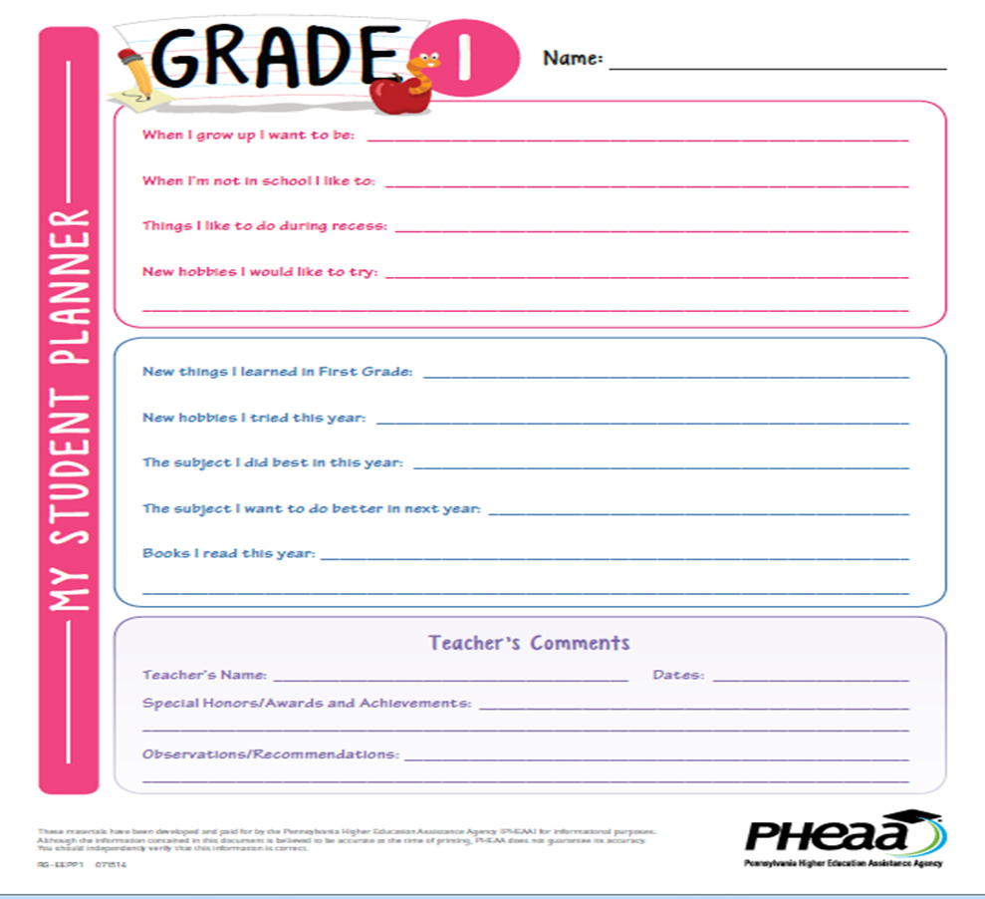

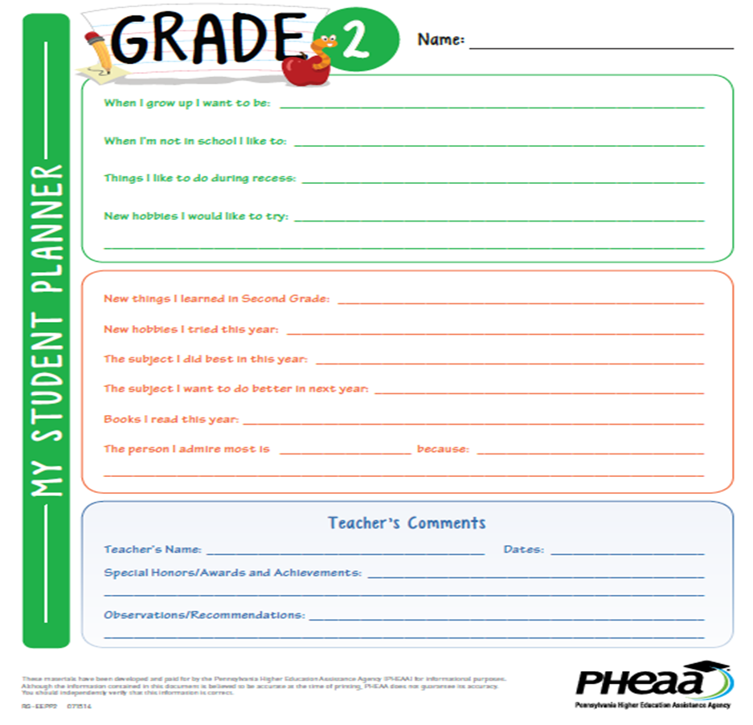

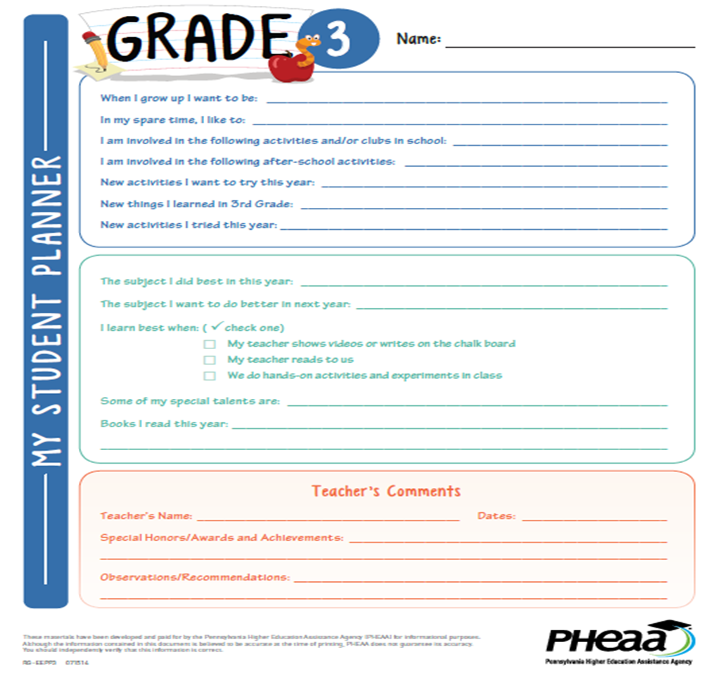

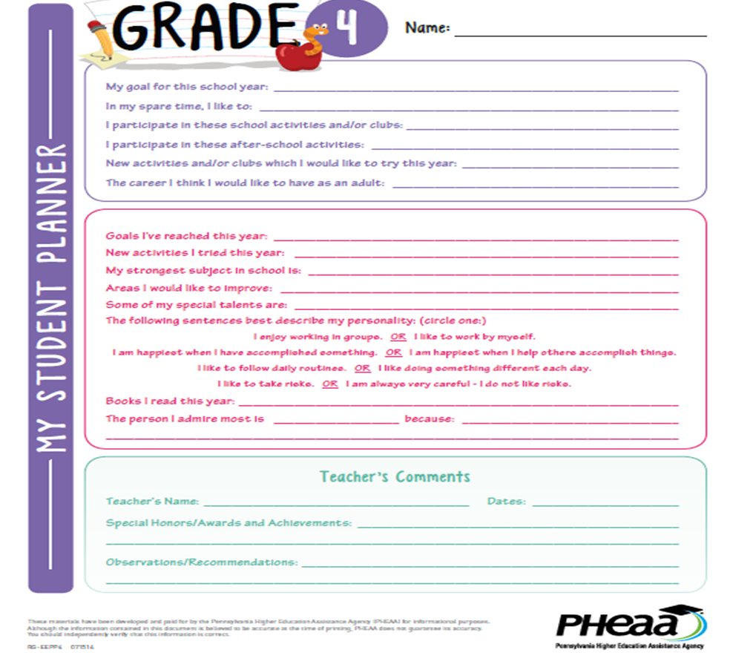

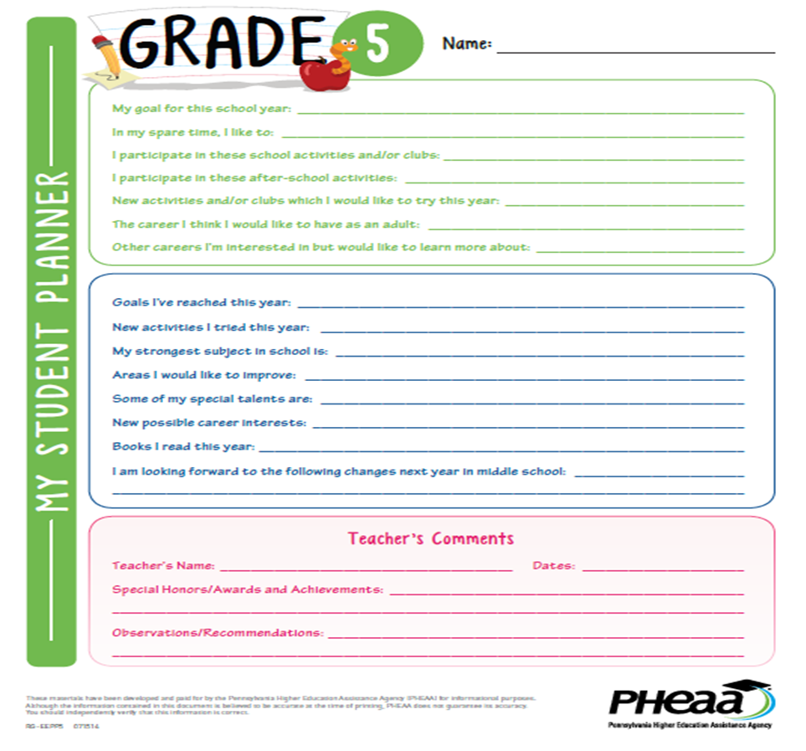


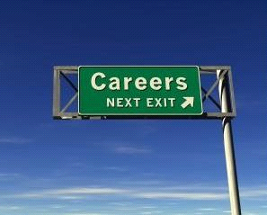
6th Grade Career Portfolio Summary Activity

Please look at your 1st- 5th career portfolio and answer the following questions:

What do you want to be when you grow up?

Kindergarten ___________________________________________

Grade 1________________________________________________

Grade 2 ________________________________________________

Grade 3 ________________________________________________

Grade 4 ________________________________________________

Grade 5 ________________________________________________

Grade 6 ________________________________________________

Have your career plans changed, or remained the same, over the years?

___________________________________________________________

Based on the portfolio you completed in previous years, what has been your strongest subject?

__________________________________________________

What has been your most difficult subject? _______________________________

How have your hobbies/interests changed or remained the same over the years?

______________________________________________________________________________

______________________________________________________________________________

______________________________________________________________________________

What was your RIASEC interest code when you did that activity in 4th grade?

___________________ ______________________ ___________________

Every year, when we discuss careers, we discuss the importance of developing good work habits to be successful in school and in your future career. Please name 2 work habits that are strengths for you: (hint – you can use your work habits questionnaire from 5th grade)

1. _______________________________________________________________

2. _______________________________________________________________

Name one work habit that you think you need to work on, and how you can make an improvement:

______________________________________________________________________________

______________________________________________________________________________

Using the resume you completed in 5th grade, name activities you have participated in during your elementary school years, or awards you have received:

___________________________________ ______________________________________

___________________________________ ______________________________________

___________________________________ ______________________________________

When choosing a career, what is the MOST important thing to consider?

___________________________________________________________



Sullivan County Jr/Sr High School
7th

Name __________________________ Student Date ____________________
Bio-Pages
7th Grade

- What are your academic strengths and interests?

- What subject area or course has given you the greatest difficulty? _____________________________

- What are your plans after high school? Circle any you are considering:

College (4 Yr) College (2 Yr) Technical/Trade School Military

Full Time Employment Undecided Other (specify) ____________________________

- What careers interest you at this time?

- Why are you interested in this/these careers?

- Describe your dream job:

- List any extracurricular activities in which you have participated or will participate this year. Indicate any offices held or special accomplishments in these activities. (in and out of school)

Activity | 7 | Offices, Awards, Special Interests or Significance

- What traits make you a good student?

- What traits can you improve upon?

- In 8th grade I am looking forward to

- In 8th grade my goals are to:

Sullivan County Jr/Sr High School
8th

Name __________________________ Student Date ____________________
Bio-Pages
8th Grade

1. What are your academic strengths and interests?

2. What subject area or course has given you the greatest difficulty? _____________________________

3. What are your plans after high school? Circle any you are considering:

College (4 Yr) College (2 Yr) Technical/Trade School Military

Full Time Employment Undecided Other (specify) ____________________________

- What careers interest you at this time?

- Why are you interested in this/these careers?

- Describe your educational plans:

- List any extracurricular activities in which you have participated or will participate this year. Indicate any offices held or special accomplishments in these activities. (in and out of school)

Activity | 7 | Offices, Awards, Special Interests or Significance

- What traits make you a good student?

- What traits make you a good class mate?

- In 9th grade I am looking forward to

- In 9th grade my goals are to:

Sullivan County Jr/Sr High School
9th

Name __________________________ Student Date ____________________
Bio-Pages
9th Grade

What are your top three RAISEC personality codes? (see handout)

1st Code _____ 2nd Code _____ 3rd Code _____

(codes are: Realistic, Artistic, Investigative, Social, Enterprising and Conventional)

- What are your academic strengths and interests?

- What subject area or course has given you the greatest difficulty? _____________________________

- What are your plans after high school? Circle one:

College (4 Yr) College (2 Yr) Technical/Trade School Military

Full Time Employment Other (specify) ________________________________

- What careers interest you at this time?

- Why are you interested in this/these careers?

- Describe your dream job:

- List any extracurricular activities in which you have participated or will participate this year. Indicate any offices held or special accomplishments in these activities. (in and out of school)

Activity | 9 | Offices, Awards, Special Interests or Significance

(Attach additional sheet if necessary)

- Rank your top work importance values 1 to 5.

_____ achievement _____ helping others _____ location/environment
_____ independence _____ working conditions _____ self-expression
_____ recognition _____ earnings _____ work/life balance
_____ relationships _____ technology _____ teamwork

Other: _____________________________________________________________________

- Read each item and decide whether it is true or false
1. _____ Career testing will tell me exactly what career is right for me.
2. _____ There is a perfect career for me.
3. _____ I’ll pursue whatever career is in demand.
4. _____ If I make the wrong decision, I’ll be stuck forever.
5. _____ I know everything I need to know about the career of my choice.
6. _____ I don't need to be concerned about making career choices until my Junior year.

- Finish the following sentence: One thing I have always done well is…….

Sullivan County Jr/Sr High School
10th

Name _______________________ Student Date ____________________
Bio-Pages
10th Grade

Your RAISEC Personality Type (from “THE RIASEC TEST”)

1. _______________________ 2. _______________________ 3. _______________________

- What are your academic strengths and interests?

- What subject area or course has given you the greatest difficulty? _____________________________

- What are your initial plans after high school?
Circle any that apply and indicate colleges/military branches/employers you may be considering. It is okay for you to leave the blanks blank if you don’t have any in mind when you complete this form.

College (4 Yr) _____________________________________________________________________
College (2 Yr) _________________________________________________________________
Technical/Trade School _________________________________________________________
Military __________________________________________________________________________
Full Time Employment ____________________________________________________________
Other or Undecided (specify) __________________________________________________________

- What field or specific occupation do you think most about pursuing? (If undecided, put undecided)

- If you woke up tomorrow, all your schooling was over and you were working in your dream job, what and where would it be?

- What would you most like to work with? Rank the following with 1 being the highest:

____ People ____Data _____Concepts ____Things

- What do you like to do with your spare time?

- List any extracurricular activities in which you have participated from grades 9 to 10. Specify by grade, and indicate any offices held or special accomplishments in these activities. (in and out of school)

Activity | 9 | 10 | Offices, Awards, Special Interests or Significance
(Attach additional sheet if necessary)

- Describe an achievement that you are most proud of. (include a list of honors and awards if there are any)

- What do you see yourself doing five years from now? Ten years from now?

Five:

Ten:



Sullivan County Jr/Sr High School
11th

Name _______________________ Student Date ____________________
Bio-Pages
11th

- What are your academic strengths and interests? ___________________________________________

- What subject area or course has given you the greatest difficulty? _____________________________

- What are your initial plans after high school?
Circle any that apply and indicate colleges/military branches/employers you may be considering:

College (4 Yr) _____________________________________________________________________
(when do you plan to take the SAT or ACT? _________________________________)
College (2 Yr) _________________________________________________________________
Technical/Trade School _________________________________________________________
Military __________________________________________________________________________
Full Time Employment ____________________________________________________________
Other (specify) ______________________________________________________________________

- What field or specific occupation do you plan to pursue? (If undecided, put undecided)

- Why have you chosen this field?
(if undecided in #4, are there any fields you are somewhat interested in?)

- What are your strongest traits/skills?

- Describe a difficult project/task and how you addressed it:

- List any extracurricular activities in which you have participated from grades 9 to 12. Specify by grade, and indicate any offices held or special accomplishments in these activities. (in and out of school)

Activity | 9 | 10 | 11 |  | Offices, Awards, Special Interests or Significance
(Attach additional sheet if necessary)

- How would someone describe you as a classmate?

- What do you see yourself doing ten years from now?

To be completed after taking the ASVAB :

Your ASVAB Interest Codes: ______ ______ ______

What were your two highest aptitude areas? (look under ASVAB tests)

_____________________________ _____________________________

What was your AFQT? _________

Sullivan County Jr/Sr High School
12th

Name _______________________ Senior Date ____________________
Bio-Pages

- What are your academic strengths and interests? __________________________________________

- What subject area or course has given you the greatest difficulty? _____________________________

- What are your initial plans after high school?
Circle any that apply and indicate colleges/military branches/employers you may be considering:

College (4 Yr) _____________________________________________________________________
Have you taken or when will you take the SAT or ACT? ______________________________
College (2 Yr) _________________________________________________________________
Technical/Trade School _________________________________________________________
Military __________________________________________________________________________
Full Time Employment ____________________________________________________________
Do you work now? _________ If yes, where? _______________________________________
Other (specify) ______________________________________________________________________

- What field or specific occupation do you plan to pursue? (If undecided, put undecided)

- Why have you chosen this field?
(if undecided in #4, are there any fields you might be leaning towards)

- What personal traits will make you successful at a university/tech school or workplace?

- What do you consider your greatest strengths?

- What do you consider your greatest weaknesses?
- List any extracurricular activities in which you have participated from grades 9 to 12. Specify by grade, and indicate any offices held or special accomplishments in these activities. (in and out of school)

Activity | 9 | 10 | 11 | 12 | Offices, Awards, Special Interests or Significance
(Attach additional sheet if necessary)

- Please describe an experience that you learned a great deal from – this could be a single event or an ongoing circumstance such as part time employment, community service etc.

- Describe an achievement that you are most proud of. (include a list of honors and awards if there are any)

- What do you see yourself doing five years from now?

- What help can the guidance office give you in pursuing your future plan? (Let me know if there are specific questions or areas of help that you need!)

K-12 Career Development Intervention Matrix

Use the chart below to identify career related interventions (activities and experiences) by grade that all students receive. This table will represent a mapping tool of all interventions linked to the K-12 school-counseling curriculum in the career domain.
(School Counselor interventions are taken from the curriculum action plan if they cover any CEW standards. Grade team interventions are taken from the comprehensive CEW standards gap analysis conducted fall 2016)
(For Grades 7 to 12, subject specific interventions are highlighted in blue)
Grade | Career Development Interventions for All Students
K | Berenstain Bears on the Job (School Counselor)  Career Riddles (School Counselor)  Student/Career Work Habits (School Counselor)  Personal Space/Cooperation (School Counselor)  Kid Writing – Interests, likes/dislikes (K teachers), and what they want to be when they  grow up.  Classmate interviews/opinions/show-tell/personal interests (K teachers)  Roles of individuals – Mother’s & Father’s Day activities (K teachers)  Community Helpers unit: range of jobs in community, work done by school personnel  and individuals in community, how to prepare for careers, education/training important  to careers (K teachers)  Speaking and Listening Skills: Show & Tell (K team) and Howard Wigglebottom Learns  To listen (School Counselor)  Resources available in researching job opportunities (K team report writing/use internet)  Letter writing (K team)  Workplace skills and work habits (K team)  Cooperation and group interaction activities (K team)  How money is used (K team)  Entrepreneurship (K team Community Helpers unit)  Collage of objects & symbols that tell about you. (Art teacher)  Group interaction – bucket fillers (K team)
1 | Careers Portfolio activity (School Counselor)  Conflict Resolution/Cooperation (School Counselor)  Self Esteem: I Like Myself (School Counselor)  All About Me interest writing and sharing (1st grade team)  Collage of objects & symbols that tell about you. (Art teacher)  Curriculum writing and reading about personal interests (1st grade team)  Classroom jobs (1st grade team)  Discussion of school personnel work (1st grade team)  Speaking and listening – sharing of ideas (1st grade team)  Letter writing (1st grade team)  Attitudes/Work habits/Cooperating – positive behavior program (1st grade team)  Group interaction (1st grade team)  How money is used (1st grade team)  Daily time management (1st grade team)
2 | Careers Portfolios (School Counselor)  I Care Rules Conflict Resolution Unit (School Counselor)  Ready for Success lessons (School Counselor)  Self Esteem (Victim’s Services)  All About Me posters (2nd grade team)  Interview partners about interests (2nd grade team)  Brown Bag share (2nd grade team)  Collage of objects & symbols that tell about you. (Art teacher)  My Family story (roles of individuals – 2nd grade team)  Discussion of jobs in stories in reading series (2nd grade team)  Thank you notes to school personnel and discussion of school jobs (2nd grade team)  Videos about careers and preparing, and discussion of further schooling (2nd grade team)  Speaking & Listening: Think-Pair Share strategy, book reports, show/tell (2nd grade  Team)  Working with partners (2nd grade team)  Workplace skills, cooperating, and work habits – SWPB program (2nd grade team)  Group interaction – Rules for being a good partner poster (2nd grade team)  How money is used (2nd grade team)  Time management: centers checklists, specials schedule, discussions of after school  scheduling and time management. (2nd grade team)
3 | Career Hush (School Counselor)  Work Skills (School Counselor)  Careers Portfolios (School Counselor)  Entrepreneurship Arthur’s Pet Business (School Counselor)  Entrepreneurship Research and Entrepreneur (School Counselor)  Conflict Resolution Rules for Fighting Fair Unit (School Counselor)  Botvin Life Skills Unit (Victim’s Services)  Writing about self and others (3rd grade team)  Collage of objects & symbols that tell about you. (Art teacher)  Letter writing (3rd grade team)  Discussion of jobs done by school personnel and importance of being responsible, (3rd  grade team)  Discussion of various careers, job requirements, and education required (3rd grade team)  Speaking & Listening: Students present stories, reports, friendly letters, riddles and other  information to their class or smaller groups. They do a lot of speaking/listening  activities in Reading, Math, Social Studies, and English. Rules of conversation &  listening skills are emphasized (3rd grade team)  Resources available to research jobs – using newspapers and magazines to gather  Information (3rd grade team), as well as learning to use email (library)  Plan for the future – activity at the end of the school year for planning for improvements  in the next school year. (3rd grade team)  Workplace skills & importance of being a good citizen discussions (3rd grade team)  Rules for working in a group – a lot of group work and/or partner work (3rd grade team)  Time management: Math lessons cover their daily student schedule and elapsed time for  chores, tv, etc.(3rd grade team)  Students helpers are given different jobs. Also reading on people and families in variety  of roles (3rd grade team)

4 | Careers: Which Job for Me (School Counselor)  Work Ethics (School Counselor)  Careers Portfolio (School Counselor)  Holland Types (School Counselor)  Laura’s Lesson (interests & factors influence career choices) – 4th grade team  Discussion of types of science jobs (4th grade team)  Career choice rationale writing activity in English (4th grade team)  Personal interest inventories (4th grade team)  Speaking and Listening skills (4th grade team)  Business, Friendly, and Personal letters (4th grade team)  Workplace skills addressed in SWPBS program lessons, as well as discussion throughout  the year (4th grade team)  Cooperation skills modeled by the team of teachers, as well through group work and  science explore & inquiry activities (4th grade team)  Group interaction strategies: “Easy for Some; Hard for Others” activity on tolerance (4th  grade team)  Personal schedule standard – Students receive schedules and planners, and are taught  to use them and are monitored to see if using correctly (4th grade team)  Entrepreneurship – Wright Brothers vs. Curtiss in Social Studies (4th grade team)
5 | Careers Are Everywhere Interests & Work Habits (School Counselor)  Careers Are Everywhere Resume & Work Environment (School Counselor)  Careers Are Everywhere Career Clusters (School Counselor)  Careers Portfolio (School Counselor)  Careers Post-Secondary Options & PA Career Zone (School Counselor)  Careers Entrepreneurship lesson (School Counselor)  Griffin Greeters Job Application (School Counselor)  The Respect Connection (Victim’s Services)  Interests, and how strengths influence career choices (5th grade team)  English class communication skills (writing, speaking, & listening) (5th grade team)  Environmental Day (4th grade team)  Social Studies: Regional jobs of geographic regions, as well as biography writings (5th grade team)  “What about an Interest Inventory?” & “How do I Work Best” (5th grade team)  Speaking and Listening skills during presentation, sharing, social studies debates, group  discussions, and classroom discussions (5th grade team)  Business, Friendly, and Personal letters (5th grade team)  Research jobs in the states they’re studying (5th grade team)  Work habits addressed throughout the year, especially when working in groups (5th grade  team)  Cooperation skills addressed through group work training, as well as in all classes (5th  grade team)  Group interaction strategies – discussion of appropriate ways to disagree in history (5th  grade team)  Budgeting – Math work on taxes, savings, expenses, as well as Social Studies taxes (5th  grade team)  Personal schedules – Students follow schedules at school and assignment books to help  them learn to budget time. (5th grade team).  Entrepreneurship – Social Studies lesson on historical and current entrepreneurship and  Its implications. (5th grade team)

6 | Careers Clusters (School Counselor)  Careers Portfolio K-6 Summary activity (School Counselor)  Botvin Life Skills Unit (Victim’s Services)  Career Research project (Library)  6th grade team indicated CEW standards covered in the curricular areas of Science  Reading, Social Studies, English, Library, Art. The gap analysis for this band did not  ask them to list activities. The 8th grade standards addressed in the subjects listed are:  13.1.8.A, 13.1.8.B, 13.1.8.C, 13.1.8.D, 13.1.8.E, 13.1.8.F, 13.1.8.H  13.2.8.A, 13.2.8.B, 13.2.8.D, 13.2.8.E  13.3.8.A, 13.3.8.B, 13.3.8.C, 13.3.8.E, 13.3.8.G
7 | Who’s Who?  What Could I do with my Life? Career Exploration DVD and assessment.  The World of Work and You pages 1 – 4 (What do you want to be When You Grow Up. Key Motivators Worksheet)  The World of Work and You pages 5 – 12 (What are your interests and abilities? Your Career Interest Areas Worksheet. Your Career Clues Worksheet)  The World of Work and You pages 13 -17 ( Your Key Job Skills Checklist. What are your Values? Your Work Values Worksheet. Your Preferred Working Conditions.)  The World of Work and You pages 17 – 32 (Identify Specific Job Titles. Interest to Jobs Career Chart. Careers to Explore in More Detail Worksheet.)  What Personality Type Are You?  The World of Work and You pages 33 to 40 (Do you Need or Want More Training or Education. Your High School to Career Options. Your Action Plan Worksheet. Keep Exploring Your Options.)  PA Career Zone: Introduction to the site, overview of job families  PA Career Zone: Quick Assessment and Career Exploration Activity Sheets  Education Planner: Introduction to the site and Career Clusters Activity  Education Planner: What Careers Match Your Skills Activity and Character Trait Activity  Current Events and Careers  Assignment book usage, organizational skills  Get Involved  Sullivan County High School brochure (extra-curricular activities)  Life Skills Training  SCHS Career Fair  SCHS Career/College Fair  7th Grade Academy – career interest survey, schedule planning.  7th Grade FCS – Team/Group member roles, time management, listening skills.  Math 8:  Lesson on careers that require in-depth math knowledge  Teaching students to work independently but alsot how to seek help from peers or  supervisors.  Requiring neat/proper work, deadlines, preparedness, teamwork and conflict  resolution.  Art 7:  transferable skills related to career preparation including critical thinking,  creativity, organization.  Art History oral presentation emphasizes coherence, presence and accuracy of  Information.  Work Habits grade. (attitude, effort, punctuality, care for supplies and workspace)  Art Room Cleanup (teamwork, responsibility, time management)  Learning Support: Transition planning  Reading: Lesson on Facebook use and social media impact on job acquisition and  retention.  Math 7: Group Work: teamwork, responsibility, roles, effort, conflict resolution.
8 | High Five Principles: Power Point and activity  High Five Quiz  How important are soft skills?  School to Careers Classroom Rules  Career Choice Requires Self-Assessment (article review)  Real Game Introduction  World of Work Survey  Random Career Assignment  Wish List Poster Activity  What’s My Line?  Hello Who am I Who are You?  Reality Check Activity (Budgeting)  the Spin Game  SCHS and the American Workforce  Budgeting with PA CareerZone  After Work.  Where does all the time Go  Time for Me  A slice of Life  Getting Away  Fair Play Unit  Man’s Work or Woman’s Work  Reflecting on Gender Facts  Gender Equity Facts and Figures  the Pink Slip  Winds of Change (Power Point and Quiz)  The Big Picture  Circle of Life Activity  Field Trip to the Guidance Office  Holland Types Power Point  RAISEC interest inventory  What would I be good at?  Introduction to Choices  Choices Interest Survey  Choices Work Importance Locater  Education Planner: Overview of site, Career Clusters Activity and Skills Match  Education Planner: Character Traits Activity  PA Career Zone. Site overview and quick assessment using previous Holland type results. Job Families HPO Activity and Match the Career to the Job Family Activity  Printed Resource Review  Career & Life Summary  Hobbies that Make Great Careers.  Volunteering Pays: Video and Handout  Summer and Part Time Jobs: Video and Handout  Looking at Careers  Case History  SCHS Career Fair  SCHS Career/College Fair  PE – Football Play book Project: every member of the team must give input, has a job  description, must execute his/her job for team to be successful.  English: Self-Analysis. (This I Believe essay)  English: Career Anecdotes with career related vocabulary.  English: Speaking and Listening Skills  English: Group work with assigned roles and leaders  English: Time management with long range writing assignments.  Math 8:  Lesson on careers that require in-depth math knowledge  Teaching students to work independently but also how to seek help from peers or  supervisors.  Requiring neat/proper work, deadlines, preparedness, teamwork and conflict  resolution.  Language 8: Lesson on how learning Spanish will give students and advantage in the  job market.  Learning Support: Transition planning  Multi-Communications: communications skills
9 | Career Directions  Your Career Direction in 7 Steps.  What’s out There…Your Personal Values  What’s out There…Career Preparation.  Career Directions Interest Inventory  An Honest Look At Yourself…career Possibilities  Career Directions Interest Inventory – What Your Scores Mean  The Career For You….Setting Your Goals  The Career for You…Making a Critical Decision  Additional training and Education Sources  Education Expense Worksheet  Sources of Financial Aid  Get that Job…Using a Chronological Resume  Get that Job…Using a Functional Resume  Get that Job…Create Your Own Resume  Get that Job…the Application  Get that Job…and Effective Cover Letter  Get that Job…Interview Strategies  Making Choices…Your Plan of Action  Bio Pages  SCHS Career Fair  SCHS Career/College Fair  Entrepreneurship (elective)  Family and Consumer Science I and II  Teamwork, roles, time management and listening skills  Algebra 2  Lesson on careers that require in-depth math knowledge  Teaching students to work independently but alsot how to seek help from peers or  supervisors.  Requiring neat/proper work, deadlines, preparedness, teamwork and conflict  resolution.  Art 9: Unit on graphic design including skills, interests needed to pursue this career,  Advancement, technical skills and growth of the field.  Elective Art:  Students offered information about a variety of design related careers.  Art Portfolio (assistance/guidance for required documentaiton for college admissions  and career acquisistion)  Scheduling oportunities (electives) related to artistic aptitudes and interests.  Peer to Peer critiques (formative and sumative, require peer to peer dialog,  instruction on constructive criticism)  Work Habits grade. (attitude, effort, puncutality, care for supplies and workspace)  Art Room Cleanup (teamwork, repsonsilbility, time management)  Spanish Elective: Lesson on how learning spanish will give students and advantage in  the job market.  Learning Support: Transition planning  Entrepreneurship (Elective) PE CEW 13.4.11 A,B,C
10 | Success in the New Economy  Job Gateway  NTCC Presentation  NTCC Tour  Bio Pages  SCHS Career Fair  SCHS Career/College Fair  Entrepreneurship (elective)  Accounting 1  American History 2  Impact of Industrialization on Employment.  Impact of Globalization on Employment  Impact of Technology on Employment  Research on Labor Unions use/impact of strikes and negotiation to gain better  working conditions, better pay and shorter work weeks.  Research on Robber Barons of late 1800’s and early 1900’s (entrepreneurial traits)  Family and Consumer Science I and II  Teamwork, roles, time management and listening skills  English: Self-Analysis. (This I Believe essay)  English: Career Anecdotes with career related vocabulary.  English: Speaking and Listening Skills  English: Group work with assigned roles and leaders  English: Time management with long range writing assignments.  Algebra 2  Lesson on careers that require in-depth math knowledge  Teaching students to work independently but also how to seek help from peers or  supervisors.  Requiring neat/proper work, deadlines, preparedness, teamwork and conflict  resolution.  Elective Art:  Students offered information about a variety of design related careers.  Art Portfolio (assistance/guidance for required documentation for college admissions  and career acquisition)  Scheduling opportunities (electives) related to artistic aptitudes and interests.  Peer to Peer critiques (formative and summative, require peer to peer dialog,  instruction on constructive criticism)  Work Habits grade. (attitude, effort, punctuality, care for supplies and workspace)  Art Room Cleanup (teamwork, responsibility, time management)  Spanish Elective: Lesson on how learning Spanish will give students and advantage in  the job market.  Learning Support: Transition planning  CSC 124:  Research Technology is various occupations and how it effects the workforce  Research paper on career field and post-secondary education/training  Entrepreneurship (Elective) PE CEW 13.4.11 A,B,C  Geometry: Group Work: teamwork, responsibility, roles, effort, conflict resolution.
11 | ASVAB  ASVAB Interpretations  FYI (Find Your Interests: Interest Survey  Understanding your Scores  How Does Gender Influence Your Interest Codes?  Learning about Careers and the World of Work  Educational Opportunities  The Occu-Find  Next Steps  Career Clusters  College Fair  Penn College Career Day  Your Key to Success  Bio Pages  Individual Career Planning meeting  SCHS Career Fair  SCHS Career/College Fair  Entrepreneurship (elective)  Accounting 1 (elective)  Intro to Financial Accounting (elective)  Intro to Business Management (elective)  Business Law (elective)  PE – Football Play book Project: every member of the team must give input, has a job description, must execute his/her job for team to be successful.  Family and Consumer Science I and II  Teamwork, roles, time management and listening skills  Elective Art:  Students offered information about a variety of design related careers.  Art Portfolio (assistance/guidance for required documentation for college admissions  and career acquisition)  Scheduling opportunities (electives) related to artistic aptitudes and interests.  Peer to Peer critiques (formative and summative, require peer to peer dialog,  instruction on constructive criticism)  Work Habits grade. (attitude, effort, punctuality, care for supplies and workspace)  Art Room Cleanup (teamwork, responsibility, time management)  Spanish Elective: Lesson on how learning Spanish will give students and advantage in  the job market.  Learning Support: Transition planning  Entrepreneurship (Elective) PE CEW 13.4.11 A,B,C  Geometry: Group Work: teamwork, responsibility, roles, effort, conflict resolution.  Intro to Stats: Group Work: teamwork, responsibility, roles, effort, conflict resolution.
12 | Welcome to your Future  Financial Aid Night  Scholarships 101  Casting Call  Mock Interviews  Resume and Cover Letters  Bio Pages  Individual Career Plan meetings  SCHS Career Fair  SCHS Career/College Fair  Entrepreneurship (elective)  Accounting 1 (elective)  Intro to Financial Accounting (elective)  Intro to Business Management (elective)  Family & Consumer Science for Seniors:  Interviewing skills  Power Point Project on desired career.  Identifying where to research job openings  Family and Consumer Science I and II  Teamwork, roles, time management and listening skills  Single Living (elective):  Students identify career of choice and complete project including lifestyle goals,  salary, budget and short and long term financial goal.  Elective Art:  Students offered information about a variety of design related careers.  Art Portfolio (assistance/guidance for required documentation for college admissions  and career acquisition)  Scheduling opportunities (electives) related to artistic aptitudes and interests.  Peer to Peer critiques (formative and summative, require peer to peer dialog,  instruction on constructive criticism)  Work Habits grade. (attitude, effort, punctuality, care for supplies and workspace)  Art Room Cleanup (teamwork, responsibility, time management)  Spanish Elective: Lesson on how learning Spanish will give students and advantage in  the job market.  Power Lab and Manufacturing & Construction:  Mass production and working with others in a shop setting.  Learning Support: Transition planning  Elementary Tutoring: Careers in Education, portfolios  Entrepreneurship (Elective) PE CEW 13.4.11 A,B,C  Intro to Stats: Group Work: teamwork, responsibility, roles, effort, conflict resolution.

Career and Technical Center Strategy

Describe your activities/events and interventions for increasing awareness for students/parents and educators regarding your local Career and Technical Center. (Include these in your curriculum action Plan and stakeholder strategy charts.)

The following activities are designed to increase awareness for students, parents and educators regarding Northern Tier Career Center and the program the center offers.
Every 5th grade student will receive information about the NTCC during a classroom guidance lesson. Teachers will be invited to participate in the lesson to learn about NTCC options. Students will be encouraged to share the information with their parents.
In 8th grade, students will take part in a unit in the school to careers class that goes over all of the curricular opportunities in high school, including the NTCC option for 11th and 12th grade.
Each 8th grade student will complete a four year schedule planner that may include NTCC as an option for their high school plan.
Every 9th grader will receive information about the NTCC options during an annual scheduling presentation.
Every 10th grader will take part in a lesson about career and technical education, including but not limited to the Success in the New Economy video and a brief RAISEC interest inventory.
Every 10th graders will take part in an assembly to learn about the NTCC and each of the programs offered.
Every 10th grader will be offered the opportunity to tour the Northern Tier Career Center on a school day to learn more about the center.
Every 10th grader and any 9th graders interested in cosmetology will be offered the opportunity to shadow at the Northern Tier Career Center to explore individual programs further.
All parents will be invited to attend an open house at the Northern Tier Career Center to learn about the programs offered there. Letters will be sent home at scheduling time, and the power point will be posted to the district website.
Educators in grades K-12 will be invited to tour the Northern Tier Career Center with the 10th grade tour.

Career and Technical Center Strategies

Student Awareness:
Grade | Intervention/  Program/Events | Stakeholder  Delivering | Data Used  Success Indicator | Begin & End | Contact Person
5th | Classroom Guidance Lesson | School Counselor | No. of students in attendance | December | Laura Fiester
8 - 11 | Scheduling Presentation | School Counselor | No. of scheduling sheets returned. | March | Ellen Koschak
9 | NTCC Cosmetology Program Tour/Shadow | NTCC | No. of students in attendance | February | Jen Farley
10 | NTCC Tour/Shadow (All shops) | NTCC | No. of students in attendance | February | Jen Farley

Parent Awareness:
Intervention/  Program Events | Date | Stakeholder  Delivering | Data Used Success Indicator | Contact Person
NTCC Open House | TBD | NTCC | No. of parents attending | Jen Farley
Scheduling Letter | March | School Counselor | No of parents receiving letter | Ellen Koschak
NTCC informational Power Point | On-going | School Counselor | No. of hits on the website | Ellen Koschak
NTCC Website Link | March | NT/  SC Technology Director | No. of hits on the website | Lance Mabus

Educator Awareness:
Intervention/  Program Events | Date | Stakeholder  Delivering | Data Used Success Indicator | Contact Person
NTCC Tour | February | NTCC | No. of faculty in attendance | Jen Farley/Ellen Koschak
In-Service Presentation | TBD | TBD | TBD | TBD
SULLIVAN COUNTY SCHOOL DISTRICT

TITLE: Elementary Guidance Counselor DATE: March 17, 2015

REPORTS TO: Elementary Principal APPROVED BY: Board of Education

STATUS:

JOB SUMMARY: Provides guidance activities for elementary students and consults with staff and parents regarding social/emotional concerns.

PRIMARY DUTIES AND RESPONSIBILITIES:

- Counsel with students individually and in groups.

- Provide in-service training for staff concerning new counseling programs.

- Develop and implement curricular programs related to the guidance area, such as career programs and self-concept programs.

- Maintain communication with staff, parents, teachers, district staff, community agencies, and LEA’s.

- Consult with teachers, administrators, and other school staff regarding social and emotional concerns and participate as a member of the Student Assistance Program.

- Assist teachers in focusing on the learning style and environment of the individual student, developing sound guidance practices within their classrooms and working with students to resolve classroom conflicts.

- Communicate test results so that students and parents understand and use the information appropriately.

- Assist students to learn responsibility by becoming aware of the consequences of their behavior.

- Conduct informational programs for parents and community.

- Assist the elementary principal with the district-wide assessment program.

- Facilitate the guidance records transfer from sixth grade to seventh grade in coordination with the high school guidance office.

- Coordinate activities with community agencies based on student needs.

- Present classroom programs on topics relevant to students’ needs.

- Maintain communication with the Principal regarding all cases of suspected child abuse.

- Perform other duties as assigned by the Principal.

QUALIFICATIONS: Pennsylvania Elementary Guidance Counselor certificate required
Submission of pre-employment medical examination (Section 148 of the Pennsylvania School Code)
Submission of a report of criminal history record from the Pennsylvania State Police (Section 111 of the Pennsylvania School Code)
Submission of a clearance report from the Pennsylvania Department of Public Welfare in accordance with Act 151 of 1994
Submission of Federal Criminal History Record in accordance with Act 114 of 2006
Submission of the Arrest/Conviction Report and Certification Form as required under Act 24 of 2011
Submission of the Child Abuse Recognition and Reporting Training certification form as required under Act 126 of 2012
Such alternatives to the above qualifications as the Board may find appropriate and acceptable

PHYSICAL DEMANDS: Ability to reach above and below the waist
Ability to use fingers to pick, feel and grasp objects
Some stooping, bending, kneeling, and twisting of the body required
Ability to lift and/or carry supplies weighing no more than 40 lbs.
Ability to sit, walk, stand or move throughout the building, often for extended periods of the workday
SENSORY ABILITIES: Visual acuity
Auditory acuity

WORK ENVIRONMENT: Typical office environment
Subject to inside environmental conditions

TEMPERAMENT: Must possess excellent interpersonal skills
Must be able to work in an environment with frequent interruptions
Able to make judgments and work under high level of stress
Exhibit patience and tact

COGNITIVE ABILITY: Ability to communicate effectively
Ability to organize tasks
Ability to handle multiple tasks
Ability to exercise good judgment

SPECIFIC SKILLS: Must possess computer skills
Ability to operate various office equipment
Must possess conflict mediation skills
Ability to structure a daily schedule, group and individual meetings
Ability to de-escalate volatile situations
Must appropriately handle confidential information

(Reasonable accommodations may be made to enable a qualified individual with a disability or disabilities to perform the primary duties and responsibilities of the job.)
SULLIVAN COUNTY SCHOOL DISTRICT

TITLE: Secondary Guidance Counselor DATE: March 17, 2015

REPORTS TO: High School Principal APPROVED BY: Board of Education

STATUS:

JOB SUMMARY: Provide guidance for secondary students and consults with staff, parents and, outside agencies regarding social/emotional concerns.

PRIMARY DUTIES AND RESPONSIBILITIES:

- Assist students during college, scholarship and financial aid application processes and provides letters of recommendation when needed.

- Provide counseling to students, individual and in groups, related to personal, academic, social, emotional, and career issues.

- Develop and facilitate career curriculum for grades 7 to 12; teach courses related to the areas of academic, career, and personal-social development; develop and implements curricular programs related to the guidance area and present classroom programs relevant to student needs.

- Maintain communication with staff, parents, teachers, district staff, community agencies, and LEA’s.

- Consult with teachers, administrators, and other school staff regarding social and emotional concerns.

- Assist teachers in focusing on the learning style and environment of the individual student; developing sound guidance practices within their classrooms and; working with students to resolve classroom conflicts.

- Coordinate VLINC on-line education, the Dual enrollment and scholarship programs.

- Assist students in the selection of courses with the principal in the scheduling process.

- Conduct informational programs for parents and community.

- Facilitate the administration of standardized assessments, train test administrators and explain test results to students, teachers and parents.

- Maintain communication with the Principal regarding all cases of suspected child abuse.

- Coordinate activities with community agencies based on student needs.

- Prepare and maintain required reporting to include the Homeless Report and the monthly counselor’s report for the board meeting.

- Perform other duties as assigned by the high school principal.

QUALIFICATIONS: Pennsylvania Secondary Guidance Counselor certificate required
Submission of pre-employment medical examination (Section 148 of the Pennsylvania School Code)
Submission of a report of criminal history record from the Pennsylvania State Police (Section 111 of the Pennsylvania School Code)
Submission of a clearance report from the Pennsylvania Department of Public Welfare in accordance with Act 151 of 1994
Submission of Federal Criminal History Record in accordance with Act 114 of 2006
Submission of the Arrest/Conviction Report and Certification Form as required under Act 24 of 2011
Submission of the Child Abuse Recognition and Reporting Training certification form as required under Act 126 of 2012
Such alternatives to the above qualifications as the Board may find appropriate and acceptable

PHYSICAL DEMANDS: Ability to reach above and below the waist
Ability to use fingers to pick, feel and grasp objects
Some stooping, bending, kneeling, and twisting of the body required
Ability to lift and/or carry supplies weighing no more than 40 lbs.
Ability to sit, walk, stand or move throughout the building, often for extended periods of the workday

SENSORY ABILITIES: Visual acuity
Auditory acuity

WORK ENVIRONMENT: Typical office environment
Subject to inside environmental conditions

TEMPERAMENT: Must possess excellent interpersonal skills
Must be able to work in an environment with frequent interruptions
Able to make judgments and work under high level of stress
Exhibit patience and tact

COGNITIVE ABILITY: Ability to communicate effectively
Ability to organize tasks
Ability to handle multiple tasks
Ability to exercise good judgment

SPECIFIC SKILLS: Must possess computer skills
Ability to operate various office equipment
Must possess conflict mediation skills
Ability to structure a daily schedule, group and individual meetings
Ability to de-escalate volatile situations
Must appropriately handle confidential information

(Reasonable accommodations may be made to enable a qualified individual with a disability or disabilities to perform the primary duties and responsibilities of the job.)

