Southampton High School English Department Curriculum and Pacing Guide 10th GRADE

 Pacing |  | Week 1 | Week 2 | Week 3 | Week 4 |  | Week 5 |  | Week 6 | Week 7 | Week 8 | Week 9
Speaking  & Listening  10.1 –  Communication |  | Students will participate in, collaborate in, and report on small-group learning in weekly activities throughout the semester.
 |  | Presenting a Response to a Short Story |  |  |  | Participating in a Group Discussion |  |  |  | Conducting an Interview
Standard of Learning 10.2 – Media Literacy
Students will analyze, produce, and examine similarities and differences between visual and verbal media messages throughout the quarter.
Topics: Creating Suspense on Film, Credibility in News Reports
Standard of Learning 10.3 – Vocabulary Development
Students will engage in a study of word families from Latin and Greek roots weekly throughout the semester.
English 10 students will apply vocabulary usage skills working with in-text vocabulary within weekly reading activities.
Reading  Standards of Learning  10.4- Fiction  10.5-  Nonfiction | Curriculum Novels: Animal Farm, Fahrenheit 451, Lord of the Flies
 | The World of a Story  Harrison Bergeron  Everyday Use  The Race to Save Apollo 13 |  |  | World Portraits  The Possibility of Evil  Shoofly Pie  Like the Sun |  |  | A Writer’s Choice  By the Waters of Babylon  There Will Come  Soft Rains  Dyaspora |  |  | Message & Meaning  The Interlopers  When Mr. Pirzada  Came to Dine | Disaster & Devastation:  Tragedy & Heroism  The Johnstown Flood  And of Clay We Are Created  The Man in the Water
Writing  Standards of Learning  10.6- Developing Writing  10.7-  Editing & Grammar | Daily Writing Assignments:  journals, topic-driven assignments, SOL-prompts  Autobiographical Narrative  Utopia Project (Academic, Honors)  Writing Workshop  Literary Analysis, Analysis of Literary Nonfiction |  |  |  |  |  |  | Daily Writing Assignments:  journals, topic-driven assignments, SOL-prompts  Writing Workshop  Comparison/Contrast Essay, Persuasive Letter
 | Students will improve in the skills of effective organization, clear structure, sentence variety, effective word choice, and appropriate usage/mechanics through review and editing of student writing throughout the semester.

 Pacing | Week 10 | Week 11 | Week 12 | Week 13 |  |  | Week 14 | Week 15 | Week 16 |  |  | Week 17 | Week 18
Speaking  & Listening  10.1 –  Communication | Students will participate in, collaborate in, and report on small-group learning in weekly activities throughout the semester.
Speaking  & Listening  10.1 –  Communication | Presenting an Argument |  |  |  | Giving and Following Oral Instructions |  |  |  |  | Participating in a Critic’s Debate
Standard of Learning 10.2 – Media Literacy  Students will analyze, produce, and examine similarities and differences between visual and verbal media messages throughout the quarter.  Topics: Persuasion in Political Ads, History Through Media, Shakespearean Drama on Film |  |  |  |  |  |  |  |  |  |  |  |  |  | Presenting a Response to a Short Story | Participating in a Group Discussion | Conducting an Interview
Standard of Learning 10.3 – Vocabulary Development
Students will engage in a study of word families from Latin and Greek roots weekly throughout the semester.
English 10 students will apply vocabulary usage skills working with in-text vocabulary within weekly reading activities.
Reading  Standards of Learning  10.4- Fiction  10.5-  Nonfiction | Curriculum Novels: Animal Farm, Fahrenheit 451, Lord of the Flies
 | Argument & Persuasion  Doing Nothing Is Something  I Acknowledge Mine  Use of Animals in  Biomedical Research  Abolishing the Penny Makes  Good Sense  The Blue Stones  Honors:  Survey of Titanic Literature  Titanic Research & Presentation |  | History & Culture  Only Daughter  Caramelo  Marriage is  a Private Affair  Night  Montgomery Boycott |  |  | The Language of Poetry  Survey of poetry from  a variety of eras and cultures  Students will also create & share poetry.   |  |  |  |  | Drama:  William Shakespeare’s  Julius Caesar  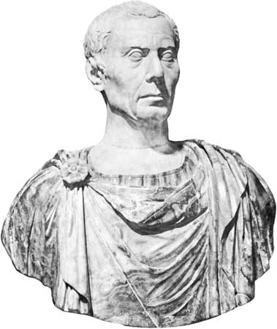  Honors: Antigone
Writing  Standards of Learning  10.6- Developing Writing  10.7-  Editing & Grammar  10.8-  Research & Documentation | Daily Writing Assignments:  journals, topic-driven assignments,  SOL-prompts  Writing Workshop  Persuasive Essay, Cause-and-Effect Essay |  |  |  |  | Daily Writing Assignments:  journals, topic-driven assignments, SOL-prompts  Qualities of a Good Leader Essay / Tragic Hero Essay  Writing Workshop- Research Product:  Comparing Animal Farm to the Russian Revolution
 | Students will improve in the skills of effective organization, clear structure, sentence variety, effective word choice, and appropriate usage/mechanics through review and editing of student writing throughout the semester.

