Lesson 4-1: Telling Time: Seatwork
Draw the Time Face with All Numbers Five Minute Intervals

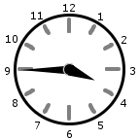  _____________ | 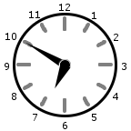  _____________ | 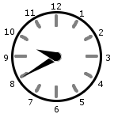  _____________
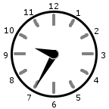  _____________ | 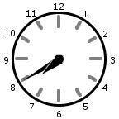  _____________ | 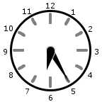  _____________
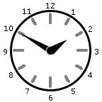  _____________ | 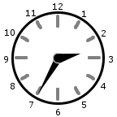  _____________ | 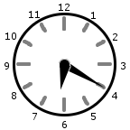  _____________

There are special ways to say times that end with the numbers 00, 15, 30, and 45.
5:00 - five o'clock
5:15 - quarter after five (or, you could say, quarter past five)
5:30 - half past five
5:45 - quarter to six (or, you could say, quarter 'till six)

Lesson 4-1: Telling Time: Seatwork

Read each sentence below then circle the best answer.

How long does it take to grow a crop of corn? Circle the best answer.

10 days 10 weeks 10 years

How long do most songs on the radio last? Circle the best answer.

5 weeks 5 days 5 minutes

How long does it take to train for a marathon? Circle the best answer.

5 minutes 5 days 5 months

How long does it take for an elephant to reach full size? Circle the best answer.

14 minutes 14 days 14 years

How long does it take to paint a bedroom? Circle the best answer.

2 hours 2 weeks 2 months

How long does a bear hibernate? Circle the best answer.

3 minutes 3 hours 3 months

How long does it take to cook dinner? Circle the best answer..

2 hours 2 days 2 months

Lesson 4-1: Telling Time: Homework

Draw the Time Face with All Numbers Five Minute Intervals
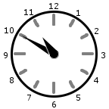  _____________ | 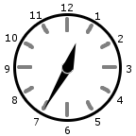  _____________ | 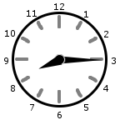  _____________
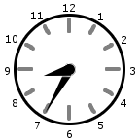  _____________ | _____________ | 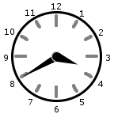  _____________
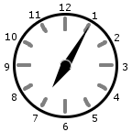  _____________ | 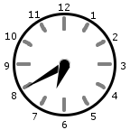  _____________ | _____________
Write each time the “smart way”.
a. 6:30 ______________________________________
b. 3:15 ______________________________________
c. 9:45 ______________________________________

Lesson 4-1: Telling Time: Homework
Read each sentence below then circle the best answer.

How long does autumn last? Circle the best answer.

4 hours 4 months 4 years

How long would it take an airplane to fly around the world? Circle the best answer.

2 hours 2 days 2 years

How long would it take to ride a bike across the United States? Circle the best answer.

9 minutes 9 weeks 9 years

How long does it take a tree to reach its full height? Circle the best answer.

25 minutes 25 days 25 years

How long would it take to sail across the Atlantic Ocean? Circle the best answer.

7 hours 7 weeks 7 years

How long does it take to make a sandwich? Circle the best answer.

7 minutes 7 days 7 months

How long does a baseball game last? Circle the best answer.

2 minutes 2 hours 2 weeks

Want extra fun practice? Go to
http://math4children.com/Grade1/games/time/index.html
Lesson 4-2: Units of Time: Seatwork

Drill and Practice Circle your correct answer.
1. The amount of time it takes to take a shower 15 minutes 15 hours
2. The time it takes to wash one load of clothes 45 minutes 45 seconds
3. The time it takes to eat a sandwich 6 minutes 6 hours
4. The time it takes to build a house 18 months 18 years
5. The time it takes to change the oil in a car 20 minutes 20 days

MEASURES OF TIME
1 minute (min.) = 60 second (sec.)
1 hour (hr.) = 60 minutes (min.)
1 day = 24 hours (hr.)
1 week (wk.) = 7 days
1 year (yr.) = 52 weeks (wk.)
1 year (yr.) = 12 months (mo.)

Fill in the blanks .
6. 7 Days = 1 _______ 7. _____ Minutes = 1 Hour
8. _____ Days = 1 Year 9. 24 Hours = 1 _______
10. 60 Minutes = 1 _______ 11._____ Days = 1 Week

Answer the next questions on a sheet of paper and turn them in when you have completed them.
Write the equivalents. (note 8 -10 are challenging)
6) 13 months = _______year _____months

7) 6 hours = ______minutes

8) 4 minutes = _______seconds

9) 68 months = _____ years _____weeks
10) 400 days = ______years _____ weeks ___days
Lesson 4-2: Units of Time: Homework

Write >, < or = for each problem.

1. 48 hours ________ 4 days 2. 1 year _______ 12months

3. 60 minutes _______ 2 hours 4. 17 days _______ 2 weeks

5. 5 months _______ 40 weeks 6. 1 millennium_______ 10 centuries

7. 6 decades _______ 1 century 8. 5 decades _______ 48 years

Drill and Practice Circle your correct answer.
1. The amount of time it takes to watch a cartoon 15 minutes 15 hours
2. The time it takes to tie your shoes 45 minutes 45 seconds
3. The time it takes to cook toast 6 minutes 6 hours
4. The time it takes to complete 4th grade 9 months 9 years
5. The time it takes to have a vacation 10 minutes 10 days
Sally wanted to travel around the world. She worked out that the trip would take her four years. How many months would that be?

The school holiday starts in three weeks. How many school days are left until the holiday?

It takes 12 hours to house sit a dog at dog Bruno's Home. How many minutes would it take?

Want extra fun practice? Go to http://math4children.com/Grade4/games/Time/time%20units/index.html or
http://math4children.com/Kidergarden/games/time_/time_with_clocks_memory_game/index.html
Lesson 4-3: Elapsed Time: Seatwork

Figuring out elapsed time, or how much time has passed, is really just adding and subtracting units of time.

An airplane left the Newport News/Williamsburg Airport at 9:50 A.M. and arrived at Detroit, Michigan at 11:45 A.M. How long did the trip take? | Start Time |  | Hours | Minutes
❐

❑
 | Total | ❐  

Fred is making brownies. They need to bake for 47 minutes. She put them in the oven at 6:30 P.M. At what time should she take them out? | Start Time |  | Hours | Minutes
❐

❑
 | Total | ❐  

How long did John sleep if he went to bed at 9:40 P.M., and got up at 7:20 A.M.? | Start Time |  | Hours | Minutes
❐

❑
 | Total | ❐  
Lesson 4-3: Elapsed Time: Seatwork

If Mrs. Stone leaves home at 6:45 A.M. and arrives at school at 7:51 A.M., how long did it take her to get there? | Start Time |  | Hours | Minutes
❐

❑
 | Total | ❐  

Mrs. Duncan set a timer at 9:15 A.M. to ring in 35 minutes for a practice quiz in her classroom. What time will it be when the timer rings? | Start Time |  | Hours | Minutes
❐

❑
 | Total | ❐  

Jill took a trip to Georgia from Virginia during Spring Break. She left home at 6:45 A.M. and arrived at 5:55 P.M. How long did the trip take? | Start Time |  | Hours | Minutes
❐

❑
 | Total | ❐  

Lesson 4-3: Elapsed Time: Homework

Figuring out elapsed time, or how much time has passed, is really just adding and subtracting units of time.

Five hours and 42 minutes after he started a bike tour, Chen completed the tour. If he finished at 2:17 P.M., what time did he start? | Start Time |  | Hours | Minutes
❐

❑
 | Total | ❐  

Bill left home at 4:42 P.M. and rode his bike to his friend's house. It took him 23 minutes. What time did he arrive? | Start Time |  | Hours | Minutes
❐

❑
 | Total | ❐  

Gail did her science project in three parts. Part one took her 45 minutes. Part two took her 36 minutes. Part three took her 14 minutes. What was the total time it took her to finish her project? | Start Time |  | Hours | Minutes
❐

❑
 | Total | ❐  

Lesson 4-3: Elapsed Time: Homework

Dad began cutting grass on Saturday morning at 9:28 A.M. He finished the entire yard by 10:33 A.M. How long did it take him? | Start Time |  | Hours | Minutes
❐

❑
 | Total | ❐  

Mrs. Lyford started playing her drums at 9:30 P.M. She practiced for 1 h our and 35 minutes. What time will it be when she is done? | Start Time |  | Hours | Minutes
❐

❑
 | Total | ❐  

Mrs. Kreamer walks her dog for 45 minutes. She finished at 7:23 A.M., what time did she start? | Start Time |  | Hours | Minutes
❐

❑
 | Total | ❐  

Having some trouble remembering? Try the following links. http://www.youtube.com/watch?v=5bu14OfrbLE
http://www.youtube.com/watch?v=TQSfAzgAKmk

Lesson 4-3: Elapsed Time Continued: Seatwork
Remember: Elapsed time is the time that has passed. This is also the amount of time between beginning and end of time.

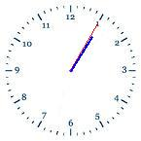 | 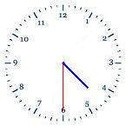 | How much time has gone by  between the times on the  first and second clocks?

Donna and Ashley left the school at 2:05 P.M. They drove for 46 minutes before arriving at Donna's house. What time did they arrive at Donna's house?

The Smith's will visit their cousin, who lives 3 hours and 10 minutes away. They want to get there at 11:30 A.M. What time should they leave?

Tom scored a touchdown at 7:48 P.M. Steve intercepted a pass and scored a touchdown 11 minutes later. What time did Steve score the second touchdown?

Your dance partner for this year's hula hoop contest arrives at 3:30 P.M. and leaves at 7:45 P.M. How long do you practice together?

The music performance began at 6:25 P.M. It ended at 9:15 P.M. How long did it last?

The birds began chirping at 3:45 A.M. They chirped for 2 hrs. 20 mins. What time did they finish chirping?

Jane went to the mall from 12:15 until 3:45. How long was she at the mall?

Lesson 4-3: Elapsed Time Continued: Homework

Remember: Elapsed time is the time that has passed. Solve the following problems.

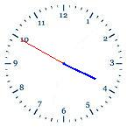 | 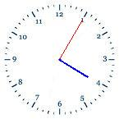 | How much time has gone by  between the times on the  first and second clocks?

Maggie took a walk. She left at 10:33 A.M. and got home at 1:45 P.M. How long was she gone?

The baseball game started at 7:05. It ended at 9:15. How long was the baseball game?

The Smiths went to dinner at 5:48 P.M. and returned home at 7:30 P.M. How long were they gone?

The family went to the circus for one hour and 15 minutes. If they got to the carnival at 1:45 P.M., what time did they leave?

The cookies need 18 minutes to cook. If they are put in the oven at 1:05 P.M., what time do they need to come out of the oven?

Mary went to work at 9:00 A.M. She got home at 3:22 P.M. How long did she work?

The Johnson Family took a road trip that took 2 hours and 45 minutes. If they left their house at 4:13 P.M., what time did they arrive at their destination?

Having some trouble remembering? Try the following links. http://www.youtube.com/watch?v=5bu14OfrbLE
http://www.youtube.com/watch?v=TQSfAzgAKmk
Lesson 4-5: Calendar: Seatwork

Use the Calendars to answer the questions below

1. five weeks from January 10th. 2. Two weeks before February 24th.
____________________________ ____________________________

3. one week after December 14th. 4. three weeks after February 1st.
____________________________ ____________________________

5. Suppose you had tuba lessons every Friday. What are the dates of your lessons in January?

________________________________________________________________________

6. What date is it 11 days after February 24?
________________________________________________________________________

7. Which months have thirty days or less?

________________________________________________________________________

8. Sean’s birthday is 4 weeks after January 18th. What day is it?

________________________________________________________________________
Lesson 4-5: Calendar: Seatwork

You can use this trick to help you remember the number of days in each month.

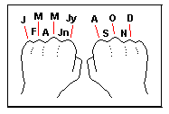
Thirty days hath September,
April, June and November;
February has twenty eight alone
All the rest have thirty-one
Except in Leap Year, that's the time
When February's Days are twenty-nine

9. How many days are there in June?

________________________________________________________________________

10. Which is the shortest month? How many days does it usually have?
________________________________________________________________________

11. How many days does April have?

________________________________________________________________________

12. How many days does September have?

________________________________________________________________________

13. How many days does March have?

________________________________________________________________________

14. How many days does August have?

________________________________________________________________________

15. When is your birthday? How many months is that away?

________________________________________________________________________
Lesson 4-5: Calendar: Homework

Use the Calendars to answer the questions below.

Find the date
1. Seven weeks from June 8th. 2. Two weeks before July 3rd.

____________________________ ____________________________

3. One week after June 25th. 4. Three weeks after June 4th .

____________________________ ____________________________

5. Suppose you had underwater archery lessons every Friday. What are the dates of your lessons in June?

________________________________________________________________________

6. What date is it 11 days after June 30?

________________________________________________________________________

7. Which months have thirty one days? (no this is not a trick!)

________________________________________________________________________

8. Karen’s birthday is two weeks after June 6th. What day is her birthday?

________________________________________________________________________

Lesson 4-5: Calendar: Homework

REMEMBER: You can use this trick to help you remember the number of days in each month.

Thirty days hath September,
April, June and November;
February has twenty eight alone
All the rest have thirty-one
Except in Leap Year, that's the time
When February's Days are twenty-nine

9. How many days are there in November?

________________________________________________________________________

10. If a Saturday falls on the 12th of the month what day is 24Th?
________________________________________________________________________

11. How many days does October have?

________________________________________________________________________

12. How many days does July have?

________________________________________________________________________

13. If a Friday falls on the 7th of the month what day is 24Th?
________________________________________________________________________

14. If a Monday falls on the 7th of the month what day is 24Th?

________________________________________________________________________

15. If a Tuesday falls on the 15th of the month what day is 23rd?

________________________________________________________________________

Lesson 4-6: Pictographs: Seatwork
Answer the following questions on the basis of the given pictograph (one picture represents 10 plants):

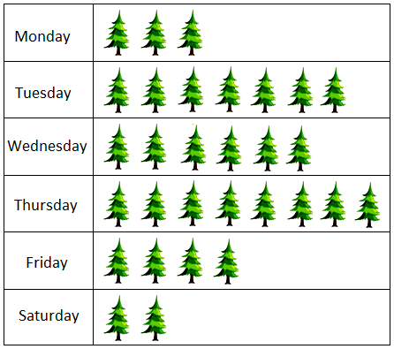
 | → 1 plant represents 10 plants

On which day were the maximum numbers of plants planted? _______________
On which day were the minimum numbers of plants planted? _______________
What is the difference between the maximum and minimum numbers of plants planted on the two days?
_______________
How many plants were planted each day?
Monday: _______________
Tuesday: _______________
Wednesday: _______________
Thursday _______________
Friday: _______________
Saturday: _______________
How many plants were planted in the week? _______________
Lesson 4-6: Pictographs: Seatwork

Make a pictograph using the following data.

Aliens from different planets
Gilese 30
Mars 10
Titan 20
Zeenex 45
Zeta Reta 50

Aliens from Different Planets

Key  = 10 aliens

Gilese
Mars
Titan
Zeenex
Zeta Reta

Lesson 4-5: Pictographs: Homework

Lesson 4-6: Pictographs: Homework
Answer the following questions on the basis of the given pictograph (one picture represents 4 students):

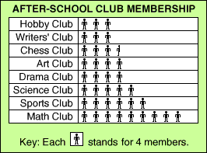

Which club(S) has the maximum number of students ? _______________
Which club(s) has the least number of students ? _______________
What is the difference in number of students in the DRAMA CLUB and SPORTS CLUB?
_______________
How many students are in:
Hobby Club _______________
Chess Club: _______________
Science Club: _______________
Sports Club _______________
Math Club: _______________
How many students are in after school clubs? _______________

Lesson 4-6: Pictographs: Homework

Make a pictograph using the following data.

Tikis from different Islands
Barbados 40
Hawaii 25
St. Lucia 30
Bermuda 35
Easter 60

Key = = 10 tikis

Barbados
Hawaii
St. Lucia
Bermuda
Easter



Lesson 4-7: Line Plots: Seatwork

Line Plots
One of the most basic ways to display statistical data is a line plot. This is used for surveys of small numbers of people, or to show a distribution of data about a small set.
Example:
Suppose you count the number of students in each classroom in your school. Since there are only a few classrooms, you can use a line plot to organize your data.
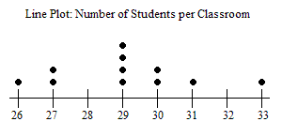
- How many classes have a higher number than 29? _______________________
- How many classes have less than 28? ____________________________
- What is the most common size? ____________________________
- Are there any outliers? If so what? ____________________________
- How many classes are there altogether? ____________________________

Look at the Line Plot Graph on the Left. It is a graph of students in different grades.

6. How many students are in 1st & 2nd grade? ________________________
7. How many students are in 4th & 5th grade? ________________________
8. What grade has the most students? _________
9. What grade has the least students? _________
10. What would you call one students in 10th grade? ____________________________

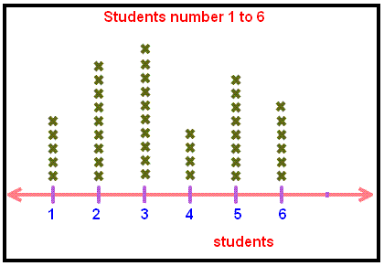

Lesson 4-7: Line Plots: Seatwork
Use the data taken from a survey on how many raisins are in 17 half ounce boxes to construct your own line plot in the space below.
Number of Raisins in 17 Half-Ounce Boxes
 | 29 |  | 27 |  | 27 |  | 28 |  | 31 |  | 26 |  | 28 |  | 28 |  | 30 |  | 29 |  | 26 |  | 27 |  | 29 |  | 29 |  | 25 |  | 28 |  | 28

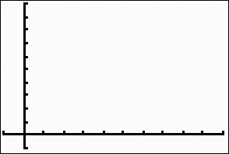


Lesson 4-7: Line Plots: Homework
Line plots are another way to organize data as it is being collected. The line plot below shows the amount of money 8 students spent on snacks.
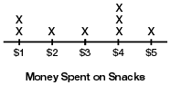

- What was the most common amount spent on snacks? _____________________
2. How many people bought snacks? __________________
- What was the least common amount spent on snacks? _____________________
- Are there any outliers? If so what? ________________________

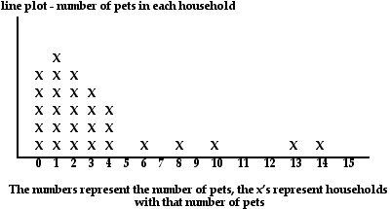

Look at the Line Plot Graph on the Left. It is a graph of students in different grades.

5. How many households have 4 pets? ________________________
6. How many households have 1 pet or less? ________________________
7. How many households have 3 pets? ________________________
8. What is the most common number of pets per household? ______________________
9. What is the greatest amount of pets a household has? How many? _______________
10. Are there any outliers? If so what? ______________________________

Lesson 4-7: Line Plots: Homework

Use the data taken from a survey on how many M and Ms are in a small bag to construct your own line plot in the space below.
Number of M & M in a bag
 | 15 |  | 17 |  | 16 |  | 18 |  | 21 |  | 16 |  | 17 |  | 18 |  | 20 |  | 19 |  | 16 |  | 17 |  | 16 |  | 19 |  | 15 |  | 18 |  | 17



Lesson 4-8: Bar Graphs: Seatwork

Graphs are a great way to give people information without writing it out in a paragraph. For instance, you could write a paragraph telling about how tall you and your friends are, or you could make a graph to show the same information.
Looking at either bar graph, you can see the title at the top. The sides of the graph are also labeled.
One side has the scale of numbers used. A scale is a series of numbers placed at fixed distances on a graph to help label the graph and assist you in reading the number each bar shows. A scale usually starts with 0. The top value of the scale when making a bar graph should be greater than the greatest value of the data.
An interval is also selected on a bar graph. An interval is the distance between two numbers on the scale of a graph or the difference between two numbers on the scale. If you are counting by 2’s on the bar graph(0, 2, 4, 6, 8, 10, 12) then The interval is 2.
The other side of the bar graph has a label entitled with the items that are to be compared.
Title

label

scale

interval

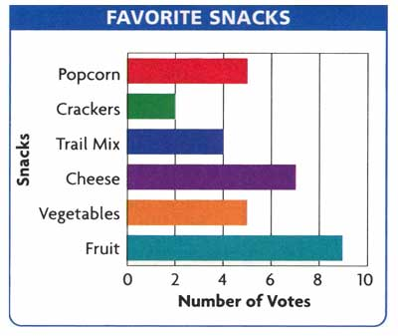

Lesson 4-8: Bar Graphs: Seatwork

A bar graph is useful for comparing facts. The bars provide a visual display for comparing quantities in different categories. Bar graphs help us to see relationships quickly. Another name for a bar graph is a bar chart. Each part of a bar graph has a purpose.

New Eagle Elementary Student’s Favorite water ice flavor
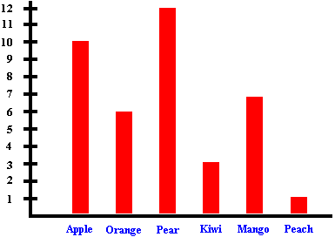

What is the title of this graph?

_______________________________________________________________________

What are the intervals?

_______________________________________________________________________

What is the highest number on the scale?

_______________________________________________________________________

What is the least favorite flavor?

_______________________________________________________________________

What is the most favorite flavor?

_______________________________________________________________________

Lesson 4-8: Bar Graphs: Seatwork
Try making a bar graph using the data below. Review the steps below to make the bar graphs.
Your Data: Bill did research on how long animals live. He looked at 4 different animals. He found that the mouse can live 6 years, the
octopus 3 years, the red fox 14 years, and the chipmunk 8 years. Use the data to make both a horizontal and a vertical bar graph.
Steps to Make Bar Graphs
1. Decide whether your graph will be horizontal or vertical.
2. Select a title for your bar graph and write it at the top of your graph.
3. Write what labels you will use on either side of the bar graph. You need a data label and a scale label.
4. Decide on a scale for your bar graph.
5. Determine an interval between the numbers on a scale.
6. Read the data and make the bars on the bar graph.

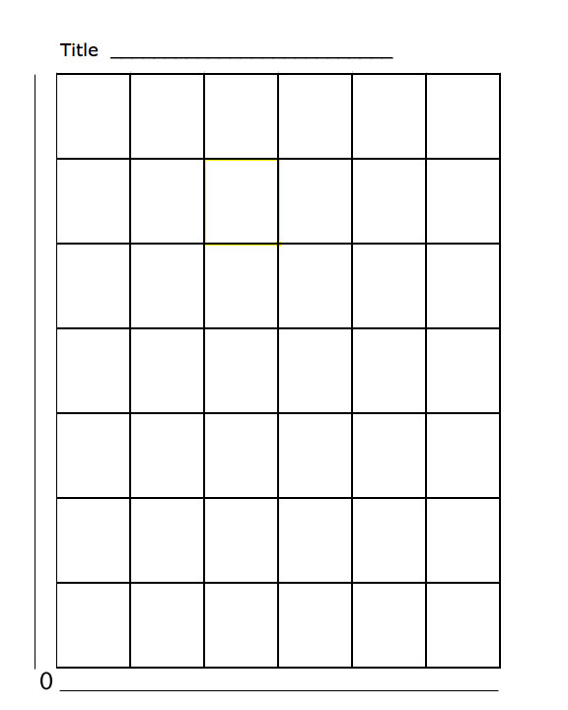
Lesson 4-8: Bar Graphs: Homework
Use what you have learned about bar graphs to answer the questions below.

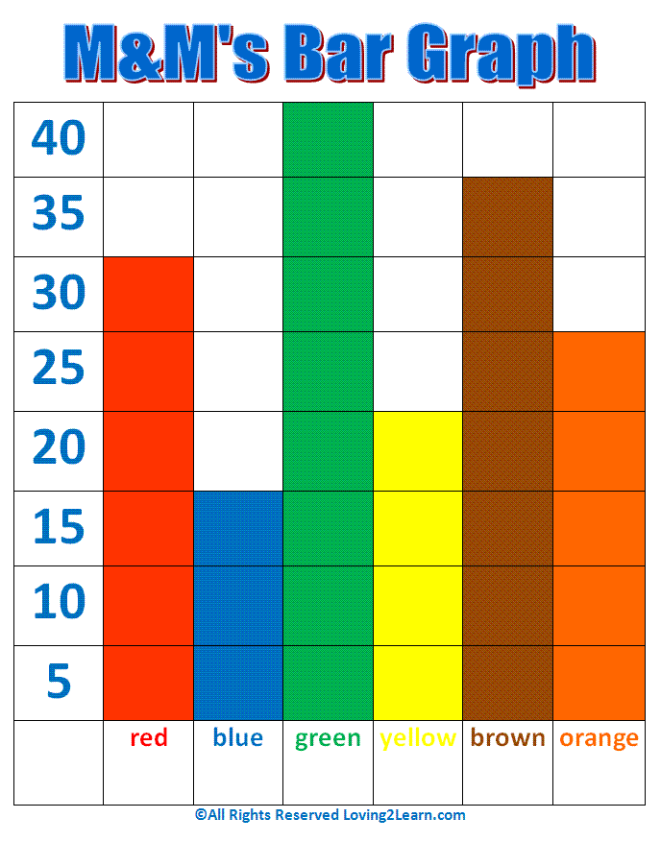

What is the title of this graph?

_______________________________________________________________________

What are the intervals?

_______________________________________________________________________

What is the highest number on the scale?

_______________________________________________________________________

What is the least occurring color? How often does it occur?

_______________________________________________________________________

What is the most occurring color? How often does it occur?

_______________________________________________________________________
Lesson 4-8: Bar Graphs: Homework

Now create your own graph in the space provided. Be sure Your interval is greater than one.

Favorite Color | Number of Students
Red | 22
Blue | 15
Green | 11
Black | 5
Pink | 2

Lesson 4-9: Ordered Pairs: Seatwork

An 'ordered pair' is simply two numbers in a certain order. For example, the numbers '2' and '3' can form two ordered pairs:
2, 3 and 3, 2
Ordered pairs can also contain the same number twice. For example:
2, 2 and 3, 3
In mathematics, we use two numbers to accurately locate a position on a rectangular grid, like this:

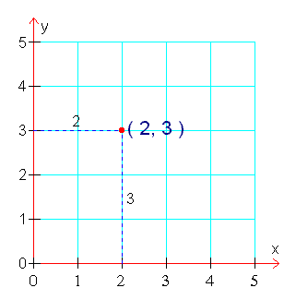
When an ordered pair is used to locate a point on a grid, the two numbers are called the 'coordinates' of the point. In the diagram above, the point (2, 3) has been marked with a red dot. The coordinates of this point are '2' and '3'.
On a graph grid, the point (0,0) is called the 'origin' The first coordinate of a plotted point is called the 'x' coordinate. The 'x' coordinate is the horizontal distance from the origin to the plotted point. The second coordinate of a plotted point is called the 'y' coordinate. The 'y' coordinate is the vertical distance from the origin to the plotted point.
So, to locate the point: (2, 3) on our graph grid above, we start at the origin, move 2 units horizontally and 3 units vertically

Lesson 4-9: Ordered Pairs: Seatwork

Answer the following questions dealing with ordered pairs. Use the grid to answer each question

Remember: The order in which the numbers are given is important.
The first number tells you to move to the right.
The second number tells you to move up.
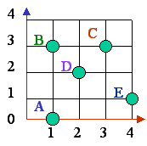
- What ordered pair gives the location of point A? _______________
- What point is located at ( 4, 1 )? _______________
- What ordered pair gives the location of point B? _______________
- What point is located at ( 3, 3 )? _______________
- What point is located at ( 2, 2 )? _______________

Find each ordered pair. Write the letter for the point named by the ordered pair.

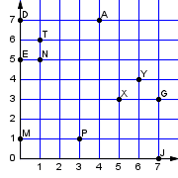
Lesson 4-9: Ordered Pairs: Seatwork

Lesson 4-9: Ordered Pairs: Homework

Answer the following questions dealing with ordered pairs. Use the grid to answer each question

Remember: The order in which the numbers are given is important.
The first number tells you to move to the right.
The second number tells you to move up.

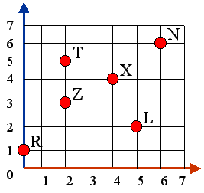 | What is the ordered pair of point N? ________  What point is located at ( 5, 2) ? __________  What is the ordered pair of point X? ________  What point is located at ( 2, 3 )? __________  What point is located at ( 0, 1 )? __________

Find each ordered pair. Write the letter for the point named by the ordered pair. |  | 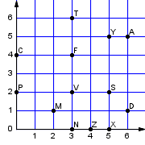
A = ( , ) | D = ( , )
C = ( , ) | P = ( , )
T = ( , ) | F = ( , )
M = ( , ) | V = ( , )
Extra practice can be found on line @
http://www.funbrain.com/cgi-bin/co.cgi?A1=s&A2=0
http://www.beaconlearningcenter.com/weblessons/gridgraph/default.htm
Lesson 4-9: Ordered Pairs: Homework

Lesson 4-10: Line Graphs: Seatwork
-A line graph connects points to show how data changes over time.
-In a line graph, when the line goes up from left to right, there is an increase in the data.
-When the line goes down, there is a decrease.
-The increase or decrease indicates the trend in the data.
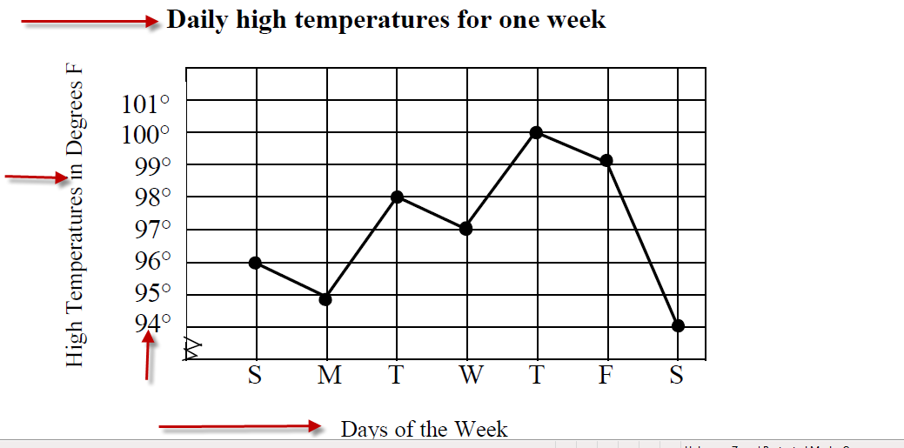
The title of the graph tells what it's about.
The labels on the bottom and the side of the graph tell what kinds of facts
had been gathered.
The scales along the bottom and side tell how much or how many.
The points, or dots, tell the facts.
The lines connecting the points give estimated values about the line graph
1. What is the graph about? ____________________________________
2. Which day had the greatest high temperature? ____________________ 3. Which day has the lowest high temperature? ____________________
4. What was the high temperature on Monday? ____________________
5. What happened to the temperature between Monday and Tuesday? __________________________________________________________________________________________________________________________

Lesson 4-10: Line Graphs: Homework

Hiking in the Mountains
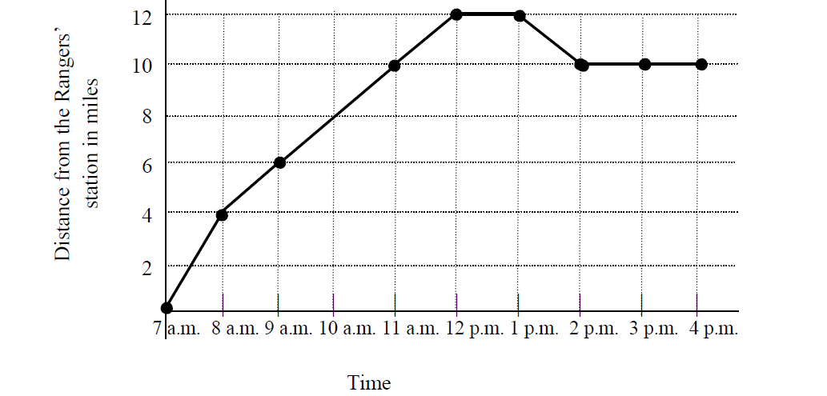
1. What is the graph about? _________________________________________
2. What is shown on the horizontal axis? _______________________________
3. What is happening to time on the graph? ____________________________
4. What is shown on the vertical axis? __________________________________
5. What is the scale for distance from the Rangers station? _________________
6. From 7:00 a.m. to 11:00 a.m., what happened to the distance from the
Rangers station? __________________________________________________
7. What happened to the distance from the Rangers station between 12
p.m. and 1:00 p.m.? What might be the reason? ___________________________
________________________________________________________________
8. What happened to the distance from the Rangers station between
1:00 p.m. and 2:00 p.m. ____________________________________________
________________________________________________________________
9. What happened from 2:00 p.m. until 4:00 p.m.? What might be the
reason? __________________________________________________________
10. How many miles were hiked from 7:00 a.m. to 8:00 a.m.? _________________________________________________________________
Need more? Go to http://nces.ed.gov/nceskids/graphing/classic/line.asp
Lesson 4-12: Mean, Median, Mode & Range: Seatwork

Mean, Median, Mode, & Range
The median is the middle number when the data are listed in order.
The number of raisins in our boxes:
10, 26, 26, 27, 30, 32, 32, 32, 34.
x
30 is the median.
The mode is the number o r numbers that occur most often in the data.
10, 26, 26, 27, 30, 32, 32, 32, 34. The mode is 32.
The range is the difference between the greatest and the least number in the data.
10, 26, 26, 27, 30, 32, 32, 32, 34
The greatest number is 34. The least number is 10.
34 – 10 = 24. The range is 24.
The mean is the average. It is found by adding all the numbers in a set and dividing by the number of values.
10, 25, 20, 5, 20
The sum is 75.
We added 5 numbers.
Divide 75 by 5.
The average or mean is 15.
Outlier -A number in a data set that is very different from the other numbers

Lesson 4-12: Mean, Median, Mode & Range: Seatwork

Mean, Median, Mode
Directions: In the space to the right, determine the mean, median, and mode for each data set.
1) 2, 3, 4, 5, 4, 6 | mean =
 | median =
 | mode =
 | range =
2) 1, 3, 5, 7, 9, 5 | mean =
 | median =
 | mode =
 | range =
3) 1, 6, 5, 4, 8, 2, 6, 8 | mean =
 | median =
 | mode =
 | range =
4) 3, 4, 5, 1, 3, 3, 4, 1 | mean =
 | median =
 | mode =
 | range =
5) 9 , 2, 3, 1, 4, 1, 7 | mean =
 | median =
 | mode =
 | range =
6) 6, 2, 2, 3, 1, 4 | mean =
 | median =
 | mode =
 | range =

Lesson 4-12: Mean, Median, Mode & Range: Seatwork

1) 2, 7, 3, 8, 8, 8, 6, 6, 6 | mean =
 | median =
 | mode =
 | range =
2) 3, 16, 3, 2, 8, 2, 8, 6 | mean =
 | median =
 | mode =
 | range =
3) 2, 12, 2, 8, 2, 6, 1, 6, 6, 5 | mean =
 | median =
 | mode =
 | range =
4) 8, 4, 5, 2, 5, 2, 8, 9, 2 | mean =
 | median =
 | mode =
 | range =
5) 5, 6, 5, 5, 5, 9, 9, 2, 8 | mean =
 | median =
 | mode =
 | range =
6) 7, 3, 4, 11, 10, 4, 10 | mean =
 | median =
 | mode =
 | range =
Mr. O’Hara’s daughter and her friends were asked how many times they were on the phone yesterday. Each friend gave a numerical answer. The answers were:
11, 4, 3, 4, 2 What is the:
mean = ______ median = ______ mode =______ range =______
Lesson 4-12: Mean, Median, Mode & Range: Homework
Directions: In the space to the right, determine the mean, median, and mode for each data set.
1) 4, 2, 4, 1, 4 | mean =
 | median =
 | mode =
 | range =
2) 3, 2, 4, 7, 1, 2, 2, | mean =
 | median =
 | mode =
 | range =
3) 6, 9 , 8, 7, 10, 8 | mean =
 | median =
 | mode =
 | range =
4) 2, 6, 3, 6, 6, 2, 1, 2, 2, 1, 2 | mean =
 | median =
 | mode =
 | range =
5) 7, 4, 9, 7, 3 | mean =
 | median =
 | mode =
 | range =
6) 5, 3, 4, 9, 5, 4, 5 | mean =
 | median =
 | mode =
 | range =
Mr. O’Hara noted how many times his son asked him to play video games each day over a week. The answers were: 8, 3, 3, 1, 5, 6, 9. Find the…
mean = ______ median = ______ mode =______ range =______
Lesson 4-14: Misleading Graphs: Seatwork

Lesson 4-14: Misleading Graphs: Seatwork
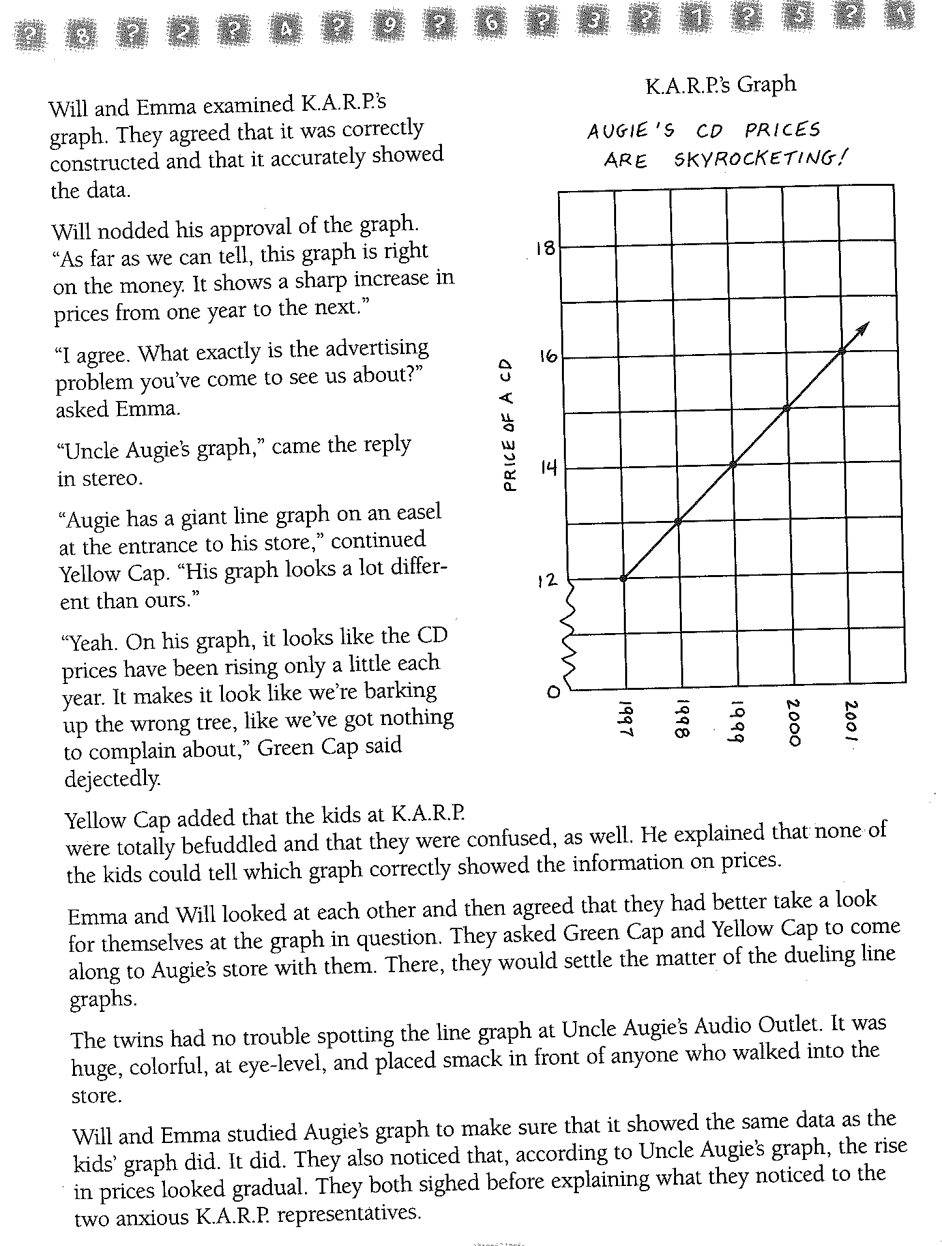
Lesson 4-14: Misleading Graphs: Seatwork

Lesson 4-14: Misleading Graphs: Homework

Take a look at the graph on the left.
This graph makes it appear as though there are twice as many girls in the class as boys.
1. How many girls are in the class?
_________________________
2. How many boys are in the class?
_________________________
3. Are there twice as many girls as boys? ____________________

2. What has this student done to make his parents think he is trying hard in school?
_______________________________
_______________________________
_______________________________
_______________________________
_______________________________

Lesson 4-1: Telling Time:

Draw the Time Face with All Numbers Five Minute Intervals
_____________ | _____________ | _____________

Read each sentence below then circle the best answer.

How long does it take to grow a crop of oranges? Circle the best answer.

10 days 10 weeks 10 years

How long do most cartoons on tv last? Circle the best answer.

15 weeks 15 days 15 minutes

MEASURES OF TIME

1 minute (min.) = 60 second (sec.)
1 hour (hr.) = 60 minutes (min.)
1 day = 24 hours (hr.)
1 week (wk.) = 7 days
1 year (yr.) = 52 weeks (wk.)
1 year (yr.) = 12 months (mo.)

Lesson 4-3: Elapsed Time
Dad began yardwork on Saturday morning at 8:32 A.M. He finished the entire yard by 11:52 A.M. How long did it take him? | Start Time | Are you adding or subtracting time? | Hours | Minutes
 | End Time?
 | Total

Your dance partner for this year's hula hoop contest arrives at 2:30 P.M. and leaves at 6:23 P.M. How long do you practice together?

The music performance began at 3:27 P.M. It ended at 6:15 P.M. How long did it last?

The birds began chirping at 4:37 A.M. They chirped for 2 hrs. 20 mins. What time did they finish chirping?

Jane went to the mall from 2:15 PM. until 7:32 PM. How long was she at the mall?

Lesson 4-6: Pictographs:
Answer the following questions on the basis of the given pictograph (one picture represents 10 computers):
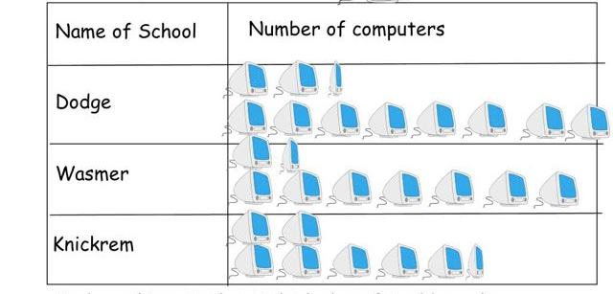
How many computers does the Dodge School have ? _______________
How many computers does the Wasmer School have ? _______________
How many computers does the Knickrem School have ? _______________

Lesson 4-7: Line Plots:
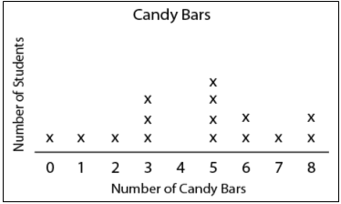 | How many kids have 5 candy bars? ________  How many kids have 2 candy bars? ________  How many kids were there in the survey?  ___________________

Lesson 4-8: Bar Graphs:
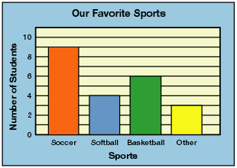 | How many kids like softball? ________  How many kids like soccer? ________  How many kids were there in the survey?  ___________________

Lesson 4-9: Ordered Pairs
Find each ordered pair. Write the letter for the point named by the ordered pair.
N = ( , ) | Y = ( , )
S = ( , ) | X = ( , )
Z = ( , ) | V = ( , )
T = ( , ) | D = ( , )
Extra practice can be found on line @
http://www.funbrain.com/cgi-bin/co.cgi?A1=s&A2=0
http://www.beaconlearningcenter.com/weblessons/gridgraph/default.htm

Lesson 4-10: Line Graphs

1. What is the graph about? _________________________________________
2. What is shown on the horizontal axis? _______________________________
3. What is happening to time on the graph? ____________________________
4. What is shown on the vertical axis? __________________________________
5. What is the scale for distance from the Rangers station? _________________

Lesson 4-12: Mean, Median, Mode & Range:

1) 4, 2, 4, 1, 4 | mean =
 | median =
 | mode =
 | range =
2) 1, 3, 5, 7, 9, 5 | mean =
 | median =
 | mode =
 | range =
3) 2, 12, 2, 8, 2, 6, 1, 6, 6, 5 | mean =
 | median =
 | mode =
 | range =

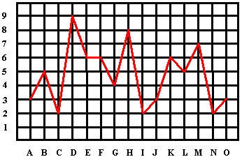

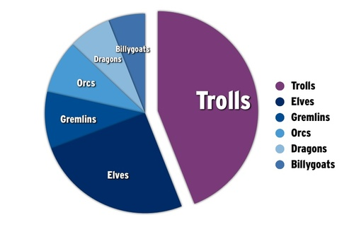

- How many people does the symbol represent? _______________________
- How many people prefer the green? _______________________________
- How many people prefer the brown? _______________________________
- How many people prefer the blue? _______________________________
- How many people prefer the red & purple? _______________________
- How many people prefer the orange & yellow? ________________________
- How many people were interviewed? _______________________________

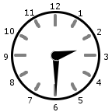  ________________ | 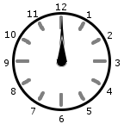  ________________ | How much time has gone by  between the times on the  first and second clocks?  ____________________________
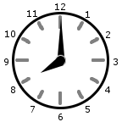  ________________ | 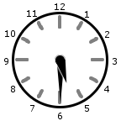  ________________ | How much time has gone by  between the times on the  first and second clocks?  ____________________________

Frank starts his math homework at twenty minutes past three and completes it
at 4:17. How long did it take him to do his math homework? Explain how you
found your answer.

After taking a break, Frank starts his science homework at 5:18 and works for
47 minutes. At what time does he Þ nish his science homework? Explain how
you found your answer.

Lesson 4-3: Elapsed Time: Homework

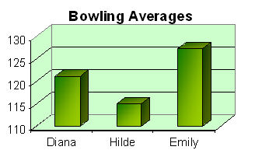

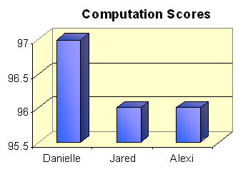

Name:____________________

1. | Sam spent 35 minutes on his homework last night. He started it at 6:20pm. What time did he finish his homework? | _______
2. | The soccer match started at 7:00pm. Each half was 45 minutes. What time did the first half end? | _______
3. | The school holiday starts in four weeks. School is open 5 days a week. How many school days are left until the holiday? | _______
4. | Mary wanted to travel around the world. She worked out that the trip would take her five years. How many months would that be? | _______
5. | It takes 17 minutes to bathe a dog at Bruno's Dog Home. How long would it take to bathe 20 dogs? | _______
6. | Erin walked one mile in 20 minutes. How long would it take her to walk five miles at the same speed?

1. | Here is part of a bus timetable. It takes 5 minutes to travel from one stop to the next. Complete the timetable.
  Blueberry Hills |  | 1:20
  Evergreen Park
  Public Library |  |  | 3:10
  Riverside Mall | 10:20
2. | This is part of the same timetable but the bus is running 5 minutes late. Complete the empty column to show when the bus actually arrives at each stop.
  Blueberry Hills | 5:20
  Evergreen Park | 5:25
  Public Library | 5:30
  Riverside Mall | 5:35
3. | Anna leaves home at 12:45 to catch the 13:05 bus from the public library to Riverside Mall. The bus ride takes 20 minutes. How long does her whole journey take?
_____ minutes

A family medical practice has four doctors that work during the day (Dr. Karp, Dr. Moore, Dr. Conwit, and Dr. Nguyen). The computer somehow mixed up the records for some of the appointments (10:10 a.m., 11:05 a.m., 10:05 a.m., and 11:30 a.m.). The nurse who is trying to fix the records knows that Nathan, Michael, Jose, and Matthew made the appointments. The patients have already been to their doctor a different number of times (zero, one, two, and three).
Help the nurse by figuring out which doctor each patient is going to see, the number of times they have already seen the doctor, and the time of their appointment.
1. |  | Dr. Conwit read in his charts that his patient has previously seen him three times.
2. |  | Dr. Karp did not schedule any appointments before 11:00 a.m.
3. |  | The person who has an appointment at 10:05 a.m. has already been to the same doctor, however the patient is not the one who has been to the doctor either three or zero times.
4. |  | Dr. Conwit did not schedule any appointments before 11:25 a.m.
5. |  | Dr. Moore did not schedule any appointments before 9:55 a.m.
6. |  | Dr. Moore read in his charts that his patient has previously seen him two times.
7. |  | Dr. Nguyen did not schedule any appointments before 9:45 a.m.
8. |  | Dr. Karp read in his charts that his patient has previously seen him one time.
9. |  | Dr. Karp is not currently accepting new patients.
10. |  | Jose's appointment is after Nathan's and before Michael's.
11. |  | Michael's appointment is 1 hour and 20 minutes after Matthew's appointment.
12. |  | Michael has been to the doctor either three or one time.

Rebecca, Austin, Dylan, Alexis, Shelby, and Katherine watched television on Monday and Tuesday. On Monday they started watching at 8:00 p.m. and on Tuesday they started watching at 7:30 p.m. Their mother kept track of the time they each stopped watching.
On Monday the times they stopped watching TV were: 8:33 p.m., 9:51 p.m., 8:39 p.m., 10:00 p.m., 9:03 p.m., and 9:42 p.m.
On Tuesday the times they stopped watching TV were: 10:20 p.m., 9:10 p.m., 8:40 p.m., 9:00 p.m., 9:50 p.m., and 9:30 p.m.
Figure out how long each person watched TV on Monday and Tuesday.
1. |  | Shelby watched TV for thirteen-twentieth of an hour on Monday.
2. |  | Alexis watched a total of 3 hours and 23 minutes of TV on Monday and Tuesday.
3. |  | Rebecca watched TV for one and two-third hours on Tuesday.
4. |  | The person that watched two hours of TV on Monday was not the one who watched two and five-sixth hours of TV on Tuesday.
5. |  | Katherine watched TV for two hours on Tuesday.
6. |  | Dylan watched TV for one-half of an hour longer on Monday than on Tuesday.
7. |  | Austin watched TV for 2 hours and 17 minutes longer on Tuesday than on Monday.
8. |  | Rebecca watched TV for one and seventeen-twentieth hours on Monday.

Christopher, Samuel, and Olivia watched television on Monday and Tuesday. On Monday they started watching at 8:00 p.m. and on Tuesday they started watching at 7:30 p.m. Their mother kept track of the time they each stopped watching.
On Monday the times they stopped watching TV were: 9:25 p.m., 10:15 p.m., and 9:45 p.m.
On Tuesday the times they stopped watching TV were: 8:50 p.m., 10:10 p.m., and 10:10 p.m.
Figure out how long each person watched TV on Monday and Tuesday.
1. |  | Samuel watched less TV on Monday. Samuel only spent 21/32 as much time watching TV on Monday as he did on Tuesday.
2. |  | Olivia watched TV for two and two-third hours on Tuesday.
3. |  | Christopher watched less TV on Tuesday. Christopher only spent 16/17 as much time watching TV on Tuesday as he did on Monday.

Russia, Austria, Britain, and United States competed in a two run bobsled competition.
The times on the first run were one minute and 23.38 seconds, one minute and 23.92 seconds, one minute and 23.65 seconds, and one minute and 24.27 seconds.
The times on the second run were one minute and 24.54 seconds, one minute and 24.14 seconds, one minute and 24.45 seconds, and one minute and 24.63 seconds.
Figure out the time needed for each run and the combined run time for each team.
1. |  | On the second run, the team from Russia was ninety-eight hundredths of a second slower than their first run.
2. |  | The team that finished the first run in one minute and 23.38 seconds was not the team that finished the second run in either one minute and 24.54 seconds or one minute and 24.14 seconds.
3. |  | On the first run, the team from United States was eighty-nine hundredths of a second behind the winners of the first run.
4. |  | The team from Britain finished the second race in less than one minute and 24.30 seconds.
5. |  | The team from Austria finished the first race in less than one minute and 23.96 seconds.
6. |  | The bobsled team from United States clocked a combined time of two minutes and 48.81 seconds

John, Brandon, Steven, and Christina each completed their homework. One took fifty-nine minutes, one took eighty-six minutes, one took forty-six minutes, and one took eighty-two minutes to complete their homework.
How long did each person take to finish his or her homework?
1. |  | Brandon started working at 3:28. Christina started working eighteen minutes after Brandon and finished at 4:45.
2. |  | John needed less time than Christina to finish.
3. |  | Steven started working twenty-two minutes after Brandon and finished twenty-six minutes after Brandon.
4. |  | John needed less time than Brandon to finish.
5. |  | Brandon needed more than an hour to finish.
6. |  | Christina needed less than an hour to finish.
7. |  | Christina started on the assignment at 4:41 p.m. Christina took a thirty-six minute break at 5:30 p.m. to eat dinner. Christina continued working after dinner and finished the assignment at 6:16 p.m.

