10th Grade Science Book Study

The Immortal Life of Henrietta Lacks
Author Rebecca Skloot
ISBN 978-1-4000-5218-9

About the Book
In 1950, Henrietta Lacks, a young mother of five children, entered the colored ward of The Johns Hopkins Hospital to begin treatment for an extremely aggressive strain of cervical cancer. As she lay on the operating table, a sample of her cancerous cervical tissue was taken without her knowledge or consent and given to Dr. George Gey, the head of tissue research. Gey was conducting experiments in an attempt to create an immortal line of human cells that could be used in medical research. Those cells, he hoped, would allow scientists to unlock the mysteries of cancer, and eventually lead to a cure for the disease. Until this point,
all of Gey’s attempts to grow a human cell line had ended in failure, but Henrietta’s cells were different: they never died.
Less than a year after her initial diagnosis, Henrietta succumbed to the ravages of cancer and was buried in an unmarked grave on her family’s land. She was just thirty-one years old. Her family had no idea that part of her was still alive, growing vigorously in laboratories—first at Johns Hopkins, and eventually all over the world. Thirty-seven years after Henrietta’s death, sixteen-year-old Rebecca Skloot was a high school student sitting in a biology class when her instructor mentioned that HeLa, the first immortal human cell line ever grown in culture, had been taken from an African American woman named Henrietta Lacks. His casual remark sparked Skloot’s interest, and led to a research project that would take over a decade to complete. Her investigation of the true story behind HeLa eventually led her to form significant––and in some cases, life changing–– relationships with the surviving members of the Lacks family, especially Henrietta’s daughter, Deborah.
In telling Henrietta’s story, Skloot draws from primary sources and personal interviews to provide insightful narrative accounts of Henrietta’s childhood, young adulthood, diagnosis, illness, and tragic death. She also explores the birth and life of the immortal cell line HeLa, and shows how research involving HeLa has changed the landscape of medical research, leading to not only scientific and medical breakthroughs, but also new and evolving policies concerning the rights of patients and research subjects.
As the story of HeLa unfolds, so does the story of Henrietta’s surviving children, who for two decades were unaware of the existence of their mother’s cells—and the multimillion dollar industry that developed around the production and use of HeLa. Central to this narrative is the relationship between Skloot and Deborah. As Skloot tenaciously worked to gain Deborah’s trust, Deborah struggled to understand what had happened to her mother and her mother’s cells. The result of their relationship is an illuminating portrait of the enduring legacy of Henrietta’s life, death, and immortality.

Important Info: WHAT IS A STEM CELL?
HOW IS IT FORMED?

A stem cell begins as a fertilized egg (sperm and oocyte join). The fertilized egg will grow into a Morula through the process of Mitosis or cell reproduction (see picture below). During Mitosis, the cell will copy its DNA and eventually divide into two new daughter cells. The daughter cells that form the Morula will continue to grow into a Blastocyst that contains many more cells. These cells are called inner mass cells. These cells can be retrieved and grown in a Petri dish in science laboratories and are referred to as stem cells. Stem cells are “generic” in the sense that they have all of the parts of a cell that are needed to stay alive, they just do not perform any “special” functions. When the stem cells are implanted into organs they will then become specialized or differentiate into high functioning cells like the heart, nerves, and immune cells in the picture below.

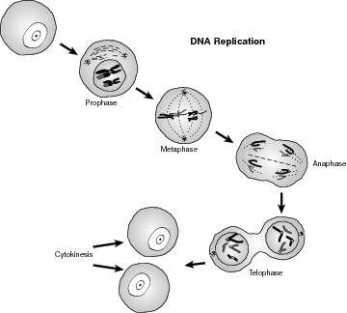
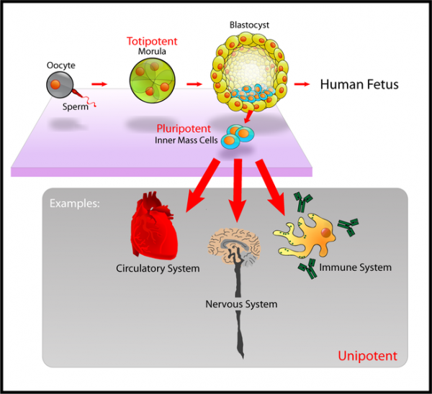

MITOSIS
2 new daughter cells form

Note to Student -
The Immortal Life of Henrietta Lacks is characterized as ‘creative nonfiction.’ This is a genre in which all facts are accurate and verifiable, but presented in a creative way that emphasizes storytelling through the use of scenes, dialogue, and other techniques more often found in fiction. Also, there may be a few words in this novel you may be unfamiliar with, if that occurs then you are expected to look the meaning of those words up on your own in order to answer the required questions correctly.

Assignment – While you read the book, you will need to complete the following reading questions on a separate sheet of paper. Make sure to organize them by chapter (write down the chapter) and number the questions. You DO NOT have to write the question. The questions are also on Mrs. Bradley’s school website and you may type your answers and print them. *Other assignments may be given during or after the completion of the book. NOTE: some questions have more than one part. Make sure you answer ALL parts of the question!

Questions
Prologue
- What is mitosis? What beneficial biological processes involve mitosis?
- What happens when there is a mistake during the process of mitosis?
- According to Defler, how important was the discovery of HeLa cells?

Chapter 1
- Review the notes on Henrietta’s medical history found on page 16. Based on the objective details in her medical chart, what can you infer about Henrietta’s life and personality?
- What did Howard Jones find “interesting” about Henrietta’s medical history? What does this finding suggest about Henrietta’s cancer?

Chapter 2
- How was Day related to Henrietta?
- How old was Henrietta when she had her first child with Day? Explain how age can be a factor in delivering a healthy baby.
- What was different about Henrietta’s second child, Elsie? What could have caused this?

Chapter 3
- How are different types of cancer categorized?
- Explain what an immortal cell line is.
- Analyze the consent statement that Henrietta signed on page 31. Based on this statement, do you believe TeLinde and Guy had the right to obtain a sample from her cervix to use in their research?
- Do you think Henrietta would have given explicit consent to have a tissue sample used in medical research if she had been asked? Do you think she would have understood what was being asked of her? Explain your answers.
Chapter 4
- Summarize the main obstacles Gey and his assistants faced in their effort to grow cells.
- Where did the name “HeLa” come from?
- Explain how Gey’s roller-tube culturing technique works.
- What happened to the HeLa cells that Mary cultured?
- Gey chose to give away samples of HeLa to his colleagues almost immediately. Do you think this was a good decision? Explain your answer.
- Once HeLa started growing, was Henrietta informed that her cells were being used in Gey’s research?

Chapter 5
- What important information did Henrietta’s doctor fail to give her before starting her cancer treatments? How did she react when this information was eventually shared with her?

Chapter 6
- Paraphrase the information on page 50 describing the Tuskegee Syphilis Study.
- What do the Tuskegee Syphilis Study and the Mississippi Appendectomies suggest about the history of African Americans and medicine?

Chapter 7
- What did Gey hope to accomplish with HeLa cells?
- What did HeLa allow scientists to do for the first time?
- Who is Alexis Carrel? Why did he win the Nobel Prize?
- What details suggest that Carrel’s claims about the immortal cell line were not scientifically sound?

Chapter 8
- After her initial round of treatment, what did Henrietta’s doctors assume about the effectiveness of the radium therapy?
- When did the doctors realize that Henrietta had been correct about the growth of her cancer?
- While most accounts suggest that Henrietta never met George Gey or knew about HeLa, Laure Aurelian says that Gey recounted meeting with Henrietta before her death. Do you find this story believable? Use specific facts about Henrietta, Gey, and/or medical practice in the 1950s to support your opinion.

Chapter 9
- What does Skloot realize after watching the BBC documentary about HeLa?

Chapter 10
- How was Cootie related to Henrietta?
- What illness did Cootie have as a child?
- Cootie seems to know and understand a little bit about HeLa cells, but he believes that Henrietta’s spirit is still present in her cells. What does Cootie think about the reason that HeLa cells were used to develop a polio vaccine?
- Where does Cootie think Henrietta’s cancer came from?

Chapter 11
- Describe the progression of Henrietta’s cancer in the eight months between her diagnosis and her death.
- Why did doctors stop giving Henrietta blood transfusions?
- What was Henrietta’s final request? What does this request tell you about her?

Chapter 12
- Why did Henrietta’s doctors need to ask for her family’s permission to remove tissue samples after her death? How did Day initially respond to their request?

Chapter 13
- Explain how a neutralization test is used to determine a vaccine’s efficacy.
- What unusual characteristics of HeLa cells made them ideal for use in the polio vaccine trials?
- Why did the Tuskegee Institute become involved in the mass production of HeLa cells? Describe the depth of the Institute’s involvement.
- Paraphrase the explanation of how a virus reproduces found on page 97. Why did the fact that HeLa cells are malignant make them particularly useful in the study of viruses?
- Why was the development of methods of freezing cells an important scientific breakthrough?
- Why did scientists want to be able to clone cells for research?
- Explain the contribution that HeLa made to the emerging field of genetics.
- Describe the role Microbiological Associates played in the development of the field of cell culture, and the industry of selling HeLa cells and other human biological materials.
- Who profited monetarily from the sale of HeLa cells and other human biological materials?

Chapter 14
- Why didn’t Henrietta’s family know that her cells were still alive?
- In what specific ways do you think that learning of HeLa soon after Henrietta’s death might have changed her family members’ lives?

Chapter 15
- Describe Deborah’s childhood. What challenges did she have to overcome?

Chapter 16
- How are white and black Lackses related? Who are their common ancestors?

Chapter 17
- Describe the experiment that Southam developed to test his hypothesis about HeLa.
- Who were the test subjects in Southam’s first study? Were they informed about the research and its risks?
- What was the result of Southam’s first research study? Based on these results, did his hypothesis appear to be correct?
- Based on the results of the second study, what two things did Southam believe that injections of HeLa cells might be able to do?
- How did Southam justify his decision to inject HeLa cells into patients without their knowledge or consent?
- What does the term ‘informed consent’ mean?
- Explain how the action against Southam and Mandel led to the development of informed consent forms as a standard medical practice.

Chapter 18
- Summarize the various ways that HeLa was used in the space program.
- What disturbing discovery did scientists make about the way HeLa responded in orbit?
- Explain what happens during somatic cell fusion.
- What scientific discoveries were made possible as a result of fused hybrid cells?

Chapter 19
- What crime did Joe commit?
- How did prison change Joe?

Chapter 20
- What did Stanley Gartler discover about eighteen of the most commonly used cell cultures?
- How was Gartler able to link the contamination problem to HeLa?
- What unique abilities did HeLa have that allowed it to contaminate cultures without researchers being aware that contamination had occurred?
- Why would HeLa contamination be a problem for researchers?
- What is ‘spontaneous tranformation’? What did Gartler suggest about spontaneous transformation?

Chapter 21
- Why did Johns Hopkins start a medical school and hospital in a poor black neighborhood? What purpose was the school/hospital intended to serve?
- What is the Lacks family’s biggest complaint about the way they have been treated by Johns Hopkins and Dr. Gey?

Chapter 22
- What type of cancer was George Gey diagnosed with?
- Did Gey benefit or profit in any way from his participation in the research studies?
- What did Howard Jones realize when he reviewed Henrietta’s medical records?
- What was the purpose of President Nixon’s National Cancer Act?
- Do you agree that Henrietta should have been correctly identified in order to “give her the fame she so richly deserves,” or do you think her anonymity should have been protected? Explain your answer.

Chapter 23
- How long had Henrietta been dead when her family found out that her cells were still alive?
- Why did researchers want DNA samples from Henrietta’s family?
- Did researchers explain why they wanted DNA samples to the Lacks family? Did the family give informed consent for the research done on those samples?
- From a legal standpoint, how is the fact that the doctors failed to obtain consent prior to taking blood from the Lacks family in 1973 different from their initial failure to obtain consent form Henrietta in 1951?
- Why did advances in genetic research necessitate establishing the legal requirement that doctors or researchers obtain informed consent documentation prior to taking DNA samples from patients for research?

Chapter 24
- Paraphrase the paragraph in Roger’s article that the Lacks family found extremely upsetting. What conclusion did they draw about George Gey and Johns Hopkins?
- What facts about George Gey’s life support the assertion that he never personally profited from the development of HeLa?
- Explain how the sale of HeLa evolved into a business. Describe the extent to which the profits form that business are likely a direct result of the sale of HeLa cells. In what other ways do scientists, corporations, and individuals profit as a result of HeLa?

Chapter 25
- Describe the lawsuit that set a legal precedent for patenting biological “products” such as cell lines.
- Summarize the pros and cons of giving patients legal ownership of their cells.

Chapter 26
- Explain why Gold’s journalism could be considered irresponsible and or unethical?
- How have laws regarding medical privacy changed since the early 1980s?

Chapter 27
- Explain how the human papillomavirus (HPV) causes cervical cancer.
- Are scientists able to definitively explain why HeLa grew so powerfully?
- Describe the contribution that HeLa has made to research on the HIV virus and the AIDS epidemic.
- Explain Van Valen’s theory that HeLa cells are “no longer human.” Was his theory accepted by the scientific community?
- According to Stevenson, why did scientists develop the argument that HeLa cells are no longer human?
- Explain the Hayflick limit.
- Why are HeLa cells able to live beyond the Hayflick limit?

Chapter 28
- Describe Keenan Kester Cofield. Why did he get involved with the Lacks family?
- What did Cofield do when he realized that the Lacks family had blocked his access to their family records? What were the results of his actions?

Chapter 29
- What specific things did Deborah ask Skloot to promise she would do?
- What did Deborah hope would happen as a result of Skloot’s research about Henrietta?

Chapter 30
- Zakariyya uses the term ‘disrespect’ to describe Gey’s treatment of Henrietta and the family. Explain the specific reasons why Zakariyya feels disrespected. Do you believe Gey was disrespectful? Explain.

Chapter 31
- Why did Deborah decide to go see her mother’s cells? What obstacle almost kept her from doing so?

Chapter 32
- What important misunderstanding about HeLa does Lengauer clarify for Deborah?
- What does Lengauer believe about the Lackses’ right to be financially compensated for the sale of their mother’s cells?

Chapter 33
- Why were the hospital’s medical records from the 1950s and earlier disposed of?
- What part of Elsie’s medical records did Lurz have? Why had he saved patients’ medical records?

Chapter 34
- How does Deborah respond when Skloot suggests photocopying some of Henrietta’s records? Why do you think she responds this way?
- What reason does Deborah give for not wanting Skloot to type out Henrietta’s records word-for-word?

Chapter 35
- How are Gladys and Gary related to Deborah?

Chapter 36
- Summarize Gary’s spiritual explanation for why Henrietta’s cells lived on after her death.

Chapter 37
- According to Deborah and Pullum, how is Henrietta’s story going to be different for Henrietta’s great-grandchildren and future generations?

Chapter 38
- BIO – At the time of this book’s publication, how had the lives of Henrietta’s great- and great-great-grandchildren been affected by Skloot’s research, and by the knowledge and understanding of Henrietta’s contribution to science?

Where are they now?/Afterword
- What legal options do the Lackses have? What is their position on suing over the use of HeLa?
- If Henrietta Lacks could know how important her cells have been to science, do you think she would approve of the fact that they were taken from her without her knowledge or consent?

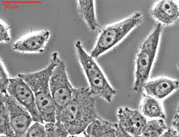


*Questions and material for The Immortal Life of Henrietta Lacks reading assignment were created by Triad staff in conjunction with www.randomhouse.com/highschool.

