IM3: Math 2 Unit 10 Name:
10.3, 10.4 assessment preview

10.3 I can combine outcomes using and, or, and not, and calculate their probabilities.
The following is a Venn diagram of what customers bought at a fast food store on a given week:
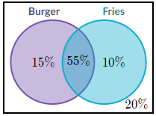
1. Calculate 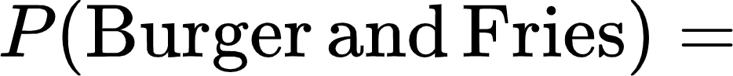 2. Calculate
$55\%$ $15\%$
3. Calculate 4. Calculate 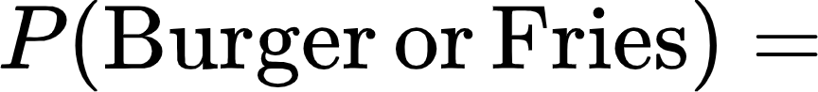
$20\% (outside both circles)$ $15\%+55\%+10\%=80\%$
5. Calculate 6. Calculate
$(10\%+20\%)+(15\%+20\%)-(20\%)=45\%$ $100\%$
10.4 I can determine whether two events are independent using two different rules.
7. Using the Venn diagram above, are Burger and Fries independent events?

Are 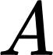 and 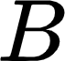 independent events if…
8. 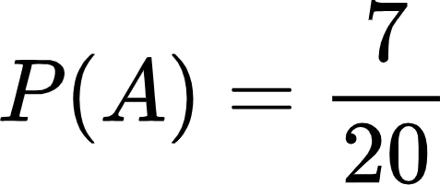 and 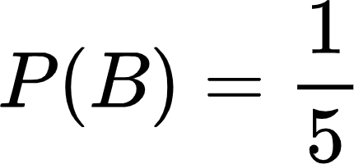 and 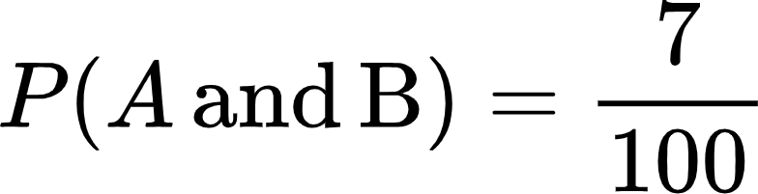

9. 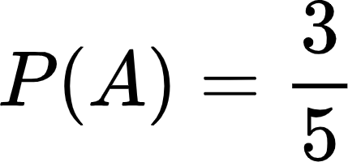 and 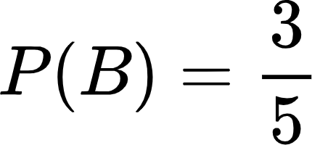 and 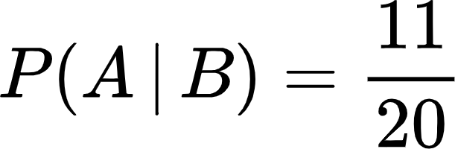

10. and 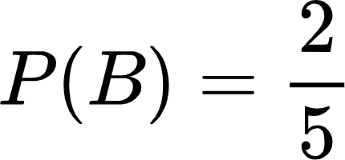 and 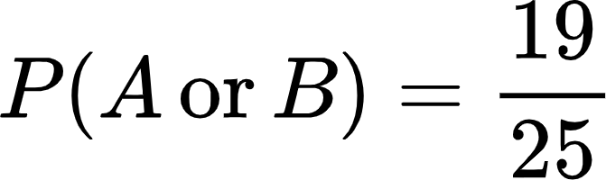
Answers
1. 55% 2. 15%
3. 20% 4. 80%
5. 45% 6. 100%
7. no, They are dependent
8. yes, They are independent
9. no, They are dependent
10. yes, They are independent

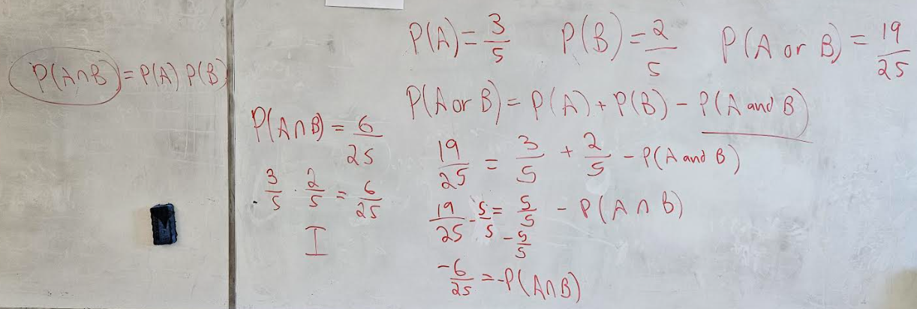

M2 10.3 I can combine outcomes using and, or, and not, and calculate their probabilities. (Modeling)
Proficient | Exemplary Proficient Developing Beginning Missing
Computes basic probabilities of combinations of events using:
- and
- or
- not
Honors Proficient
- and some conditional probabilities

M2 10.4 I can determine whether two events are independent using two different rules. (Reasoning)
Proficient | Exemplary Proficient Developing Beginning Missing
Determines and explains independence based on
- Multiplication rule test
- Conditional probability rule test
…given probabilities directly relevant to the test
Honors Proficient
- including at least one problem in which the relevant probabilities must be calculated

