Name

Date Pd

Unit 3 - Worksheet 1 – E Bar Charts
- For each of the situations described below, draw a Temperature vs. time (energy) graph for the situation.
- Then, use an energy bar chart to represent the ways that energy is stored in the system and flows into or out of the system.
- Below each diagram, briefly describe how the motion and/or arrangement of the molecules changes from the initial to the final state.

1. A cup of hot coffee cools as it sits on the table.
A. Temp/time Graph: B. Bar Chart:
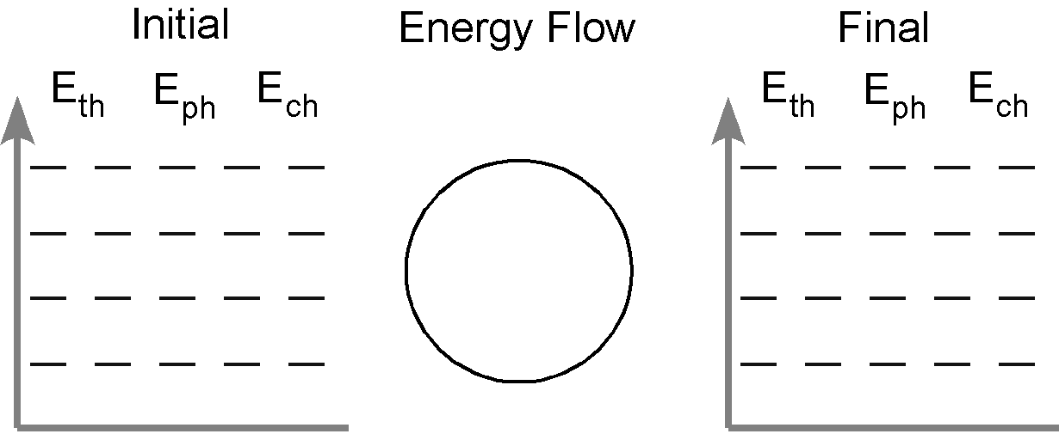
C. Molecule Description:

2. A glass of cold iced-tea warms as it is left on the counter.
A. Temp/time Graph: B. Bar Chart:
C. Molecule Description:

3. A tray of water (20 ˚C) is placed in the freezer and turns into ice cubes (- 8 ˚C)
A. Temp/time Graph: B. Bar Chart:
C. Molecule Description:

4. Where does the energy that leaves the system in #3 go? How does this energy transfer affect the room temperature in the kitchen? Do you have any experience that supports your answer?

5. One of the ice cubes described in #3 is placed in a glass of room temperature (25 ˚C) soft drink.
Do separate bar charts for the ice cube and the soft drink.
A. Temp/time Graph: B. Bar Chart:

A. Temp/time Graph: B. Bar Chart:

Describe how the arrangement and the motion of the molecules in each system change from the initial to the final state.

6. The graph below left shows the cooling curve for a substance as it freezes.
a. On the graph at right sketch the cooling curve for a larger sample of the same substance.
b. Label which phase (or phases) of the substance is present in each of the three portions of the cooling curve.
c. Describe how the arrangement and motion of the molecules changes during each portion of the graph:

