I. Background
A) Mercantilism & the Navigation Acts
1. British established colonies on east coast of North America starting in early 1600s
2. As part of Mercantilism, America expected to support mother country with raw materials
3. Passed Navigation Acts to control/ restrict colonial trade
B) French and Indian War
1. British victory=French “kicked out of” North America
2. Britain goes deeply in debt because of the war
3. Some Americans gain experience fighting the war

II. Key Events 1763-1770
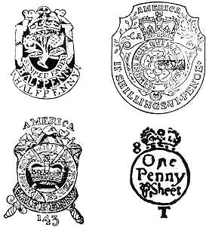 | A) Proclamation of 1763  1. To keep peace with Native Americans that helped British during F&I war, reserved land west of Appalachian mountains for them  2. Americans were told the could not move west of the Appalachians and any Americans living west of the Appalachians had to move back  3. Americans are upset because they felt they had helped win that land by fighting in the war,  4. The Proclamation was almost impossible to enforce and was largely ignored by Americans  B) Stamp Act (1765)  1. Taxed paper goods  2. Proposed by George Greenville, the Prime Minister of Great Britain  3. Americans protest because of “No Taxation without Representation” = taxes are OK, but they should be made by representatives that the people elect, and American colonies have no rep in Parliament (Britain’s Legislature)  4. Americans protest violently (ex: tarring and feathering, hanging tax collectors in effigy) and non-violently {petition by Stamp Act Congress} {Committees of Correspondence} boycotts (not buying certain products from Britain)  5. Stamp Act is repealed (canceled) in 1766  C) Declaratory Act  British can make any law they want for the American colonies.
Key events 1763-1770 (continued)
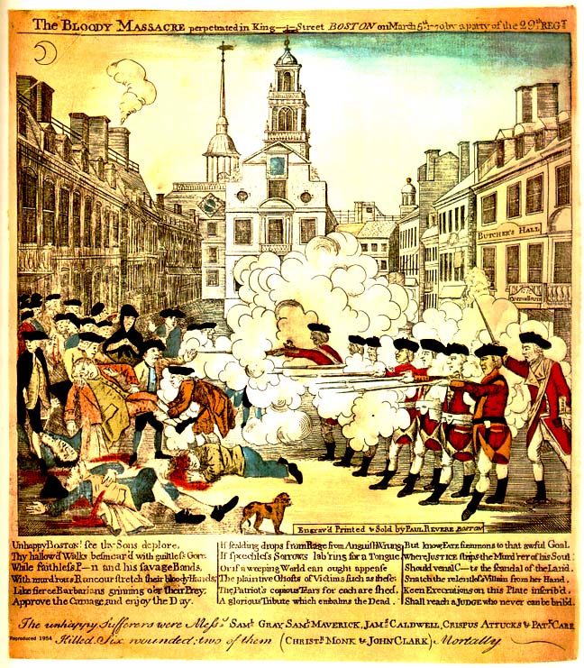 | C) Townshend Acts (1767)  1. Taxed everyday household items like tea, paper, lead and glass  2. Still no rep in Parliament =still taxation without representation  3. Writs of Assistance- allows search of American ships  D) Boston Massacre (March 5,1770)  1. American mob harasses and attacks squad of British soldiers in Boston  2. British soldiers fire on the crowd  3. Some are killed, British tried for murder, John Adams defends soldiers, gets acquital  4. American patriots spin event as an example of British tyranny (see Paul Revere’s pic on left)

III. KEY EVENTS 1773-1774
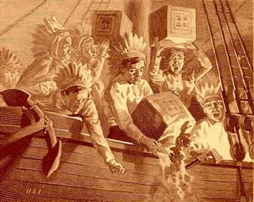  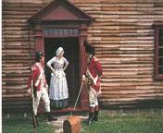 | A) Boston Tea Party (December 16, 1773)  1. protest to Tea Act, which gave monopoly to  British East India Tea company on American tea trade  2. Protest organized by the Sons of Liberty  3. Patriots disguised as Indians board three British tea ships  (the Dartmouth, Eleanor and the Beaver) and dumped 342  chests of tea overboard  B) The Intolerable Acts (1774) Known in Britain as the  “Coercive Acts,” series of laws passed to punish Boston for the  Boston Tea Party and restore order  1. Boston Port Act: shut down Boston harbor until dumped  tea was paid for  2. The Quartering Act- stated British troops could be  stationed in people’s houses.  3. Massachusetts Government Act:  a. limited town meetings to once a year;  b. most positions in colonial government were to be  appointed by the King (not elected by the  people. as most were before)

Key Events 1773-1774 (continued)
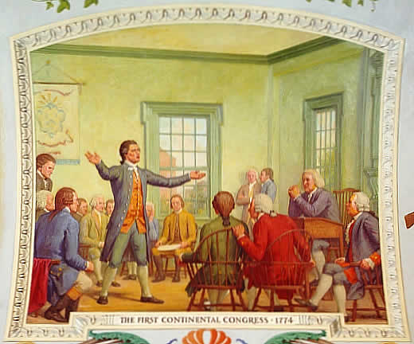 | B) the Intolerable Acts (continued)  4. Administration of Justice Act—royal officials accused of a crime could be tried in England, not Massachusetts – Americans felt this amounted to diplomatic immunity (sort of a “free pass”) for British officials to commit crimes as English courts wouldn’t convict them for crimes against colonists  C) First Continental Congress  1. Other colonies deeply troubled by how British  treat Boston  2. Delegates from 12 of the 13 colonies meet in  Philadelphia to discuss situation and take action  3. Important step towards colonial unity  4. Key decisions/actions include  a. send food to Boston  b. raise militias in each colony  c. store up arms/ ammunition (just in case)  d. boycott British goods  e. send petition to king asking him to repeal  Intolerable Acts  f. If British do not repeal Intolerable Acts--  which they don’t—then they will meet  following year (which they do)-- the Second  Continental Congress, which winds up  creating the Continental Army and declaring  independence

IV FIRST BATTLES
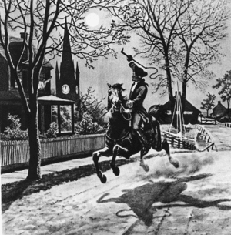 | A) Lexington and Concord (April 19, 1775)  1. British learn about rebel arms in Concord and move to confiscate them and arrest rebel ringleaders John Hancock and Sam Adams  2. American spies learn of British movement, so Paul Revere and two other riders warn militia outside Boston of British advance

I. First Battles (continued)
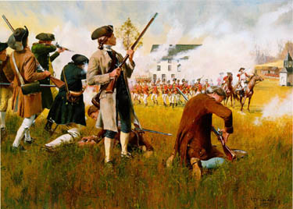  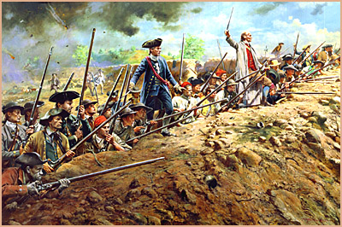 | A) Lexington and Concord (continued)  3. On way to Concord, British meet small group  of American militia in Lexington  4. American Militia told “Disperse, ye rebels” and  are giving ground, when someone fires  (unknown which side fired first)  5. Several Americans are killed, British continue  advance to Concord  6. British meet larger force of American militia at  North Bridge in Concord and retreat back to  Boston  7. As they retreat, American engage in guerilla  tactics, harassing and sniping at the British  8. Battle becomes known as “The Shot Heard  Round the World”  B) Battle of Bunker Hill (June 17, 1775)  1. After Lexington and Concord American militia lay siege to Boston to drive British out  2. set up position on Breed’s Hill, from which they can fire on British ships in harbor  3. Americans are low on supplies and are told “Don’t fire until you see the whites of their eyes” in order to conserve ammo  4. British attack Americans in three waves of a frontal assault (marching directly at enemy)  5. British eventually take hill on third wave of attack (because Americans ran out of ammunition) but suffer heavy losses  6. Considered first major battle of Revolution  C) Other pre-Declaration of Independence Battles  1. Capture of Fort Ticonderoga- Fort near Lake  Champlain, Captured in May of 1775. Cannons  captured there used to finally drive British out  of Boston (March of 1776)  2. Failed invasion of Canada- Americans begin  laying siege to Quebec in December of 1775 in the  hopes of gain control of the St Lawrence River, but  are unable to capture the city, and abandon the  invasion in the spring of 1776.  3. Siege of Boston- using guns of Ft. Ticonderoga, Americans drive British out of Boston March 1776

